MODULE 4

1.Get Java compiler version

2.Write method which return JDK version





3. Write method which return JAVA_HOME





4.Convey command-line arguments to application and get them from the arguments of main method.

5.Pass system property by command-line argument -Dname=value and get its value by name



7.Wrine new array, use methods toString,hashCode,equals,instanceof

8.Work with array: create, set, get value, get length

9.Write code to get ArrayIndexOutIfBoundException

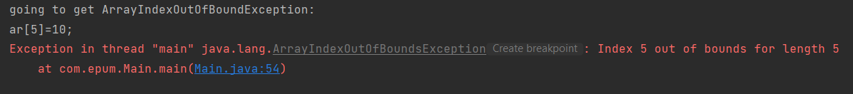

10.The Object class:create a few instances of class<Cat>. Use method equals (with true, false result),

hashCode, toString, getClass

11. The Class class: use methods getName, getPackage

12.Write method which will throw NullPointerException

