7/10/18

LDA results

Controls:



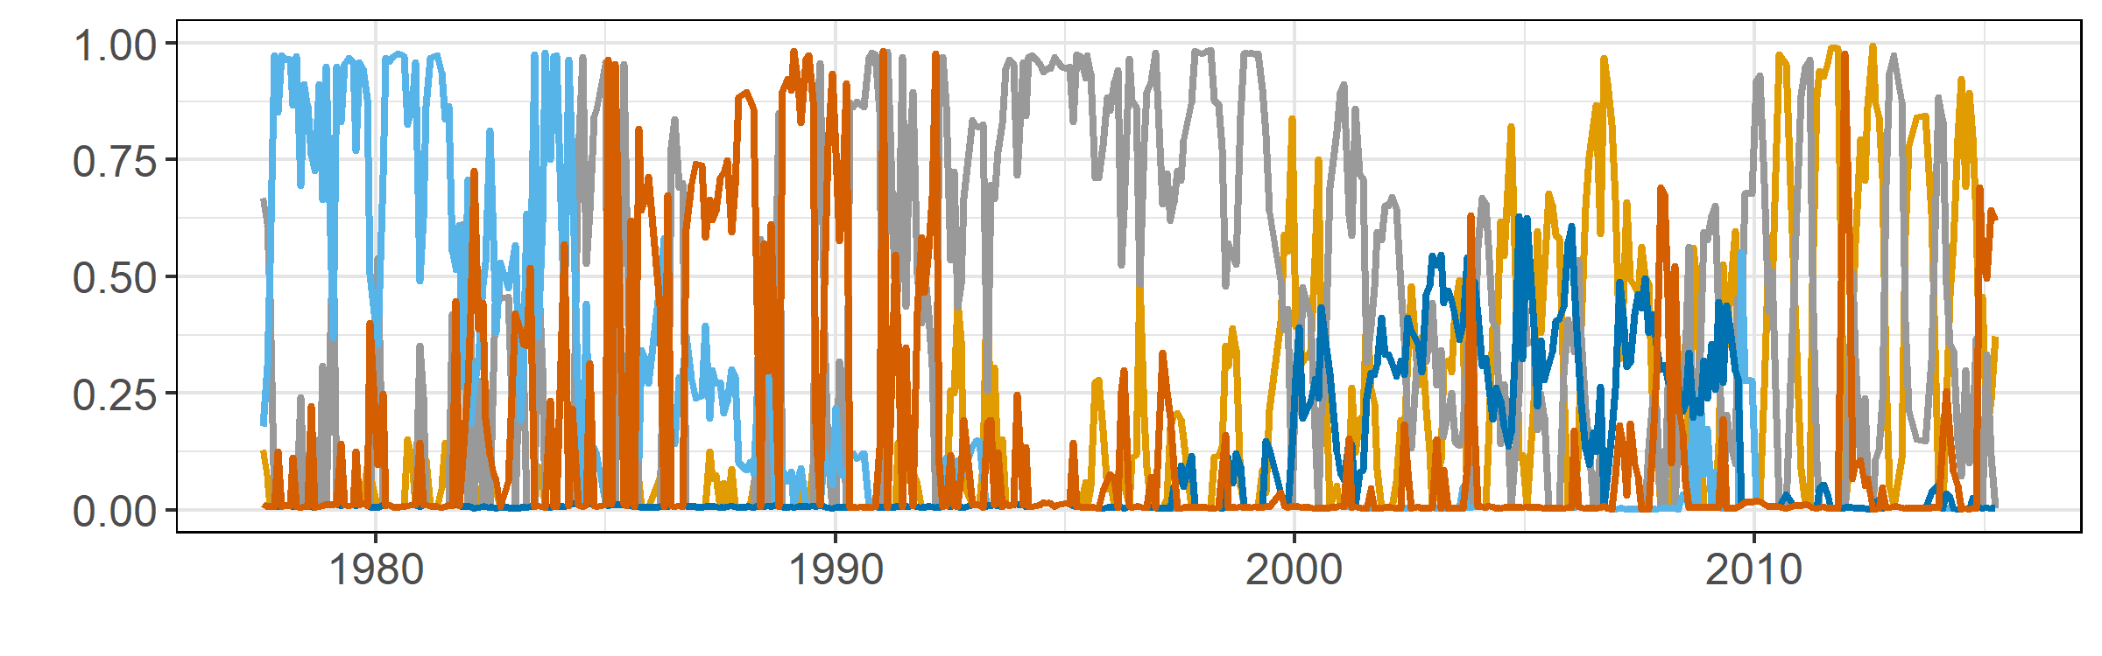

Krat exclosures:



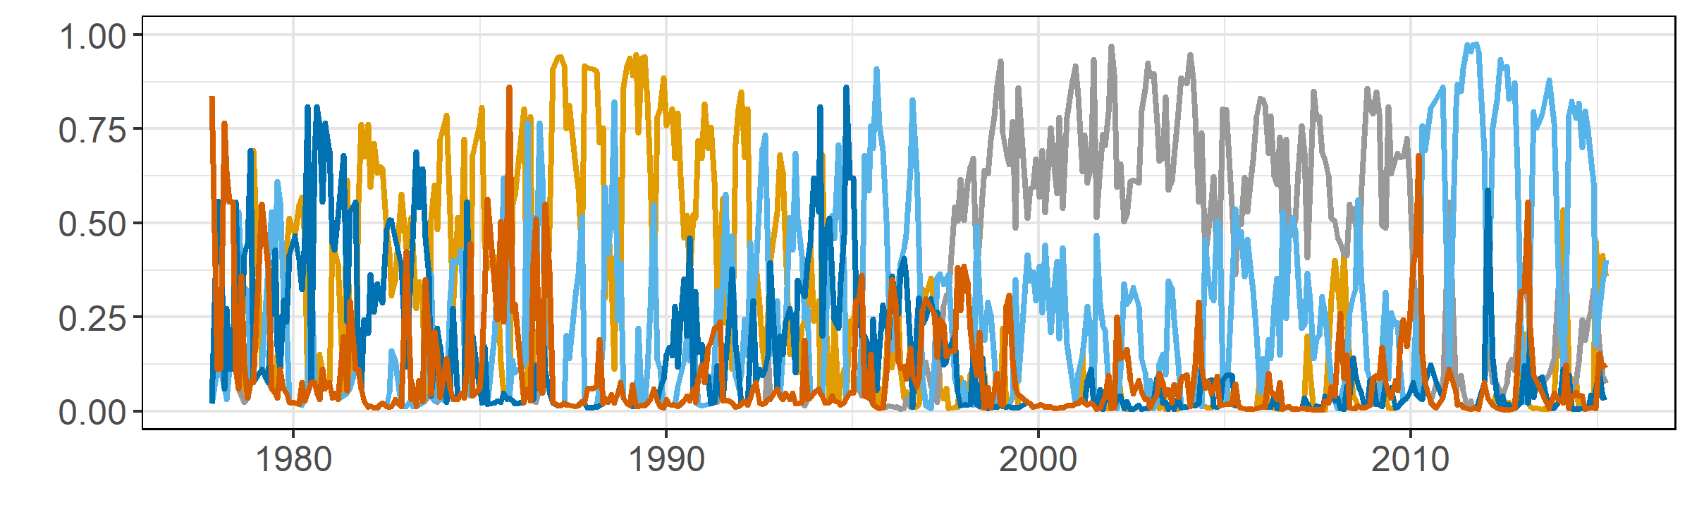

Changepoint model results

Controls:

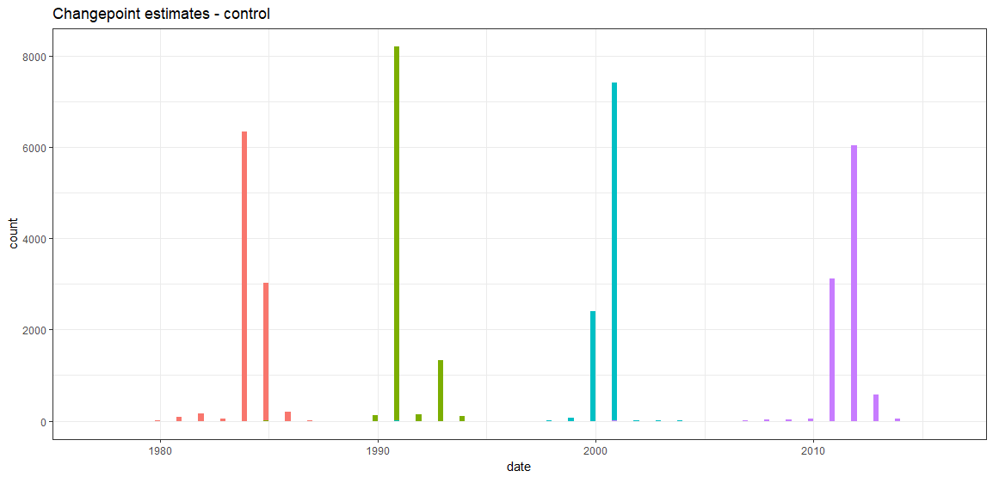

Mean_date Median_date Lower_date Upper_date SD MCMCerr AC10 ESS

1 1984-04-29 1984-04-29 1983-11-12 1985-04-05 6.28 0.0631 0.5270 234.8097

2 1990-08-16 1990-04-24 1990-01-06 1992-07-03 9.46 0.0951 0.6722 129.6082

3 1999-07-02 1999-07-22 1999-02-20 1999-12-05 3.66 0.0368 0.2908 591.2907

4 2010-01-16 2009-12-12 2009-04-26 2011-01-05 6.26 0.0629 0.3267 530.8094

Exclosures:

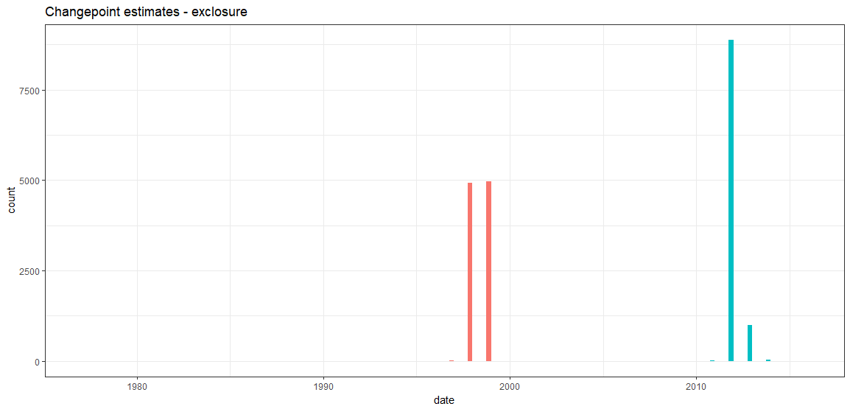

Mean_date Median_date Lower_date Upper_date SD MCMCerr AC10 ESS

1 1997-06-09 1997-06-09 1997-02-08 1997-10-25 2.52 0.0253 0.1023 1454.805

2 2010-01-16 2010-01-16 2009-08-22 2010-07-30 3.18 0.0320 0.0927 1678.957