**Transport experiment**

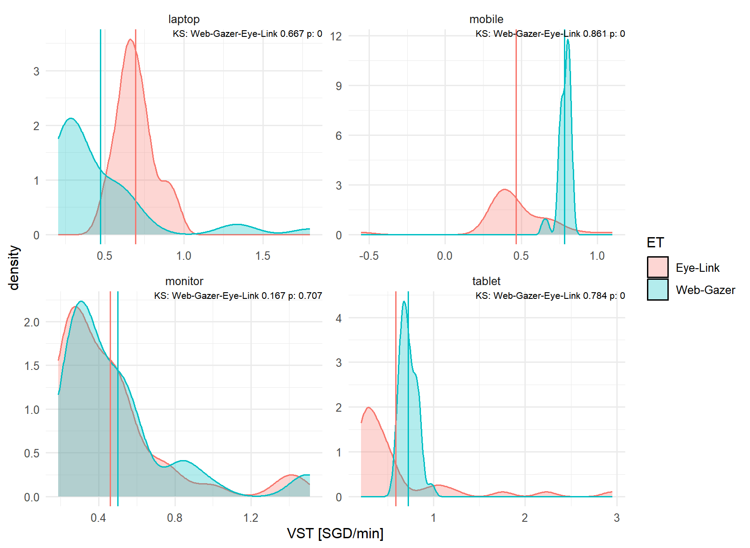

**Figure 1.** Comparison of Subjective Value of Travel Time Savings (SVTTS, SGD/min) distribution, across devices and eye-tracking. Annotation shows Kolmogorov-Smirnov test between distributions. Distributions are consistent only in the monitor case.

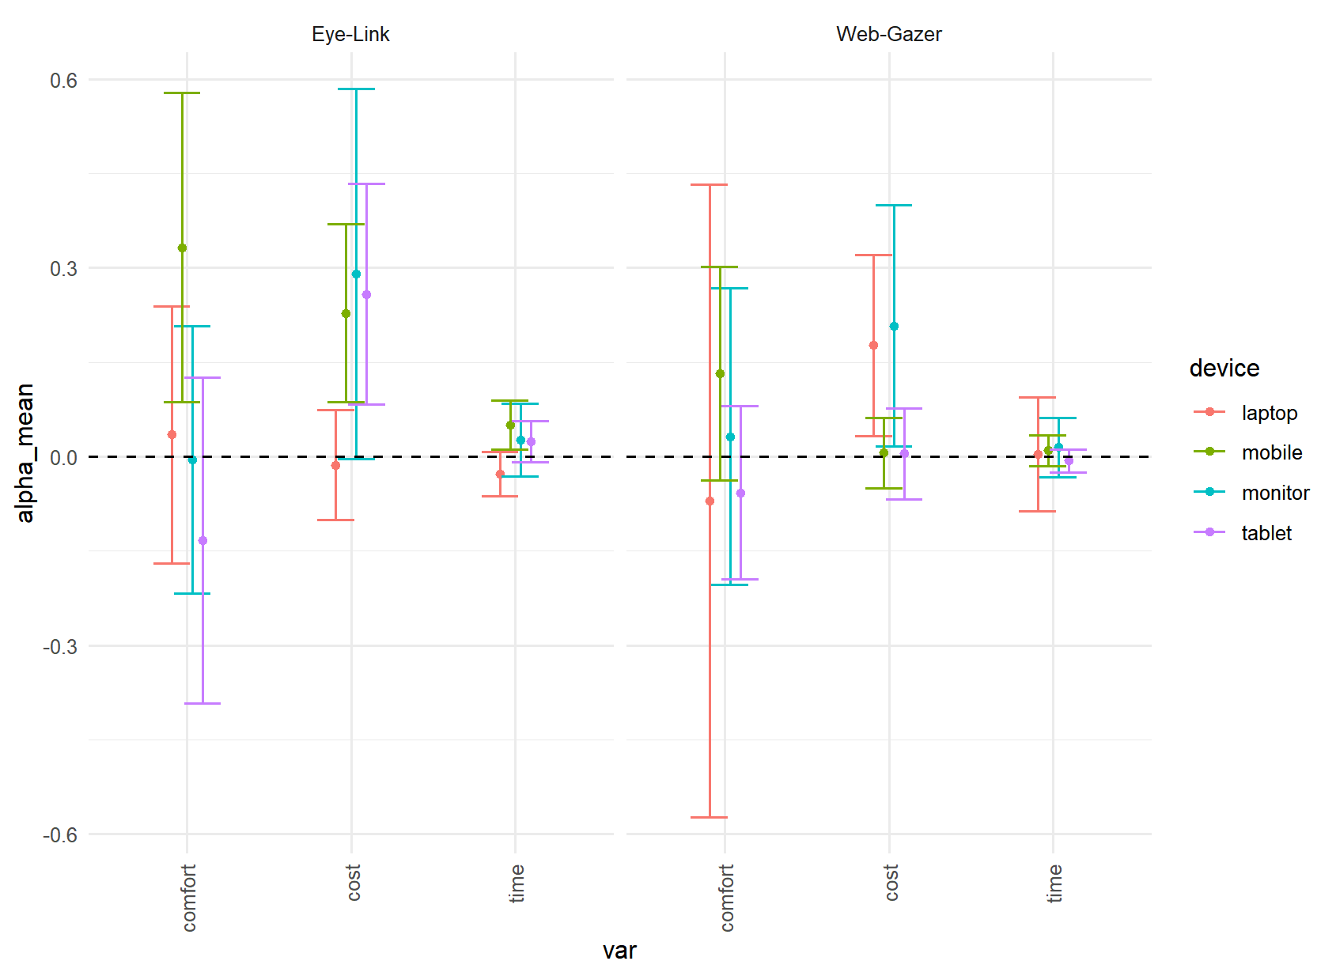

**Figure 2. $α_{k}$** Confidence interval. $α_{k}$ is the influence of the information processing on the marginal utility $β_{k}$. If $α_{k}=0 ∀ k,$ then the information processing captured with eye-tracking is not relevant in the model. The plot shows that, for Eye-link and Web-Gazer there is at least one $k$ such that $α_{k}≠0$.

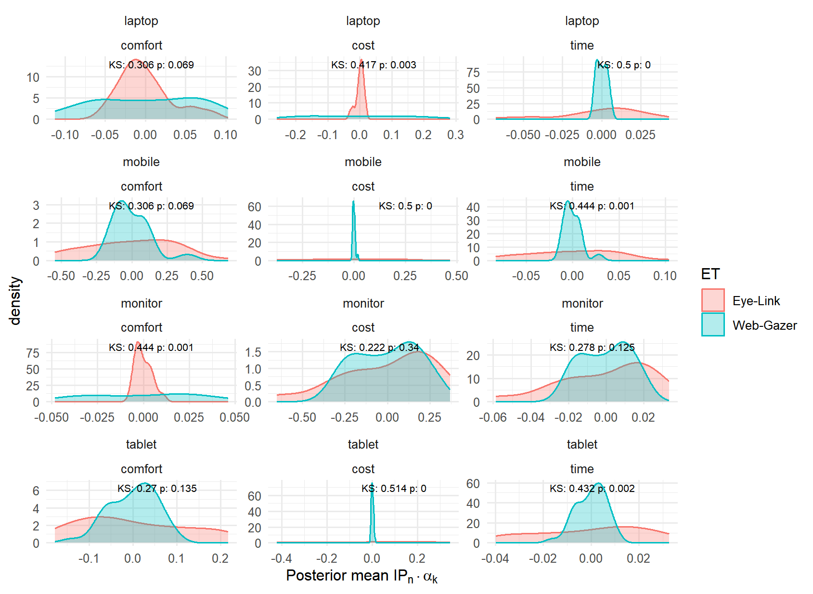

**Figure 3.** Distribution of the latent information processing ($IP_{n}$) scaled by $α_{k}$. If both eye-trackers are consistent, then this distribution should be the same. The monitor case shows the most consistent distributions. Annotations show Kolmogorov-Smirnov test between distributions.

**Pizza experiment**

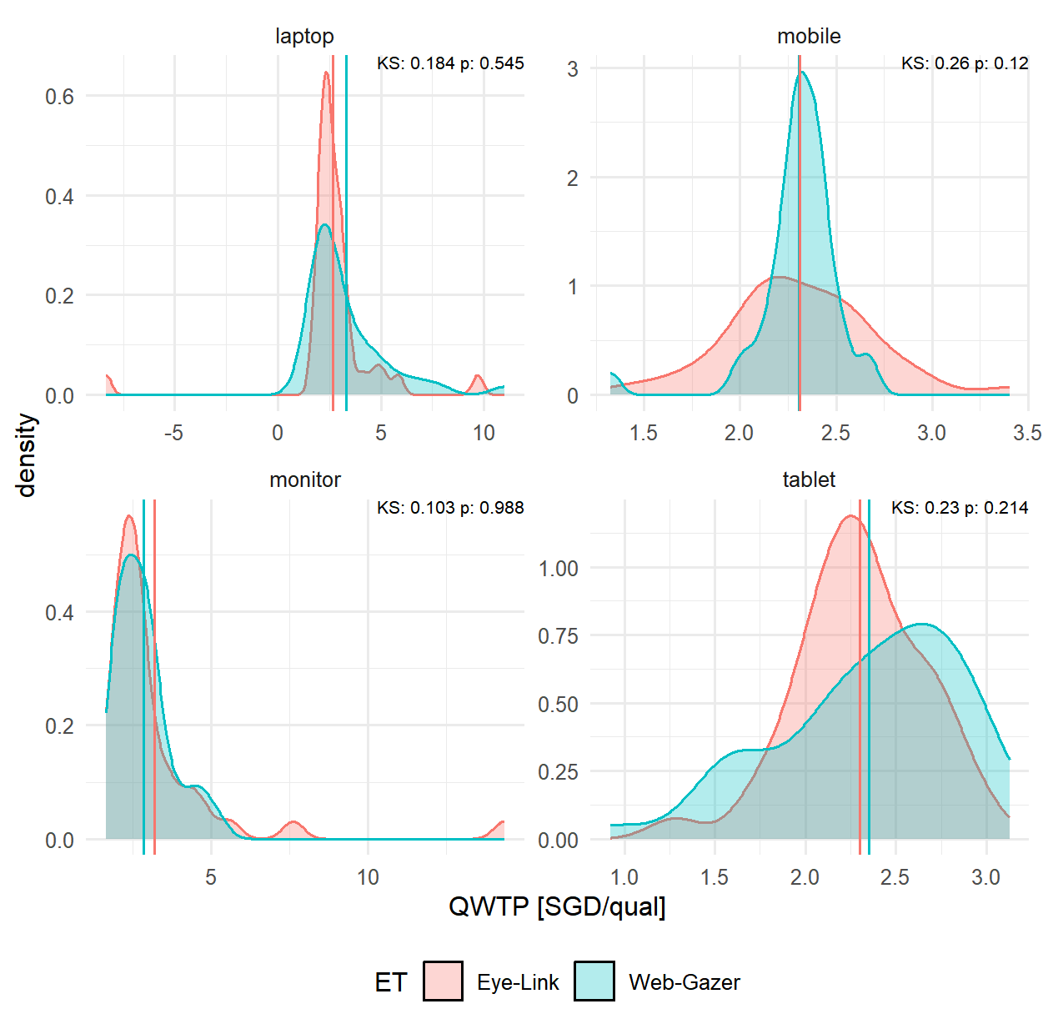

**Figure 4** Comparison of Quality Willingness to Pay (QWTP, SGD/qual) distribution, across devices and eye-tracking. Annotation shows Kolmogorov-Smirnov test between distributions. Distributions are consistent.

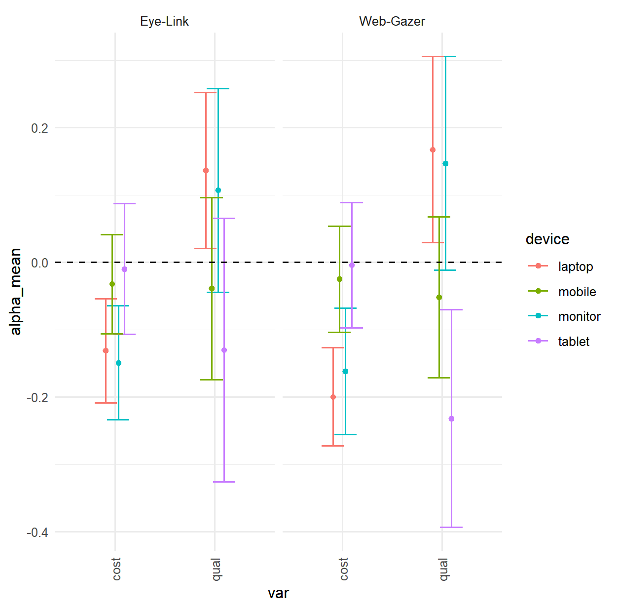

**Figure 5 $α_{k}$** Confidence interval. $α_{k}$ is the influence of the information processing on the marginal utility $β_{k}$. If $α_{k}=0 ∀ k,$ then the information processing captured with eye-tracking is not relevant in the model. The plot shows that, for Eye-link and Web-Gazer there is at least one $k$ such that $α_{k}≠0$.

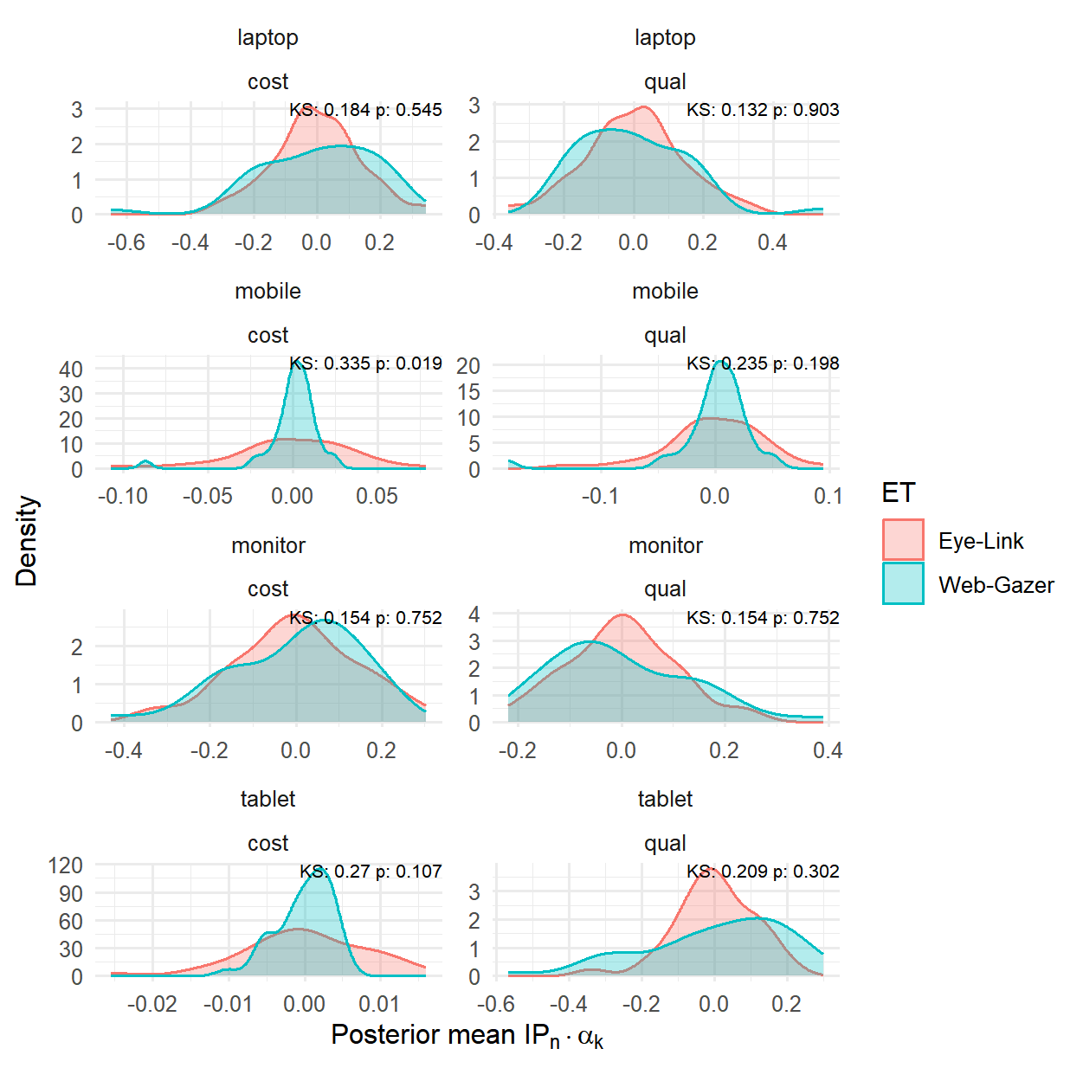

**Figure 6** Distribution of the latent information processing ($IP_{n}$) scaled by $α_{k}$. If both eye-trackers are consistent, then this distribution should be the same. Annotations show Kolmogorov-Smirnov test between distributions. All cases are consistent except mobile.

**Comparison**

|  |  |  |  |  |  |  |
| --- | --- | --- | --- | --- | --- | --- |
| **Hypothesis** | **Device** | **Experiment 1** | | **Experiment 2** | | |
| **Eye-Link** | **Web-Gazer** | | **Eye-Link** | **Web-Gazer** | |
| H1: Eye-tracking data is relevant in the model | Monitor | Yes | Yes | | Yes | Yes | |
| Laptop | Yes | Yes | | Yes | Yes | |
| Tablet | Yes | No | | Yes | Yes | |
| Mobile | Yes | No | | Yes | Yes | |
| H2: Latent IP distribution are consistent across eye-trackers | Monitor | Yes (2/3) | | Yes (2/2) | | |
| Laptop | No (0) | | Yes (2/2) | | |
| Tablet | No (1/3) | | Yes (2/2) | | |
| Mobile | No (0) | | No (1/2) | | |
| H3: The distribution of WTP for relevant attributes are consistent across eye-trackers | Monitor | Yes | | Yes | | |
| Laptop | No | | Yes | | |
| Tablet | No | | Yes | | |
| Mobile | No | | No | | |

H1: t-test of $α_{k}$. H1 is validated if exists a $k$ such that $α_{k}≠0$.

H2: Kolmogorov-Smirnov (KS) test of $α_{k}IP_{n}$ posterior distribution. H2 is validated if the distribution $α_{k}IP_{n}$ obtained with Eye-Link data is not significantly different to the one obtained with Web Gazer data, according to the KS test.

H3: Kolmogorov-Smirnov (KS) test of distributions of Subjective Value of Travel Time Savings (SVTTS) in the case of experiment 1, and WTP for pizza quality in the second experiment. Eye-Link and Web-Gazer distributions should be the same.

**Preliminary conclusions:**

Web-Gazer accuracy is sensitive to stimulus size and screen size. It is more accurate with small DCE and larger screen size.