**Bastian Nazaromi | IT Programmer**

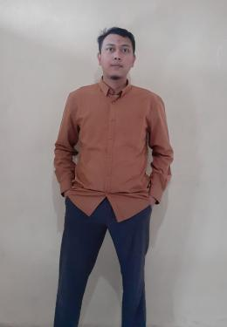

|  |  |  |
| --- | --- | --- |
| **Location** | **:** | **Brebes** |
| **Phone Number** | **:** | **085747771509** |
| **Email** | **:** | **Bastian.nazaromi@gmail.com** |
| **Date of Birth** | **:** | **March, 01th 1998** |

**Professional profile**

Professional with 4+ years experience in Website Based application creation and development. Skilled in team collaboration, problem solving, project management, and able to explain complex software problems in easy to understand terms.

**Career summary**

**2021 - 2022 Angkasa Bahari - Freelancer Programmer**

**2020 - 2022 Politeknik Harapan Bersama Tegal - Staff IT Software**

**2018 - Now Freelancer Programmer**

**2017 - 2020 State Elementary School of Pemaron 3, Brebes District -**

**Admin Staff**

**Programmer**

Outline

collect data and analyze user requirements, then implement it into applications.

Key Responsibility:

* Build application web and Internet of Things
* Create a model from data and making decission support system run based from problem user

Key Achievements/Projects

* Maju Tekno (Angka Bahari) - web based - 2021
  + Backend developer

Key Achievements/Projects

* Paduka Kencana (Dinas Pengendalian Penduduk, Keluarga Berencana, Pemberdayaan Perempuan, dan Perlindungan Anak, Tegal City) - web based - 2021
  + Fullstack developer

Key Achievements/Projects

* Catatan Ibadah Harian (State Elementary School of Kupu 2, Tegal District) - web based - 2021
  + Fullstack developer

Key Achievements/Projects

* Kandela Library (State Elementary School of Tegalsari 1, Tegal City) - web based - 2021
  + Fullstack developer

Key Achievements/Projects

* Language Proficiency Test (Politecnic of harapan bersama) - web based - 2021
  + Fullstack developer

Key Achievements/Projects

* SYNCSELEKSI (Politecnic of harapan bersama) - web based - 2021
  + Fullstack developer

Key Achievements/Projects

* OASE (Politecnic of harapan bersama) - web based - 2021
  + Fullstack developer

Key Achievements/Projects

* LAB HARDWARE (Politecnic of harapan bersama) - web based - 2020
  + Fullstack developer

Key Achievements/Projects

* SIKAPTA (Politecnic of harapan bersama) - web based - 2020
  + Fullstack developer

**Education & qualifications**

Politechnic of Harapan Bersama, Tegal

* 3-year Diploma of Computer Engineering 2016 - 2019

Programming Language Skills

* PHP ( CodeIgniter, Laravel )
* Javascript
* C++ for Microcontroller

Technologies

* MySQL
* Git
* Restful API