

**An elegant and simple application to manage photos. Built with web technologies and vue.js.**

« PICS » is the first project in which it has to be built during the two first quarters of the year of the professional training program in HS Technician programming at « Centre Professionnel du Nord Vaudois ».

« PICS » is a multi-platform application which allows users to manage pictures and it can be used in Mac OS & Windows. The project has been programming with IDE (Integrated development environment) and Github has been used for versioning the project evolution.

The project has been programmed with web technologies, **Electron** and **Vue.js.**

Since Picasa is not supported by Google. Users are finding similar software like Picasa to have same functionalities.

By the way the mission is a build of an application which can solve client issues.

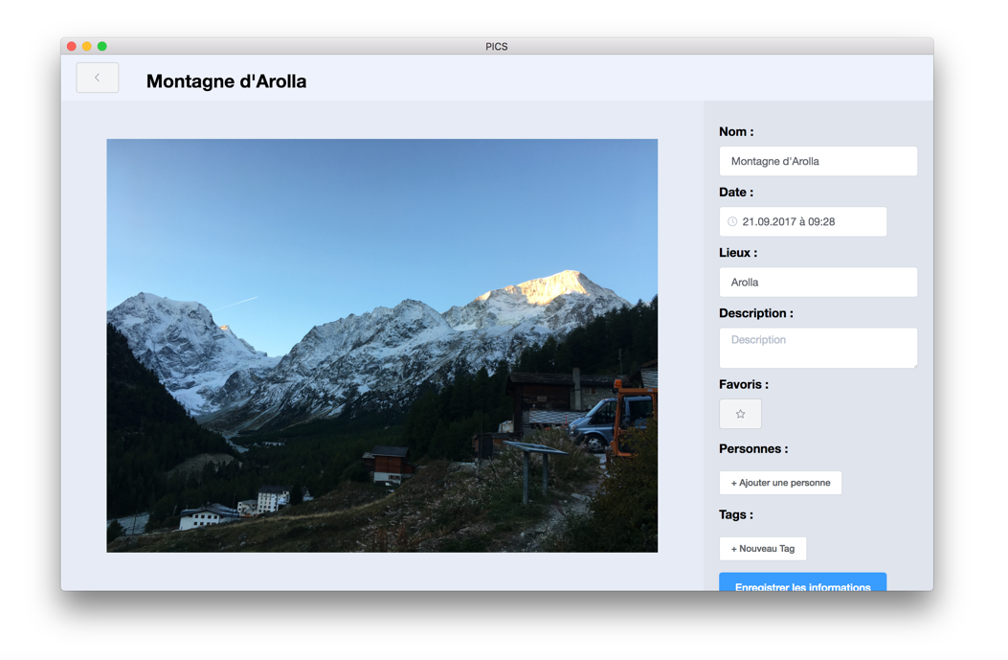

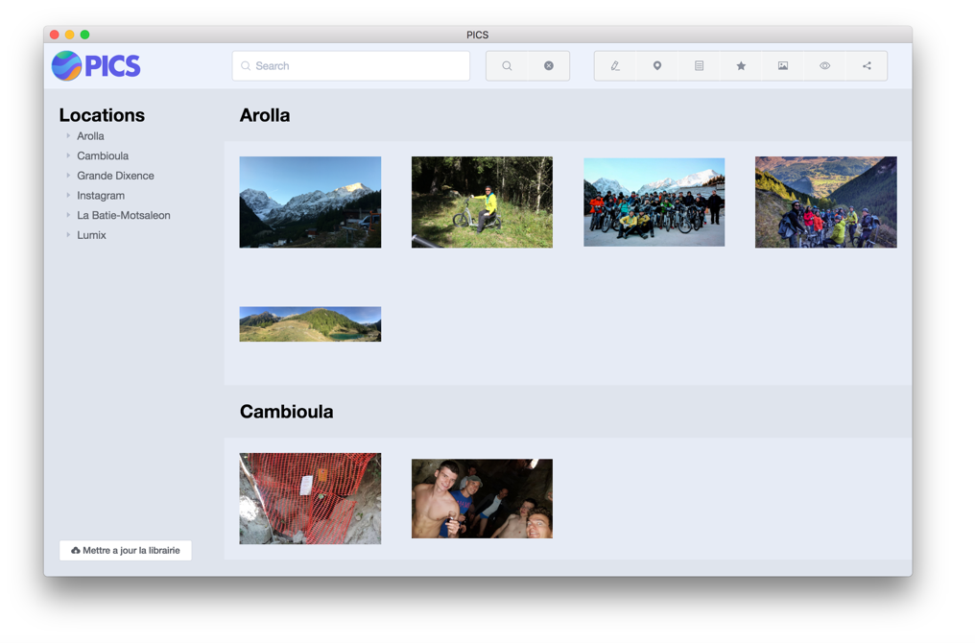

sThis project has been deployed with basic goals. It allows the user to search, filter and manage pictures smartly and quietly. They’re basically similar to Picasa’s functionalities

Vue.js

<https://vuejs.org/>

Element.io

<http://element.eleme.io/#/en-US>

Electron

<https://electronjs.org/>

### Technologies

* Show pictures classifying them by name and date.
* Edit meta-datas.
  + Add and edit tags
  + Add pictures in favorites
  + Add comments
* Rename pictures using meta-datas and folders’ name.
* Filter them by tags, favorite, panoramic view, etc…
* Search pictures with key-words.

Mostly, almost all the functionalities have been deployed. The manage was quite complicated because the programming leveling is very different.

« PICS » has a release in Github that can be downloaded:

<https://github.com/bastiennicoud>