American International University- Bangladesh (AIUB) Faculty of Engineering (FE)

|  |  |  |  |
| --- | --- | --- | --- |
| **Course Name:** | DATA COMMUNICATION | **Course Code:** | COE3103 |
| **Semester:** | Summer 2024-25 | **Section:** | D |
| **Faculty:** | MOHAMMAD ASADUZZAMAN KHAN | **Group:** | 05 |

|  |  |
| --- | --- |
| **Experiment No:** | 06 |
|  |  |
| **Experiment Name:** | **Study of Digital to Analog Conversion using MATLAB** |

|  |  |  |  |
| --- | --- | --- | --- |
| **Group Members** | | **Name** | **ID** |
|  | 1. | Basudeb Kundu | 23-50856-1 |
| 2. | Prohlad Chandra Das | 23-50922-1 |
| 3. | Debashis Kumar Das | 23-50953-1 |
| 4. | Indronill Dutta Nill | 23-50974-1 |
| 5. | Nafiur Rahman Nirob | 23-50991-1 |

|  |  |  |  |
| --- | --- | --- | --- |
| **Performance Date:** | 24-8-25 | **Due Date:** | 31-8-25 |

**Marking Rubrics (to be filled by Lab Instructor)**

|  |  |  |  |  |  |
| --- | --- | --- | --- | --- | --- |
| Category | Proficient [6] | Good [4] | Acceptable [2] | Unacceptable [1] | Secured Marks |
| **Theoretical Background, Methods & procedures sections** | All information, measures and variables are provided and  explained. | All Information provided is sufficient, but more explanation is  needed. | Most information is correct, but some information may be  missing or inaccurate. | Much information is missing and/or inaccurate. |  |
| **Results** | All of the criteria are met; results are described clearly and accurately; | Most criteria are met, but there may be some lack of clarity and/or incorrect information. | Experimental results don’t match exactly with the theoretical values and/or analysis  is unclear. | Experimental results are missing or incorrect; |  |
| **Discussion** | Demonstrates thorough and sophisticated understanding.  Conclusions drawn are appropriate for  analyses; | Hypotheses are clearly stated, but some concluding statements not supported by data or data not well  integrated. | Some hypotheses missing or misstated; conclusions not supported by data. | Conclusions don’t match hypotheses, not supported by data; no integration of data from different sources. |  |
| **General formatting** | Title page, placement of figures and figure captions, and other  formatting issues all correct. | Minor errors in formatting. | Major errors and/or missing information. | Not proper style in text. |  |
| **Writing & organization** | Writing is strong and easy to understand; ideas are fully elaborated and connected; effective transitions between sentences; no  typographic, spelling, or grammatical errors. | Writing is clear and easy to understand; ideas are connected; effective transitions between sentences; minor typographic, spelling, or grammatical errors. | Most of the required criteria are met, but some lack of clarity, typographic, spelling, or grammatical errors are present. | Very unclear, many errors. |  |
| Comments: |  | | | Total Marks (Out of **30**): |  |

**Title: Study of Digital to Analog Conversion using MATLAB**

**Abstract:**

This experiment is designed to-

1. To understand the use of MATLAB for solving communication engineering problems.
2. To develop understanding of Digital to Analog conversion using MATLAB.

# Introduction:

Digital to analogconversion is the process of changing one of the characteristics of an analog signal based on the information in digital data Figure bellow shows the relationship between the digital information, the digital to analog modulating process, and the resultant analog signal.

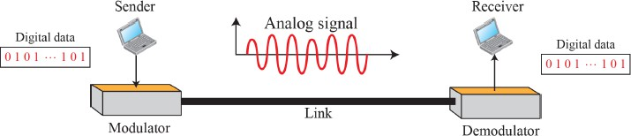

* 1. TYPES OF DIGITAL TO ANALOG CONVERSION:

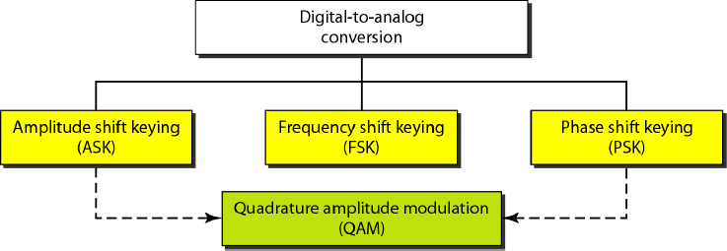

* **Amplitude Shift Keying (ASK):** The amplitude of the carrier signal changes with the digital bit value. A ‘1’ may be represented with full amplitude, while a ‘0’ is represented with zero or reduced amplitude. Frequency and phase remain constant.

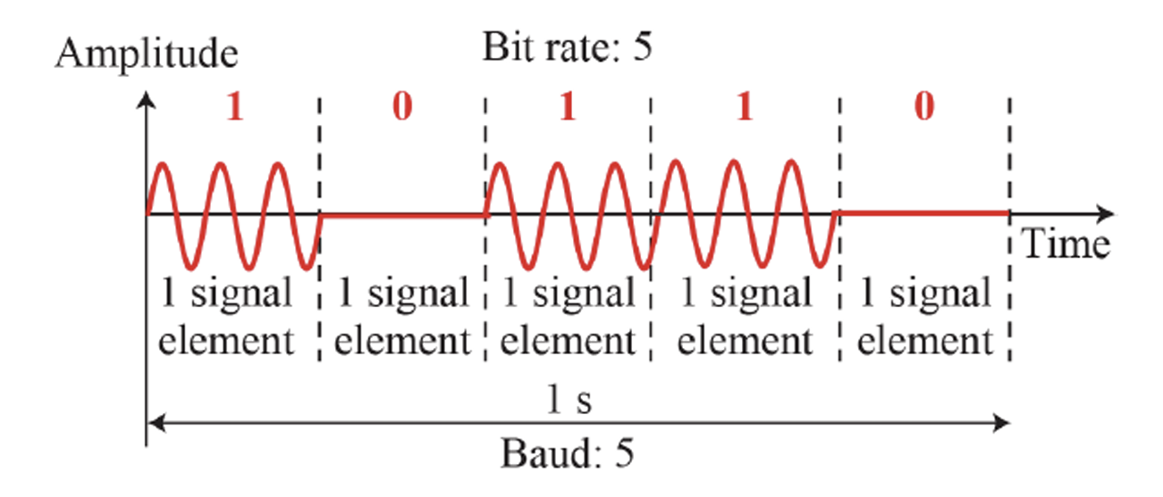

**Fig1: Binary amplitude shift keying**

**Fig2: Implementation of binary ASK**

**Frequency Shift Keying (FSK):** The frequency of the carrier signal is changed depending on the input bit, while the amplitude and phase remain constant.

**Fig3: Binary Frequency Shift Keying**

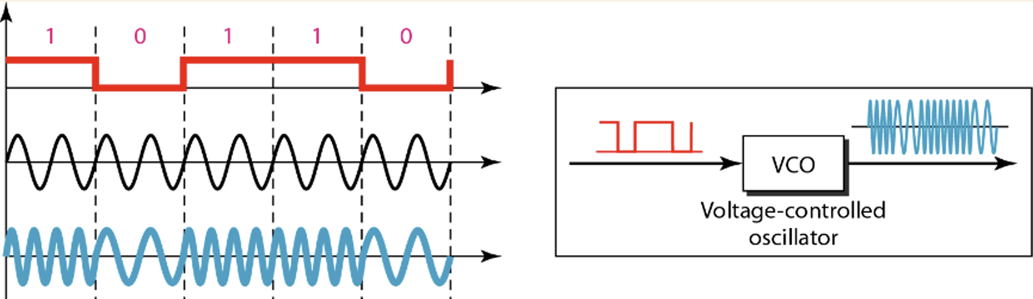

**Fig4: Implementation of BFSK**

* **Phase Shift Keying (PSK):** The phase of the carrier signal is changed to represent binary data, keeping amplitude and frequency constant. PSK is more bandwidth-efficient and noise-resilient compared to ASK and FSK.

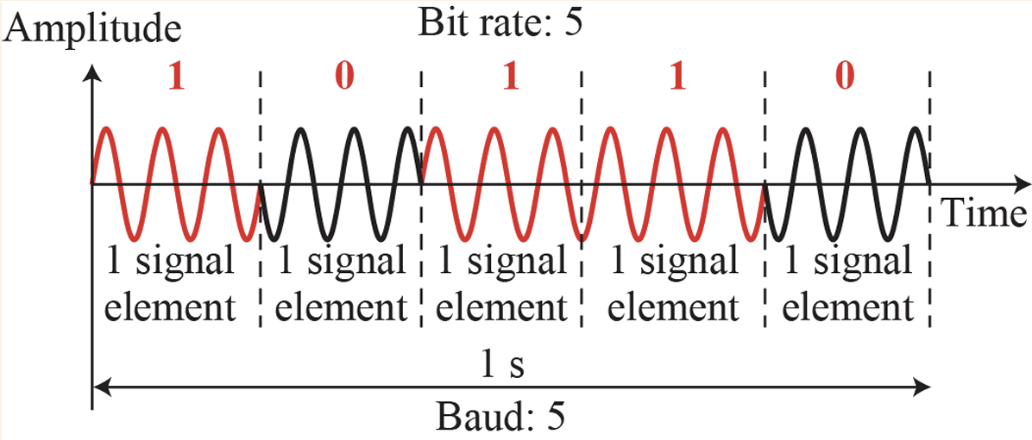

**Fig5: Binary Phase Shift Keying**

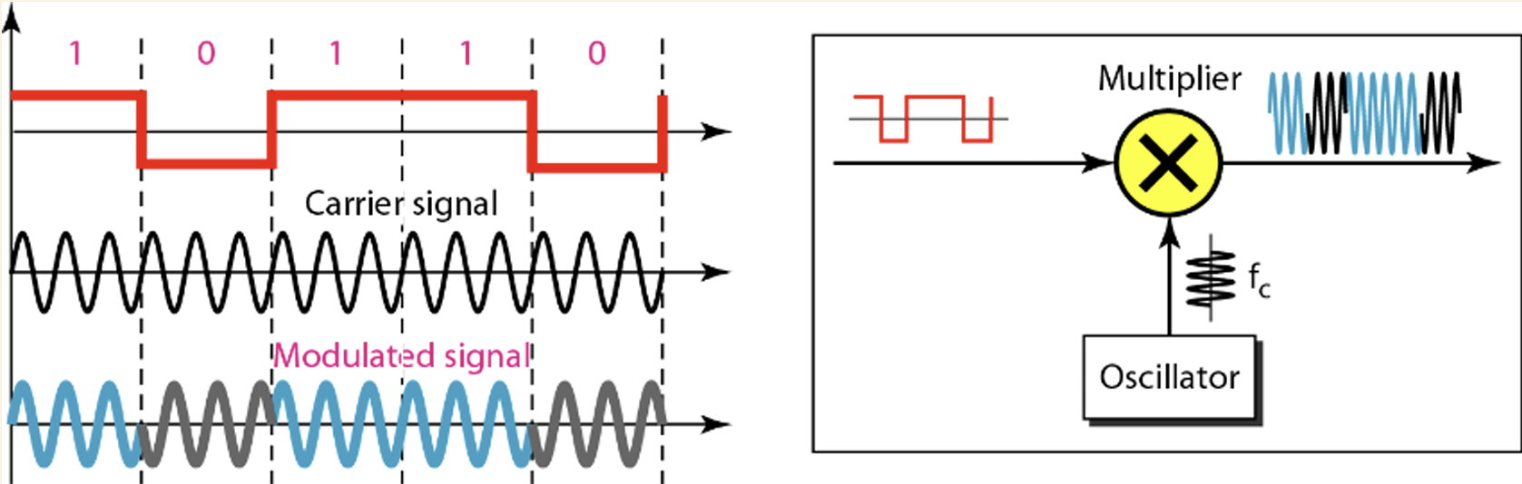

**Fig6: Implementation of BPSK**

* **Quadrature Phase Shift Keying (QPSK):** This is an extension of PSK where two bits are transmitted per symbol using four distinct phase shifts. It effectively doubles the data rate of standard BPSK without increasing bandwidth.

**Fig7: Implementation of QPSK**

**Results and Discussion**

1. 8-ASK: Different amplitudes for 000 to 111 in the modulated signal can be 0 V, 1 V, 2 V, 3 V, 4 V, 5 V, 6 V, and 7 V respectively.
2. 8-FSK: Different frequencies for 000 to 111 in the modulated signal can be 1 Hz, 2 Hz, 3 Hz, 4 Hz, 5 Hz, 6 Hz, 7 Hz, and 8 Hz respectively.
3. 8-PSK: Different phases for 000 to 111 in the modulated signal can be 0, pi/4, 3*pi/4, pi/2, -pi/4, -pi/2, pi, -3*pi/4 respectively.

Duration of each signal element must be 1 second.

𝐴𝐵 − 𝐶𝐷𝐸𝐹𝐺 − 𝐻

### 23 − 50856 − 1

### **Conversion to 8-bit ASCII characters of E, F, G:**

### **E = 8 = 00111000**

### **F = 5 = 00110101**

### **G = 6 =00110110**

### **Finally the bit stream: 001110000011010100110110**

|  |
| --- |
| **Code:** |
| close all;  clc;  f = 5;  x = [001 110 000 011 010 100 110 110];  nx = length(x);  for i = 1:nx  t = i:0.001:i+1;  if x(i) == 000  ask = 0 * sin(2 * pi * f * t);  fsk = sin(2 * pi * 1 * t);  psk = sin(2 * pi * f * t + 0);  elseif x(i) == 001  ask = 1 * sin(2 * pi * f * t);  fsk = sin(2 * pi * 2 * t);  psk = sin(2 * pi * f * t + (pi/4));  elseif x(i) == 010  ask = 2 * sin(2 * pi * f * t);  fsk = sin(2 * pi * 3 * t);  psk = sin(2 * pi * f * t + (3*pi/4));  elseif x(i) == 011  ask = 3 * sin(2 * pi * f * t);  fsk = sin(2 * pi * 4 * t);  psk = sin(2 * pi * f * t + (pi/2));  elseif x(i) == 100  ask = 4 * sin(2 * pi * f * t);  fsk = sin(2 * pi * 5 * t);  psk = sin(2 * pi * f * t + (-pi/4));  elseif x(i) == 101  ask = 5 * sin(2 * pi * f * t);  fsk = sin(2 * pi * 6 * t);  psk = sin(2 * pi * f * t + (-pi/2));  elseif x(i) == 110  ask = 6 * sin(2 * pi * f * t);  fsk = sin(2 * pi * 7 * t);  psk = sin(2 * pi * f * t + (-pi));  elseif x(i) == 111  ask = 7 * sin(2 * pi * f * t);  fsk = sin(2 * pi * 8 * t);  psk = sin(2 * pi * f * t + (-3*pi/4));  end  subplot(3,1,1);  plot(t, ask);  hold on;  grid on;  axis([1 nx+1 -8 8]);  title('Amplitude Shift Keying (ASK)');  subplot(3,1,2);  plot(t, fsk);  hold on;  grid on;  axis([1 nx+1 -1.5 1.5]);  title('Frequency Shift Keying (FSK)');  subplot(3,1,3);  plot(t, psk);  hold on;  grid on;  axis([1 nx+1 -1.5 1.5]);  title('Phase Shift Keying (PSK)');  end |

|  |
| --- |
| **Result and Discussion:** |
| **Fig8: 8-Level ASK, FSK, and PSK Signal Representations for 3-bit Digital Symbols** |
| In this experiment, digital-to-analog conversion techniques including Amplitude Shift Keying (ASK), Frequency Shift Keying (FSK), and Phase Shift Keying (PSK) were implemented using MATLAB. By utilizing 3-bit symbols (ranging from 000 to 111), eight distinct signal variations were generated for each modulation technique, corresponding to unique amplitudes, frequencies, and phases for ASK, FSK, and PSK, respectively.  The simulation effectively demonstrated how digital data can be represented in analog form using these modulation methods. The MATLAB plots clearly illustrated the changes in waveform characteristics over time for each technique. ASK signals exhibited varying amplitude levels while maintaining constant frequency and phase. FSK signals showed consistent amplitude and phase but varied in frequency based on the symbol values. PSK signals manifested phase changes while keeping amplitude and frequency constant. These visualizations confirmed the theoretical principles and emphasized the unique encoding approaches of each modulation scheme.  Additionally, the code efficiently grouped the bitstream into symbols and applied the corresponding modulations. The use of color-coded plots further enhanced the clarity, allowing easy identification of symbol transitions in each modulation technique. |

**Conclusion**

This experiment clearly showed how Digital to Analog Conversion works using MATLAB. The use of 8-ASK, 8-FSK, and 8-PSK techniques demonstrated how digital bits are changed into different analog signals by adjusting amplitude, frequency, and phase. The simulation results matched well with what theory predicts, helping to better understand each type of modulation. In summary, the experiment gave practical knowledge about digital modulation methods used in communication systems and showed how useful MATLAB is for signal processing and analysis..