**Question # 1**

The source code is in Question1.c. The program will randomly generate vertices and ask for density to put by user. Then using the given formula, it will calculate the edges and prepare the adjacency matrix.

I will also generate a txt file named as **adjacency.txt.**

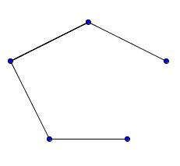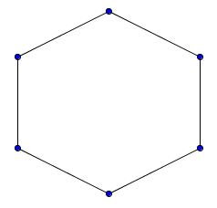

We get random graphs for the two scenarios as:

a) n=6 and edge density as 0.4

b) n=5 with edge density as 0.5

**Question # 2**

The source code is in Question2.c. The program will randomly generate vertices and ask for density to put by user. Then using the given formula, it will calculate the edges and prepare the adjacency matrix. Then it will show the degree sequence in non-increasing order.

I will also generate a txt file named as **degree sequence.txt.**