PKCS #11: Cryptographic Token Interface Standard (Cryptoki)

An RSA Laboratories Seminar

Revised September 12, 1995

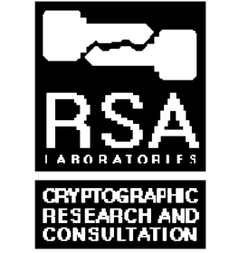

Copyright © 1995 RSA Laboratories, a division of RSA Data Security, Inc. All rights reserved. 901-903008-132-000-000
Introduction
- Portable devices ideal for public-key cryptography

- store private keys securely

- cryptographic operations performed by device

- Standard programming interface increasingly important

- PKCS #11 (Cryptoki) offered as candidate
Status
- Announced in January 1994

- First draft in February

- Review meeting May 19–20

- Second draft released October 19

- Third draft released March 22, 1995

- Pre-release of final document April 22, 1995

- Final document released April 28, 1995

Design goals
1. Technology independence

- any kind of cryptographic device

- any operating system

2. Resource sharing

- more than one application per device, or device per application

General model
- Cryptoki is a programming interface that gives a common logical view to all kinds of cryptographic device

- a cryptographic token

- “software” devices also supported

- A given Cryptoki implementation supports certain classes of device

- initially, each class expected to have its own Cryptoki implementation

- eventually, a single implementation for all classes?

General model (cont’d)
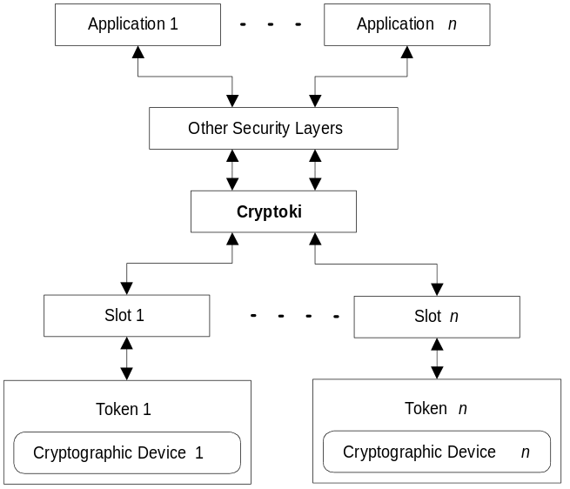

- “Other Security Layers” might include:

- Generic Security Services Application Programming Interface (RFCs 1508 and 1509)
- Generic Cryptographic Service API (X/Open)
- Cryptographic API (CAPI) (Microsoft)

Programming model
- Cryptoki maintains a list of slots that interface to tokens, and a list of tokens “in the system”

- Application opens a session with a token, and a user “logs in”

- Token stores collection of objects

- Application data, certificates, and keys
Tokens and slots
- Application can obtain information about each slot, such as:

- description (e.g., “PCMCIA”)

- if the device is removable

- if the slot is a “hardware” or “software” slot

- if a token is present
Tokens and slots (cont'd)
- Application can obtain a list of tokens in the system and information about each one, such as:

- a label

- description (manufacturer, model)

- serial number

- status (read-only, random number generator)

- maximum of sessions

- maximum and minimum length of PIN

- amount of total and free memory on the token
Sessions
- Application opens a session with a token

- read-only session

- read/write session

- For greater access, application user logs in

- requires PIN

- Security Officer or normal user access

Objects
- Classes

- Application data objects hold information defined by an application

- Certificate objects hold public-key certificates

- Key objects hold public, private, and secret keys

- Lifetime

- Token objects exist on token and remain after session is closed

- Session objects exist only for the duration of the session

Objects
- Visibility

- Public objects are visible to all sessions

- Private objects are visible only after a user has logged in

- Objects consist of attributes

- An application can create or destroy objects, and manipulate attributes

- An application can also search for objects based on attributes

- Attributes supported depends on application profile

Object types
- Application data

- Certificate

- Public key

- RSA
- DSA
- Diffie-Hellman

- Private key

- RSA
- DSA
- Diffie-Hellman

- Secret key

- RC2
- RC4
- DES (single, double, or triple length)

Cryptographic operations
- An application can perform cryptographic operations on objects and data supplied by the application

- operation may run in parallel with application

- Cryptographic operations supported depends on mechanisms supported by device
Functions
- C_Initialize: initializes Cryptoki

- C_GetInfo: obtains general information about Cryptoki

- C_GetSlotList: obtains a list of slots in the system

- C_GetSlotInfo: obtains information about a particular slot

- C_GetTokenInfo: obtains information about a particular token

- C_GetMechanismList: obtains a list of mechanisms supported by a token

- C_GetMechanismInfo: obtains information about a particular mechanism supported by a token

Functions (cont’d)
- C_InitToken: initializes a token

- C_InitPIN: initializes the normal user’s PIN

- C_SetPIN: modifies the PIN of the current user

- C_OpenSession: opens a connection or “session” between an application and a particular token

- C_CloseSession: closes a session

- C_CloseAllSessions: closes all sessions with a token

- C_GetSessionInfo: obtains information about the session

Functions (cont’d)
- C_Login: logs into a token

- C_Logout: logs out from a token

- C_CreateObject: creates an object

- C_CopyObject: creates a copy of an object

- C_DestroyObject: destroys an object

- C_GetObjectSize: obtains the size of an object in bytes

- C_GetAttributeValue: obtains an attribute value of an object

- C_SetAttributeValue: modifies an attribute value of an object

- C_FindObjectsInit: initializes an object search operation

- C_FindObjects: continues an object search operation
Functions (cont’d)
- C_EncryptInit: initializes an encryption operation

- C_Encrypt: encrypts single-part data

- C_EncryptUpdate: continues a multiple-part encryption operation

- C_EncryptFinal: finishes a multiple-part encryption operation

Functions (cont’d)
- C_DecryptInit: initializes a decryption operation

- C_Decrypt: decrypts single-part encrypted data

- C_DecryptUpdate: continues a multiple-part decryption operation

- C_DecryptFinal: finishes a multiple-part decryption operation

Functions (cont’d)
- C_DigestInit: initializes a message-digesting operation

- C_Digest: digests single-part data

- C_DigestUpdate: continues a multiple-part digesting operation

- C_DigestFinal: finishes a multiple-part digesting operation

Functions (cont’d)
- C_SignInit: initializes a signature operation

- C_Sign: signs single-part data

- C_SignUpdate: continues a multiple-part signature operation

- C_SignFinal: finishes a multiple-part signature operation

- C_SignRecoverInit: initializes a signature operation, where the data can be recovered from the signature

- C_SignRecover: signs single-part data, where the data can be recovered from the signature

Functions (cont’d)
- C_VerifyInit: initializes a verification operation

- C_Verify: verifies a signature on single-part data

- C_VerifyUpdate: continues a multiple-part verification operation

- C_VerifyFinal: finishes a multiple-part verification operation

- C_VerifyRecoverInit: initializes a verification operation where the data is recovered from the signature

- C_VerifyRecover: verifies a signature on single-part data, where the data is recovered from the signature

Functions (cont’d)
- C_GenerateKey: generates a secret key

- C_GenerateKeyPair: generates a public-key/private-key pair

- C_WrapKey: wraps (encrypts) a key

- C_UnwrapKey: unwraps (decrypts) a key

- C_DeriveKey: derives a key from a base key

- C_SeedRandom: mixes in additional seed material to the random number generator

- C_GenerateRandom: generates random data

Functions (cont’d)
- C_GetFunctionStatus: obtains updated status of a function running in parallel with the application

- C_CancelFunction: cancels a function running in parallel with the application

- Notify: callback function to process notifications from Cryptoki
Example: Signing a message
1. Find token

- C_GetSlotList, C_GetTokenInfo (one or more times)

2. Open session, and log in

- C_OpenSession, C_Login

3. Find key that supports signatures

- C_FindObjects

4. Run signature functions

- C_SignInit, C_Sign

5. Log out and close session

- C_Logout, C_CloseSession

Example application profiles
- Privacy-Enhanced Mail (PEM)

- RSA, DES, MD2, MD5

- Government authentication-only

- DSA, SHA

- Cellular Digital Packet Data (CDPD)

- Diffie-Hellman, RC4

- More to be defined
Conclusions
- Cryptoki is a standard programming interface for portable cryptographic devices

- More application profiles to be defined

- First libraries demonstrated at 1995 RSA Data Security conference, more to come

- RSA has a software-only implementation of Cryptoki called “SofToken”

- RSA also has a Cryptoki test program for Windows 3.1x Cryptoki DLL’s
Obtaining copies
- E-mail responder: pkcs@rsa.com

- FTP: rsa.com, pub/pkcs/pkcs-11 directory

- Mailing list: pkcs-11-dev@rsa.com

- to subscribe: pkcs-11-dev-request

