WLP
Installation : -
D:\IBM\IM\eclipse\tools>imcl.exe install com.ibm.websphere.liberty.BASE.v85_8.5.250006.20250602_1102 com.ibm.java.jdk.v8_8.0.8011.20231027_0741 ^More? -repositories https://www.ibm.com/software/repositorymanager/com.ibm.websphere.liberty.BASE ^
More? -installationDirectory "C:\Program Files\IBM\WebSphere\wasliberty" ^
More? -sharedResourcesDirectory "C:\Program Files\IBM\IMShared" ^
More? -acceptLicense -showProgress -prompt

====
To check WLP profile version
C:\Program Files\IBM\WebSphere\Liberty_1\bin>productInfo.bat version
Product name: WebSphere Application Server
Product version: 25.0.0.6
Product edition: BASE
To check FeatureInfo
C:\Program Files\IBM\WebSphere\Liberty_1\bin>productInfo featureInfo
servlet-4.0
C:\Program Files\IBM\WebSphere\Liberty_1\bin>productInfo featureInfo
featureManager install servlet-4.0
All features were successfully installed.
Start product validation...
Product validation completed successfully.

To install feature user below commands
featureManager install webProfile-8.0
featureManager install jdbc-4.2
featureManager install jaxrs-2.1
featureManager install json-1.0
https://chatgpt.com/c/6962561e-e52c-8321-a538-56de0ddc3b95
To create server
C:\Program Files\IBM\WebSphere\Liberty_1\bin>server create myserver
Server myserver created.
C:\Program Files\IBM\WebSphere\Liberty_1\bin>
To Start Server
C:\Program Files\IBM\WebSphere\Liberty_1\bin>server start myserver
Starting server myserver.
Server myserver started.
Logs location
C:\Program Files\IBM\WebSphere\Liberty_1\usr\servers\defaultServer\logs
Message.log and console .log and startlog
[AUDIT ] CWWKF0011I: The defaultServer server is ready to run a smarter planet. The defaultServer server started in 18.564 seconds.
To Stop Server

D:\wlp-webProfile7-java8-win-x86_64-19.0.0.6\wlp\bin>server stop
Stopping server defaultServer.Server defaultServer stopped.

I have update this below code in server.xml file to get admin console of WLP

To Enable AdminCenter console
<basicRegistry id="basic"><user name="admin" password="adminpwd" /></basicRegistry> <administrator-role><user>admin</user></administrator-role>

https://localhost:9444/adminCenter
<featureManager>
<feature>adminCenter-1.0</feature>
<feature>websocket-1.1</feature>
</featureManager>
Application deployment in WLP

Goto to below path and drop the application from available location

C:\Program Files\IBM\WebSphere\wasliberty1\usr\servers\wlpserver\dropins
To check application after installation snoop.

https://localhost:9443/snoop

Log files to check

log console.log- This file contains the redirected standard output and standard error streams from the JVM process. D:\wlp-webProfile7-java8-win-x86_64-19.0.0.6\wlp\usr\servers\defaultServer\logs
log messages.log- This file contains all messages that are written or captured by the logging component D:\wlp-webProfile7-java8-win-x86_64-19.0.0.6\wlp\usr\servers\defaultServer\logs

Installing additional features

First stop the server and run command

wlp-webProfile7-java8-win-x86_64-19.0.0.6\wlp\bin>server stop

Stopping server defaultServer.Server defaultServer stopped.

D:\wlp-webProfile7-java8-win-x86_64-19.0.0.6\wlp\bin>installUtility install defaultServer
Checking for missing features required by the server ...
The server does not require any additional features. No features were installed.
Start product validation...
roduct validation completed successfully
Product FeatureInfo
D:\wlp-webProfile7-java8-win-x86_64-19.0.0.6\wlp\bin>productInfo featureInfo

appSecurity-2.0 [1.0.0]

beanValidation-1.1 [1.0.0]

bluemixUtility-1.0 [1.0.0]

cdi-1.2 [1.0.0]

collectiveMember-1.0 [1.0.0]

concurrent-1.0 [1.0.0]

distributedMap-1.0 [1.0.0]

ejbLite-3.2 [1.0.0]

el-3.0 [3.0.0]

federatedRegistry-1.0 [1.0.0]

jaxrs-2.0 [1.0.0]

jaxrsClient-2.0 [1.0.0]

jdbc-4.1 [1.0.0]

jndi-1.0 [1.0.0]

jpa-2.1 [1.0.0]

jpaContainer-2.1 [1.0.0]

jsf-2.2 [1.0.0]

json-1.0 [1.0.0]

jsonp-1.0 [1.0.0]

jsp-2.3 [1.0.0]

jwt-1.0 [1.0.0]

ldapRegistry-3.0 [1.0.0]

localConnector-1.0 [1.0.0]

managedBeans-1.0 [1.0.0]

microProfile-1.0 [7.0.0]

microProfile-1.3 [7.0.0]

monitor-1.0 [1.0.0]

mpConfig-1.1 [1.0.0]

mpConfig-1.2 [1.0.0]

mpFaultTolerance-1.0 [1.0.0]

mpHealth-1.0 [1.0.0]

mpJwt-1.0 [1.0.0]

mpMetrics-1.1 [1.0.0]

mpOpenAPI-1.0 [1.0.0]

mpOpenTracing-1.0 [1.0.0]

mpRestClient-1.0 [1.0.0]

opentracing-1.0 [1.0.0]

requestTiming-1.0 [1.0.0]

restConnector-1.0 [1.0.0]

restConnector-2.0 [1.0.0]

servlet-3.1 [1.0.0]

sessionCache-1.0 [1.0.0]

sessionDatabase-1.0 [1.0.0]

ssl-1.0 [1.0.0]

transportSecurity-1.0 [1.0.0]

webCache-1.0 [1.0.0]

webProfile-7.0 [7.0.0]

websocket-1.1 [1.0.0]

Configuring SSL for Liberty profile

Create a keystore for your web server; use the securityUtility with the createSSLCertificate option. See Enabling SSL communication for the Liberty profile for more information.
Import the SSL certificate and the corresponding chain certificate into your keystore by following the instructions provided by the certificate authority.
Enable the ssl-1.0 Liberty feature in the server.xml file.
<featureManager>
<feature>ssl-1.0</feature>
</featureManager>Copy code
Add the keystore service object entry to the server.xml file. The keyStore element is called defaultKeyStore and contains the keystore password. For example:
<keyStore id="defaultKeyStore" location="/path/to/myKeyStore.p12"
password="myPassword" type="PKCS12"/>Copy code
Make sure that the value of the httpEndpoint element in the server.xml file defines the httpsPort attribute. For example:
<httpEndpoint id="defaultHttpEndpoint” host="*" httpPort="9080” httpsPort="9443" >Copy code
Restart the web server. Now you can access the web server by https://myserver:9443/

D:\wlp-webProfile7-java8-win-x86_64-19.0.0.6\wlp\bin>securityUtility.bat createSSLCertificate --server=myserver --password=password --validity=365 --subject=CN=EDELWEISS,O=EDELWEISS,C=INDIA

To install admincenter 1.0
1.If your Liberty installation does not have a server, create a Liberty server.For example, in a command window at the wlp/bin directory, create a server named myServer.
2.Open an editor on the server.xml file of the Liberty server, and configure the server for Admin Center.Add the adminCenter-1.0 feature to the feature manager.
<featureManager>
<feature>adminCenter-1.0</feature>
</featureManager>

3.For more timely updates to server and application status in the Explore tool, also add the websocket-1.1 or websocket-1.0 feature to the server configuration.<featureManager>
<feature>adminCenter-1.0</feature>
<feature>websocket-1.1</feature>
</featureManager>

4.Add one or more users to configure a secure login.
For example:
<quickStartSecurity userName="admin" userPassword="adminpwd" />

5. First install admin center
bin/installUtility install adminCenter-1.0

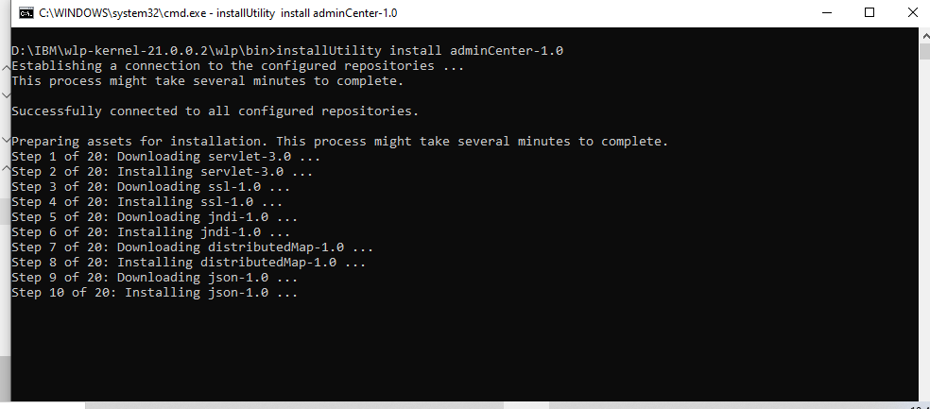

https://localhost:9446/adminCenter/

