Berke Ataseven

54326

MECH534 - COMPUTER-BASED MODELING AND SIMULATION

**HW#5**

In this homework we were asked to solve 2 coupled non-linear differential equations using numerical recipes library in C++. These equations are given as:

$\frac{dx_{1}}{dt}=\left(b_{1}-c_{1}x_{2}\right)x_{1}$ (1) $\frac{dx_{2}}{dt}=\left(-b_{2}+c_{2}x_{1}\right)x_{2}$ (2)

This simplified model of population growth is referred as the Lotka-Volterra system where $x_{1}$ and $x_{2}$ are the population levels of the prey and the predators, respectively. For our case, parameters b and c are given as 1, initial $x_{1}$ and $x_{2}$ values at t=0 are given as 0.5. Solution to this system given by the 2 different MATLAB solvers are given below.

|  |  |
| --- | --- |
| Figure 1 MATLAB’s ode45 Solution | Figure 2 MATLAB's ode23 Solution |

MATLAB’s ode solvers do not allow for a fixed step size. In figure 1, populations are calculated at 14 different time steps, whereas the in the second figure, number of time steps are 37.

In the C++ implementation, I have used a fixed step size of 0.05 seconds (200 steps in total), which resulted as the following:

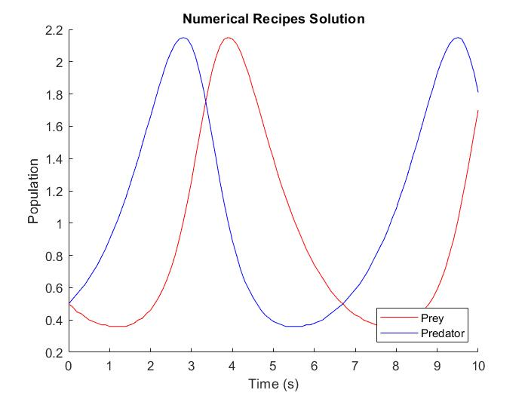

Figure 3 Result of the C++ Implementation

In such a population growth model there are some assumptions[1]. These can be listed as:

* The prey population always have access to food
* The food supply of the predator population depends entirely on the size of the prey population.
* The rate of change of population is proportional to its size.
* During the process, the environment does not change in favor of one species, and genetic adaptation is inconsequential.
* Predators have limitless appetite.

Equation (1) can be interpreted as: The rate of change of preys’ population size is equal to its own growth rate minus the rate at which they killed by the predators.

Likewise, equation (2) can be interpreted as: The rate of change of predators’ population size is equal to how much they hunt the preys minus their death rate.

Thus, the population curves follow a harmonic trajectory, slightly out of phase from each other.

1. http://www.tiem.utk.edu/~gross/bioed/bealsmodules/predator-prey.html