**Name:Raksha**

**Date: 22/7/25**

**Tasks- datatypes-primitive and complex**

Created one directory 2207

Inside that res.tf

resource "local_file" "f1" {

filename = var.filename1

content = var.content

}

resource "local_file" "f2" {

filename = var.filename2

content = var.content

}

resource "local_file" "f3" {

filename = var.filename3

content = var.content

}

resource "local_file" "f4" {

filename = var.filename4

content = var.content

}

resource "local_file" "f5" {

filename = var.filename5[0]

content = var.content

}

resource "local_file" "f6" {

filename = var.filename6[2]

content = var.content

}

resource "local_file" "f7" {

filename = var.filename7.name

content = var.content

}

resource "local_file" "f8" {

filename = var.filename8.id

content = var.content

}

resource "local_file" "f9" {

filename = var.filename9[3][1]

content = var.content

}

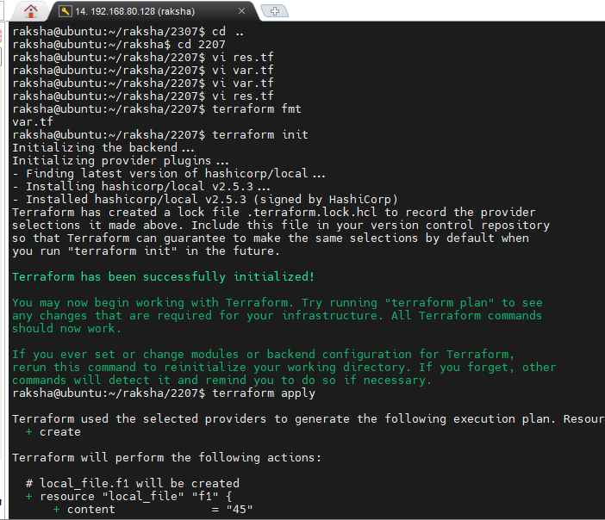

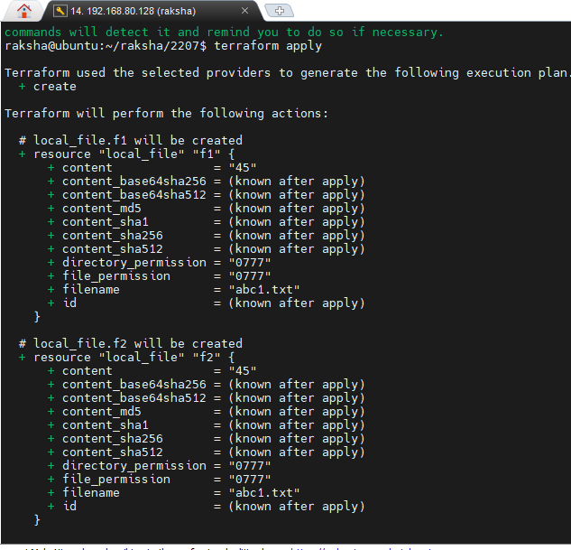

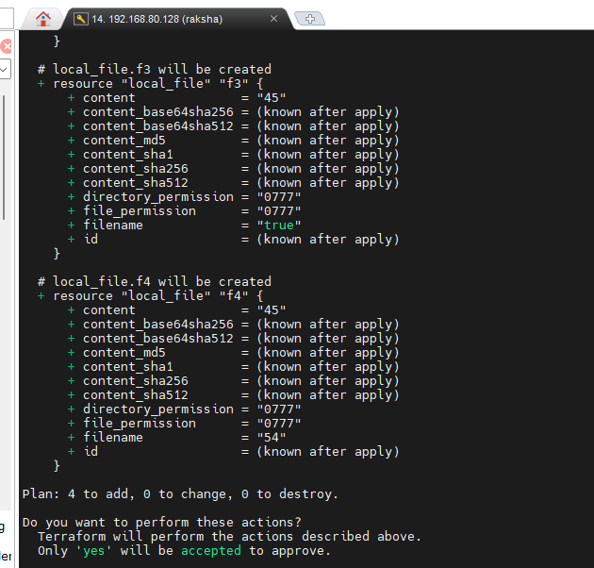

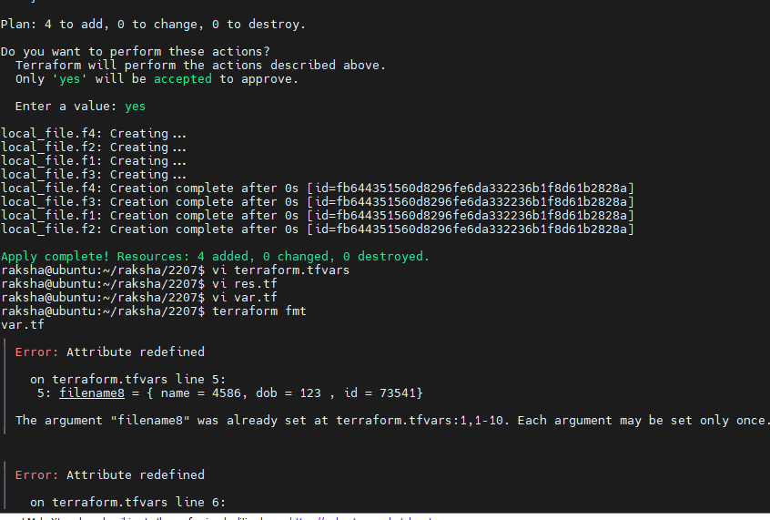

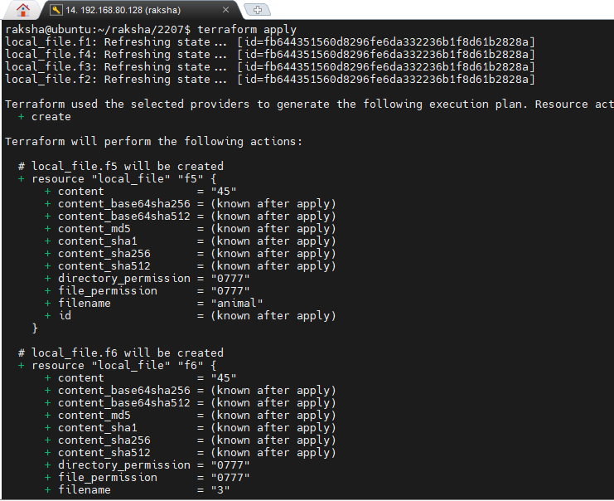

Inside var.tf

variable "filename1" {

default = "abc1.txt"

}

variable "filename2" {

default = "abc1.txt"

type=string

}

variable "filename3" {

default = true

type=bool

}

variable "filename4" {

default = 54

type=number

}

variable "content" {

default = 45

type = any

}

variable "filename5" {

type = list

default = ["animal", 120, true, "test", 123]

}

variable "filename6" {

type = list(number)

default = [1,2,3,4,5, 2, 4, 7,1,2]

}

variable "filename7" {

type = map(string)

default = {

name="raksha"

id ="560"

isactive = "no"

}

}

variable "filename8" {

type = map(number)

default = {

id =12345

phone =43154431

}

}

variable "filename9" {

type = tuple([string, number, bool, list(number)])

default=["raksha",230,true,[1,2,3]]

}

