Application Design initiative by Joe Batchelor @2019 ALL RIGHTS RESERVED

High Level Business Requirements

Establish the Structure for the operational delivery of digital services in the way of application software.

Demonstrate the capabilities of the organization to produce a quality definition of the goods and services available.

Establish a catalog ( backlog/pipeline) of Projects

High Level Design Requirements

Object Model

Detailed Business Requirements

Project :

File photo synchronization between devices over a private connection

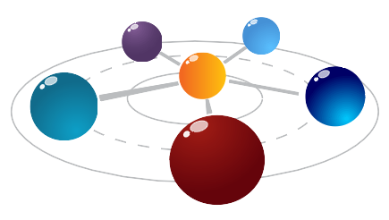
Manage my inter circle of data

Each point of reference is a component of the solution

Utilizing micro service technology to link points of contact with my information in a closed loop.

Inner Circle of Trust In Death and Taxes we trust all others must have a passkey



Design the suite of applications

Looper , the Server Module : Synchronization engine, can be hosted or run as a point to point protocol service. The server module is responsible for safekeeping the directory of assets managed in the Loop

Link , the Client Module : Passive Service that monitors the Device in which it is installed to identify assets that are available for uplink
Monitors the Chain module for instructions

Chain, the shared application code that collaborates with the Looper and other Chains,
Performs UpLink activities
Performs Downlink activities
Performs Health Link ( monitoring of other chain services ( think of it as distributed cache )

Design Philosophy

S.O.L.I.D and GRASP

Design Components

Triggers : Events driven by user action , Example : take a photo, create a new file, save an email attachment.

Trigger Fields : allow for users to input modifiers for a given trigger

Ingredients : attributes emitted from a given trigger . For the trigger “New photo added” there would be ingredients “PhotoURL” and “TakenAt”

Actions : sending data or creating resources. Some examples “Create photo” or “Upload photo”

Action Fields , a user assembles ingredients in the action’s action fields. Action fields are like form fields. For the action “Create post” there would be an action field for “Title” and another for “Post body”

Enterprise Architecture (EA) , while no single definition of Enterprise Architecture, it is commonly understood to be a practice or discipline of organizing processes that promote and IT infrastructure in support of successful business practices.

1. Organize Process
2. Promote IT infrastructure
3. Support Successful business practices

Purpose is to create a map of IT assets and business processes and a set of governing principle that drive an ongoing discussion about business strategy and how it can be expressed through IT.

Architectural Principles:

Architectural Frameworks - applied governance to the governance of business systems structure

The Awakening (s)

The Measure of progression from the perspective of a technologist.

Adoption of technology was by destiny since birth , however it is not until now that I am able to realize this inevitable outcome. Raised by blue collar
When I began my journey into the world of technology

The world of technology defined in the terms of enterprise architecture

Enterprise Domains ;

Infrastructure Maintenance and design , from facilities management to virtual networks of application services

Application Systems Design and Development , the interpretation of business process by binary code processing units

Data Structures and Management and Governance of digital information,

Business Structure and Process

Document your work :

Audience Targets

* Users
* Developers
* Investors

The problem the project solves : generates a revenue stream so that I do not have to work for someone else until I am dead.
Using Fabric for basic information on what problem this project solves

A small code example:

**** This content has been moved to a confluence repository ****

