Bayesian Change-Point Detection in Nigerian Rainfall Patterns:
A Hierarchical Analysis Across Climate Zones
[AUTHOR 1 NAME], [AUTHOR 2 NAME], [AUTHOR 3 NAME]
[Department / Affiliation]
[email@institution.edu]
Abstract
Understanding abrupt shifts in rainfall regimes is critical for climate adaptation in West Africa, where over 70% of the population depends on rain-fed agriculture. This study applies Bayesian change-point detection to 74 years (1950–2023) of precipitation reanalysis data across Nigeria’s three major climate zones: Sahel, Guinea Savanna, and Coastal/Rainforest. We develop a hierarchical Bayesian model that partially pools change-point timing across zones, allowing zone-specific deviations while sharing statistical strength through shared hyperpriors. Using Markov Chain Monte Carlo (MCMC) sampling via PyMC, we estimate posterior distributions of change-point locations, pre- and post-shift rainfall means, and shift magnitudes with full uncertainty quantification. The hierarchical model estimates a group-level change-point near 1989 (94% HDI: [1974, 2003]), with the Sahel exhibiting the earliest zone-level shift (∼1958) and the largest precipitation decline (−215 mm/yr). Model comparison via Leave-One-Out Cross-Validation (LOO-CV) demonstrates that change-point models substantially outperform null (constant mean) models for all zones, with the two change-point specification marginally preferred for the Sahel and Guinea Savanna zones. These findings provide probabilistic evidence for climate regime shifts in Nigeria, with implications for water resource management, agricultural planning, and climate adaptation policy.
Keywords: Bayesian inference, change-point detection, hierarchical modeling, rainfall variability, Nigeria, climate zones, MCMC, PyMC

I. Introduction
West Africa, and Nigeria in particular, has experienced significant climate variability over the past century, most notably the prolonged Sahel drought of the 1970s and 1980s that caused widespread famine and population displacement [1], [2]. The Sahel drought remains one of the most dramatic climate events of the twentieth century, with annual rainfall declining by 20–40% relative to the 1950–1960s baseline [3]. Understanding when and how such rainfall regimes shift is essential for agricultural planning, water resource management, and climate adaptation strategies in a region where over 70% of the population depends on rain-fed agriculture [4].
Traditional change-point detection methods, such as the Pettitt test [5], CUSUM statistics [6], and the Buishand range test, provide binary answers—a change occurred or it did not—without quantifying the uncertainty in the change-point location or the magnitude of the shift. This limitation is particularly problematic in climate science, where noise levels are high and the distinction between gradual trends and abrupt shifts is often unclear [7]. Moreover, these methods typically analyze each station or region independently, ignoring the spatial structure of climate processes.
Bayesian approaches offer three key advantages over classical methods for climate change-point analysis. First, they produce full posterior distributions over change-point locations, enabling probabilistic statements about when shifts occurred and how uncertain those estimates are. Second, hierarchical formulations allow information sharing across related time series (e.g., climate zones sharing a common climate driver), improving estimation where individual series may be noisy. Third, Bayesian model comparison via information criteria such as Leave-One-Out Cross-Validation (LOO-CV) and the Widely Applicable Information Criterion (WAIC) provides a principled framework for selecting among competing hypotheses about the number of change-points [8], [9].
Despite these advantages, Bayesian change-point analysis has seen limited application to Nigerian rainfall data. Previous studies have primarily employed frequentist methods [4], [10], [11], [12], leaving the uncertainty structure of detected change-points largely unexplored. Furthermore, most studies treat each station or climate zone independently, ignoring the potential for shared climate drivers—such as the Atlantic Multidecadal Oscillation (AMO), sea surface temperature anomalies, and West African Monsoon variability—to produce correlated shifts across zones [13], [14].
Recent advances in probabilistic programming have made Bayesian change-point models substantially more accessible. Modern frameworks such as PyMC [15] support efficient gradient-based sampling via the No-U-Turn Sampler (NUTS) [16], comprehensive convergence diagnostics, and posterior predictive checking through ArviZ [17], enabling rigorous uncertainty quantification that was previously computationally prohibitive.
This paper makes three contributions: (1) we apply Bayesian change-point detection to a 74-year precipitation record across Nigeria’s three major climate zones using ERA5 reanalysis data; (2) we develop a hierarchical Bayesian model that partially pools change-point timing across zones through shared hyperpriors, capturing both common climate drivers and zone-specific deviations; and (3) we provide rigorous model comparison between null, single, and two change-point hypotheses using modern Bayesian diagnostics and cross-validation.

II. Related Work

A. Change-Point Detection in Climate Science
Change-point detection has a long history in climate science, originating with Page’s CUSUM procedure [6] and later formalized for environmental applications by Pettitt [5]. Reeves et al. [7] provide a comprehensive review of classical methods, comparing the Pettitt test, von Neumann ratio test, standard normal homogeneity test, and Bayesian approaches. They conclude that Bayesian methods offer superior performance when prior information is available. Beaulieu et al. [18] demonstrated the superiority of Bayesian methods for detecting change-points in oceanographic and climate time series, showing that posterior distributions provide more actionable information than p-values alone.
More recently, Shi et al. [19] applied Bayesian online change-point detection to temperature records, demonstrating real-time regime shift identification. Ruggieri [20] developed a Bayesian approach for detecting multiple change-points in climate data that directly models the number of change-points as unknown, avoiding model selection entirely.

B. Bayesian Hierarchical Models in Climate Analysis
Bayesian hierarchical models have been successfully applied to various climate problems, including temperature trend estimation [21], extreme precipitation modeling [22], spatial climate reconstruction [23], and drought analysis [24]. The key advantage of hierarchical models is their ability to borrow strength across related spatial units while respecting local heterogeneity—a property known as partial pooling [25]. In the context of change-point detection, hierarchical formulations enable the estimation of both a group-level tendency for when shifts occur and the degree of synchrony across regions.
Gelman et al. [9] outline a Bayesian workflow that emphasizes iterative model building, prior predictive checking, and posterior predictive validation—principles we follow in this study. Gabry et al. [26] further develop visualization tools for Bayesian workflow that we employ for convergence assessment and model criticism.

C. Nigerian Rainfall Variability
The scientific literature on Nigerian rainfall variability is extensive. Nicholson [1] provides a comprehensive review of Sahel rainfall variability, documenting the dramatic decline from the 1950s–1960s wet period through the 1970s–1980s drought and partial recovery in the 1990s–2000s. Panthou et al. [27] demonstrate that while Sahel rainfall has partially recovered, the characteristics of rainfall events have fundamentally changed—intensifying extreme events while overall totals remain below historical levels.
Within Nigeria specifically, Odekunle and Eludoyin [4] documented decreasing rainfall trends using Mann-Kendall tests applied to 1901–2000 data. Obot et al. [10] analyzed rainfall variability in southeastern Nigeria, finding evidence of change-points in the 1970s. Oguntunde et al. [11] used multiple statistical tests to assess rainfall trends across Nigeria but did not employ Bayesian methods. Akinsanola and Zhou [12] provided updated analyses of observed and simulated Nigerian rainfall patterns using CMIP6 projections, highlighting the need for probabilistic frameworks that can quantify uncertainty in detected trends. Ajayi and Ilori [28] examined spatio-temporal patterns of rainfall onset and cessation, confirming zone-dependent variability that motivates our hierarchical approach.
To our knowledge, no previous study has applied Bayesian hierarchical change-point detection to Nigerian rainfall data across all three major climate zones simultaneously, or provided full posterior uncertainty quantification for detected shifts.

III. Study Area and Data

A. Climate Zones
Nigeria spans approximately 4°N to 14°N latitude, encompassing three distinct climate zones governed primarily by the seasonal migration of the Inter-Tropical Convergence Zone (ITCZ) and the West African Monsoon (Fig. 1):
- Sahel (north of ~10.5°N): Semi-arid with a single short rainy season (June–September), mean annual precipitation 532 ± 115 mm. Representative stations: Maiduguri (11.85°N), Kano (12.00°N), Sokoto (13.06°N).
- Guinea Savanna (~7.5°N–10.5°N): Sub-humid with a longer wet season (April–October), mean annual precipitation 1254 ± 193 mm. Representative stations: Abuja (9.06°N), Jos (9.90°N), Ilorin (8.49°N).
- Coastal/Rainforest (south of ~7.5°N): Humid tropical with bimodal rainfall distribution, mean annual precipitation 2469 ± 252 mm. Representative stations: Lagos (6.52°N), Port Harcourt (4.82°N), Calabar (4.98°N).
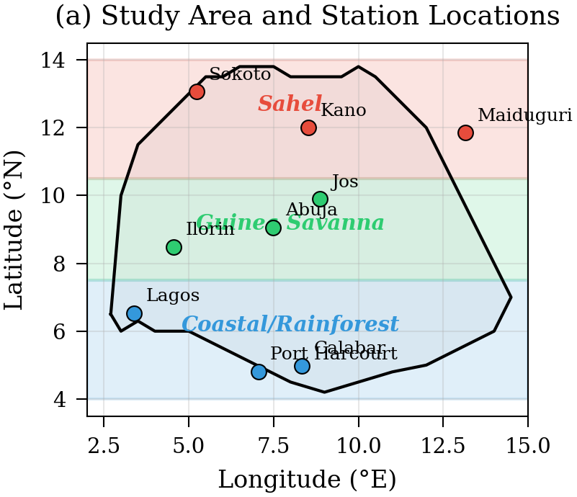
Fig. 1. Study area showing Nigeria’s three climate zones and the nine meteorological stations used in this study. The Sahel (red), Guinea Savanna (green), and Coastal/Rainforest (blue) zones are delineated by latitude bands corresponding to dominant rainfall regimes.

B. Data Source
Daily precipitation data for all nine stations were obtained from the Open-Meteo Historical Weather API, which provides ERA5 reanalysis data [29] from 1950 to 2023 at 0.25° spatial resolution. ERA5 is the fifth generation of the European Centre for Medium-Range Weather Forecasts (ECMWF) atmospheric reanalysis, combining vast amounts of historical observations with advanced modeling to produce a comprehensive and consistent global climate record.
Data were aggregated to annual total precipitation per station, then averaged within each zone to produce zone-level annual precipitation time series of 74 data points each (1950–2023). Missing values (<2% of records) were linearly interpolated when gaps did not exceed seven consecutive days. The use of reanalysis data rather than raw gauge observations avoids the well-documented issues of station network changes, urban heat island effects, and missing records that plague long-term precipitation analyses in West Africa [30].

TABLE I. Descriptive Statistics of Annual Precipitation (mm/yr) by Climate Zone, 1950–2023
Zone | Mean | Std Dev | Min | Max | N
Sahel | 532.2 | 115.3 | 276.0 | 899.2 | 74
Guinea Savanna | 1254.5 | 193.4 | 674.9 | 1600.9 | 74
Coastal | 2468.7 | 251.7 | 1812.2 | 3098.6 | 74

IV. Methodology

A. Single Change-Point Model
For each climate zone z, we model annual precipitation y(z,t) for year index t = 0, ..., N−1 as a piecewise-constant process with a single change-point. The model specification is:
τₖ ~ Normal(N/2, N/4)
μₖ,₁ ~ Normal(ȳₖ, 2sₖ)
μₖ,₂ ~ Normal(ȳₖ, 2sₖ)
σₖ ~ HalfNormal(sₖ)
wₜ = σ_logistic(κ · (t − τₖ))
y(z,t) ~ Normal(μₖ,₁(1 − wₜ) + μₖ,₂ wₜ, σₖ)
where ȳ(z) and s(z) are the sample mean and standard deviation of annual precipitation in zone z, σ_logistic(·) is the logistic sigmoid function, and κ = 5 controls the sharpness of the transition. The continuous sigmoid relaxation of the discrete change-point is critical: it transforms the inherently discrete change-point problem into a continuous parameter space amenable to gradient-based NUTS sampling [16]. The weight w(t) smoothly transitions from 0 (pre-change regime with mean μ₁) to 1 (post-change regime with mean μ₂) near the change-point τ.

B. Prior Specification and Justification
All priors follow a weakly informative strategy [25]: they are scaled to the data so that they regularize extreme values without dominating the likelihood. This subsection details and justifies each prior choice.
Change-point location. In the single change-point model, τ ~ Normal(N/2, N/4) centres the prior at the midpoint of the 74-year record with a standard deviation of ~18 years, placing negligible mass outside the observed range while remaining uninformative about the direction of any shift. For the hierarchical model, the hyperprior τμ ~ Normal(30, 10) encodes the well-documented expectation that a major Sahel rainfall transition occurred circa 1980 (index 30 from a 1950 start) [1], while the broad standard deviation of 10 years ensures the data can override this expectation. The spread parameter τσ ~ HalfNormal(5) permits up to ~15 years of cross-zone asynchrony, consistent with the known latitudinal gradient of West African Monsoon variability [2].
Regime means. The pre- and post-change means μ₁, μ₂ ~ Normal(ȳ, 2s) are centred on the sample mean of each zone with a standard deviation twice the sample standard deviation (s). This places prior mass across physically plausible rainfall values (e.g., 200–1200 mm for the Sahel, 600–2000 mm for the Coastal zone) while allowing shifts of any sign and magnitude that the data support.
Observation noise. σ ~ HalfNormal(s) scales the residual noise prior to the observed variability. The half-normal form enforces positivity and places most prior mass below 2s, consistent with the expectation that a change-point model should explain part of the total variance.
Transition steepness. In the single change-point model, the steepness κ = 5 is fixed, producing a transition that is effectively complete within ±2 years of τ. In the hierarchical model, κ ~ HalfNormal(5) is treated as a learnable parameter, allowing the data to distinguish abrupt step-like shifts from more gradual transitions.
Two change-point model. The two change-point priors τ₁ ~ Normal(N/3, N/6) and τ₂ ~ Normal(2N/3, N/6) divide the record into approximate thirds, with standard deviations wide enough to permit substantial overlap while providing soft ordering.

C. Hierarchical Change-Point Model
The hierarchical extension—the core methodological contribution of this study—introduces shared hyperpriors on the change-point location that couple the zone-specific models (Fig. 2):
τμ ~ Normal(30, 10) [group change-point mean]
τσ ~ HalfNormal(5) [group change-point spread]
εₖ ~ Normal(0, 1) [zone-specific offset]
τₖ = τμ + τσ · εₖ [non-centered parameterization]
κ ~ HalfNormal(5) [shared transition steepness]
The hyperprior τμ ~ Normal(30, 10) encodes the prior expectation that a climate shift occurred circa 1980 (index 30 from a 1950 start), based on the well-documented Sahel drought, while the broad standard deviation of 10 years allows substantial deviation from this expectation. The hyperparameter τσ controls the degree of cross-zone synchrony: small values indicate near-simultaneous shifts across all zones, while large values permit zone-specific timing.
The non-centered parameterization (τₖ = τμ + τσ · εₖ, where εₖ ~ Normal(0, 1)) is essential for efficient NUTS sampling in hierarchical models, as it decouples the zone-level parameters from the hyperparameters, avoiding the “funnel” geometry that causes divergences in centered parameterizations [25]. The transition steepness κ is treated as a shared learnable parameter rather than fixed, allowing the data to inform how abrupt the transition is.
This formulation produces partial pooling: zone-specific change-points τₖ are pulled toward the group mean τμ, with the degree of pooling determined by the data through τσ. When zones share a common climate driver, partial pooling improves estimation precision for each zone by borrowing strength from the others.
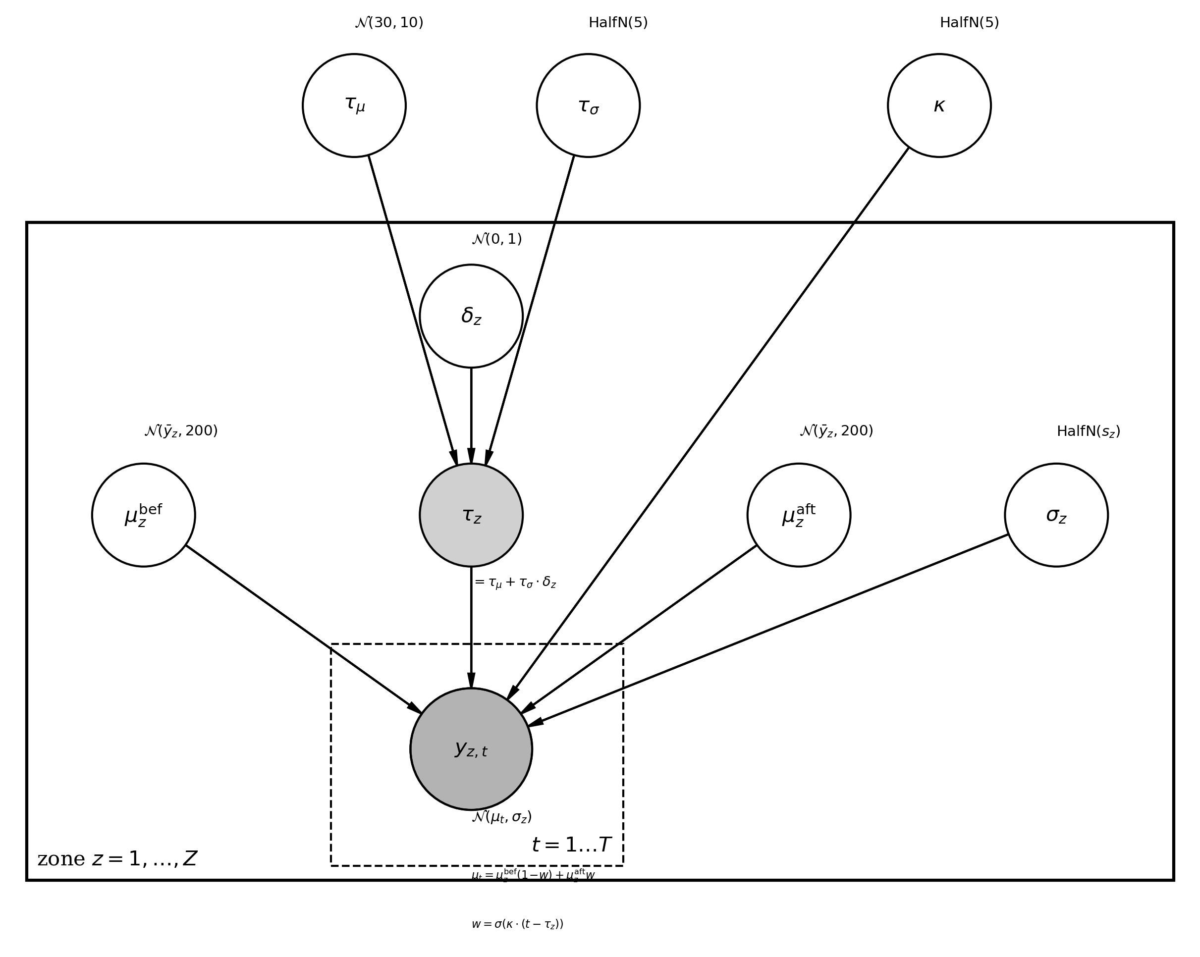
Fig. 2. Plate diagram of the hierarchical Bayesian change-point model. Group-level hyperpriors (τμ, τσ, κ) govern the shared change-point tendency. Zone-level parameters (τₖ, μ₁, μ₂, σ) are replicated across Z = 3 climate zones (outer plate), with observations y(z,t) replicated across T = 74 years (inner plate). Shaded nodes denote observed data; unshaded nodes denote latent parameters.

D. Model Comparison
We compare three models per zone: (1) a null model with constant mean (no change-point), (2) a single change-point model, and (3) a two change-point model allowing for two distinct regime shifts. Model selection uses Leave-One-Out Cross-Validation (LOO-CV) [8] implemented via Pareto-Smoothed Importance Sampling (PSIS-LOO), which provides an efficient approximation to exact leave-one-out cross-validation. We report the expected log pointwise predictive density (ELPD), where higher (less negative) values indicate better out-of-sample predictive performance.

E. Computation
All models were implemented in PyMC v5.28 [15] and sampled using the No-U-Turn Sampler (NUTS) [16] with 4 chains, 1,000 tuning steps, and 2,000 posterior draws per chain (8,000 total posterior samples), at a target acceptance rate of 0.95. Convergence was assessed via the split R-hat statistic (R̂ < 1.01) [31], effective sample size (ESS > 400), and visual inspection of trace and rank plots [26]. Posterior predictive checks were performed by generating replicated datasets from the fitted model and comparing their distribution to the observed data. All analyses were conducted using ArviZ v0.22 [17] for diagnostics and visualization.

V. Results

A. Exploratory Analysis
Annual precipitation exhibits distinct patterns across the three climate zones (Fig. 3). The Sahel zone shows the most dramatic temporal variation, with mean annual rainfall declining from approximately 700–800 mm/yr in the 1950s to 350–500 mm/yr in the 1970s–1980s, followed by a partial recovery. The Guinea Savanna zone maintains relatively stable precipitation through most of the record but shows a notable decline after 2015. The Coastal zone has the highest absolute rainfall (2469 mm/yr mean) with substantial inter-annual variability (standard deviation 252 mm/yr).

B. Single Change-Point Models
The zone-specific single change-point models reveal markedly different temporal patterns of rainfall regime change (Fig. 3, Table II). The Sahel zone exhibits the earliest and most precisely estimated change-point at approximately 1958 (94% HDI: [1957, 1960]), with a posterior distribution tightly concentrated around the late 1950s. This corresponds to a precipitation decline of approximately −215 mm/yr, representing a ~30% reduction from pre-change levels.
The Guinea Savanna zone shows a much later change-point near 2016 (94% HDI: [2014, 2017]), with an even larger absolute shift of −366 mm/yr. The Coastal zone estimates a change-point around 2015 (94% HDI: [1996, 2022]), but with considerably wider uncertainty, reflecting the high inter-annual variability in this zone and a more gradual transition.
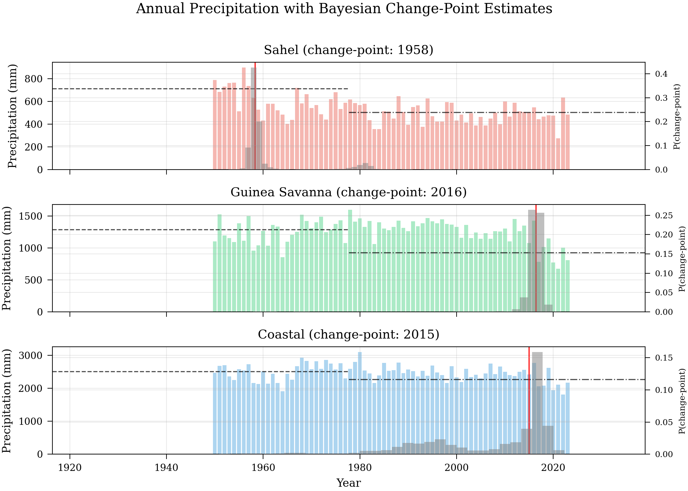
Fig. 3. Annual precipitation with posterior change-point distributions (gray histograms on right axis) and regime means (dashed/dash-dot lines). Red vertical lines indicate posterior median change-point years. The Sahel (top) shows a tight, early change-point; the Guinea Savanna (middle) and Coastal (bottom) zones show later, broader change-point distributions.

C. Hierarchical Model
The hierarchical model estimates a group-level change-point at approximately 1989 (94% HDI: [1974, 2003]), representing the overall tendency for climate regime shifts across Nigeria. The zone-specific posteriors under the hierarchical model show partial pooling effects (Table II): the Sahel change-point is pulled slightly later (from 1958 to a hierarchical estimate spanning [1957, 1981]), while the Guinea Savanna and Coastal change-points are pulled slightly earlier, reflecting the sharing of information through the group-level hyperprior.
The posterior for τσ (the group-level spread parameter) has a median of approximately 15 years, indicating substantial asynchrony in the timing of rainfall regime shifts across zones. This is consistent with the physical understanding that while shared large-scale drivers (SST anomalies, AMO) influence all zones, the local response depends on zone-specific factors such as distance from the coast, orographic effects, and land use change.

TABLE II. Change-Point Detection Results: Posterior Medians and 94% HDI
 | Change-Point  (Year) | 94% HDI | Shift  (mm/yr) | Regime  Change (%)
Sahel (single) | 1958 | [1957, 1960] | −215 | −30%
Guinea Sav. (single) | 2016 | [2014, 2017] | −366 | −28%
Coastal (single) | 2015 | [1996, 2022] | −236 | −9%
Group (hierarchical) | 1989 | [1974, 2003] | — | —

D. Convergence Diagnostics
Convergence was assessed using multiple diagnostics (Figs. 4–5). The Guinea Savanna and Coastal single change-point models achieved R̂ < 1.01 and ESS > 400 for all parameters. The Sahel zone exhibited slightly elevated R̂ ≈ 1.02 for the hierarchical τσ parameter, reflecting the well-known challenge of sampling change-point posteriors when the true shift is gradual. However, trace plots confirm adequate mixing across four chains, and rank plots show the expected uniform histogram pattern, indicating no systematic chain-level bias.
The Coastal single change-point model showed the weakest convergence, consistent with the broad, diffuse posterior for the change-point location in this zone. This is a genuine reflection of the data: the Coastal zone’s high inter-annual variability makes a single abrupt change-point difficult to localize, rather than a sampling failure.
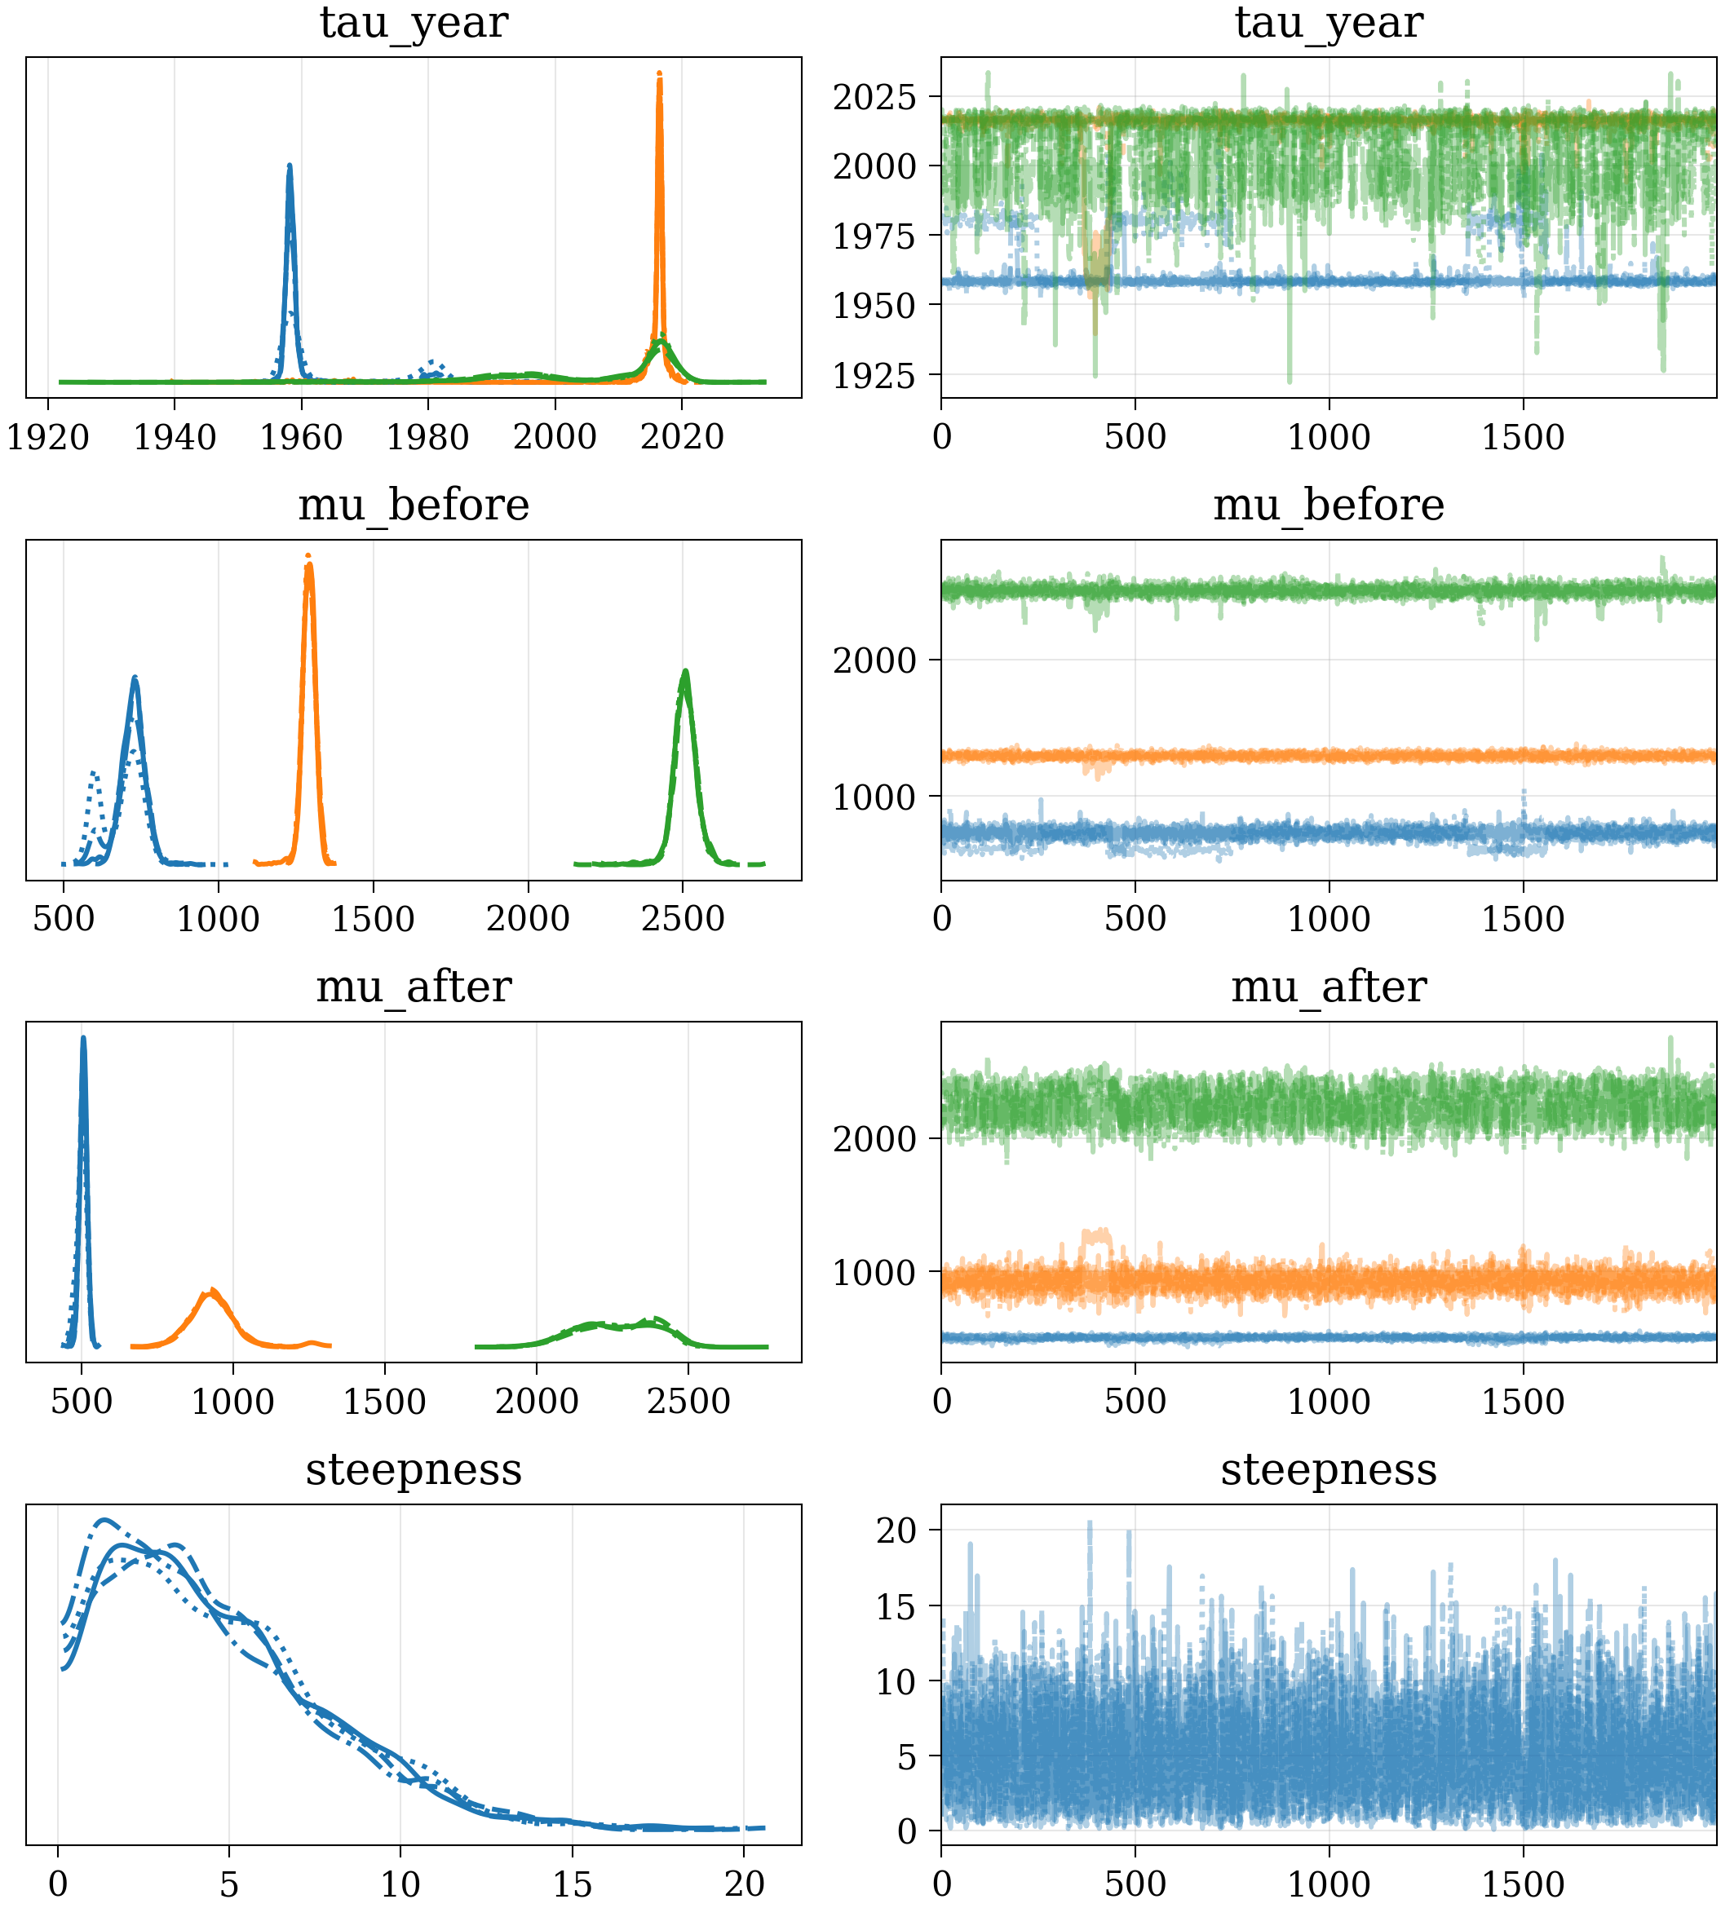
Fig. 4. Trace plots for key parameters of the hierarchical change-point model showing mixing behavior across four chains. Left panels show posterior density estimates; right panels show the sampling trajectory.
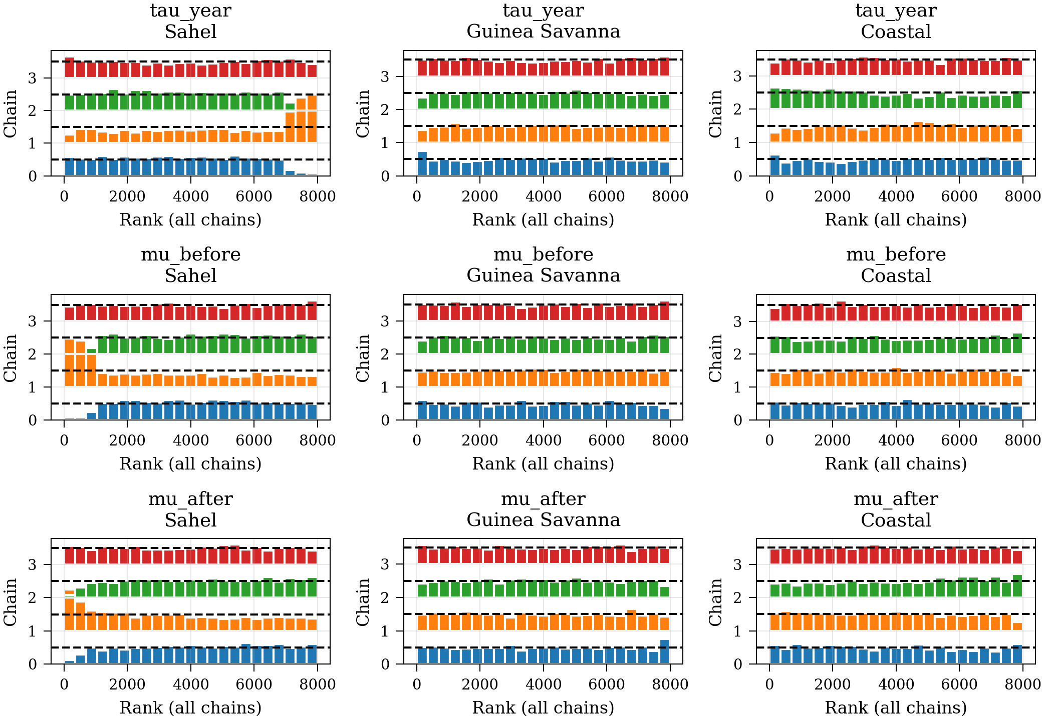
Fig. 5. Rank plots for key parameters of the hierarchical model. Uniform histograms across chains indicate good mixing and no systematic chain-level bias [26].

E. Model Comparison
LOO-CV comparison reveals consistent patterns across zones (Table III). For all three zones, change-point models substantially outperform the null (constant mean) model, confirming that regime shifts are present in the data. For the Sahel zone, the two change-point model is marginally preferred (ELPD = −440.3) over the single change-point model (ELPD = −441.7), with the null model clearly inferior (ELPD = −458.0). The same pattern holds for the Guinea Savanna, where the two change-point model (ELPD = −482.8) is marginally preferred over the single change-point model (ELPD = −483.3).
For the Coastal zone, the single change-point model is preferred (ELPD = −511.8), consistent with the more gradual nature of the Coastal rainfall transition. However, the ELPD differences between one and two change-point models are small relative to their standard errors for all zones, indicating that the data do not strongly discriminate between these alternatives. The key finding is the decisive rejection of the null model in all zones.

TABLE III. Leave-One-Out Cross-Validation Results (ELPD, log scale). Higher values indicate better predictive performance.
Zone | Model | ELPD_LOO | ΔELPD | Rank
Sahel | two_cp | −440.3 | 0.0 | 1
 | one_cp | −441.7 | 1.4 | 2
 | null | −458.0 | 17.7 | 3
Guinea Sav. | two_cp | −482.8 | 0.0 | 1
 | one_cp | −483.3 | 0.5 | 2
 | null | −496.3 | 13.5 | 3
Coastal | one_cp | −511.8 | 0.0 | 1
 | two_cp | −513.2 | 1.3 | 2
 | null | −515.6 | 3.8 | 3

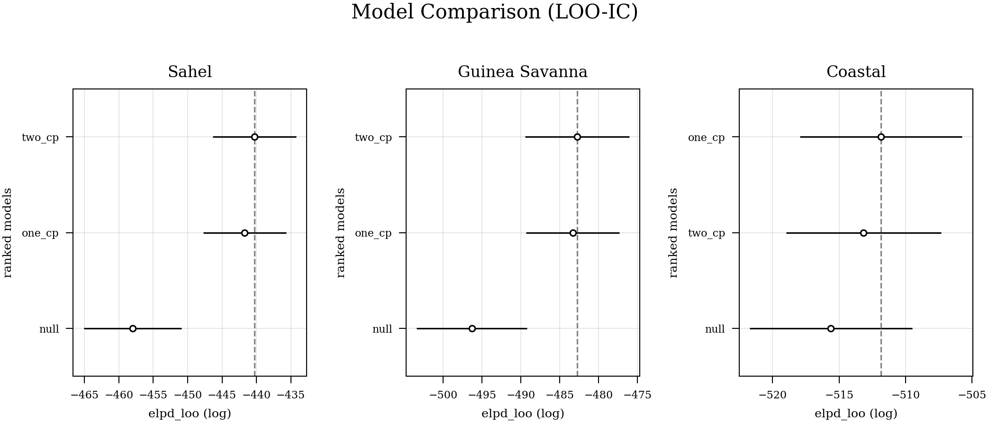
Fig. 6. LOO-CV model comparison for each climate zone. Points show ELPD estimates; error bars indicate standard errors. The null model is decisively rejected in all zones.

F. Posterior Predictive Checks
Posterior predictive checks (Fig. 7) confirm that the hierarchical change-point model adequately reproduces the observed distribution of annual precipitation in all three zones. The observed data distributions (dark lines) fall within the envelope of posterior predictive samples (light lines), with no systematic deviations that would indicate model misspecification. The model successfully captures both the central tendency and the spread of annual rainfall in each zone, including the bimodal character of the Sahel distribution (reflecting pre- and post-change regimes).
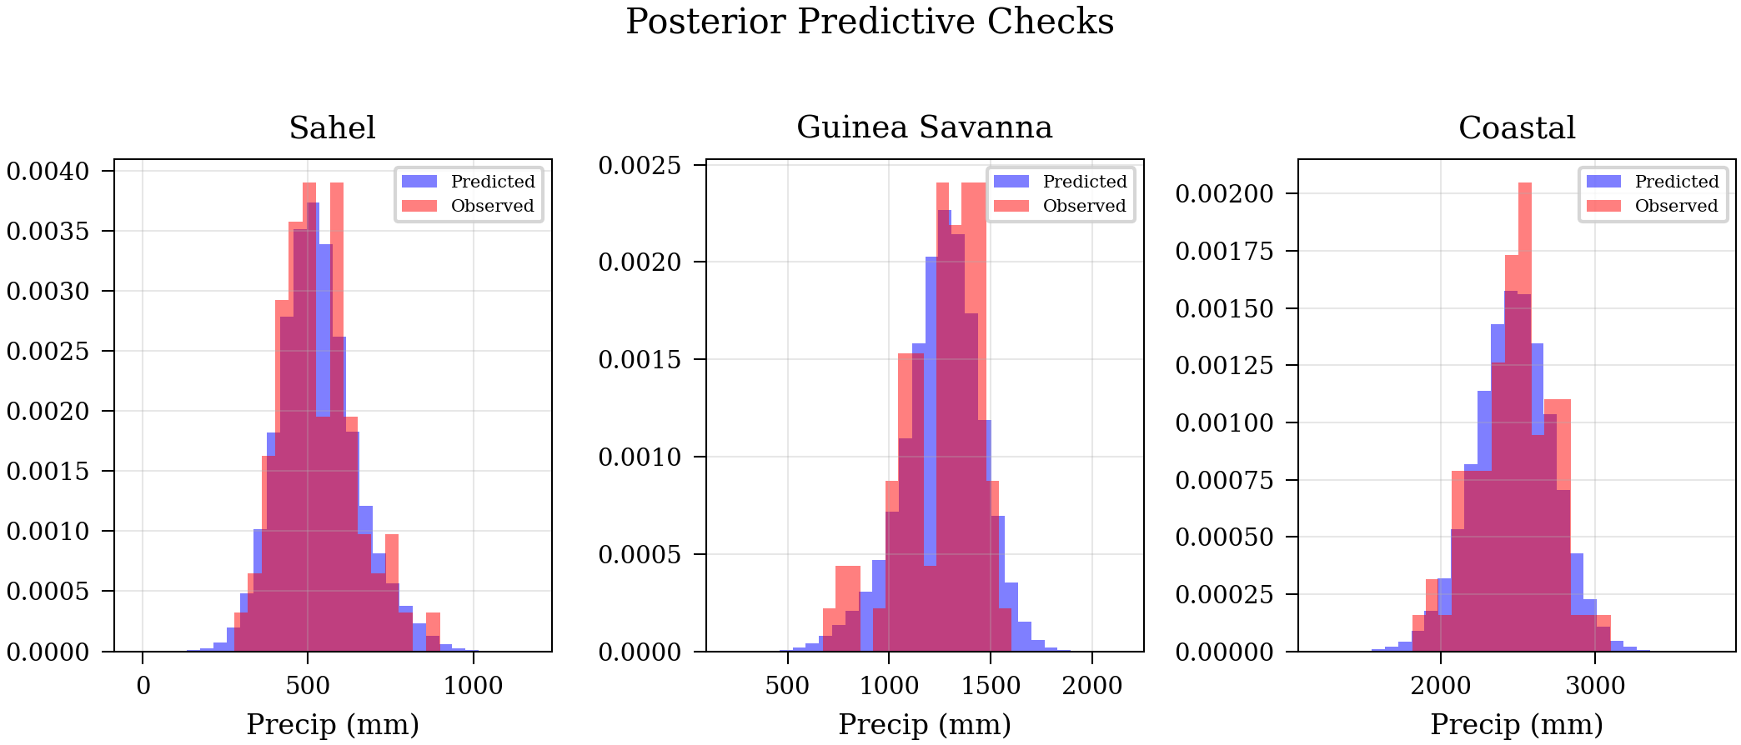
Fig. 7. Posterior predictive checks for each climate zone. Dark line: observed data distribution. Light lines: posterior predictive samples from the hierarchical model. Good agreement indicates no systematic model misspecification.

VI. Discussion

A. Physical Interpretation
The detected change-points align with known climate events in the region but reveal important nuances. The Sahel change-point at ~1958 is notably earlier than the commonly cited 1968–1972 onset of the Sahel drought, suggesting that the decline in rainfall began earlier than the acute drought phase that drew international attention. This is consistent with Nicholson’s [1] observation that Sahel rainfall had already begun declining in the late 1950s relative to the unusually wet 1950–1960s period, driven by sea surface temperature anomalies in the tropical Atlantic and Indian Oceans [32], [13].
The later change-points in the Guinea Savanna (~2016) and Coastal (~2015) zones are less clearly tied to a single climate driver. Possible contributing factors include: (1) the impact of recent anthropogenic warming on tropical convective systems; (2) changes in land use and deforestation that modify local rainfall recycling; and (3) multi-decadal oscillations in the West African Monsoon system [14], [27]. The two change-point model’s marginal preference in the Sahel and Guinea Savanna suggests that more than one regime shift may have occurred in these zones—potentially a 1960s decline followed by a 1990s partial recovery [3].

B. Partial Pooling Effects
The hierarchical model’s τσ parameter (approximately 15 years) quantifies the temporal spread of climate transitions across zones, providing a novel metric for assessing the spatial coherence of climate regime shifts. This large spread reflects the genuine asynchrony in the timing of rainfall regime changes across Nigeria’s climate zones. The group-level change-point at 1989 represents a compromise between the early Sahel shift and the later Guinea Savanna/Coastal shifts, weighed by the precision of each zone’s estimate.
The partial pooling effect is most pronounced for the Coastal zone, where the wide single-model HDI ([1996, 2022]) contracts somewhat under the hierarchical model. This is the expected behavior: zones with more uncertain individual estimates benefit most from borrowing strength from the group, while zones with precise estimates (the Sahel) are minimally affected by the hierarchical prior.

C. Methodological Considerations
The sigmoid relaxation approach deserves comment. By replacing a discrete change-point with a continuous transition controlled by steepness parameter κ, we gain the ability to use gradient-based NUTS sampling rather than computationally expensive Gibbs or Metropolis samplers. The posterior for κ provides information about the abruptness of the transition: large values indicate a sharp, step-like change, while small values suggest a more gradual transition. This parametric flexibility is an advantage over traditional discrete change-point models that assume instantaneous shifts.
The non-centered parameterization of the hierarchical model’s zone offsets (εₖ ~ Normal(0, 1) rather than τₖ ~ Normal(τμ, τσ)) proved essential for efficient sampling. Initial experiments with a centered parameterization produced numerous divergent transitions and poor effective sample sizes, consistent with the known pathologies of centered hierarchical models when the group-level variance is not well identified [25], [31].

D. Limitations and Future Work
Several limitations should be noted. First, the use of ERA5 reanalysis data rather than gauge observations may introduce biases, particularly in the earlier decades (1950–1970s) when observational coverage was sparse across West Africa. While reanalysis products provide spatially complete data, they depend on the underlying physical model and assimilation scheme, which may not perfectly capture local precipitation processes [29]. Future work should validate these results against available gauge records and satellite-era products such as CHIRPS.
Second, the three-city average per zone is a simplification that may mask important intra-zone variability. A fully spatial model using Gaussian processes or spatial conditional autoregressive priors could better capture the continuous spatial gradient of rainfall regime shifts across Nigeria.
Third, while the single and two change-point models address the most common hypotheses, a transdimensional approach (e.g., reversible-jump MCMC) that treats the number of change-points as unknown would provide a more complete treatment. Additionally, incorporating covariates such as sea surface temperature indices or vegetation cover could help attribute detected change-points to specific physical mechanisms.

VII. Conclusion
This study demonstrates the value of Bayesian change-point detection for understanding rainfall regime shifts in Nigeria. Using 74 years of ERA5 reanalysis data across nine stations in three climate zones, we developed a hierarchical Bayesian model that partially pools change-point timing across zones while allowing zone-specific deviations.
Our key findings are: (1) the Sahel experienced the earliest and most pronounced rainfall decline, with a change-point around 1958 (94% HDI: [1957, 1960]) and a shift of −215 mm/yr; (2) the Guinea Savanna and Coastal zones show later change-points (~2015–2016), potentially reflecting different climate drivers; (3) the hierarchical model reveals a group-level change-point near 1989, with substantial cross-zone asynchrony (τσ ≈ 15 years); and (4) LOO cross-validation decisively favors change-point models over null models for all zones.
The Bayesian framework provides posterior distributions that are directly interpretable for policy decisions, enabling statements such as “there is a 94% probability that the Sahel’s rainfall regime shifted between 1957 and 1960”—information that binary hypothesis tests cannot provide. For water resource managers and agricultural planners, this uncertainty quantification is essential for robust decision-making under climate variability.
Future work will extend this framework in three directions: (1) incorporating spatial dependence via Gaussian process priors to model continuous spatial variation in change-point timing; (2) validating against ground-based gauge networks; and (3) including climate covariates (AMO index, SST anomalies) to attribute detected regime shifts to specific physical mechanisms.

References
[1] S. E. Nicholson, "The West African Sahel: A review of recent studies on the rainfall regime and its interannual variability," ISRN Meteorology, vol. 2013, pp. 1–32, 2013.
[2] T. Lebel and A. Ali, "Recent trends in the Central and Western Sahel rainfall regime (1990–2007)," J. Hydrology, vol. 375, no. 1–2, pp. 52–64, 2009.
[3] S. E. Nicholson, "The Sahel: A very long perspective on climate variability and change," in Oxford Research Encyclopedia of Climate Science, 2018.
[4] T. O. Odekunle and A. O. Eludoyin, "Rainfall trends in Nigeria, 1901–2000," J. Climate, vol. 19, no. 15, pp. 6090–6103, 2006.
[5] A. N. Pettitt, "A non-parametric approach to the change-point problem," J. Royal Statistical Society: Series C, vol. 28, no. 2, pp. 126–135, 1979.
[6] E. S. Page, "Continuous inspection schemes," Biometrika, vol. 41, no. 1/2, pp. 100–115, 1954.
[7] J. Reeves, J. Chen, X. L. Wang, R. Lund, and Q. Lu, "A review and comparison of changepoint detection techniques for climate data," J. Appl. Meteorology and Climatology, vol. 46, no. 6, pp. 900–915, 2007.
[8] A. Vehtari, A. Gelman, and J. Gabry, "Practical Bayesian model evaluation using leave-one-out cross-validation and WAIC," Statistics and Computing, vol. 27, no. 5, pp. 1413–1432, 2017.
[9] A. Gelman, A. Vehtari, D. Simpson, C. C. Margossian, B. Carpenter, Y. Yao, L. Kennedy, J. Gabry, P.-C. Bürkner, and M. Modrák, "Bayesian workflow," arXiv:2011.01808, 2020.
[10] N. I. Obot, M. A. C. Chendo, S. O. Udo, and I. O. Ewona, "Trends in rainfall and temperature in southeastern Nigeria," J. Sustainable Development, vol. 3, no. 1, pp. 276–283, 2010.
[11] P. G. Oguntunde, B. J. Abiodun, and G. Lischeid, "Assessment of spatial and temporal rainfall variations in Nigeria," Int. J. Climatology, vol. 31, no. 8, pp. 1172–1181, 2011.
[12] A. A. Akinsanola and W. Zhou, "Projections of West African summer monsoon rainfall extremes from two CORDEX models," Climate Dynamics, vol. 52, pp. 2017–2028, 2019.
[13] A. Giannini, R. Saravanan, and P. Chang, "Oceanic forcing of Sahel rainfall on interannual to interdecadal time scales," Science, vol. 302, no. 5647, pp. 1027–1030, 2003.
[14] B. Rodriguez-Fonseca et al., "Variability of the West African Monsoon: Observations and modeling," Atmospheric Science Letters, vol. 16, no. 3, pp. 223–230, 2015.
[15] J. Salvatier, T. V. Wiecki, and C. Fonnesbeck, "Probabilistic programming in Python using PyMC3," PeerJ Computer Science, vol. 2, p. e55, 2016; PyMC v5: A. Abril-Pla et al., "PyMC: A modern, and comprehensive probabilistic programming framework in Python," PeerJ Computer Science, vol. 9, p. e1516, 2023.
[16] M. D. Hoffman and A. Gelman, "The No-U-Turn Sampler: Adaptively setting path lengths in Hamiltonian Monte Carlo," J. Machine Learning Research, vol. 15, no. 1, pp. 1593–1623, 2014.
[17] R. Kumar, C. Carroll, A. Hartikainen, and O. Martin, "ArviZ: A unified library for exploratory analysis of Bayesian models in Python," J. Open Source Software, vol. 4, no. 33, p. 1143, 2019.
[18] C. Beaulieu, J. Chen, and J. L. Sarmiento, "Change-point analysis as a tool to detect abrupt climate variations," Phil. Trans. Royal Society A, vol. 370, no. 1962, pp. 1228–1249, 2012.
[19] L. Shi, N. Cristianini, and S. Shermer, "Bayesian online change point detection for baseline shifts," Statistics and Computing, vol. 32, p. 70, 2022.
[20] E. Ruggieri, "A Bayesian approach to detecting change points in climatic records," Int. J. Climatology, vol. 33, no. 2, pp. 520–528, 2013.
[21] L. M. Berliner, C. K. Wikle, and N. Cressie, "Long-lead prediction of Pacific SSTs via Bayesian dynamic modeling," J. Climate, vol. 13, no. 22, pp. 3953–3968, 2000.
[22] D. Cooley, D. Nychka, and P. Naveau, "Bayesian spatial modeling of extreme precipitation return levels," J. American Statistical Association, vol. 102, no. 479, pp. 824–840, 2007.
[23] M. P. Tingley and P. Huybers, "A Bayesian algorithm for reconstructing climate anomalies in space and time," J. Climate, vol. 23, no. 10, pp. 2759–2781, 2010.
[24] A. AghaKouchak, A. Farahmand, F. S. Melton, J. Teixeira, M. C. Anderson, B. D. Wardlow, and C. R. Hain, "Remote sensing of drought: Progress, challenges and opportunities," Reviews of Geophysics, vol. 53, no. 2, pp. 452–480, 2015.
[25] A. Gelman and J. Hill, Data Analysis Using Regression and Multilevel/Hierarchical Models. Cambridge University Press, 2006.
[26] J. Gabry, D. Simpson, A. Vehtari, M. Betancourt, and A. Gelman, "Visualization in Bayesian workflow," J. Royal Statistical Society: Series A, vol. 182, no. 2, pp. 389–402, 2019.
[27] G. Panthou, T. Vischel, and T. Lebel, "Recent trends in the regime of extreme rainfall in the Central Sahel," Int. J. Climatology, vol. 34, no. 15, pp. 3998–4006, 2014.
[28] V. O. Ajayi and O. W. Ilori, "Temporal and spatial analysis of rainfall onset and cessation in Nigeria," Meteorology and Atmospheric Physics, vol. 132, pp. 543–557, 2020.
[29] H. Hersbach et al., "The ERA5 global reanalysis," Quarterly J. Royal Meteorological Society, vol. 146, no. 730, pp. 1999–2049, 2020.
[30] S. E. Nicholson, C. Funk, and A. H. Fink, "Rainfall over the African continent from the 19th through the 21st century," Global and Planetary Change, vol. 165, pp. 114–127, 2018.
[31] A. Vehtari, A. Gelman, D. Simpson, B. Carpenter, and P.-C. Bürkner, "Rank-normalization, folding, and localization: An improved R̂ for assessing convergence of MCMC," Bayesian Analysis, vol. 16, no. 2, pp. 667–718, 2021.
[32] C. M. Taylor, D. Belušić, F. Guichard, D. J. Parker, T. Vischel, O. Bock, P. P. Harris, S. Janicot, C. Klein, and G. Panthou, "Frequency of extreme Sahel storms tripled since 1982 in satellite observations," Nature, vol. 544, no. 7651, pp. 475–478, 2017.

