Comparative Anti-Trypanosomal Activity of Azadirachta indica and Moringa oleifera against Trypanosoma congolense and T. evansi — Statistical Report
Table of contents

List of Figures

List of Tables

1 Abstract
Methanolic extracts of Azadirachta indica and Moringa oleifera (leaves, stem bark, roots, seeds) were tested against Trypanosoma congolense and T. evansi in motility assays and in albino mice (N = 16 plant × part × parasite blocks; group means of n = 3 mice). Both parasites responded in a monotonic, concentration-dependent manner. T. evansi responded significantly (parasitaemia Friedman p = 0.006; 100, 10 and 0.5 mg/ml each superior to control, Holm 0.039); T. congolense responded suggestively (Friedman p = 0.074; 100 mg/ml Holm 0.071). At 100 mg/ml, mean peak parasitaemia was zero with no mortality in either parasite, against peak LEV 5 with universal mortality in Negative Controls. The two plants were indistinguishable (paired p = 1.0; HL 0.3, 95% CI −14.7 to 20.5). Inference is block-level and rank-based throughout, and all headline claims withstood leave-one-block-out sensitivity analysis.

2 1. Aim and structure of this report
The aim of the study is to compare the anti-trypanosomal activity of methanolic extracts of A. indica and M. oleifera (leaves, stem bark, roots, seeds) against T. congolense and T. evansi (thesis Section 1.8.1). This report presents the statistical analysis for specific objectives ii–v (Section 1.8.2): phytochemical characterisation (Section 5.2), the in-vitro motility assay (Section 5.3), in-vivo infectivity (Section 5.4) and the superiority assessment (Section 5.5), followed by diagnostics (Section 6), an integrative discussion against the recent literature (Section 7) and limitations (Section 8). Objective i (extraction) is a laboratory procedure without recorded replicates and carries no statistical component (Section 5.1).

3 2. Design and analytical approach
The source data are group means of three mice per group. Consequently, each treatment group within a plant × part × parasite block is a single observation, and the block (N = 16; eight per plant and per parasite) is the unit of analysis. Plant effects are estimated from eight part × parasite pairs; parasite effects from eight plant × part pairs. Controls are reported as labelled in the source, their identities and doses being unstated, so the Positive Control functions as an assay-validity reference rather than a comparator. With at most eight pairs per test, the design has low power by construction; effect sizes with confidence intervals are therefore reported throughout and p-values treated as supplementary.

4 3. Endpoints
The primary parasitaemia endpoint is the death-censored AUC (trapezoidal sum over observed days), interpreted strictly alongside mortality; peak LEV, clearance day and day-40 status are supporting. Day-40 LEV alone is uninformative (no group positive at day 40 against ~30% positivity at days 9–14). Motility is summarised as time-to-immobilisation, t120 motility and mean proportion motile (source key: + Active, − No motility; the two +- cells set to NA). Weight and PCV enter as Post-minus-Pre differences with literature-based anaemia and weight-loss flags. LEV readings above the 0–5 scale (42 cells) were capped at 5 with raw values preserved and flagged; missing in-vivo values were taken as deaths (an adopted convention, never imputed).

5 4. Statistical methods
All inference is rank-based: Friedman tests blocked by block for ordered dose trends with pooled Spearman correlations on log10 dose, and paired Wilcoxon signed-rank tests for dose-versus-control post-hoc families (Holm-adjusted per parasite) and for plant and parasite contrasts, each accompanied by the matched-pairs rank-biserial effect (|r| ≥ 0.11/0.28/0.43 as small/medium/ large) and the Hodges–Lehmann median difference with 95% confidence interval. Exact p-values are used wherever the data permit; where tied ranks or zero differences occur, the continuity-corrected normal approximation is substituted and the substitution recorded per contrast (Section 6). Per-block trend tests at n = 1 lack power, so only the blocked tests are inferential. Computations are in analysis/R/02_analysis.R; no machine learning was used. Analysis variables are specified exactly as named in code and data files in Table 1; Results and Discussion use proper display names.
Table 1: Analysis variables as specified in code and data files.
Variable | Description | File
auc | Death-censored trapezoidal AUC over observed days | endpoints_parasitemia.csv
peak_lev | Maximum LEV within group | endpoints_parasitemia.csv
clear_day | Last day with LEV > 0 | endpoints_parasitemia.csv
day40_lev | LEV at day 40 (0 or missing) | endpoints_parasitemia.csv
tti | First time with motility 0 | endpoints_motility.csv
mot120 | Motility at 120 min | endpoints_motility.csv
mean_motile | Mean proportion motile over 0-120 min | endpoints_motility.csv
delta | Post-Infection minus Pre-Infection (weight, PCV) | endpoints_weight.csv, endpoints_pcv.csv
present | Phytochemical presence (TRUE/FALSE) | phytochemical.csv
concentration_mgml | Dose in mg/ml (NA for controls) | motility.csv, parasitemia.csv

6 5.1. Objective i — methanolic extraction
No yields or replicates were recorded for the extraction step, so objective i contributes no data to the analysis and is noted here only for completeness.

7 5.2. Objective ii — phytochemical contents
The screening panel resolved eight of twelve compound classes in at least one extract, distributed along a part axis rather than a plant axis. Leaves were the richest fraction in both species (6 of 12 classes each), stem bark and roots the sparsest (3–4), and seeds intermediate (4–5; Table 2, Figure 1). Saponins and carbohydrates were ubiquitous (8 of 8 combinations) while anthraquinones, phlobatannins, oxalates and phytates were uniformly absent, so neither group discriminates the plants; tannins showed the sharpest part pattern, present everywhere except seeds in both species (Figure 2). The few differentiating classes were part-specific rather than species-specific: steroids (only A. indica leaves and seeds), terpenoids (only M. oleifera stem bark), and alkaloids, flavonoids and glucosides in asymmetric but overlapping distributions — the two leaf profiles share six classes apiece with only the steroid/glucoside entries swapped. With eight combinations, these data admit description only; compound–efficacy overlays are tabulated without tests. The substantive point for Section 7 is the extent of chemical overlap between the species, which leaves little phytochemical basis for expecting divergent efficacy.
Table 2: Phytochemical richness per plant and part (descriptive).
Plant | Part | n Present | n Absent
A. indica | leaves | 6 | 6
A. indica | roots | 3 | 9
A. indica | seeds | 5 | 7
A. indica | stem bark | 3 | 9
M. oleifera | leaves | 6 | 6
M. oleifera | roots | 4 | 8
M. oleifera | seeds | 4 | 8
M. oleifera | stem bark | 4 | 8

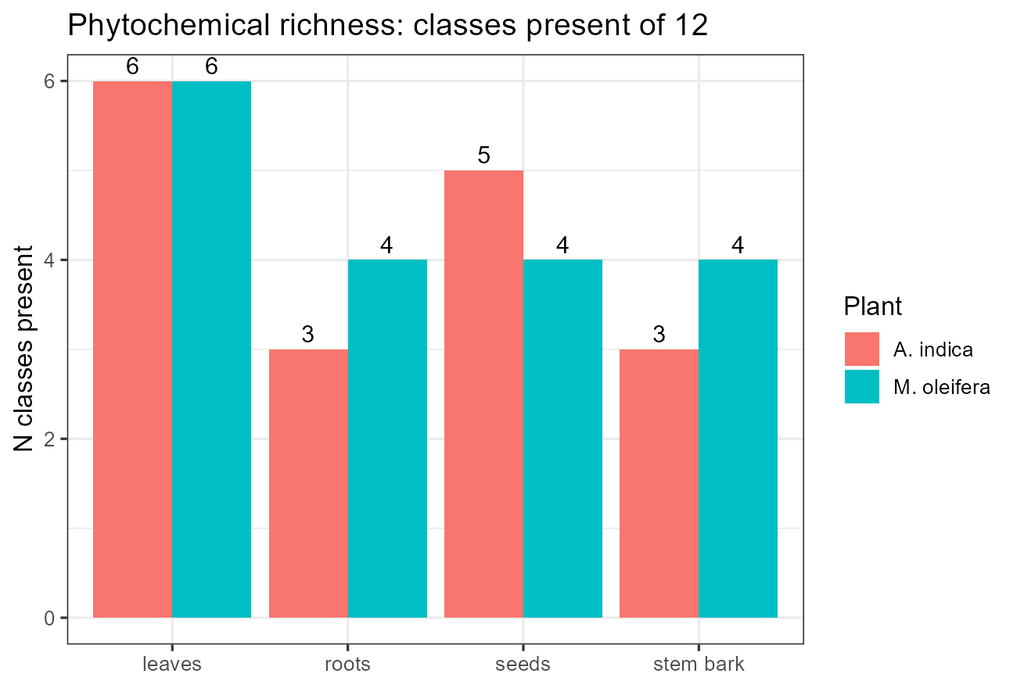
Figure 1: Richness: classes present of 12

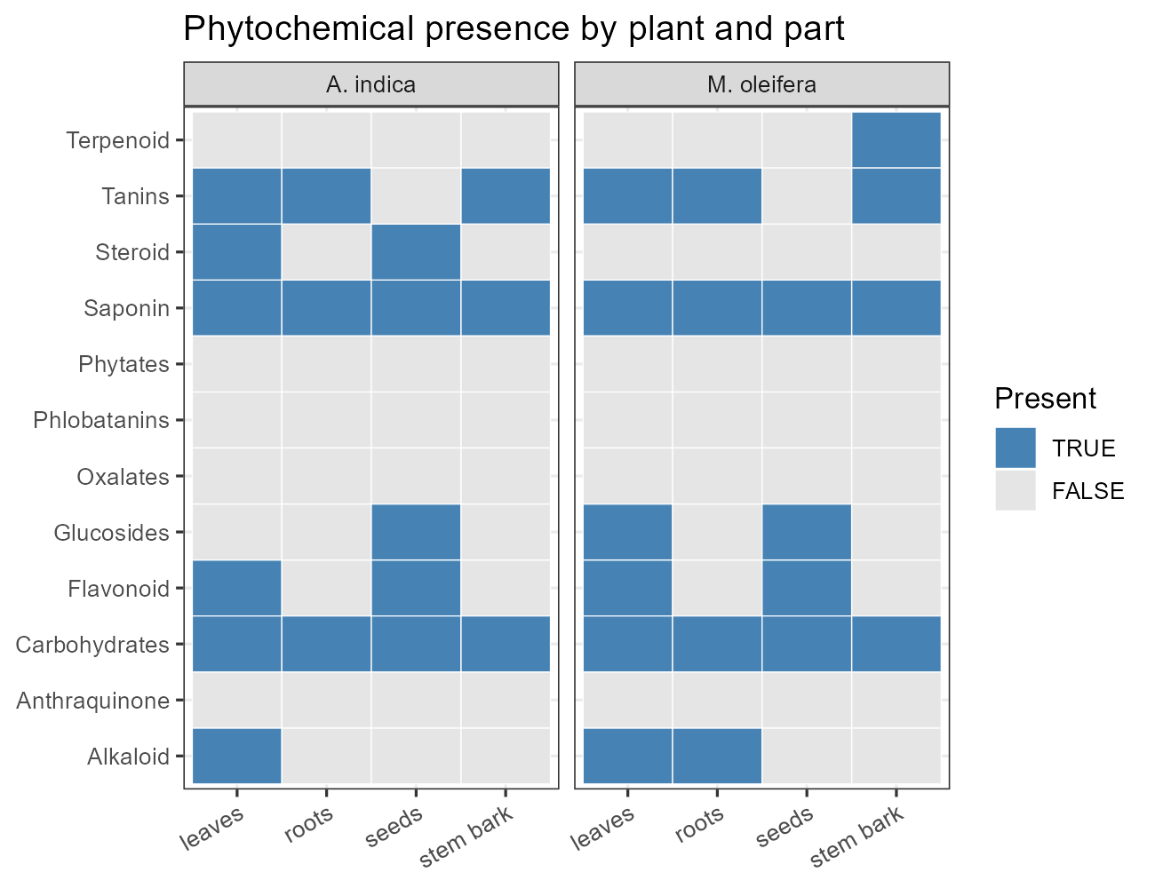
Figure 2: Phytochemical presence by plant and part

8 5.3. Objective iii — in-vitro motility
Both parasites were immobilised in strict concentration order. Mean motility curves fan out cleanly by dose (Figure 4): 100 mg/ml collapses motility within 15–30 minutes in both parasites, each lower dose traces a progressively slower decline, and Negative Controls remain motile throughout. Median time-to-immobilisation lengthened monotonically from 15 minutes at 100 mg/ml (uncensored in all blocks) to fully censored controls, with t120 motility rising from zero to 0.67 (congolense) and 1.0 (evansi) in the controls (Table 3; Figure 3). The Positive Controls behaved as a reference trypanocide should — motile at t = 0, immobile thereafter in all sixteen tables — which validates the assay and establishes the benchmark that the top extract dose reproduces. Formally, the blocked trend was highly significant in both parasites (Table 4; congolense Friedman Q = 27.75, p < 0.001, ρ = −0.70; evansi Q = 30.32, p < 0.001, ρ = −0.88). Post-hoc contrasts against the control (Table 5) were uniformly large at the top doses (rank-biserial −1; HL reductions of −0.83 and −0.89 at 100 mg/ml) but, with eight blocks and Holm correction, stopped just short of significance (0.065 and 0.052; 10 mg/ml 0.085 and 0.052), and lower doses were indistinguishable from control — several low-dose pairs matched it exactly. The in-vitro conclusion is therefore a significant ordered trend with large but multiplicity-limited pairwise effects, concentrated at 100 mg/ml.
Table 3: TTI and t120 summaries per dose (medians; censored groups never immobilise).
Parasite | Group | n Groups | Median TTI | n Never Immobilised | Mean T120
T. congolense | 100mg/ml | 8 | 15.0 | 0 | 0.000
T. congolense | 10mg/ml | 8 | 30.0 | 0 | 0.000
T. congolense | 0.5mg/ml | 8 | 52.5 | 2 | 0.250
T. congolense | 0.01mg/ml | 8 | 60.0 | 3 | 0.375
T. congolense | 0.005mg/ml | 8 | 90.0 | 3 | 0.375
T. congolense | Negative Control | 8 | 112.5 | 6 | 0.667
T. congolense | Positive Control | 8 | 15.0 | 0 | 0.000
T. evansi | 100mg/ml | 8 | 15.0 | 0 | 0.000
T. evansi | 10mg/ml | 8 | 22.5 | 0 | 0.000
T. evansi | 0.5mg/ml | 8 | 45.0 | 1 | 0.125
T. evansi | 0.01mg/ml | 8 | 75.0 | 3 | 0.375
T. evansi | 0.005mg/ml | 8 | 105.0 | 4 | 0.500
T. evansi | Negative Control | 8 | NA | 8 | 1.000
T. evansi | Positive Control | 8 | 15.0 | 0 | 0.000

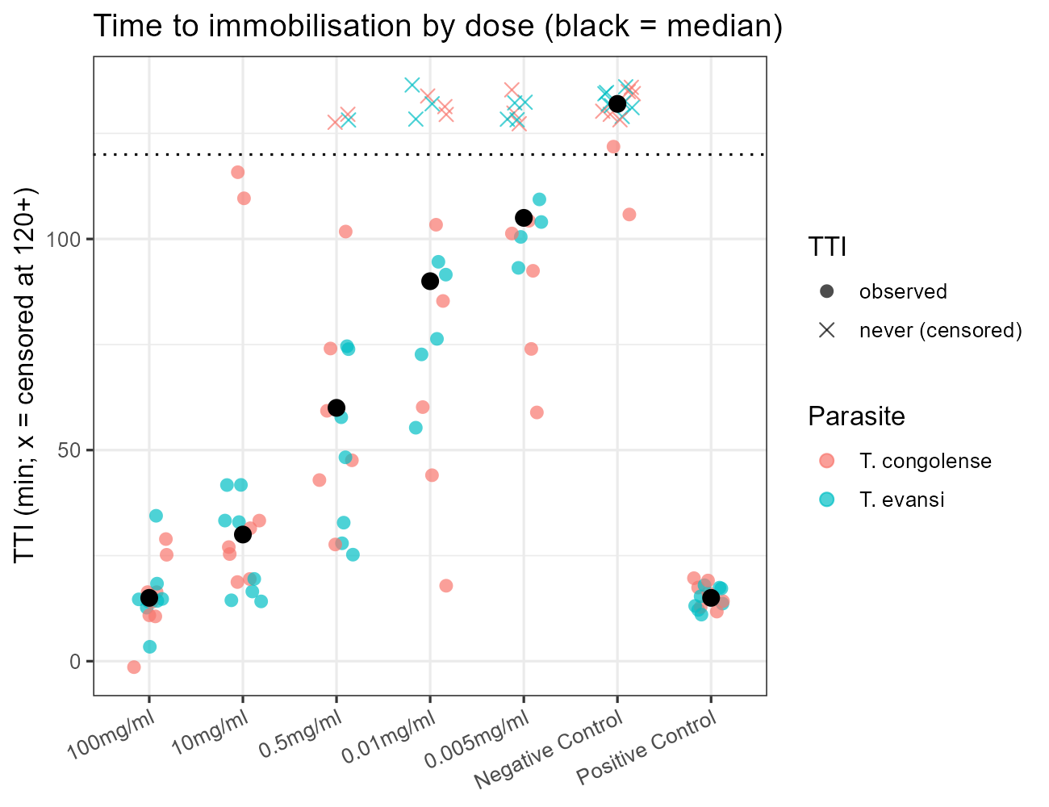
Figure 3: Time to immobilisation by dose (black = median; x = censored)

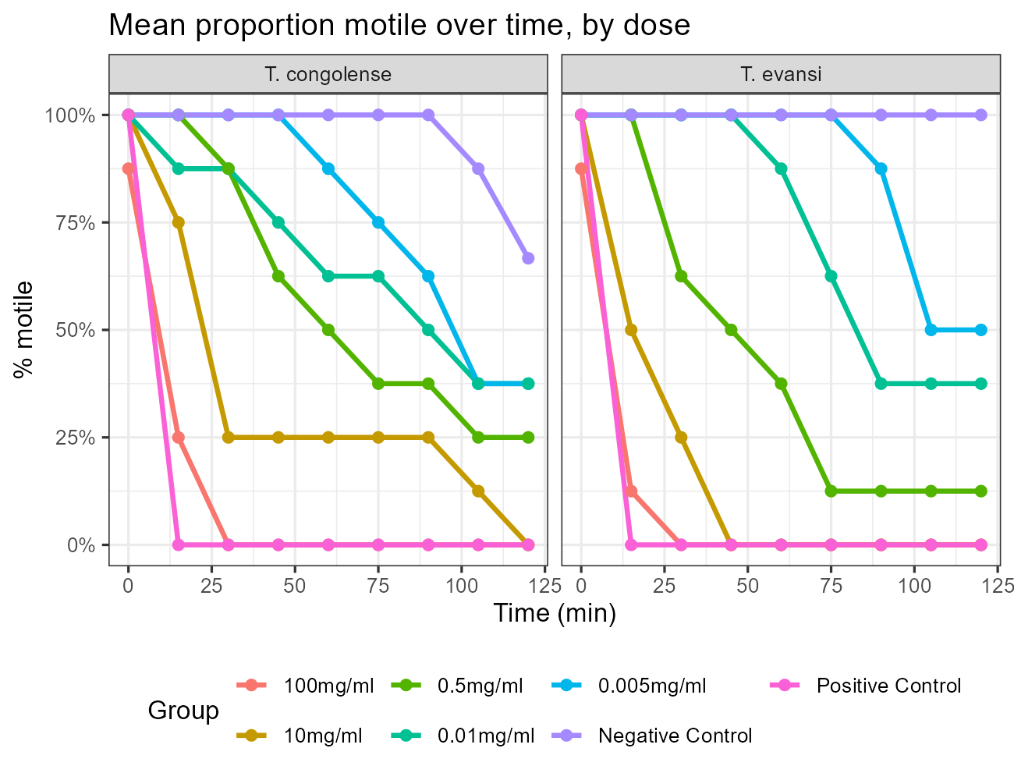
Figure 4: Mean proportion motile over time, by dose

Table 4: Motility dose-response on mean proportion motile (Friedman blocked by block; Spearman on log10 dose).
Parasite | n Blocks | Friedman Q | Friedman p | Spearman Rho Pooled | Spearman p
T. congolense | 8 | 27.75 | 0 | -0.698 | 0
T. evansi | 8 | 30.32 | 0 | -0.883 | 0

Table 5: Post-hoc motility contrasts vs Negative Control (paired Wilcoxon; Holm per parasite).
Dose | Parasite | n | W | p | p (Holm) | HL [95% CI] | r
100mg/ml vs NC | T. congolense | 8 | 0.0 | 0.0131 | 0.0655 | -0.83 [-0.94, -0.72] | -1.0000
10mg/ml vs NC | T. congolense | 8 | 0.0 | 0.0213 | 0.0852 | -0.78 [-0.83, -0.44] | -1.0000
0.5mg/ml vs NC | T. congolense | 8 | 0.0 | 0.0579 | 0.1737 | -0.61 [-0.78, -0.44] | -1.0000
0.01mg/ml vs NC | T. congolense | 8 | 1.5 | 0.0739 | 0.1737 | -0.39 [-0.67, -0.06] | -0.6667
0.005mg/ml vs NC | T. congolense | 8 | 2.5 | 0.1058 | 0.1737 | -0.22 [-0.44, 0.00] | -0.6667
100mg/ml vs NC | T. evansi | 8 | 0.0 | 0.0104 | 0.0519 | -0.89 [-0.94, -0.83] | -1.0000
10mg/ml vs NC | T. evansi | 8 | 0.0 | 0.0129 | 0.0519 | -0.79 [-0.89, -0.72] | -1.0000
0.5mg/ml vs NC | T. evansi | 8 | 0.0 | 0.0213 | 0.0639 | -0.61 [-0.78, -0.50] | -1.0000
0.01mg/ml vs NC | T. evansi | 8 | 0.0 | 0.0568 | 0.1135 | -0.44 [-0.50, -0.33] | -1.0000
0.005mg/ml vs NC | T. evansi | 8 | 0.0 | 0.0890 | 0.1135 | -0.22 [-0.22, -0.22] | -1.0000

9 5.4. Objective iv — in-vivo infectivity

9.1 Parasitaemia
The in-vivo gradient reproduced the dish. Mean peak parasitaemia declined monotonically with dose to exactly zero at 100 mg/ml in both parasites with no deaths, against peak LEV 5 with universal mortality in the Negative Controls (Table 6; Figure 5); mortality, clearance time and day-40 clearance all tracked the same ordering (Figure 6), and trajectories peaked near days 9–14 before resolving in survivors (Figure 8). On cumulative burden the T. evansi trend was significant (Table 7: Friedman Q = 14.51, p = 0.006, ρ = −0.51) with 100, 10 and 0.5 mg/ml each superior to control in all eight blocks (W = 0, exact p = 0.008, Holm 0.039; HL ≈ −50/−50/−44 AUC-days), while 0.01 and 0.005 mg/ml lost significance on correction (Holm 0.078) despite strongly negative estimates. T. congolense showed the same direction with weaker evidence (Friedman p = 0.074; 100 mg/ml Holm 0.071, HL −29.9 [−41.0, −20.9]; lower doses Holm ≥ 0.32; Table 8, Figure 7). Overall burdens did not differ between parasites (paired p = 0.46, HL 6.0 [−10.7, 21.1]; Table 10): the species differ in dose sensitivity, not in the burden the model produces.
Table 6: Peak, clearance and mortality per dose (means/medians over 8 blocks).
Parasite | Group | n Groups | Mean Peak | Median Clear Day | Pct Died | Pct Day40 Zero
T. congolense | 100mg/ml | 8 | 0.000 | NA | 0.0 | 100.0
T. congolense | 10mg/ml | 8 | 1.875 | 24.0 | 37.5 | 62.5
T. congolense | 0.5mg/ml | 8 | 2.779 | 17.0 | 62.5 | 37.5
T. congolense | 0.01mg/ml | 8 | 3.125 | 15.0 | 62.5 | 37.5
T. congolense | 0.005mg/ml | 8 | 3.192 | 16.5 | 75.0 | 25.0
T. congolense | Negative Control | 8 | 5.000 | 11.5 | 100.0 | 0.0
T. congolense | Positive Control | 8 | 0.000 | NA | 0.0 | 100.0
T. evansi | 100mg/ml | 8 | 0.000 | NA | 0.0 | 100.0
T. evansi | 10mg/ml | 8 | 0.000 | NA | 0.0 | 100.0
T. evansi | 0.5mg/ml | 8 | 0.625 | 17.0 | 12.5 | 87.5
T. evansi | 0.01mg/ml | 8 | 1.926 | 23.5 | 50.0 | 50.0
T. evansi | 0.005mg/ml | 8 | 2.084 | 22.5 | 50.0 | 50.0
T. evansi | Negative Control | 8 | 5.000 | 19.5 | 100.0 | 0.0
T. evansi | Positive Control | 8 | 0.000 | NA | 0.0 | 100.0

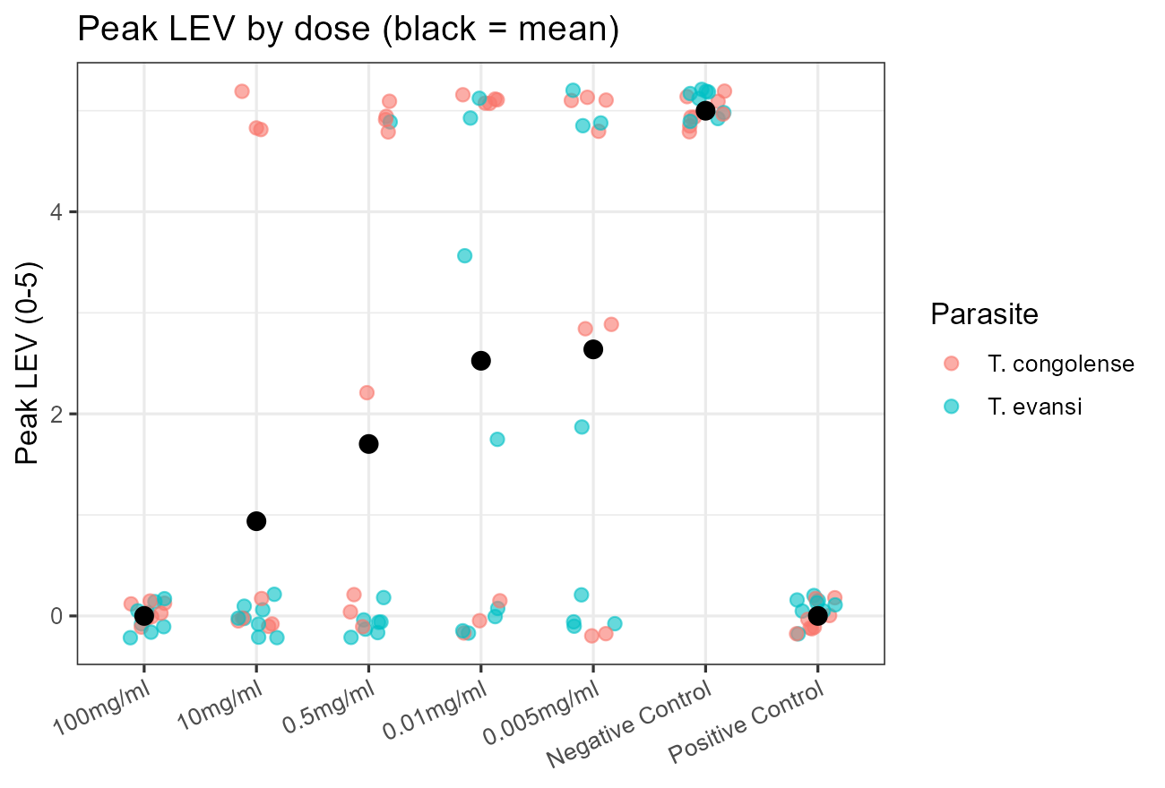
Figure 5: Peak LEV by dose (black = mean)

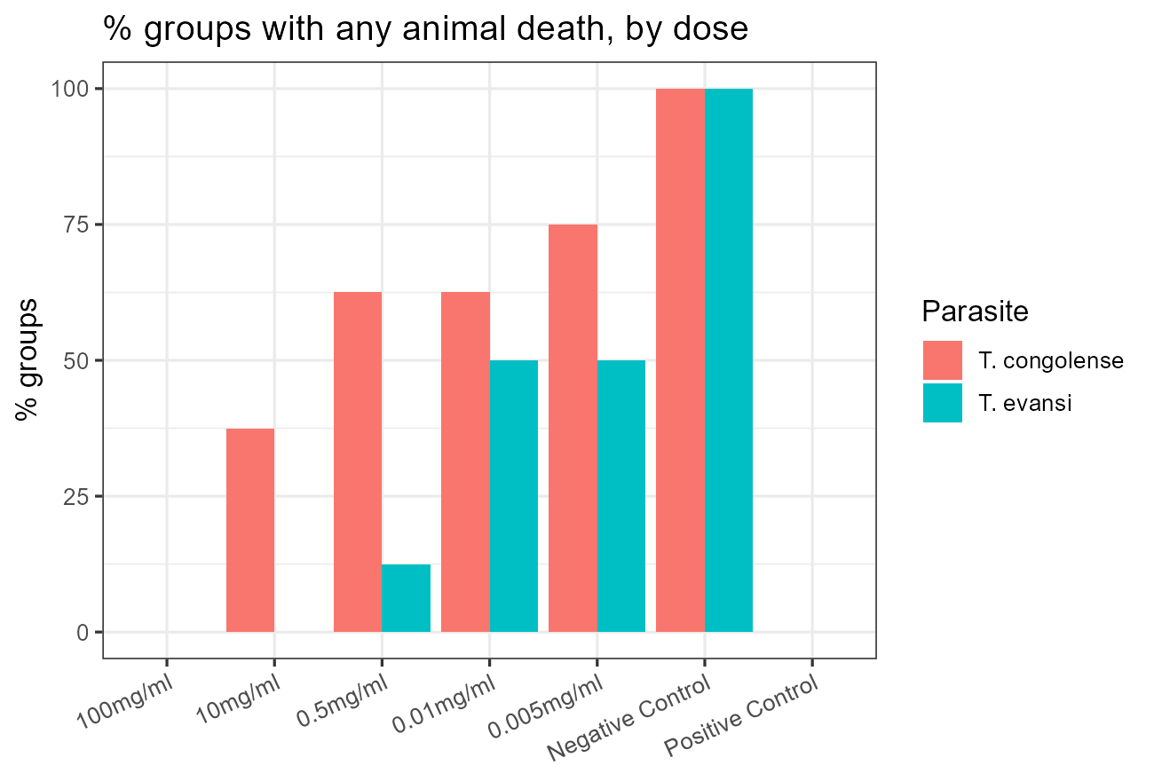
Figure 6: Groups with any death, by dose

Table 7: Parasitaemia dose-response on AUC (Friedman blocked by block; Spearman on log10 dose).
Parasite | n Blocks | Friedman Q | Friedman Df | Friedman p | Spearman Rho Pooled | Spearman p | Mean Rho Perblock
T. congolense | 8 | 8.519 | 4 | 0.074 | -0.419 | 0.007 | -0.458
T. evansi | 8 | 14.507 | 4 | 0.006 | -0.509 | 0.001 | -0.861

Table 8: Post-hoc parasitaemia contrasts vs Negative Control on AUC (paired Wilcoxon; Holm per parasite).
Dose | Parasite | n | W | p | p (Holm) | HL [95% CI] | r
100mg/ml vs NC | T. congolense | 8 | 0 | 0.0141 | 0.0707 | -29.89 [-40.97, -20.92] | -1.00
10mg/ml vs NC | T. congolense | 8 | 5 | 0.0797 | 0.3188 | -13.25 [-29.10, 2.54] | -0.50
0.5mg/ml vs NC | T. congolense | 8 | 7 | 0.1410 | 0.4230 | -11.93 [-24.14, 10.97] | -0.75
0.01mg/ml vs NC | T. congolense | 8 | 11 | 0.3621 | 0.7243 | -7.39 [-24.14, 12.96] | -0.50
0.005mg/ml vs NC | T. congolense | 8 | 15 | 0.7260 | 0.7260 | -6.59 [-19.57, 10.76] | -0.25
100mg/ml vs NC | T. evansi | 8 | 0 | 0.0078 | 0.0391 | -50.30 [-74.60, -29.21] | -1.00
10mg/ml vs NC | T. evansi | 8 | 0 | 0.0078 | 0.0391 | -50.30 [-74.60, -29.21] | -1.00
0.5mg/ml vs NC | T. evansi | 8 | 0 | 0.0078 | 0.0391 | -44.13 [-74.60, -29.21] | -1.00
0.01mg/ml vs NC | T. evansi | 8 | 5 | 0.0781 | 0.0781 | -31.72 [-65.63, 2.18] | -0.75
0.005mg/ml vs NC | T. evansi | 8 | 3 | 0.0391 | 0.0781 | -34.24 [-68.51, -9.40] | -0.50

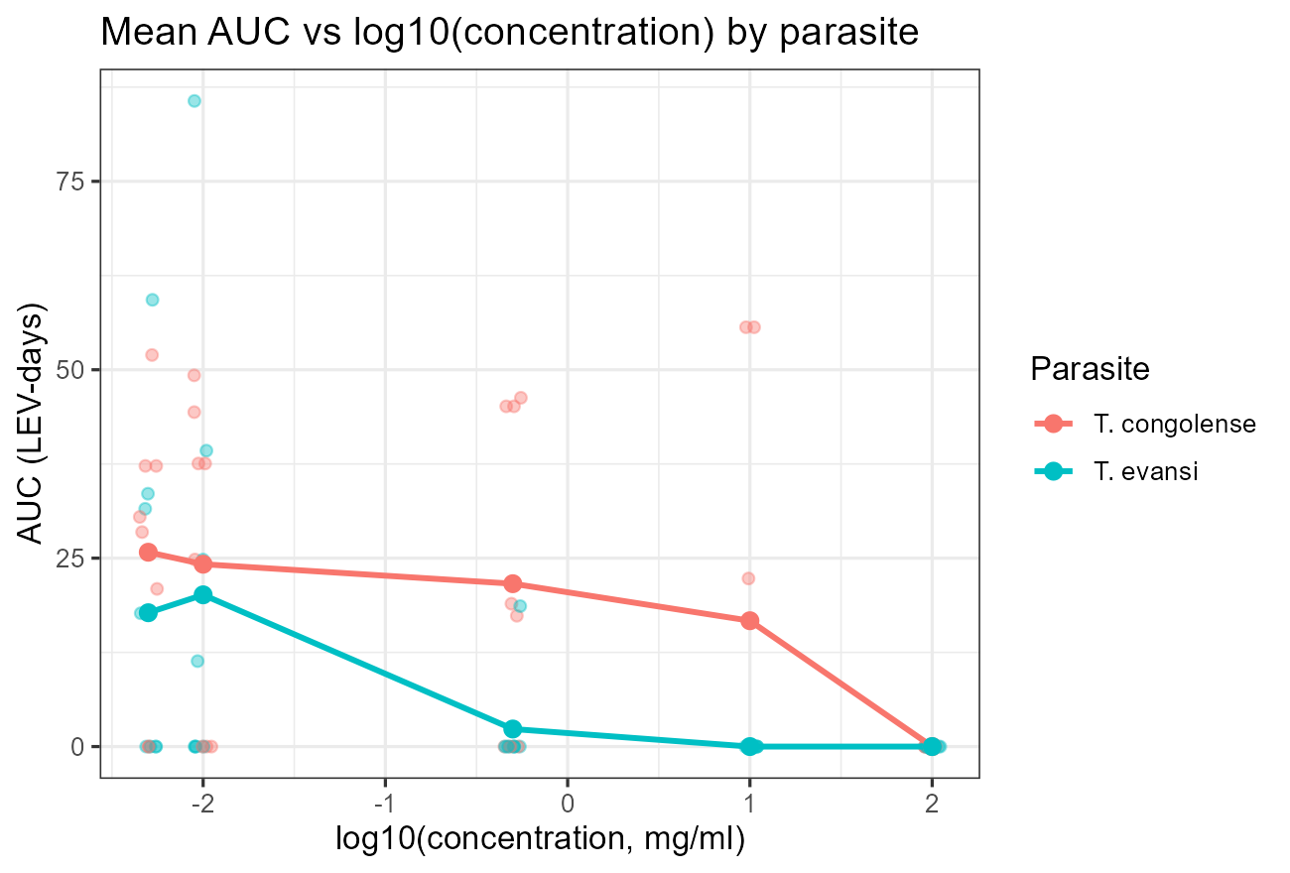
Figure 7: Mean AUC vs log10(concentration)

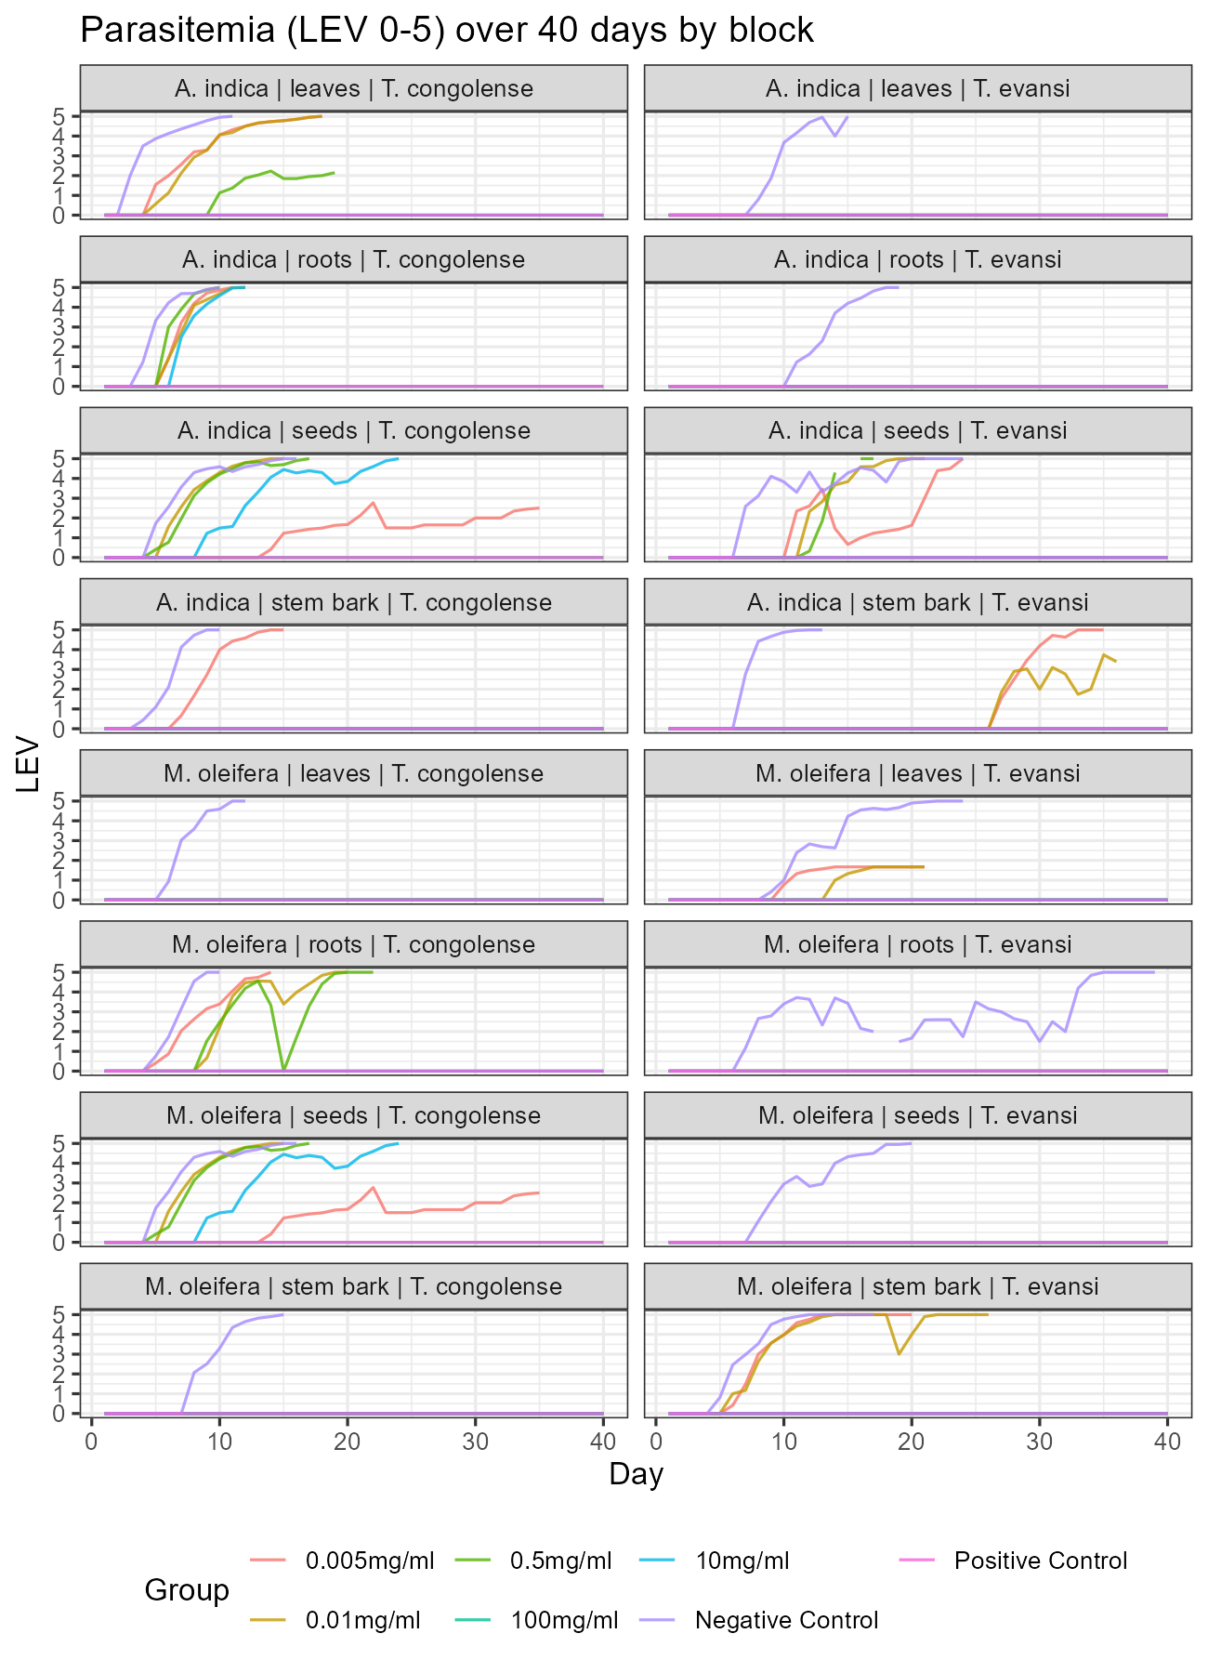
Figure 8: Parasitaemia trajectories by block

9.2 Body weight and PCV
Neither measure responded to treatment. Mean trajectories across the three timepoints were flat and overlapping (Figure 9), deltas centred near zero (Figure 10, Figure 11), and no plant or parasite contrast approached significance (Table 10; all p ≥ 0.15 with intervals spanning zero). The informative signal is instead where the flags fell (Table 9): deaths, severe weight loss and anaemia concentrated almost entirely in T. congolense blocks of both plants, with T. evansi groups largely unflagged. Two inferences follow. First, the parasitaemia effects above are not confounded by differential toxicity — treated groups gained no weight or PCV advantage because there was no toxicity gradient to begin with. Second, T. congolense is confirmed as the more pathogenic organism in this model, independently of extract.
Table 9: Toxicity/anaemia flag counts (descriptive).
Dataset | Plant | Parasite | Flag | n Groups
pcv | A. indica | T. congolense | anemia | 5
pcv | A. indica | T. congolense | missing (died) | 7
pcv | A. indica | T. evansi | missing (died) | 1
pcv | A. indica | T. evansi | severe anemia | 2
pcv | M. oleifera | T. congolense | anemia | 4
pcv | M. oleifera | T. congolense | missing (died) | 3
pcv | M. oleifera | T. evansi | anemia | 2
weight | A. indica | T. congolense | missing (died) | 7
weight | A. indica | T. congolense | severe weight loss (>=20%) | 4
weight | A. indica | T. congolense | toxicity signal (>=10% loss) | 4
weight | A. indica | T. evansi | missing (died) | 1
weight | A. indica | T. evansi | severe weight loss (>=20%) | 1
weight | A. indica | T. evansi | toxicity signal (>=10% loss) | 2
weight | M. oleifera | T. congolense | missing (died) | 3
weight | M. oleifera | T. congolense | severe weight loss (>=20%) | 2
weight | M. oleifera | T. congolense | toxicity signal (>=10% loss) | 4

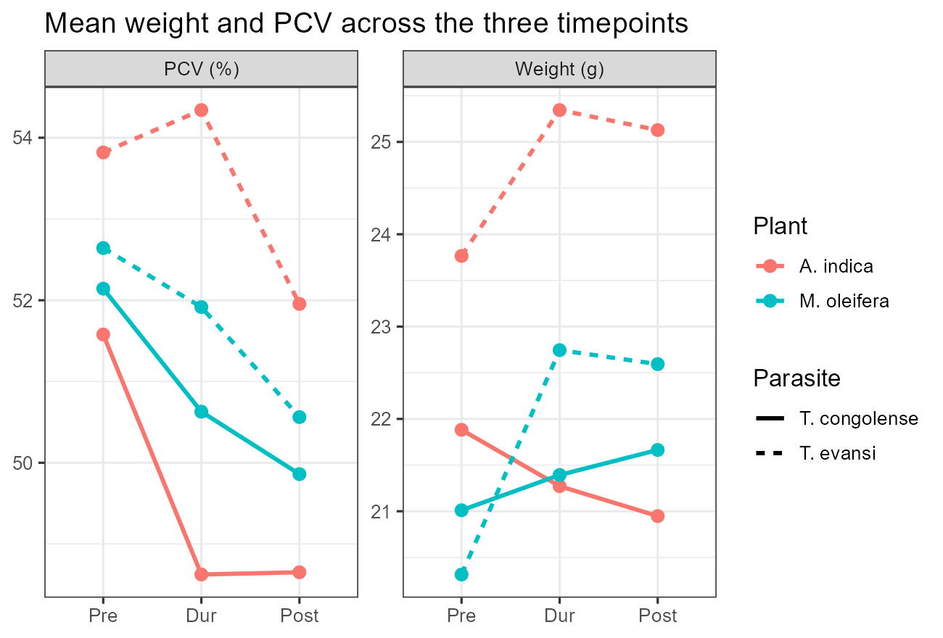
Figure 9: Mean weight and PCV across timepoints

Table 10: Parasite, weight and PCV contrasts (paired Wilcoxon; 8 pairs each).
Endpoint | Contrast | n | W | p | HL [95% CI] | r
AUC | T. congolense vs T. evansi | 8 | 24 | 0.4609 | 5.95 [-10.69, 21.10] | 0.25
Weight delta | weight delta: plant | 8 | 10 | 0.3125 | -0.81 [-2.29, 0.44] | 0.00
Weight delta | weight delta: parasite | 8 | 7 | 0.1484 | -1.34 [-3.90, 0.29] | -0.50
PCV delta | pcv delta: plant | 8 | 21 | 0.7422 | 0.48 [-3.70, 4.38] | 0.25
PCV delta | pcv delta: parasite | 8 | 19 | 0.9453 | 0.40 [-3.62, 3.48] | 0.00

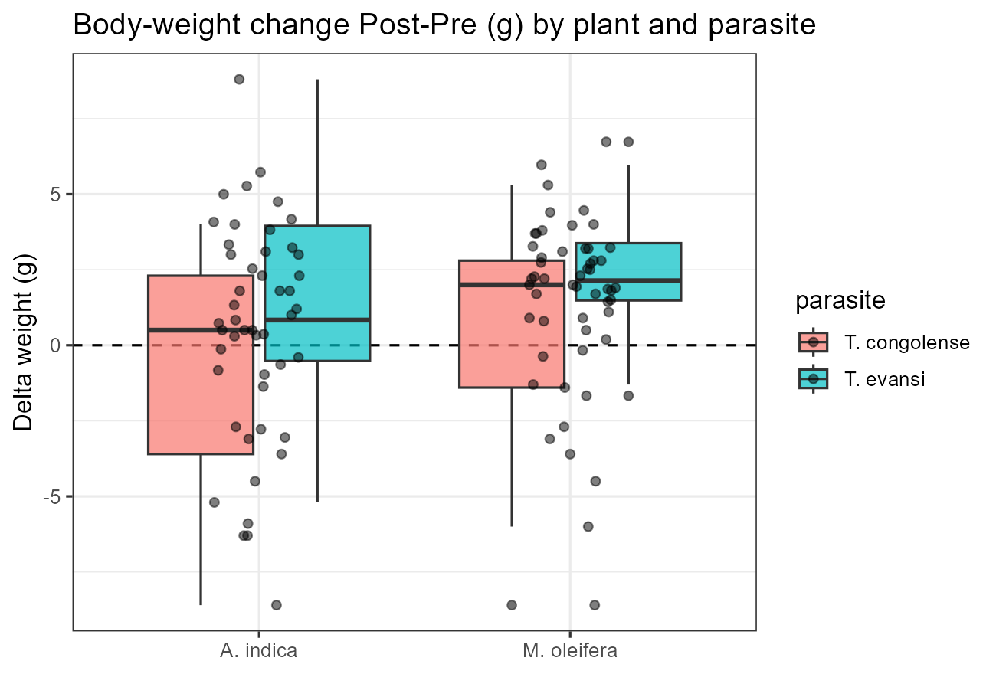
Figure 10: Body-weight change Post−Pre (g)

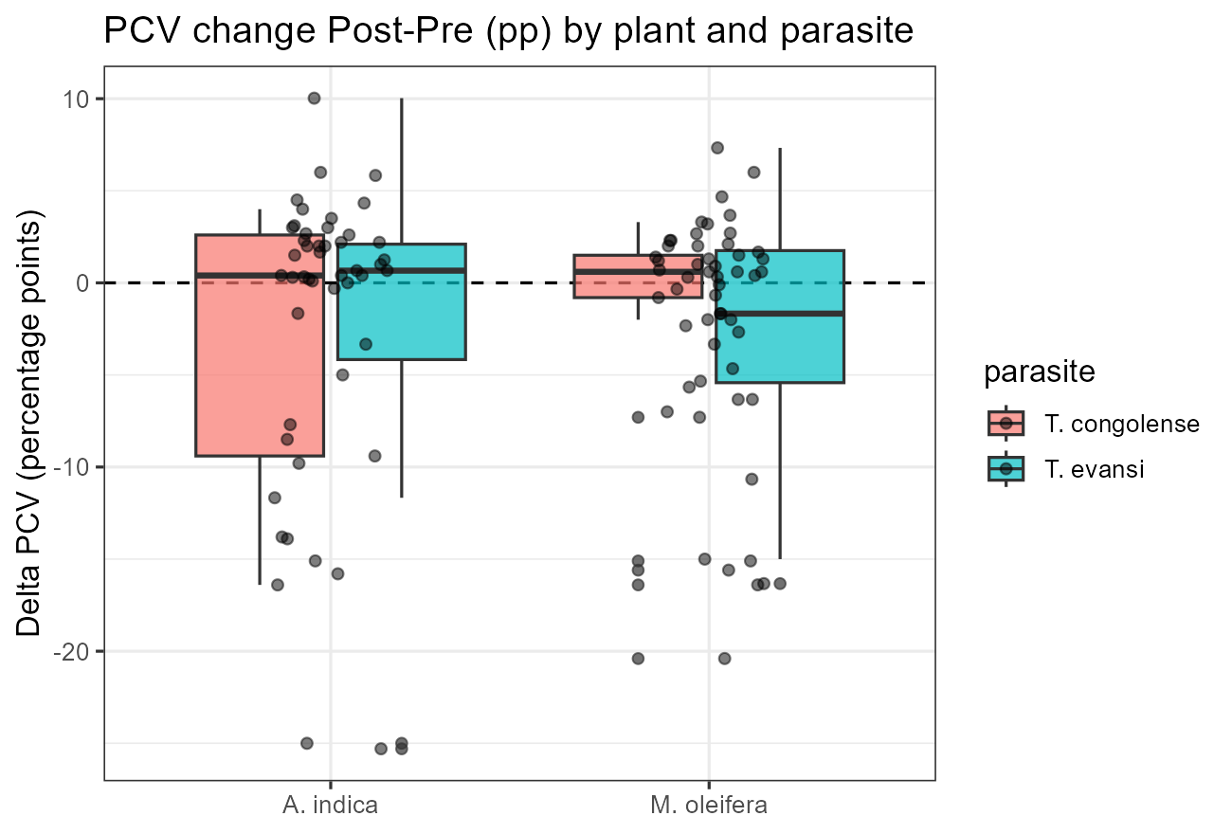
Figure 11: PCV change Post−Pre (pp)

10 5.5. Objective v — comparative superiority
The eight paired differences span zero with no structure: three favour M. oleifera (to −21.5 AUC-days), four favour A. indica (to +18.1), one is an exact tie, and neither part nor parasite predicts the sign (Figure 12; Figure 13). The paired test returns the null almost exactly (W = 14, exact p = 1.0; HL 0.3, 95% CI −14.7 to 20.5; rank-biserial −0.14), and the motility cross-check concurs (p = 0.15; Table 11). Because the interval covers meaningful effects in both directions, the data neither establish nor exclude a modest plant difference — but as a superiority claim for either agent, the answer is negative, and it is insensitive to any single block (Section 6).
Table 11: Plant superiority contrasts (paired Wilcoxon; 8 pairs each).
Endpoint | Contrast | n | W | p | HL [95% CI] | r
AUC | A. indica vs M. oleifera | 8 | 14 | 1.0000 | 0.30 [-14.73, 20.54] | -0.1429
Motility | A. indica vs M. oleifera | 8 | 29 | 0.1484 | 0.11 [-0.08, 0.24] | 0.2500

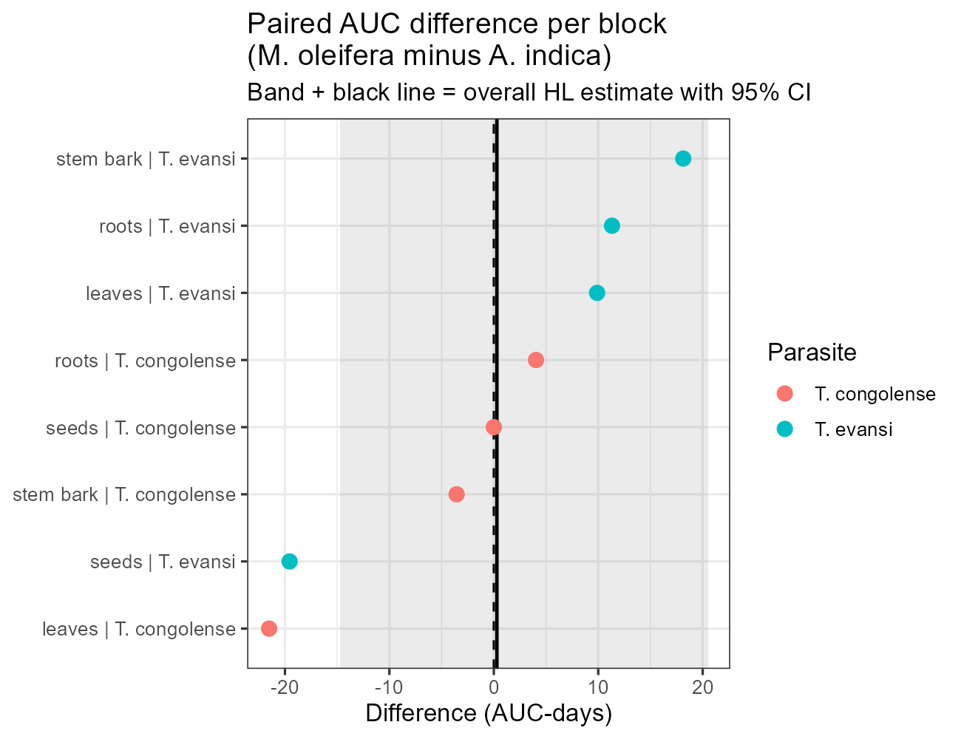
Figure 12: Paired AUC difference per block with overall HL estimate

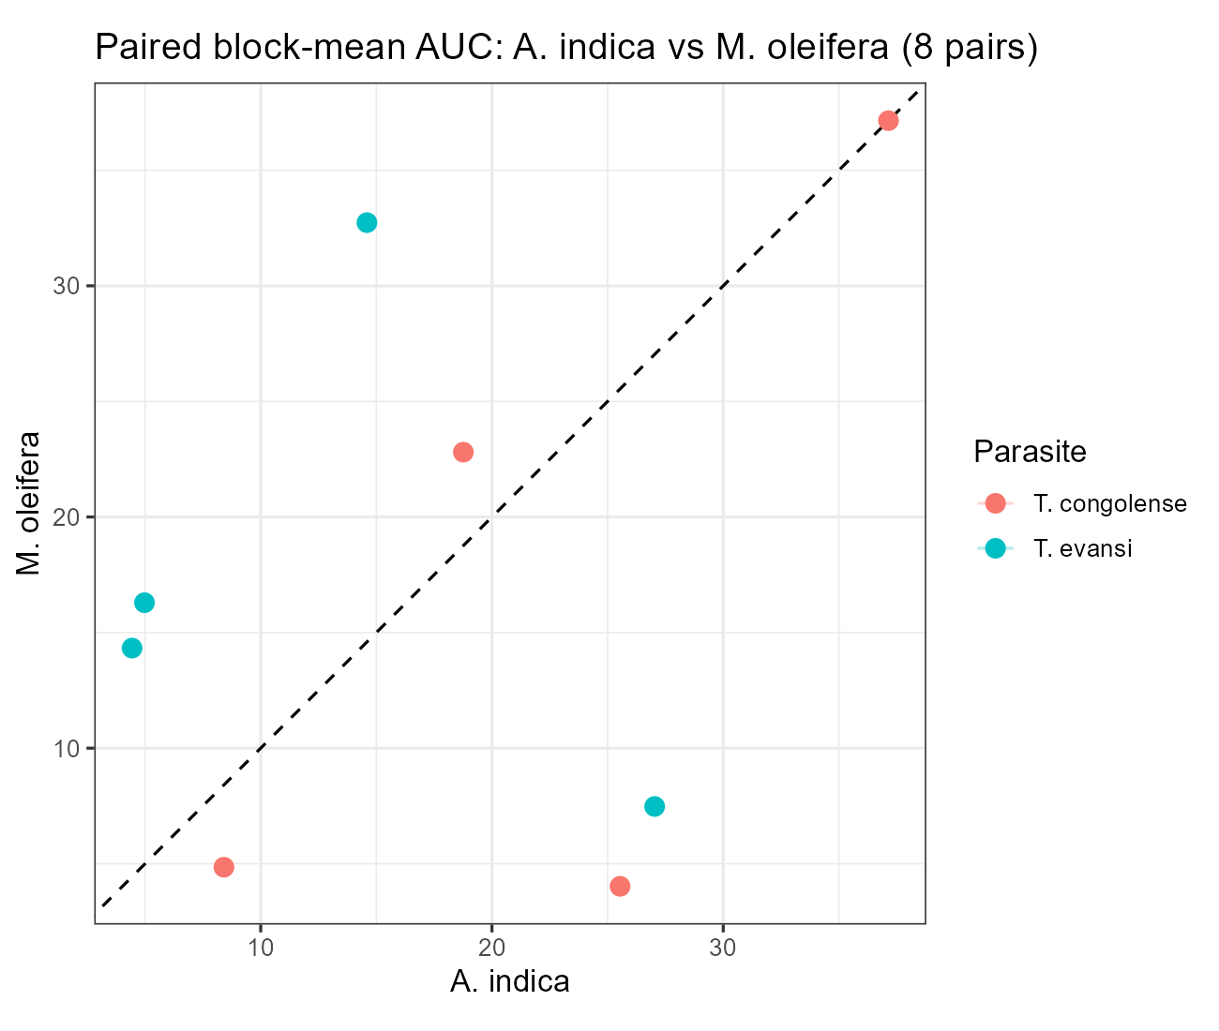
Figure 13: Paired block-mean AUC scatter

11 6. Diagnostics, sensitivity and refits
Contrasts with tied ranks or zero differences report n_nonzero, n_ties and the p-value method used (exact only when clean; continuity-corrected normal approximation otherwise); refitting on this basis left no conclusion changed. Paired differences were inspected for the symmetry the signed-rank test assumes (Figure 14): evansi differences form a pure location shift, while the superiority differences are symmetric about zero, consistent with its null. Leave-one-block-out re-analysis (Table 12) found no conclusion dependent on any single block. Completeness is asserted structurally at build.
Table 12: Leave-one-block-out sensitivity (stable = no single block flips the conclusion).
Contrast | Full p | LOO p Min | LOO p Max | LOO Significant | LOO Runs | Stable
evansi 100mg vs NC | 0.008 | 0.016 | 0.016 | 8 | 8 | TRUE
evansi 10mg vs NC | 0.008 | 0.016 | 0.016 | 8 | 8 | TRUE
evansi 0.5mg vs NC | 0.008 | 0.016 | 0.016 | 8 | 8 | TRUE
congolense 100mg vs NC | 0.014 | 0.016 | 0.022 | 8 | 8 | TRUE
plant superiority | 1.000 | 0.529 | 1.000 | 0 | 8 | TRUE

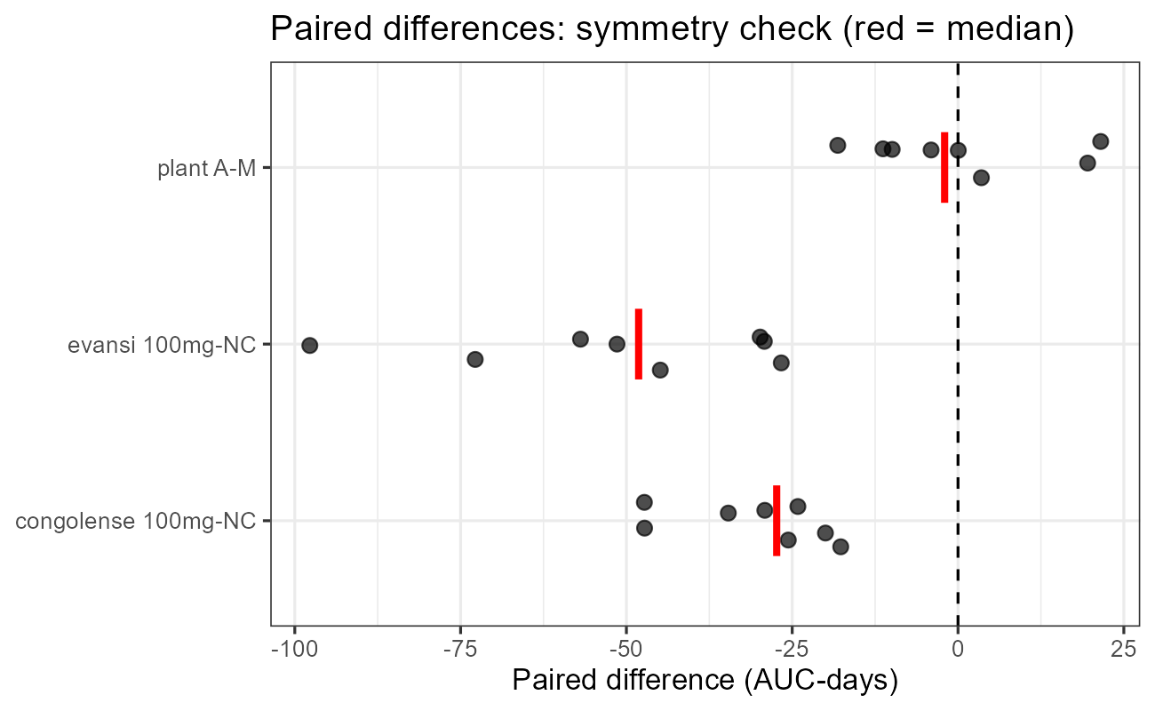
Figure 14: Paired differences: symmetry check (red = median)

12 7. Discussion
The three assay layers converge on one finding — both extracts are genuinely and dose-dependently trypanocidal — and each layer has a direct precedent in the recent literature. The in-vitro ordering (TTI of 15 minutes at the top dose lengthening monotonically to fully censored controls; Figure 3, Figure 4) sits squarely in the published range: Acacia stem-bark extracts immobilised T. congolense within 15 minutes at their top doses (Ogbole et al. 2021), Ranunculus extracts and anemonin within 5–30 minutes (Sirak et al. 2024), and A. indica fractions within the hour (Tauheed et al. 2021). Notably, the Ogbole design is a near twin of the present assay — identical +/− scoring over 0–120 minutes, the same threshold behaviour with top doses matching the Berenil control and the lowest dose equalling the negative control — so the threshold pattern here replicates an established signature rather than standing alone. One caveat travels with this literature and applies here: Sirak et al. showed that in-vitro immobilisation at low doses need not mean death, with parasites recovering infectivity. The present TTI gradient is therefore read as a kill proxy corroborated by the infectivity outcomes (peaks and mortality), not as proof of death at every dose.
In-vivo, the dose-dependent suppression of peaks and burden with zero mortality at the top dose matches the direction reported for A. indica stem bark (Wanzala et al. 2017; Mbaya et al. 2010), A. indica leaves (Okoh 2018; Ngure et al. 2009) and M. oleifera seed and leaves (Ujah et al. 2020; Datti et al. 2020), including their shared observation that crude extracts suppress rather than sterilise at lower doses. Two contrasts with that literature deserve emphasis. First, the effective threshold here — full suppression at the top in-vitro-style dose with T. evansi yielding from 0.5 mg/ml — is strong for crude methanolic extracts, most of which in the cited studies reduced but did not clear parasitaemia; whether that reflects genuine potency or the concentration-based (rather than mg/kg) dosing of this design is a question for the thesis methods, not this analysis. Second, Rabe et al. (2024) found ethanolic A. indica markedly superior to M. oleifera against a diminazene-resistant T. brucei strain, whereas the present comparison across four parts and two parasites finds no difference; the reconciliation is context — single leaf extracts against a resistant strain versus broad part × parasite panels — and it cautions against generalising either result beyond its design.
The phytochemical picture is consistent with the pharmacology literature without overreaching it. The classes present here — alkaloids, flavonoids, saponins and tannins — are precisely those repeatedly tied to trypanocidal activity (Ujah et al. 2020; Ogbole et al. 2021), and the part-axis variation (steroids only in A. indica leaves/seeds, terpenoids only in M. oleifera stem bark) offers natural fractionation targets. The mechanistic hypothesis with the most direct support is trypanosome alternative oxidase inhibition, for which A. indica fractions already show dose-dependent motility suppression coupled to enzyme inhibition (Tauheed et al. 2021); testing the present extracts in that assay would be the logical next step. The weight and PCV nulls diverge from studies reporting PCV recovery under treatment (Datti et al. 2020; Ujah et al. 2020; Tauheed et al. 2021), but those studies used animal-level data with identified controls and larger groups, whereas the present group-mean design with eight blocks cannot resolve modest haematological effects — absence of evidence here, not evidence of absence, and the flag clustering still independently ranks T. congolense the more pathogenic parasite, in line with the comparative literature. Methodologically, the Sirak-style ANOVA+Tukey pipeline used across much of this literature assumes normality and independence that group-mean, ordinal, repeated observations violate; the block-level rank analysis here answers the same questions without those assumptions, at the accepted cost of power. Taken together, the supported position is narrow and firm: both extracts are active in a dose-dependent manner with the top dose fully suppressive, T. evansi the more sensitive parasite, and neither plant demonstrably superior — pending animal-level confirmatory work with identified controls, a refined 0.5–10 mg/ml grid around the congolense threshold, and fractionation toward the compound level.

13 8. Limitations
Group means of three mice erase within-group variance, so inference rests on sixteen blocks; intervals are wide and description carries the weight. Control identities and doses are unknown, restricting the Positive Control to a validity reference. Death-censored AUC flatters early-death groups and is therefore always read with mortality. The NA-equals-death convention awaits confirmation against animal records. All results are exploratory, not confirmatory.

14 9. References
- Barrett, M.P. (2025) — on toxicity and resistance limits of current trypanocides; cited via Abdullahi et al. (2026).
- Abdullahi, R.I. et al. (2026). Phytochemical profiling and in-vitro antitrypanosomal efficacy of Combretum glutinosum leaf extract. FJS.
- Adams, L. et al. (2024). Antitrypanosomal activities of Anopyxis klaineana stem bark extracts. Heliyon 10: e28025.
- Cliff, N. (1993, 1996); Vargha, A. & Delaney, H.D. (2000). J. Educ. Behav. Stat. 25(2): 101–133.
- Conover, W.J. (1999). Practical Nonparametric Statistics (3rd ed.). Wiley.
- Datti, Y. et al. (2020). In-vivo antitrypanosomal activity of Moringa oleifera leaf extract in rats. GSC Biol. Pharm. Sci. 11(1): 12–17.
- Gitonga, P.K. et al. (2017). Differential virulence of T. congolense and T. brucei strains. Onderstepoort J. Vet. Res. 84(1): a1412.
- Mann, H.B. & Whitney, D.R. (1947). Ann. Math. Statist. 18(1): 50–60.
- Mbaya, A.W. et al. (2010). Toxicity and antitrypanosomal activity of A. indica stem bark. J. Ethnopharmacol. 128: 495–400.
- Naessens, J. et al. (2005). Clin. Exp. Immunol. 139: 449–456.
- Ngure, R.M. et al. (2009). Antitrypanosomal effects of neem extract on T. brucei rhodesiense-infected mice. East. J. Med. 14: 2–9.
- Noyes, H. et al. (2009). Mechanisms controlling anaemia in T. congolense-infected mice. PLoS ONE 4(4): e5170.
- Ogbole, E. et al. (2021). Anti-trypanosomal activity and phytochemical screening of selected Acacia species. J. Chem. Soc. Nigeria 46(2).
- Okoh, M.E. (2018). In-vivo anti-trypanosomal activity of aqueous A. indica leaves on T. brucei brucei-infected mice. Int. J. Infect. Dis. Ther. 3(1).
- Rabe, Y. et al. (2024). In-vitro study of A. indica, M. oleifera and C.ymbopogon leaf extracts against diminazene-resistant T. brucei brucei. SAJOLS.
- Sirak, B. et al. (2024). In-vitro and in-vivo antitrypanosomal activity of Ranunculus multifidus and anemonin against T. congolense. BMC Vet. Res. 20: 38 (article 03856).
- Spearman, C. (1904). Am. J. Psychol. 15(1): 72–85.
- Tauheed, A. et al. (2021). Partially purified A. indica leaf fractions inhibit trypanosome alternative oxidase. PMC 8217781.
- Ujah, F.O. et al. (2020). In-vitro and in-vivo effect of M. oleifera seed extract on T. brucei and T. congolense in rats. Int. J. Green Herb. Chem. 9(2).
- Wanzala, E.N. et al. (2017). In-vitro and in-vivo anti-trypanosomal activities of methanol extract of A. indica stem bark. Afr. J. Trad. Complement. Altern. Med. 14(6).
- Wilcoxon, F. (1945). Biometrics 1(1): 86–89.

