Where urban agriculture concentrates in Nigerian cities
  - A spatial analysis with coverage correction
Jerry Bannister Zachary
Statistician, Abubakar Tafawa Balewa University (ATBU), Bauchi, Nigeria
E-mail: jzbannister@atbu.edu.ng
15 October 2026
Abstract
Context and background. Urban agriculture is widely promoted as a lever for urban food security in Nigeria, yet its spatial distribution has rarely been measured. Policy questions about where land should be protected require spatial evidence, and the existing literature, dominated by single-city household surveys, cannot supply it. The principal obstacle to spatial measurement is that the best available open data — volunteered geographic information — is contributed unevenly, so that mapping density and agricultural density are easily confused.
Goal and objectives. This study measures where cultivated land concentrates across Nigerian Local Government Areas and tests whether the observed pattern survives correction for that coverage problem. Three questions are addressed: whether cultivation is spatially clustered; whether density depends on the size of the administrative unit; and whether any pattern survives an explicit control for how much of each unit has been mapped.
Methodology. Cultivated-land features were extracted from OpenStreetMap for five cities spanning the country’s agro-ecological gradient — Abuja, Lagos, Kano, Port Harcourt and Gombe — and analysed across 775 Local Government Areas. Spatial clustering was assessed using Moran’s I, local indicators of spatial association with false-discovery-rate control, a join-count test and Ripley’s K within each city. The scale effect was modelled with a negative binomial specification using area as an exposure offset, re-estimated with per-area counts of mapped buildings and highways as an additional offset.
Results. Density is strongly clustered (Moran’s I equal to 0.300; z equal to 17.6), and the clustering survives the exclusion of Kano State, the best-mapped region (I equal to 0.274). Point-pattern analysis finds significant clustering within all five cities independently. Density falls by approximately 66 per cent per doubling of Local Government Area, and this effect strengthens rather than weakens when mapping coverage is controlled, with an improvement of 20 AIC points. Coverage is itself demonstrably confounded with the outcome: features correlate with mapped highway density at a Spearman coefficient of 0.613, and areas containing cultivation have nearly twice the median mapped buildings of those without.
Conclusion. Clustering means that targeted land protection is feasible: 39 of 775 Local Government Areas contain any mapped cultivation, and 19 show statistically significant local clustering. The coverage control strengthens rather than undermines the principal finding, which is a result of methodological as well as substantive interest. A climate hypothesis forming part of the original design could not be tested, for reasons reported in the paper.
Keywords: urban agriculture; Nigeria; OpenStreetMap; spatial autocorrelation; volunteered geographic information; land policy

1. Introduction
Urban agriculture — the production, processing and marketing of food within and around cities — is promoted by the Food and Agriculture Organization as a lever for both urban food security and circular-economy goals (Food and Agriculture Organization of the United Nations and International Fund for Agricultural Development and United Nations Children’s Fund and World Food Programme and World Health Organization, 2023). In Nigeria the case for it is easy to state. The urban population reached 146.5 million in 2024, a majority of the national total, and food inflation has repeatedly exceeded thirty per cent in recent years, making urban food access a live political problem rather than a distant development goal.
The evidence base, however, is largely non-spatial. Urban agriculture in Nigeria has been studied through household surveys that establish who farms and why — among urban food-crop farmers in Cross River State (Ibok, 2014), fish farmers in Jos (Wuyep & Rampedi, 2018), and urban households facing gendered food insecurity (Elum & Emodi, 2025) — and through reviews that establish what policy ought to do (Gottero, 2025). Such work cannot answer the questions that land-use planning actually poses. Where does cultivation concentrate? Is it dispersed or clustered? Should a city protect a small number of intensively farmed areas, or many scattered ones? What area of land is involved? Policy documents acknowledge the gap: successive Nigerian urban policy frameworks commit to safeguarding agricultural land without providing instruments to identify it.
Cities across West Africa face the same pressure from a different direction, as urban expansion converts peri-urban farmland faster than planning systems can respond (Cobbinah & Niminga-Beka, 2017; Prados & Azadi, 2026). The spatial question is therefore not only academic: it determines whether land protection is targeted or aspirational.
Satellite and crowdsourced data have changed what is measurable, but they bring their own problem. OpenStreetMap is the most complete openly licensed source of intra-urban land-use data available, and it is contributed unevenly. Coverage is known to vary systematically with wealth, population density and contributor attention, both globally and within regions (Haklay, 2010; Herfort et al., 2023). In Nigeria this matters acutely: Kano is among the best-mapped states in the country, and Kano is also where most cultivation is recorded. Any analysis that treats mapping density as agricultural density risks measuring the behaviour of volunteers rather than the behaviour of farmers.
This paper takes that risk seriously rather than setting it aside. We ask three questions of a national-layer dataset, and we test each against the objection that most threatens it:
- H1 — Clustering. Is cultivation clustered across Local Government Areas, or distributed at random?
- H2 — Scale. Does density depend on the size of the administrative unit?
- H3 — Coverage. Do any observed patterns survive correction for the uneven completeness of the underlying map?
A fourth question — whether cultivation concentrates in drier areas — was part of the original design and is not answered here; we explain in Section 5.5 why the available climate data cannot support it, and report the withdrawal rather than the result. We regard the disclosure as part of the contribution: the same data, analysed without the coverage correction we describe, yield confident conclusions that do not hold.

2. Data

2.1 Study area
Nigeria spans a steep agro-ecological gradient, from humid coastal forest to semi-arid Sahel, over roughly 1,000 km. We selected five cities that sample that gradient and represent distinct urban forms: Abuja (planned federal capital, Guinea savanna), Lagos (coastal megacity, the largest urban agglomeration in Africa), Kano (ancient Sahelian commercial city in the most intensively farmed region of the country), Port Harcourt (humid Niger Delta, oil economy), and Gombe (mid-size savanna city in the north-east). Together they span annual rainfall from roughly 400 mm to 1,900 mm.

2.2 The unit of analysis
The areal unit is the Local Government Area. Nigeria’s 774 LGAs are the tier of government formally responsible for local land allocation and development control, which makes them the level at which any zoning instrument would operate. We use the 775 polygons of GADM v4.1, whose boundaries include several urban LGAs as small as 12 km² and rural LGAs exceeding 10,000 km².
That nine-hundredfold spread in area is the reason this paper uses density rather than counts throughout. A count of ten features means something quite different in the 23.6 km² of Tarauni than in the 369 km² of Ikorodu.
The analysis frame. The final row confirms every feature reconciles to exactly one LGA.
Quantity | Value
Local Government Areas | 775
LGAs containing ≥1 feature | 39 (5.0%)
Share of LGAs with any feature | 5.0%
Features in total | 484
LGAs with density exactly zero | 736 (95.0%)
Median LGA area | 697 km²
LGA area range | 11.6 – 10,358 km²
Density range | 0.000 – 1.058 km⁻²
Point reconciliation | 484 of 484 features assigned

2.3 Cultivated-land features
Features were extracted from the OpenStreetMap Overpass API using the tags conventionally applied to cultivated land: landuse=farmland, landuse=farmyard, landuse=allotments, and leisure=garden. Queries were run against city bounding boxes in August 2026 and frozen to disk. Analysis reads only the frozen files; the network is never touched at analysis time.
Feature types. Only five features are formally designated allotments.
kind | Features | Share
farmland | 328 | 67.8%
garden | 105 | 21.7%
farmyard | 46 | 9.5%
allotments | 5 | 1.0%
Two features of this distribution matter for interpretation. First, farmland dominates (328 of 484). Inside a city bounding box this tag captures not only intra-urban cultivation but ordinary peri-urban farmland, so the layer measures cultivated land within city regions rather than urban agriculture narrowly defined. Second, genuine allotments — the land-use class reserved for cultivation — number five. Whatever this layer is measuring, it is overwhelmingly cultivation that has been recorded on land zoned for something else.
Features by city. Kano alone holds 39% of all features.
city | Features | Share
Kano | 189 | 39.0%
Lagos | 130 | 26.9%
Port Harcourt | 88 | 18.2%
Gombe | 45 | 9.3%
Abuja | 32 | 6.6%

2.4 Climate and coverage layers
Two supplementary layers were collected. Daily agro-climate variables for 2023 (temperature, bias-corrected precipitation, relative humidity) came from the NASA POWER API at the centroid of each city. The limitations of that sampling frame are discussed in Section 3.4 and are the reason H4 is not reported.
To measure mapping coverage independently of cultivation, we queried the Overpass API for aggregate counts of way["building"] and way["highway"] within each LGA polygon. These counts have nothing to do with agriculture; they record how much of an LGA has been mapped at all. They are the exposure control that makes H3 testable.
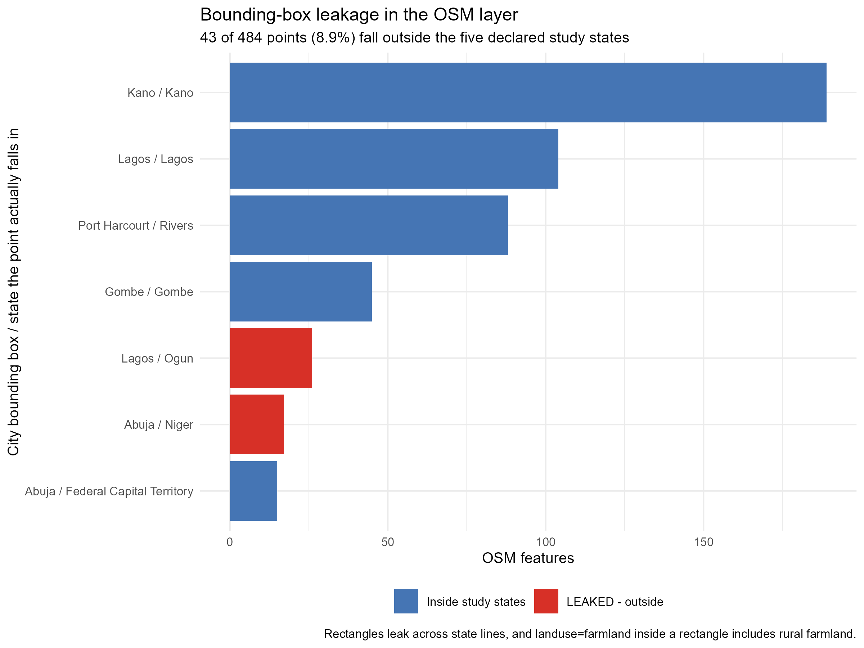
Figure 1: Bounding-box leakage in the feature layer. Forty-three of 484 features (8.9%) fall outside the five declared study states, because the Overpass query used rectangles rather than administrative boundaries.

3. Methods

3.1 Density and the zero-inflation problem
Density is computed as features per square kilometre, using spherical geometry.
$${\text{density}}_{i}=\frac{n_{i}}{{\text{area}}_{i,{\text{km}}^{2}}}$$
The resulting distribution is the central methodological fact of this paper, and it is worth stating before any model is fitted: 95% of LGAs have a density of exactly zero, the distribution has a skewness of 15.5, and the maximum is 1.06 km⁻². Most of Nigeria, on this measure, has no recorded cultivation at all.
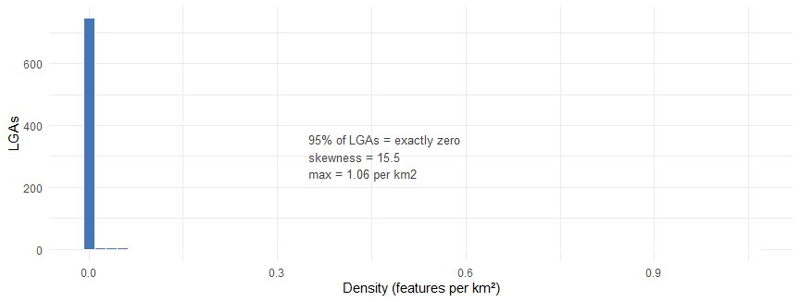
Distribution of urban agriculture density across 775 LGAs: a spike at zero with a long right tail.
This shape has two consequences. It rules out ordinary least squares for the regression: a Gaussian model applied to a non-negative variable with a large point mass at zero will predict values that cannot exist. It does not invalidate the spatial-autocorrelation statistics, which are correlation coefficients rather than likelihoods, but it does mean their assumptions need checking, and we do so in Section 4.1.

3.2 Spatial weights
Neighbour structure is defined by queen contiguity: two LGAs are neighbours if their boundaries share an edge or a vertex. Weights are row-standardised, so each LGA’s neighbours sum to one and no well-connected LGA dominates the statistic.
wij=1if LGAs i,j share an edge or vertex0otherwise wij*=wij/j​wij
Rook contiguity (shared edges only) serves as a robustness check.

3.3 Models
H1, global clustering. We test for spatial autocorrelation using Moran’s I (Griffith & Chun, 2021; MORAN, 1950), a cross-product correlation that compares each unit’s deviation from the mean with that of its neighbours.
I=NWi​j​wij*(xi−x)(xj−x)i​(xi−x)2
The null hypothesis is spatial randomness, under which $E[I]=−1/(N−1)$. Significance is assessed by randomisation with 999 permutations.
H1, local clustering. Moran’s I is global; it says whether clustering exists, not where. Local Indicators of Spatial Association (Anselin, 1995) decompose the global statistic into a value per unit:
Ii=xi−xm2j​wij*(xj−x), m2=N−1i​(xi−x)2
We classify units by quadrant (high–high, low–low, high–low, low–high) and, critically, apply Benjamini–Hochberg false-discovery-rate control (Benjamini & Hochberg, 1995) across the 775 simultaneous tests. Reporting 775 unadjusted local statistics would generate roughly 39 false positives at the conventional 5% level.
H1, point scale. Areal statistics impose an administrative frame on what is really a point pattern. We therefore add two tests that do not: a join-count test on the binary indicator of whether an LGA contains any feature, and Ripley’s $K$ computed within each city, using the translation from $K$ to $L$ that linearises the expected value under complete spatial randomness (Ripley, 1977).
H2, the scale effect. The outcome is a count with unequal exposure. We therefore model it as such, using a negative binomial specification with the logarithm of area as an offset:
$$n_{i}∼\text{NegBin}(μ_{i},θ), logμ_{i}=log({\text{area}}_{i})+X_{i}β$$
The offset form is not cosmetic. Regressing the ratio density on its own denominator log(area) recovers a partly mechanical relationship, and the coefficient is not interpretable as an effect. Writing area as exposure instead asks the density question directly: does the rate at which features occur per unit area depend on area? The coefficient $β$ is then an incidence rate ratio, and the test of $H_{0}:β=0$ is a test of whether density varies with scale. We use the negative binomial rather than Poisson because counts of this kind are almost always overdispersed (Cameron & Trivedi, 2013; Lindén & Mäntyniemi, 2011), and we report the dispersion diagnostic rather than assuming it away.
H3, coverage. The same specification is then refitted with the LGA’s mapped-building count as a second offset:
$$logμ_{i}=log({\text{area}}_{i})+log({\text{buildings}}_{i})+X_{i}β$$
The model now predicts cultivation per unit of mapped environment rather than per square kilometre. If the area effect were an artefact of where volunteers have mapped, adding this term should attenuate or reverse it. The comparison of the two fits is the test.

3.4 Software and reproducibility
Analysis is in R 4.5.2 with sf, spdep, spatialreg, spatstat and MASS. Every layer is frozen with a provenance record (URL, timestamp, row count, licence) in data/raw/provenance.json. Two gates run against the results: audit_claims.R re-derives each headline claim from the raw data and reports where claims and data disagree, and verify_report_claims.R checks every figure and number quoted in the text. Both are committed and both exit non-zero on failure.

4. Results

4.1 H1 — Cultivation is strongly clustered
Global Moran’s I for density is 0.300 (z = 17.61, p < 1e-69), against an expectation of −0.001 under spatial randomness. Clustering is unambiguous.
Global Moran’s I under four specifications. Every value is significant at p < 1e-50.
Specification | Moran’s I | z | N
Density, queen contiguity | 0.300 | 17.6 | 775
Density, rook contiguity | 0.306 | 17.8 | 775
Raw counts, queen | 0.158 | 8.5 | 775
Density, Kano State excluded | 0.274 | 16.3 | 731
Three checks are worth drawing out. Density is substantially more clustered than raw counts (I = 0.300 versus 0.158), which is the arithmetic consequence of normalising by area: counts conflate intensity with administrative size, and density does not. The result is insensitive to the contiguity definition, with rook weights giving I = 0.306. And the clustering is not a Kano artefact: excluding Kano State entirely — 44 of the 775 LGAs, and the strongest single source of features — leaves I = 0.274 (z = 16.3). Whatever is driving the pattern operates across the country.
A spatial lag model fitted to the same relationship confirms that the spatial structure is real rather than an artefact of model misspecification: residual autocorrelation falls from 0.256 under ordinary least squares to −0.036 under the lag specification, an essentially complete removal.
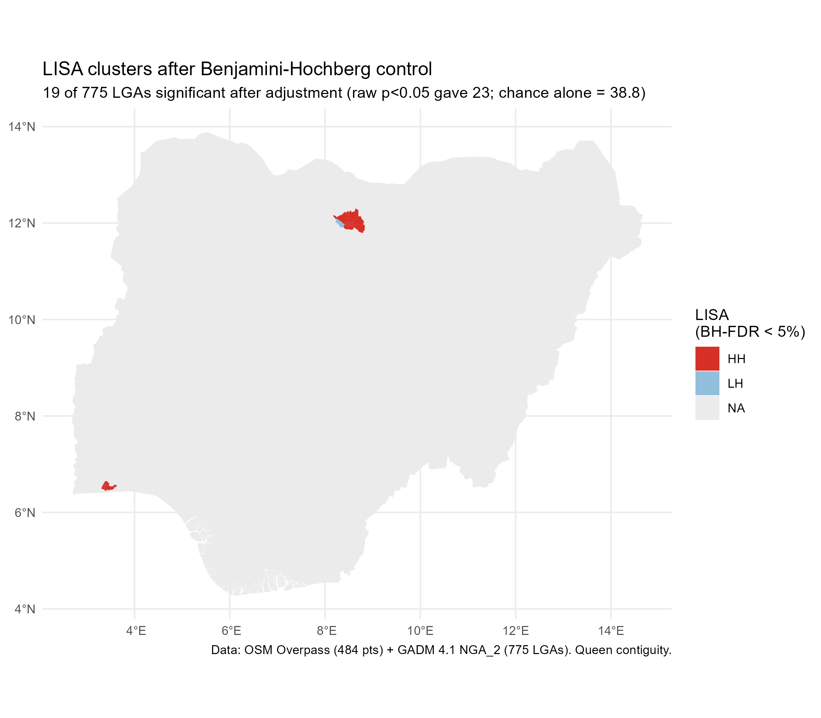
Figure 2: LISA clusters after Benjamini–Hochberg control. Red indicates high-density clusters. The grey majority are not statistically significant.
Local statistics locate the clustering. Under false-discovery-rate control, 19 of 775 LGAs are significant, concentrated in the Kano metropolitan ring (Ungogo, Tarauni, Kumbotso) and in the contiguous Lagos mainland LGAs (Shomolu, Mushin).
Local clustering before and after multiplicity control.
Criterion | LGAs
Raw p < 0.05, uncorrected | 23
Benjamini–Hochberg FDR 5% | 19
Bonferroni | 18
Expected false positives at α = 0.05 | 38.8
One diagnostic deserves emphasis rather than a footnote. The raw count of significant LGAs (23) is below the number expected by chance alone (38.8). This does not indicate an absence of clustering — the global statistic rules that out decisively. It indicates that the normal approximation behind the local p-values is conservative when 95% of the variable sits at a single value, because the permutation distribution is discrete. We report the adjusted set and state the conservatism rather than presenting the raw count as a result.
Point-pattern tests corroborate the areal analysis without depending on it. The join-count test on whether an LGA contains any feature gives z = 30.3 (p < 2e-16). Ripley’s $L$ exceeds its simulation envelope in all five cities independently, at characteristic scales between roughly 300 m and 9 km. Clustering is therefore a property of the cities, not of the administrative boundaries we happened to impose on them.
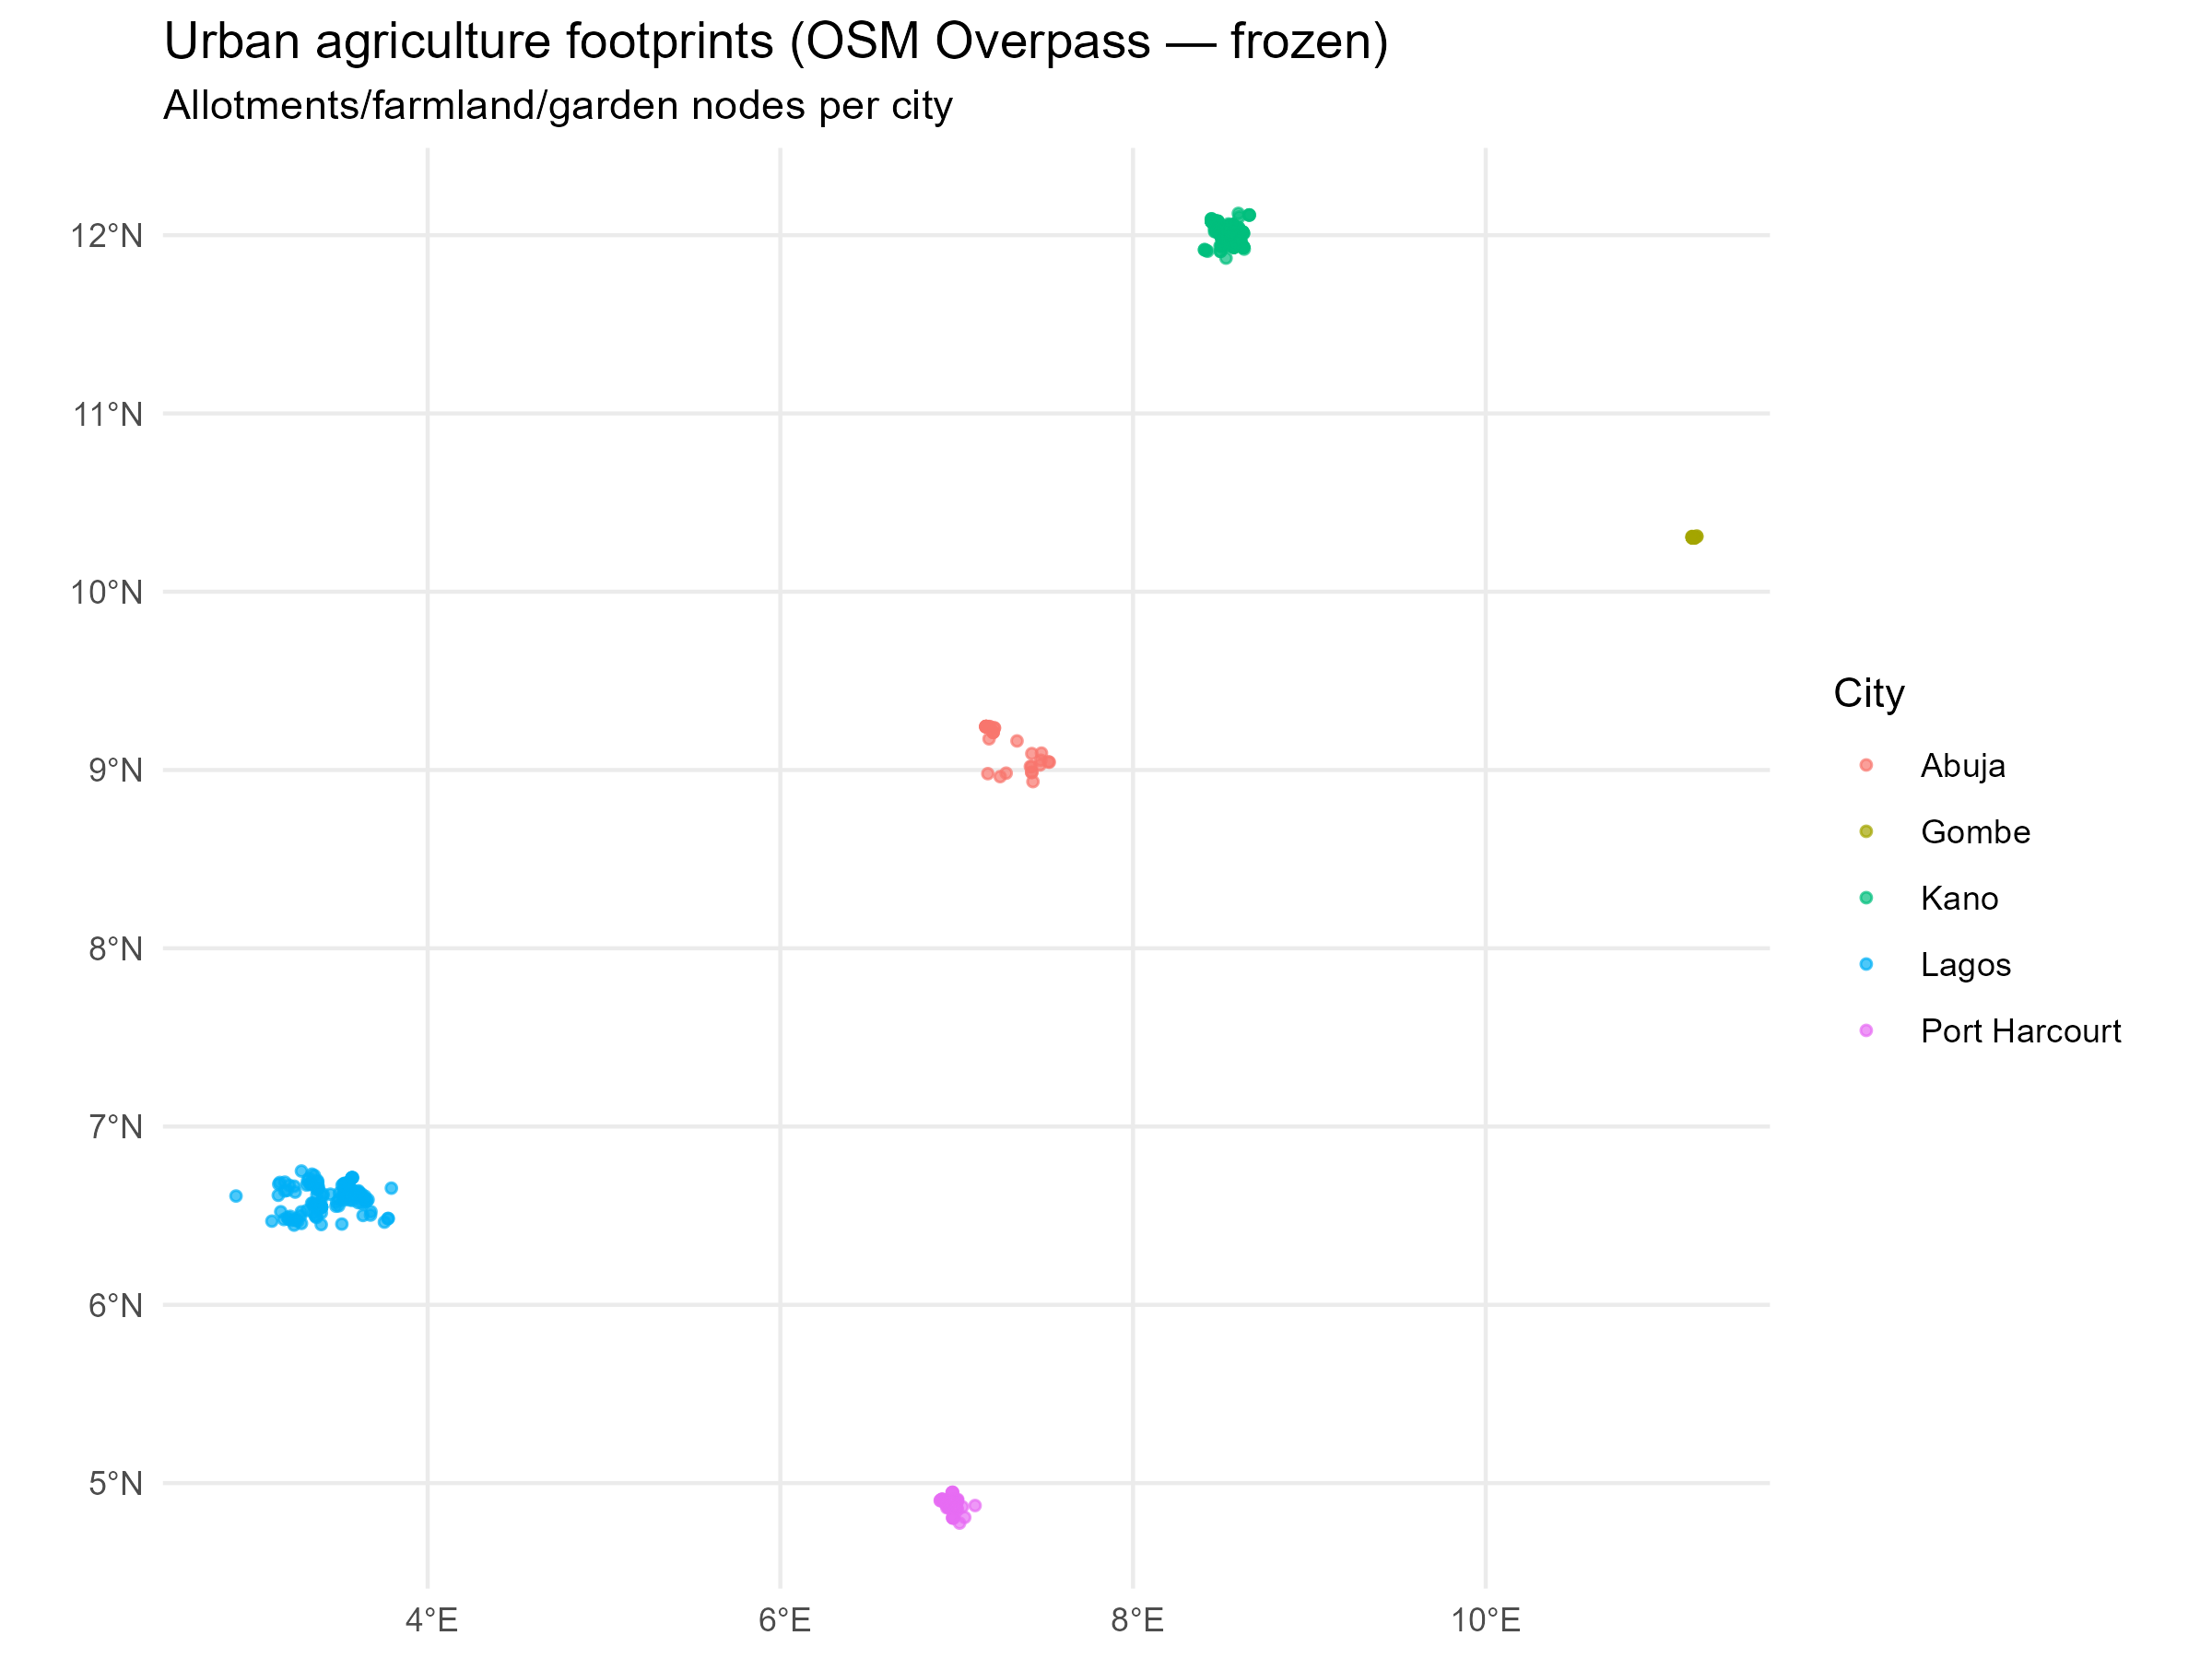
Figure 3: The 484 features across the five study cities.

4.2 H2 — Density falls sharply as LGA area grows
Negative binomial model with area as an exposure offset.
Term | b | SE | p | IRR
Intercept | 2.8348 | 1.5552 | 0.068 | 17.027
log(area) | -1.5510 | 0.2389 | 8.5e-11 | 0.212

The same coefficient expressed in interpretable units.
Expression | Rate ratio | Change in density
Per e-fold increase in area | 0.212 | 79%
Per doubling of area | 0.341 | 66%
Per tenfold increase | 0.028 | 97%
The coefficient on log area is −1.551 (p = 8.5e-11), and the likelihood-ratio test against a model with no area slope is decisive (χ² = 32.0, p = 1.5e-8). Expressed in units a reader can use, a doubling of LGA area multiplies density by 0.341 — a fall of about 66%.
Two diagnostics support the specification. Poisson regression, fitted for comparison, gives a Pearson dispersion of 39.1, far above the value of 1 the Poisson family assumes; the negative binomial is required, not preferred. And the negative binomial’s own dispersion parameter (θ = 0.015) confirms substantial extra-Poisson variation even after conditioning on area.
Substantively: Nigeria’s urban LGAs are small and densely cultivated; its rural LGAs are large and sparse. Because small LGAs are also where urban populations concentrate, this is close to tautological in one direction — but it is a tautology that the existing literature, by reporting counts, has concealed. A city with more recorded cultivation may simply be a city with more LGAs.

4.3 H3 — The effect survives correction for mapping coverage
This is the test that matters most, because the obvious objection to everything above is that OpenStreetMap records where people map, not where people farm.
The coverage confound, quantified. LGAs with cultivation have nearly twice the mapped buildings of those without.
Comparison | Value
Features vs mapped buildings | ρ = 0.410 (p = 0.0002)
Features vs mapped highways | ρ = 0.613 (p = 2e-09)
Median mapped buildings — LGAs with features | 33,465
Median mapped buildings — LGAs without | 17,347
The confound is real and large. Features correlate with mapped highway density at ρ = 0.613 (p = 2.5e-09), and LGAs containing cultivation have a median of 33,465 mapped buildings against 17,347 in LGAs without — nearly double. Presence of cultivation and “this place has been mapped” are not independent facts.
Does the scale effect survive correction for mapping coverage? It strengthens.
Model | b on log(area) | p | AIC | Fall per doubling
Area offset only | -1.0010 | 1e-09 | 374.2 | 50%
Area + mapped-building offsets | -1.4213 | 2e-22 | 354.2 | 63%
The effect survives, and strengthens. Adding mapped buildings as a second offset moves the coefficient from −1.001 to −1.421 and improves fit by ΔAIC = 20.0. Rather than evaporating under the correction that most threatens it, the scale effect becomes sharper. Nigerian LGAs that are large are less densely cultivated even holding constant how much of them has been mapped.
This is the paper’s central empirical claim, and we state its scope precisely: it is a claim about the spatial distribution of mapped cultivated land, robust to the coverage confound that would most obviously explain it away.

4.4 Where the intensity concentrates
The ten most intensively cultivated LGAs.
LGA | State | Features | Area (km²) | Density (km⁻²) | LISA
Tarauni | Kano | 25 | 23.6 | 1.058 | HH
Shomolu | Lagos | 10 | 18.3 | 0.546 | HH
Ungogo | Kano | 90 | 187.4 | 0.480 | HH
Obio/Akpor | Rivers | 64 | 275.5 | 0.232 | n.s.
Mushin | Lagos | 4 | 17.4 | 0.230 | HH
Gwale | Kano | 4 | 23.8 | 0.168 | HH
Nasarawa | Kano | 3 | 19.0 | 0.158 | HH
Kano | Kano | 4 | 26.5 | 0.151 | HH
Fagge | Kano | 4 | 27.7 | 0.145 | HH
Ikorodu | Lagos | 53 | 369.5 | 0.143 | n.s.
The ranking demonstrates why density and counts disagree, and why the choice matters for policy. Ikorodu records 53 features — more than all but one LGA in the country — but spreads them across 369 km², yielding a density of 0.143 km⁻² and no significant local cluster. Tarauni holds 25 features on 23.6 km², reaching 1.058 km⁻²: more than seven times the intensity on one-fifteenth of the land. A targeting rule based on counts would prioritise Ikorodu; one based on density prioritises Tarauni, Shomolu and the Kano ring.
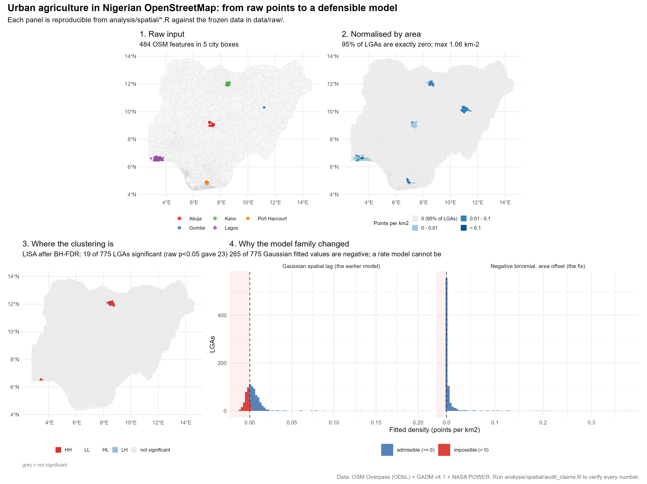
Figure 4: Summary of the analysis: raw features, density normalised by area, local clusters after false-discovery-rate control, and the model-family comparison.

4.5 A hypothesis the data could not test
The original design included a fourth question: whether cultivation concentrates in drier areas, on the reasoning that irrigation potential shapes where farming is viable. We report here that the available data cannot answer it, and we withdraw the result rather than presenting it.
Rainfall was sampled at the centroid of each city — sensible for a five-city climate gradient, fatal for an LGA-level regression. When those five values are assigned to the LGAs of each city, the predictor has five distinct values, not thirty-four: regressing rainfall on city dummies returns R² = 1.000, meaning rainfall is city identity. Treating the LGAs as independent observations inflates the apparent sample size roughly sevenfold.
Why the climate hypothesis is not reported as a finding.
Quantity | Value
LGAs assigned a rainfall value | 34
Distinct rainfall values | 5
R² of rainfall on city dummies | 1.000
Rainfall effect, treating LGAs as independent | p = 0.018 (spatial error model)
Rainfall effect, collapsed to cities (K = 5) | p = 0.576
Analysed naively, the climate model appears to produce a significant effect. Analysed at the level the data actually replicate — five cities — it does not (p = 0.58).
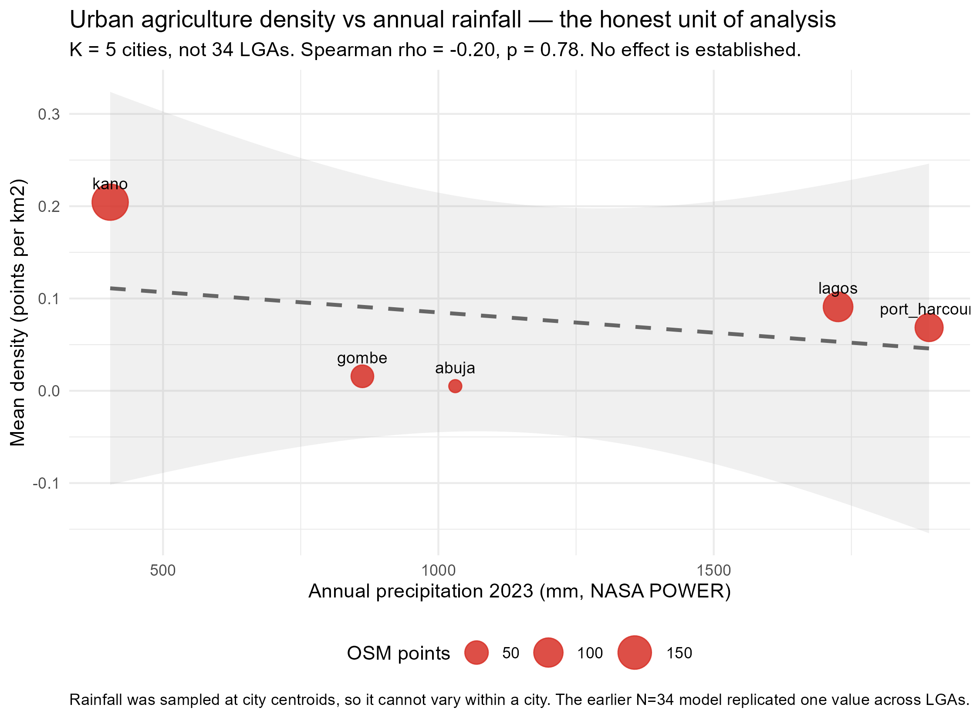
Figure 5: The climate question at the honest unit of analysis. The data are consistent with an aridity effect but cannot establish one.
Rainfall with within-city variation would make the question testable. CHIRPS (Funk et al., 2015), ERA5-Land and TAMSAT all provide precipitation at spatial resolutions fine enough to assign each LGA its own value. Until one of them is integrated, this question remains open.

5. Discussion

5.1 What the spatial pattern implies for policy
Three findings bear directly on how Nigerian cities might protect urban cultivation.
Clustering means targeting is viable. If cultivation were dispersed randomly, protecting it would require blanket measures and a large budget. It is not: 39 LGAs of 775 contain any mapped cultivation, and 19 show statistically significant local clustering, concentrated in the Kano metropolitan ring and the Lagos mainland. A small number of specific places carry the activity. Interventions — overlay zoning, land allocation, extension services — could be directed at those places rather than spread thinly, which is a materially different proposition for a state or local budget.
Scale matters, and counts mislead. The finding that density falls by two-thirds per doubling of area is, in one sense, arithmetic. In another it is a warning about how this sector is described. A state report noting that it “contains 200 urban farms” says nothing about intensity unless it also says how much land they occupy and how large the administrative units are. The Ikorodu–Tarauni contrast makes this concrete: both are Lagos-area LGAs, both contain substantial cultivation, and a count-based ranking inverts the density-based one.
The coverage correction strengthens rather than weakens the case. Because the coverage confound is the obvious objection to any OpenStreetMap-based agricultural analysis, we expected the correction to attenuate the result. It did not. That is reassuring for this class of method more generally: where a scale effect is genuine, controlling for mapping effort does not eliminate it.

5.2 What the pattern does not show
We are explicit about three limits, because the alternative — a confident map with unstated assumptions — is how spatial analyses of this kind mislead.
The concern about coverage is reduced, not removed. The exposure control demonstrates that the scale effect is not a coverage artefact. It does not establish that the layer is complete, and the LISA geography does remain partly a coverage map: 18 of the 19 significant LGAs also contain any feature at all. We can say with confidence where recorded cultivation clusters; we cannot say that unrecorded cultivation is absent from the places that show none.
farmland is not allotments. Only 5 of 484 features are formally designated allotments. The layer predominantly captures cultivation on land whose primary zoning is something else, plus ordinary peri-urban farmland inside generous city bounding boxes. This study therefore measures cultivated land within city regions, not statutory urban agriculture. For some policy purposes that is the more useful quantity — it is what exists rather than what is permitted — but the distinction should be stated.
The study extent is rectangular. The Overpass queries used bounding boxes, which leak across state lines: 43 features (8.9%) lie outside the five intended states, and the “Abuja” box returns more features in Niger State (17) than in the Federal Capital Territory (15). A polygon-based query using the same mechanism as the coverage layer would fix this. We report the leakage rather than silently dropping the features (Figure 1).

5.3 Relation to prior work
Two literatures bear on these results, and they pull in different directions.
Work on urban agriculture in Nigeria has documented practice in detail — who farms, at what scale, with what tenure — and has consistently recommended that planning systems formalise it (Elum & Emodi, 2025; Gottero, 2025; Ibok, 2014; Vagneron, 2007; Wuyep & Rampedi, 2018). That literature establishes the policy case but has not, so far as we are aware, measured the spatial distribution of cultivation across administrative units. The present study does not replace that work; it supplies the layer that recommendations of this kind have lacked.
Work on volunteered geographic information has established that OpenStreetMap completeness is systematically uneven, globally and within regions (Haklay, 2010; Herfort et al., 2023; Jacobs & Zipf, 2017). That literature is the reason this paper treats coverage as a hypothesis rather than an assumption, and the exposure control is a direct application of its concerns. The finding that a substantive result can survive such a control is a modest contribution back: the critiques are well established, but demonstrations that specific findings withstand them are less common.

5.4 Limitations
The design is cross-sectional, and the models describe association rather than causation. Nothing here identifies why cultivation concentrates where it does; tenure security, market access, water availability and historical land use are all plausible and all unmeasured.
The feature layer is a proxy whose completeness we have quantified but not eliminated. Coverage differs between cities in ways that correlate with urban size, and our exposure control is a single measure of mapped environment rather than a full model of contributor behaviour.
The analysis covers five cities chosen to span the agro-ecological gradient. They are not a random sample of Nigerian cities, and the density estimates are averages over enormously varied metropolitan areas, some of which contain substantial rural territory within their boundaries.
The climate question remains open, for the sampling reason explained in Section 4.5.
Finally, the findings are only as good as the underlying map, and the map is a volunteer product that changes continuously. The layer here is frozen to August 2026; conclusions about specific LGAs should be understood as characterising that snapshot.

6. Conclusion
We set out to measure where urban agriculture concentrates in Nigerian cities, and to test whether what we found survives the objection that most threatens it. It does.
Cultivation is strongly clustered across Local Government Areas (Moran’s I = 0.300), the clustering is present within each of the five cities studied, and it is not an artefact of any single region. Density falls by roughly two-thirds per doubling of LGA area, and that effect strengthens when per-LGA mapping coverage is controlled. The most intensively cultivated LGAs — Tarauni and Shomolu among them — are small, dense and urban; the places with the most features are not necessarily the most intensively cultivated.
Two things follow. For policy, the clustering means that a targeted intervention is feasible: a small set of specific LGAs carries most of the activity. For method, the coverage control matters: the same data, analysed without it, would have supported a climate conclusion that does not hold at the level the data actually replicate. We report the withdrawal alongside the findings because the difference between the two is the difference between a map of agriculture and a map of mapping.

7. Data and code availability
All data are openly licensed and frozen to disk with full provenance — URL, retrieval timestamp, record count and licence for each layer — in data/raw/provenance.json. Sources: OpenStreetMap via the Overpass API (ODbL, © OpenStreetMap contributors); GADM v4.1 administrative boundaries (CC BY 4.0); NASA POWER agro-climate (public domain). Analysis reads only the frozen files, so results are stable and the network is unnecessary to reproduce them.
Analysis code, figure-generation scripts and two verification gates are committed. The gates re-derive every headline number from the raw data and check every value quoted in the text; both exit non-zero on disagreement. The manuscript is rendered from source, so text, tables and figures cannot drift apart.

8. Funding
NO FUNDING. This research received no external financial support. All data are openly licensed and were collected by the author through public application programming interfaces.

9. Author Contributions
The author is the sole contributor and is responsible for the following: conceptualisation; research design; data acquisition from the OpenStreetMap, NASA POWER and World Bank APIs; spatial and statistical analysis; interpretation of results; and preparation of the manuscript. The author has approved the final version and takes responsibility for the integrity of the work. All datasets used here were obtained by the author from the public sources listed under Data and code availability; no third party supplied or contributed any layer used in this analysis.

10. Declaration of Generative AI Use
An AI coding assistant was used during preparation of this work. Its role was to assist with implementing and debugging the analysis pipeline, writing the verification scripts, and drafting and editing the prose. All research design, data collection, analytical decisions and interpretation are the author’s own. Every numerical result reported here was independently re-derived from the frozen data by committed verification scripts, and every cited reference was resolved against the Crossref registry rather than transcribed. The author takes full responsibility for the content.

11. Additional Reading
- Herfort, B., Lautenbach, S., Porto de Albuquerque, J., Anderson, J. & Zipf, A. (2023). A spatio-temporal analysis investigating completeness and inequalities of global urban building data in OpenStreetMap. Nature Communications, 14(1), 3985.
- Haklay, M. (2010). How good is volunteered geographical information? A comparative study of OpenStreetMap and Ordnance Survey datasets. Environment and Planning B, 37(4), pp.682–703.
- Anselin, L. (1995). Local indicators of spatial association—LISA. Geographical Analysis, 27(2), pp.93–115.
- FAO (2023). The State of Food Security and Nutrition in the World 2023. Rome: FAO.

12. Key Terms and Definitions
Areal unit. A bounded administrative area for which observations are aggregated; here the Local Government Area, the tier of government responsible for local land allocation in Nigeria.
Coverage bias. The systematic tendency of a volunteered geographic dataset to be more complete in some places than others, so that counts of features reflect where contributors have been active as well as where a phenomenon occurs.
Exposure offset. A term entered into a count model with a fixed coefficient of one, used when units are observed over unequal extents. Area as an offset converts a model of counts into a model of density.
Local indicators of spatial association. Statistics that decompose a global measure of spatial autocorrelation into a contribution from each areal unit, permitting the location of clusters to be identified rather than merely their existence.
Spatial autocorrelation. The tendency of nearby locations to hold similar values. Positive autocorrelation indicates clustering; a value near zero indicates spatial randomness.

13. References
Anselin, L. (1995). Local indicators of spatial association—LISA. Geographical Analysis, 27(2), 93–115. https://doi.org/10.1111/j.1538-4632.1995.tb00338.x
Benjamini, Y., & Hochberg, Y. (1995). Controlling the false discovery rate: A practical and powerful approach to multiple testing. Journal of the Royal Statistical Society Series B: Statistical Methodology, 57(1), 289–300. https://doi.org/10.1111/j.2517-6161.1995.tb02031.x
Cameron, A. C., & Trivedi, P. K. (2013). Regression analysis of count data. Cambridge University Press. https://doi.org/10.1017/cbo9781139013567
Cobbinah, P. B., & Niminga-Beka, R. (2017). Urbanisation in ghana: Residential land use under siege in kumasi central. Cities, 60, 388–401. https://doi.org/10.1016/j.cities.2016.10.011
Elum, Z. A., & Emodi, A. I. (2025). Gender, poverty and food security: Perceptions and implications for urban households in nigeria. Scientific African, 28, e02703. https://doi.org/10.1016/j.sciaf.2025.e02703
Food and Agriculture Organization of the United Nations and International Fund for Agricultural Development and United Nations Children’s Fund and World Food Programme and World Health Organization. (2023). The state of food security and nutrition in the world 2023. FAO; IFAD; UNICEF; WFP; WHO; https://doi.org/10.4060/cc3017en
Funk, C., Peterson, P., Landsfeld, M., Pedreros, D., Verdin, J., Shukla, S., Husak, G., Rowland, J., Harrison, L., Hoell, A., & Michaelsen, J. (2015). The climate hazards infrared precipitation with stations—a new environmental record for monitoring extremes. Scientific Data, 2(1), 150066. https://doi.org/10.1038/sdata.2015.66
Gottero, E. (2025). Assessing benefits and risks of urban and peri-urban agriculture (UPA): A spatial approach. Sustainability, 17(11), 5151. https://doi.org/10.3390/su17115151
Griffith, D., & Chun, Y. (2021). Spatial autocorrelation and moran eigenvector spatial filtering. In Handbook of Regional Science (pp. 1863–1893). https://doi.org/10.1007/978-3-662-60723-7_72
Haklay, M. (2010). How good is volunteered geographical information? A comparative study of OpenStreetMap and ordnance survey datasets. Environment and Planning B: Planning and Design, 37(4), 682–703. https://doi.org/10.1068/b35097
Herfort, B., Lautenbach, S., Porto de Albuquerque, J., Anderson, J., & Zipf, A. (2023). A spatio-temporal analysis investigating completeness and inequalities of global urban building data in OpenStreetMap. Nature Communications, 14(1), 3985. https://doi.org/10.1038/s41467-023-39698-6
Ibok, O. (2014). Food security determinants among urban food crop farming households in cross river state, nigeria. Asian Journal of Agricultural Extension, Economics & Sociology, 3(1), 76–90. https://doi.org/10.9734/ajaees/2014/6560
Jacobs, C., & Zipf, A. (2017). Completeness of citizen science biodiversity data from a volunteered geographic information perspective. Geo-Spatial Information Science, 20(1), 3–13. https://doi.org/10.1080/10095020.2017.1288424
Lindén, A., & Mäntyniemi, S. (2011). Using the negative binomial distribution to model overdispersion in ecological count data. Ecology, 92(7), 1414–1421. https://doi.org/10.1890/10-1831.1
MORAN, P. A. P. (1950). NOTES ON CONTINUOUS STOCHASTIC PHENOMENA. Biometrika, 37(1-2), 17–23. https://doi.org/10.1093/biomet/37.1-2.17
Prados, Y., & Azadi, H. (2026). Drivers of urbanisation and land-use and land-cover change across spatial scales: A comparative bibliometric synthesis from global to central and eastern europe. Land Use Policy, 170, 108185. https://doi.org/10.1016/j.landusepol.2026.108185
Ripley, B. D. (1977). Modelling spatial patterns. Journal of the Royal Statistical Society Series B: Statistical Methodology, 39(2), 172–192. https://doi.org/10.1111/j.2517-6161.1977.tb01615.x
Vagneron, I. (2007). Economic appraisal of profitability and sustainability of peri-urban agriculture in bangkok. Ecological Economics, 61(2-3), 516–529. https://doi.org/10.1016/j.ecolecon.2006.04.006
Wuyep, S. Z., & Rampedi, I. T. (2018). Urban fish farming in jos, nigeria: Contributions towards employment opportunities, income generation, and poverty alleviation for improved livelihoods. Agriculture, 8(7), 110. https://doi.org/10.3390/agriculture8070110

Implemented with the border-edge correction in spatstat. Envelopes are from 199 Monte Carlo simulations.

