OBJECT ORIENTED PROGRAMMING ITE-212
Group-1
GitHub link: https://github.com/batets07-cloud/OOP-LAB.git

LAB 1: INHERITANCE, CONSTRUCTORS, & METHOD OVERRIDING

Screenshot:
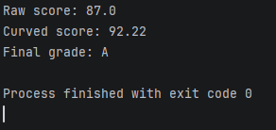

Conceptual Analysis Report
- Why does FinalExam fail to compile if it attempts to access score = numericScore; directly?

The score instance variable inside the GradedActivity superclass is declared with the private access modifier. The private keyword restricts visibility strictly to the declaring class itself. Subclasses do not inherit direct access to private members of a parent class. To change or read the score value, FinalExam must interact with the parent class through public interface channels—specifically the inherited public setter method setScore().

- How does the protected keyword alter this behavior, and what architectural risk does protected introduce to encapsulation?
Changing a variable to protected allows any child class (subclass) to access and modify that variable directly, completely skipping the need for a public getter or setter method. The risk to the encapsulation is that it breaks safety rules. When child classes can change a variable directly, they can accidentally put bad data into it (like a test score of -50 or 999). It bypasses the safety checks inside the parent class's setter methods, making the code fragile and easier to break

LAB 2: ABSTRACTION WITH ABSTRACT CLASSES & METHODS
Compiler Exception Log:
Direct instantiation is prohibited because the Student class is declared as abstract, meaning it is an incomplete blueprint with abstract methods that lack operational source code. Java strictly blocks the use of the new keyword on abstract classes to ensure compile-time safety, forcing developers to instantiate complete subclasses like CompSciStudent instead

Polymorphic Execution Verification:
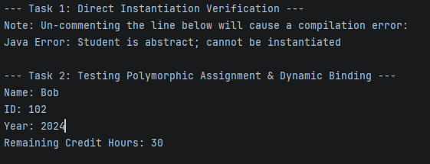

LAB 3: INTERFACES, REALIZATION, & INTERFACE POLYMORPHISM
Comparative Execution Output:


