Bioarchaeology of Umm el-Marra

Ernest K. Batey

September 13, 2016

Table of Contents

# Introduction

Schwartz (2007) summarized the findings.

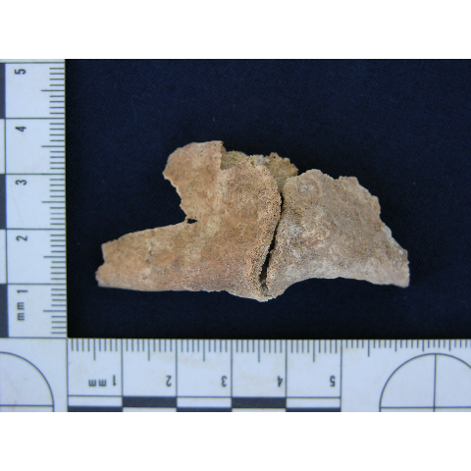

Mandibular fracture on Individual D, Tomb 4

# Human Remains from the Early-Bronze Mortuary Complex

# Additional Human Remains

# References

Schwartz, Glenn M. 2007. “Hidden Tombs of Ancient Syria.” *Natural History* 116 (4): 42–48.