Website Project

  - Name: ISAAC GRAY

  - Course: LEVEL 3 COMPUTING

  - Tutor(s): Dan Elms

  - Unit: 15

Contents
The Website - Annotated Screen Prints 3
Testing 4
Testable Specification 4
Test Log. 5
User Testing/Questionnaire 6
User Feedback 6
Answers to the questionnaire. These need to be constructive comments like ‘centralise the image to add emphasis…’ 6
Proposed Improvements 6
Reflection of the Project 7
Analysis against original intentions/ why does it suit the client’s needs 7
Appendix A 8
Original Source Code 8

The Website - Annotated Screen Prints
<P4 – ‘point to’ and describe your web pages>
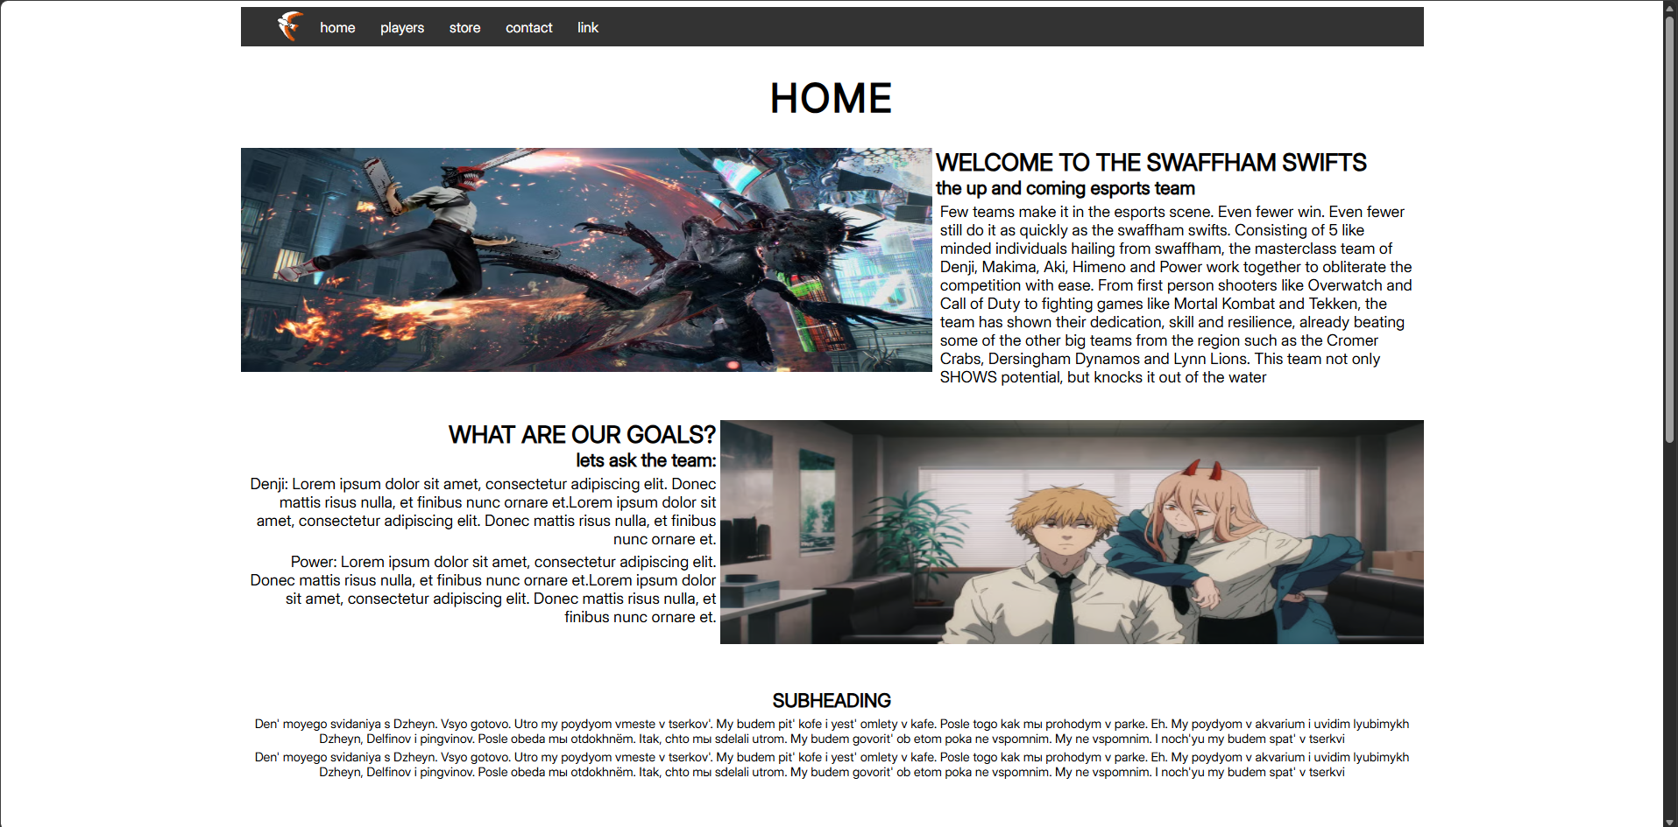 The home page of my site features the nav bar, used to traverse between each subsequent page. Pages can be selected and have an effect when hovered over, making the selected page orange and enlarged. There is also a logo for the team’s brand present on the leftmost side of the nav bar. The home heading is at the top of the page, followed by two images that are accompanied by flex content text on either side introducing the team and the client requirements. This is followed by a text area for an unspecified description under a subheading.
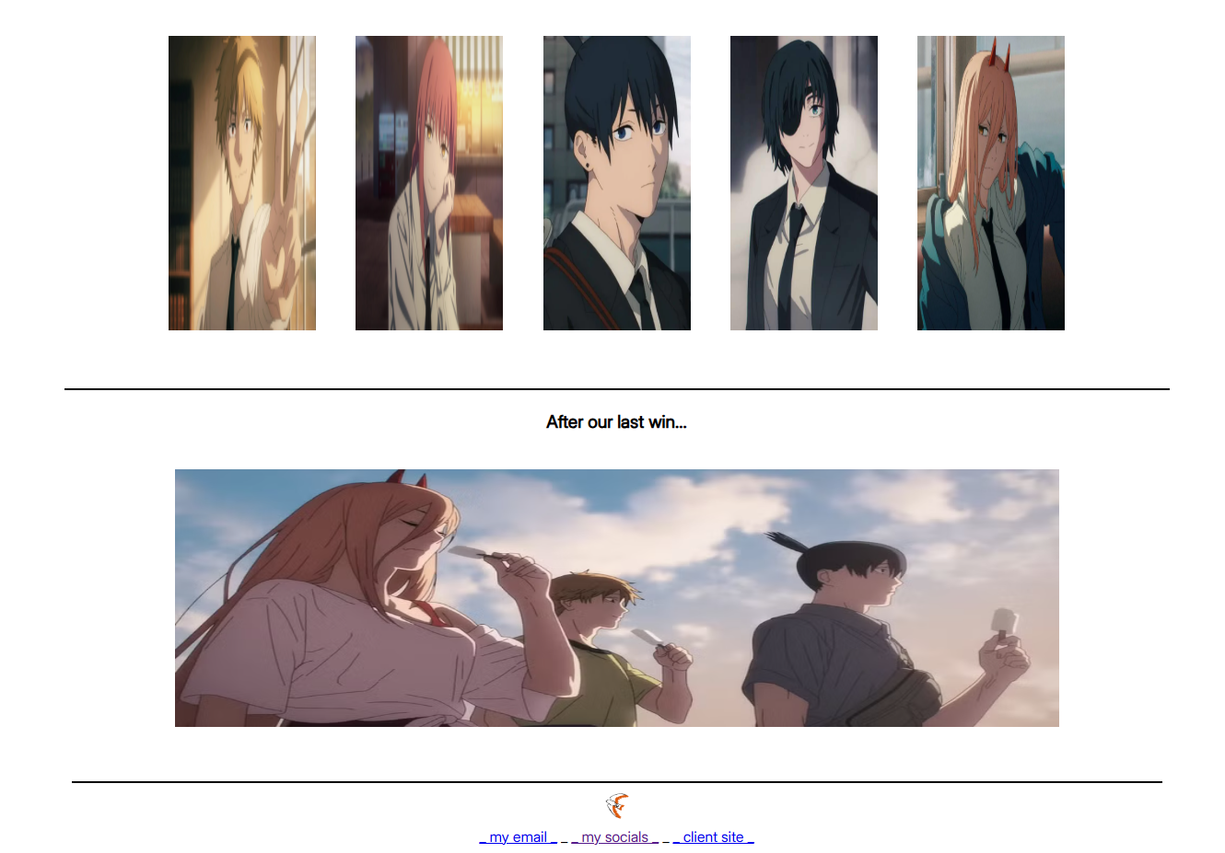
The latter half of my home page features a series of images introducing the team members, alongside a section that features an image designed to end the home page within a small section that is placed after a break but before the footer. The footer features links to socials, and email alongside a placeholder link for the client site, below the team’s logo. This part of the page is used to end the home page uniform to the rest of the pages.
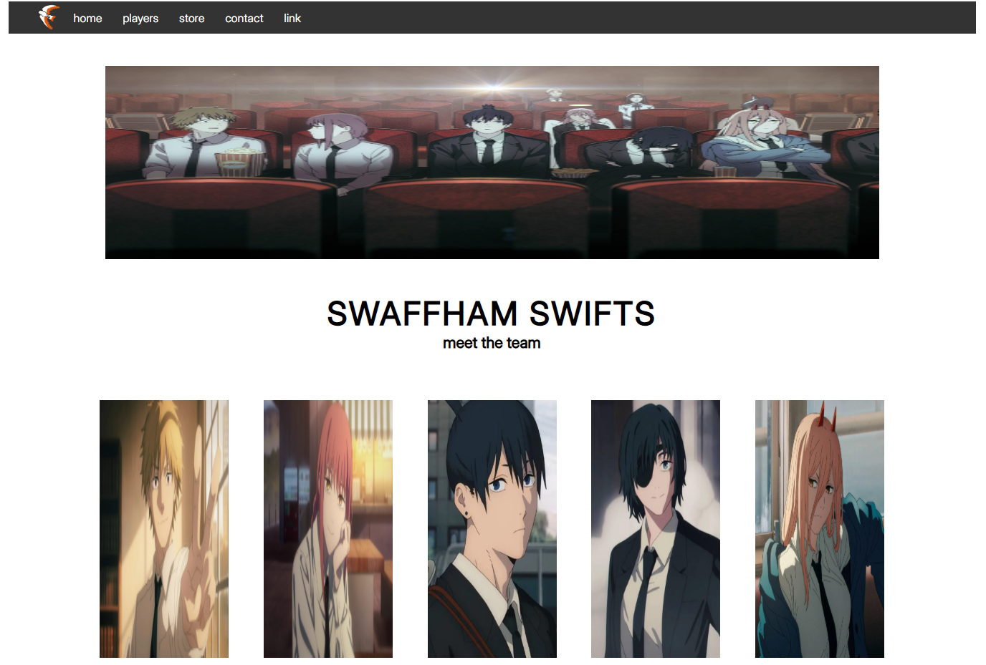
The players page begins with a large image of the team all together, followed by the heading ‘SWAFFHAM SWIFTS’ and the subheading ‘meet the team’. This is followed by the 5 team members in the same order as the image, with the intention of making it flow naturally and creatively.
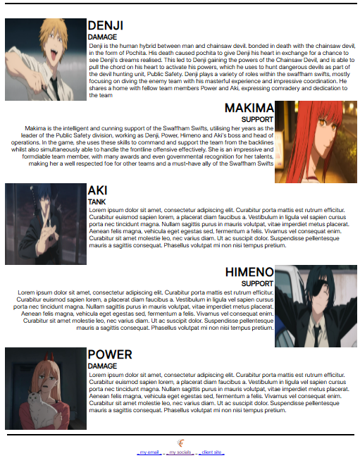
The second part of the players page features a break, followed by the five team members’ images, each with their name, role and a description either completed or placeholder. Each image uses the flex content class to place text on either the left or right side of an image, with text being placed always assigned to the side of the image. This is then followed by the same footer as the other pages
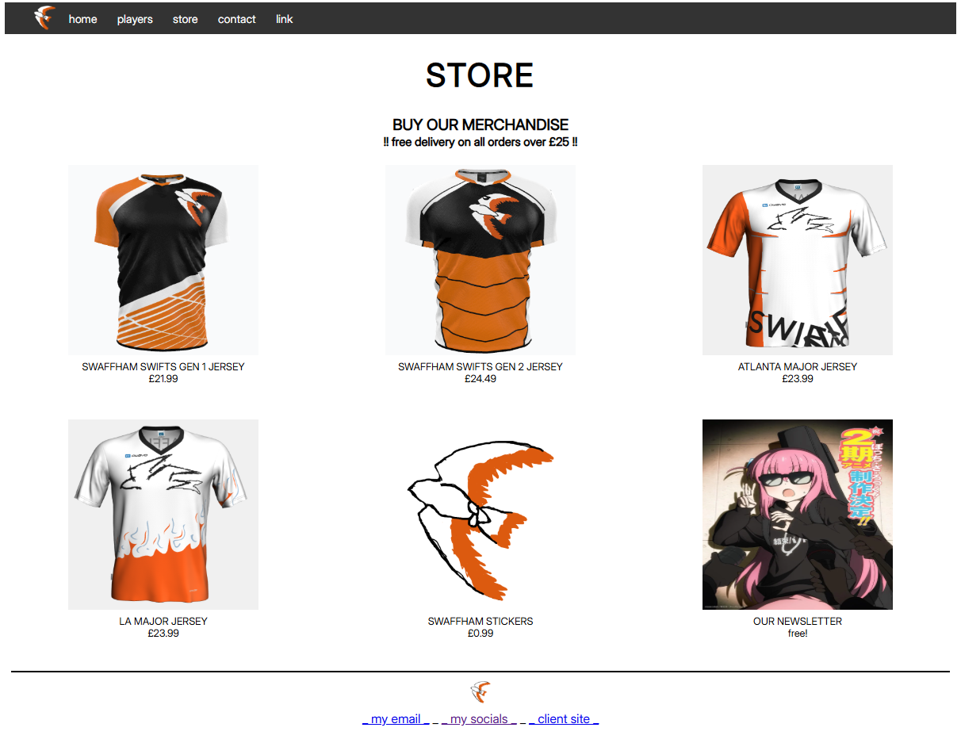
The store page features the ‘STORE’ title, the heading ‘BUY OUR MERCHANDISE’ and a subheading description about the delivery. 6 images, their headings and subheading prices. Each one has a unique image, title and price. The page has the footer at the bottom.
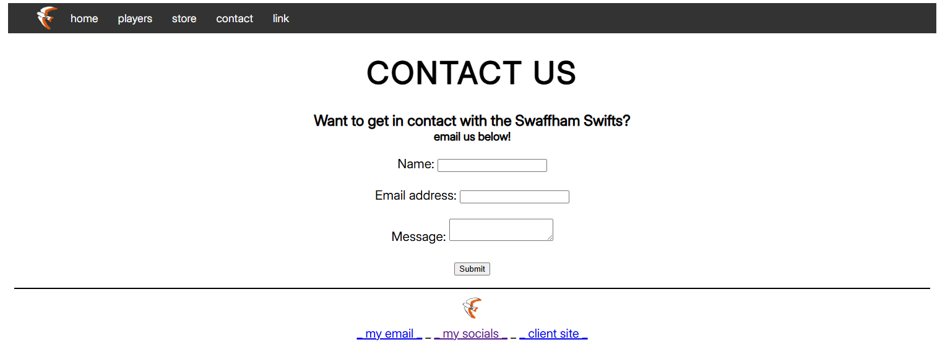The contact page allows users to contact the swaffham swifts team directly. The page has the ‘CONTACT US’ heading, a subheading and a smaller subheading, followed by the spaces to input a name, email address and a message, with a button to submit the inputs. This is followed by the footer.
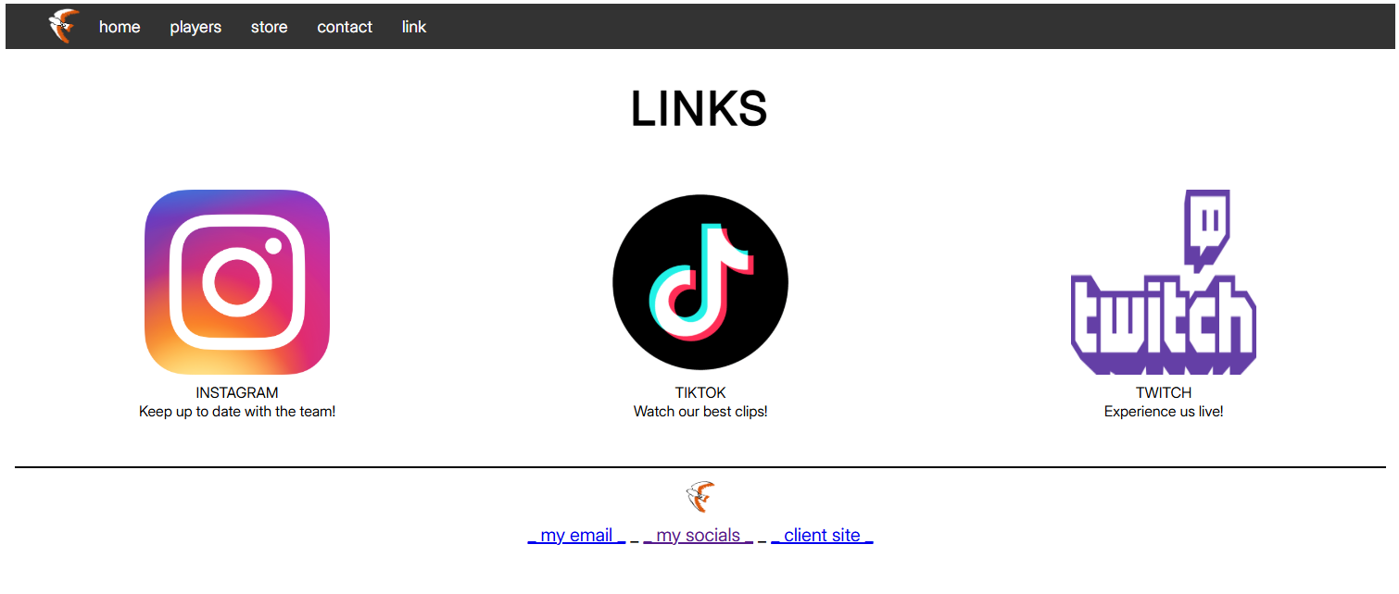
The links page features 3 links, one for Instagram, another for TikTok and another for twitch. These all have a heading and a subtitle description. Each image can be clicked and links to the site’s homepage. The page also features the footer at the bottom of the page. The page is introduced with the heading ‘LINKS’

Testing

Testable Specification

What the website will and will not do
E.g.
Player:
Will be able to move on to the next level
Will not be able to…

Test Log.
<P5>
(functionality, compatibility (with different devices and browsers))
Date:
Program Name: Version:
Author: Tested By:
If observed output same as expected then write ‘Success’ else write ‘Fail’. If not the same need to fill in comments / suggestions section.

Test No. | Test Data  Data Description | Expected o/p | Observed o/p | Success / Fail | Comments / Suggestions
Category of Test e.g. Normal/Extreme/Erroneous Data
1 | Test to see if site loads as expected | Expect site to load with no errors | 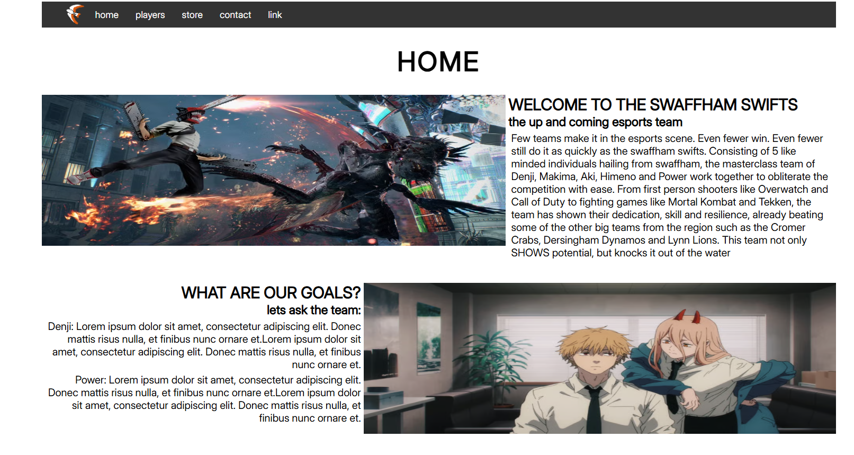 | SUCCESS | Loaded with no issues or errors
2 | Test to see if navigation bar appears as expected | Expect nav bar to load as expected | 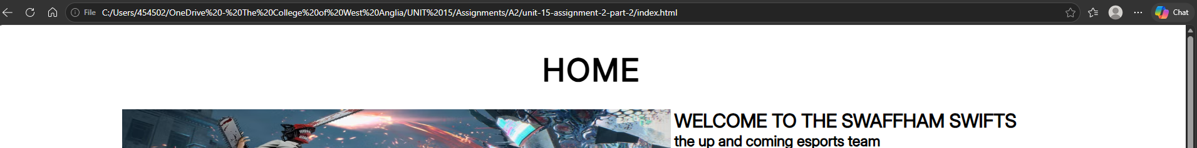 | FAIL | Navigation bar did not appear
3 | Revised test to see if navigation bar appears as expected | Expect nav bar to load as expected |  | SUCCESS | Navigation appeared and was functional
4 | Test to see if store page can open external purchase page | Expect a test page that just says PURCHASE PRODUCT to appear | 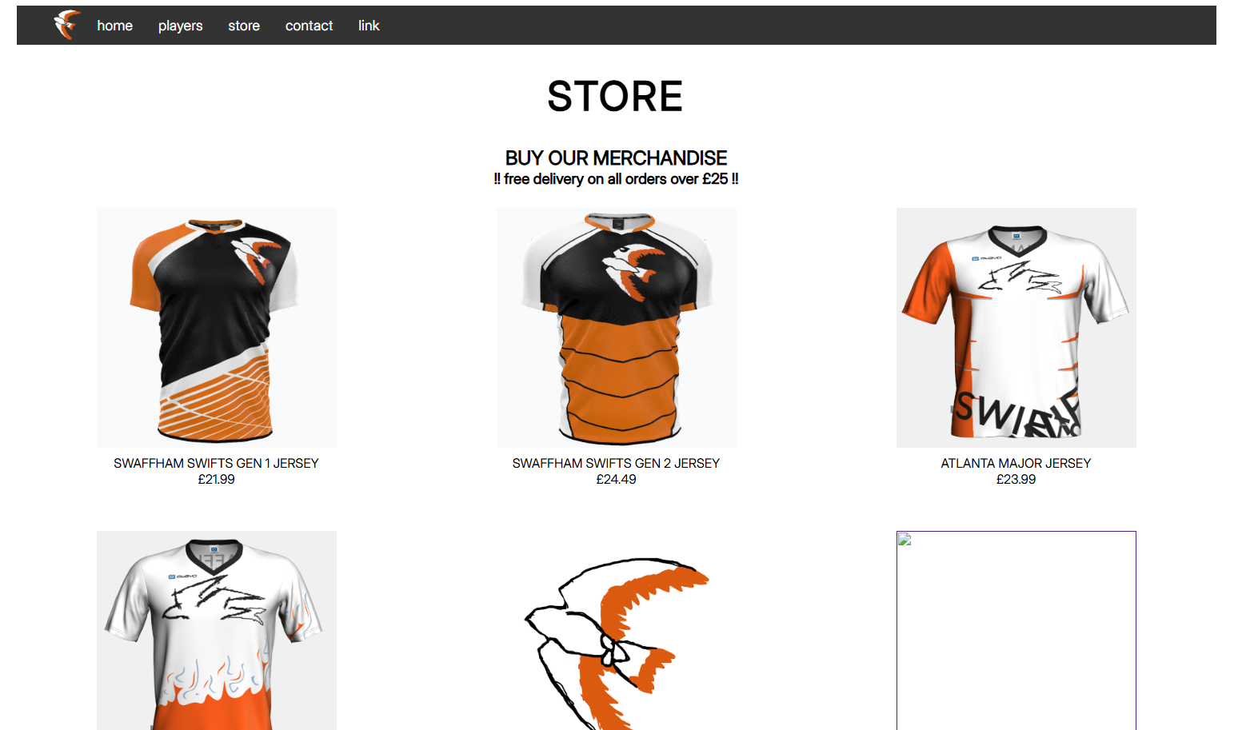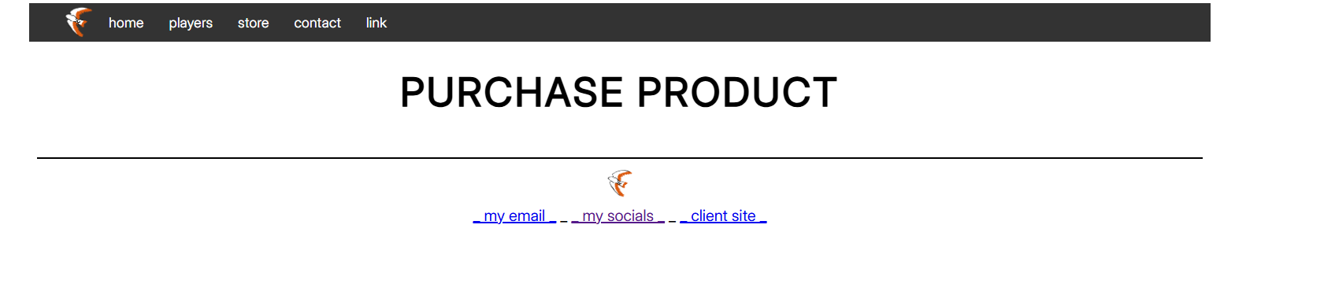 | SUCCESS | Purchase page loaded as expected
5 | Test to see if Instagram link works | Instagram opens as expected when the link is clicked | 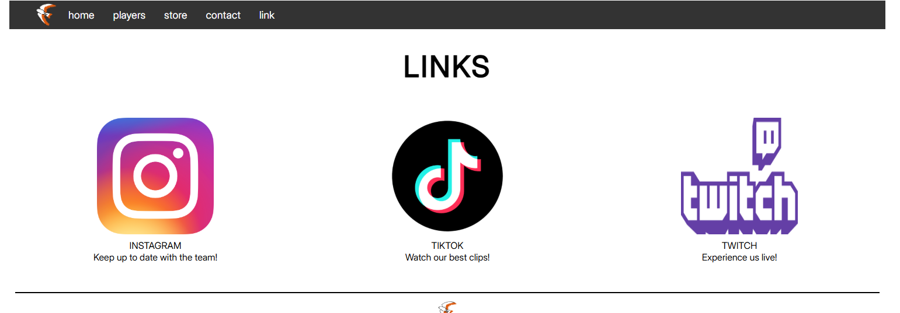 | FAIL | Instagram did not open
6 | Revised Test to see if Instagram link works | Instagram opens as expected when the link is clicked | 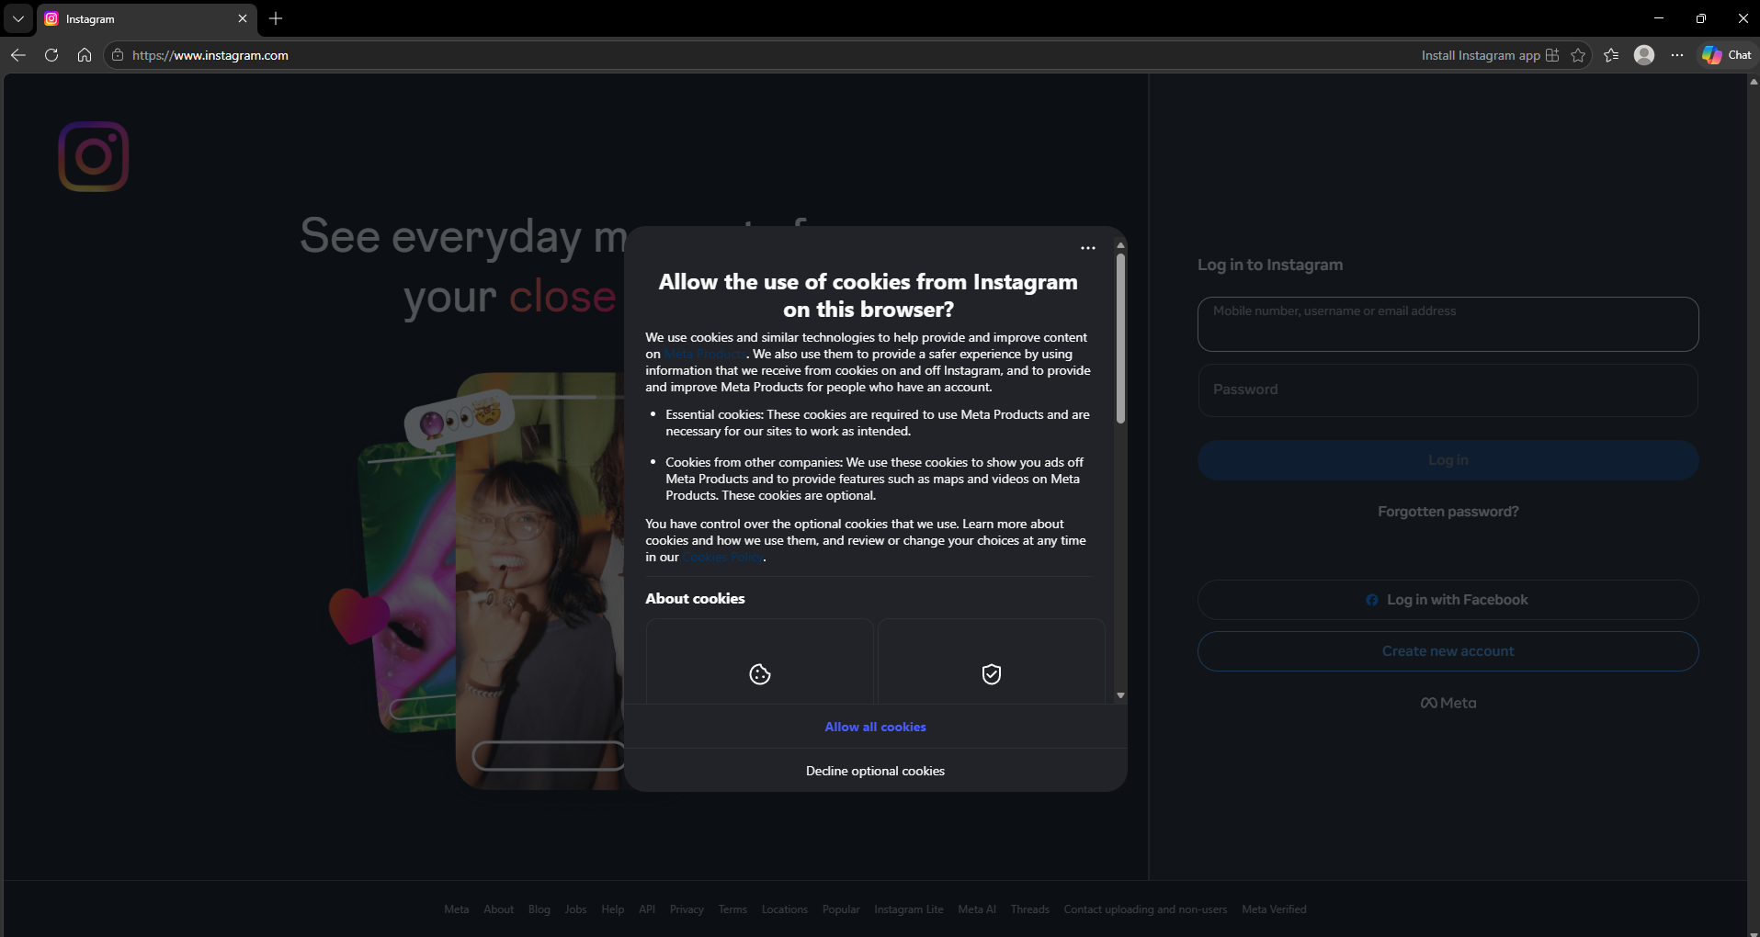 | SUCCESS | Instagram opened as expected
7 | Test to see if image loads on website | Image on website loads as expected | 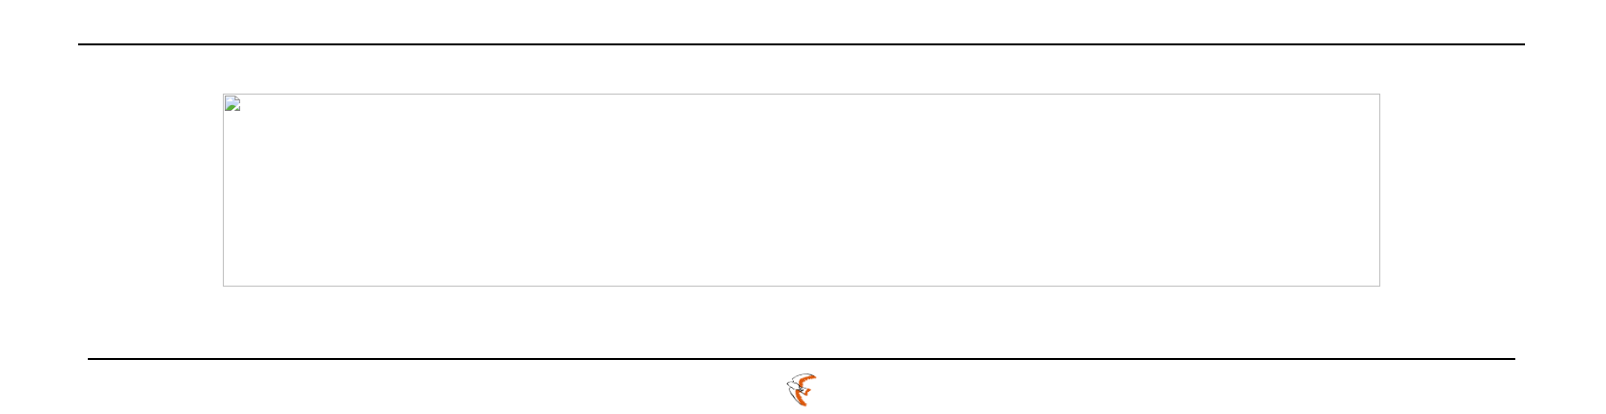 | FAIL | Image did not load when website was ran
8 | Revised test to see if image loads on website | Image on website loads as expected | 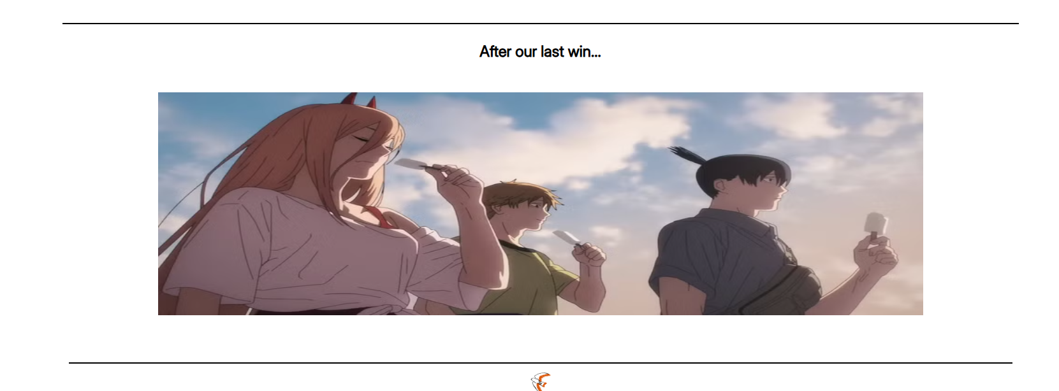 | SUCCESS | Image loaded with no issues
9
10

User Testing/Questionnaire
Create a questionnaire for others to answer to allow you to gain important feedback on how you could improve your website and optimise it but also point out the methods or sections on the website which are good.

User Feedback

Answers to the questionnaire. These need to be constructive comments like ‘centralise the image to add emphasis…’

Proposed Improvements
Proposed improvement based on the feedback

Reflection of the Project

Analysis against original intentions/ why does it suit the client’s needs
<(P6)Review the extent to which the website meets the client requirements>

Example: My original designs for the Hot Beans website were very basic and when it came to producing and creating it, I had to adjust and re-design some areas to make the website usability, readability, and navigation better for a user.
My original intentions for the Swaffham Swifts website lacked a significant amount of

Appendix A

Original Source Code
<P4: Include the source code (html, css, javascript) for each page>

