DATABEAT | Prepared for TIME
PG/PD Incremental Revenue Model
How much additional revenue TIME can generate by converting a share of open-auction programmatic impressions into Preferred Deals / Programmatic Guaranteed (US inventory)
Bottom line: across Entertainment, U.S., Health and Science & Tech, the top-6 ad slots serve about 10.4M programmatic impressions per month that earn only $29,380/month today (~$2.83 eCPM). Converting 10% of that inventory into PG/PD at $8–$10 generates $8,293–$10,366/month versus $2,938 today — an incremental $5,355–$7,428/month (~$64,254–$89,132/year), built gradually over 30/60/90 days.

Scope & Method
- What — U.S. inventory, top-6 high-impact ad slots (stickyfooter1, leaderboard1, inline1–3, rightrail1).
- Period — Google Ad Manager, January–May 2026 (5 months); monthly figures = period ÷ 5. June 2026 excluded (a CPD deal was mis-booked as CPM).
- Assumptions — shift = share of programmatic impressions re-sold as PG/PD. PG/PD priced at a fixed $8 and $10 eCPM. Scenarios: 5% / 10% / 15%.
- Formula — incremental revenue = (shifted impressions ÷ 1000) × (PG/PD eCPM − current programmatic eCPM).
1. Current State — Average Monthly Programmatic Inventory
These are the average monthly programmatic impressions on the top-6 slots for each section, and what they earn today at current open-auction eCPMs. Direct sales on the same sections clear far higher — shown for reference — which is exactly why PG/PD at $8–$10 is realistic and non-cannibalizing.
Section | Avg monthly prog. impressions | Current prog. eCPM | Current revenue / month | Direct eCPM (ref.)
Entertainment | 4,567,001 | $2.36 | $10,759 | $16.80
U.S. | 3,113,794 | $2.63 | $8,174 | $19.20
Health | 2,017,164 | $4.04 | $8,152 | $23.80
Science & Tech | 667,699 | $3.44 | $2,295 | $30.00
Total (4 sections) | 10,365,658 | $2.83 | $29,380 | —

Context: Preferred Deals in the account already clear at roughly 2× the open-auction rate, and current PG/PD volume is under ~0.1% of impressions — so this is untapped, not unproven.
2. The 10% Conversion — Current vs PG/PD at $8 / $10
Taking 10% of each section's monthly programmatic impressions and re-selling it as PG/PD:
Section | 10% impressions | Current rev | Rev @ $8 | Rev @ $10 | Uplift @ $8 | Uplift @ $10
Entertainment | 456,700 | $1,076 | $3,654 | $4,567 | $2,578 | $3,491
U.S. | 311,379 | $817 | $2,491 | $3,114 | $1,674 | $2,296
Health | 201,716 | $815 | $1,614 | $2,017 | $799 | $1,202
Science & Tech | 66,770 | $230 | $534 | $668 | $305 | $438
Total | 1,036,566 | $2,938 | $8,293 | $10,366 | $5,355 | $7,428

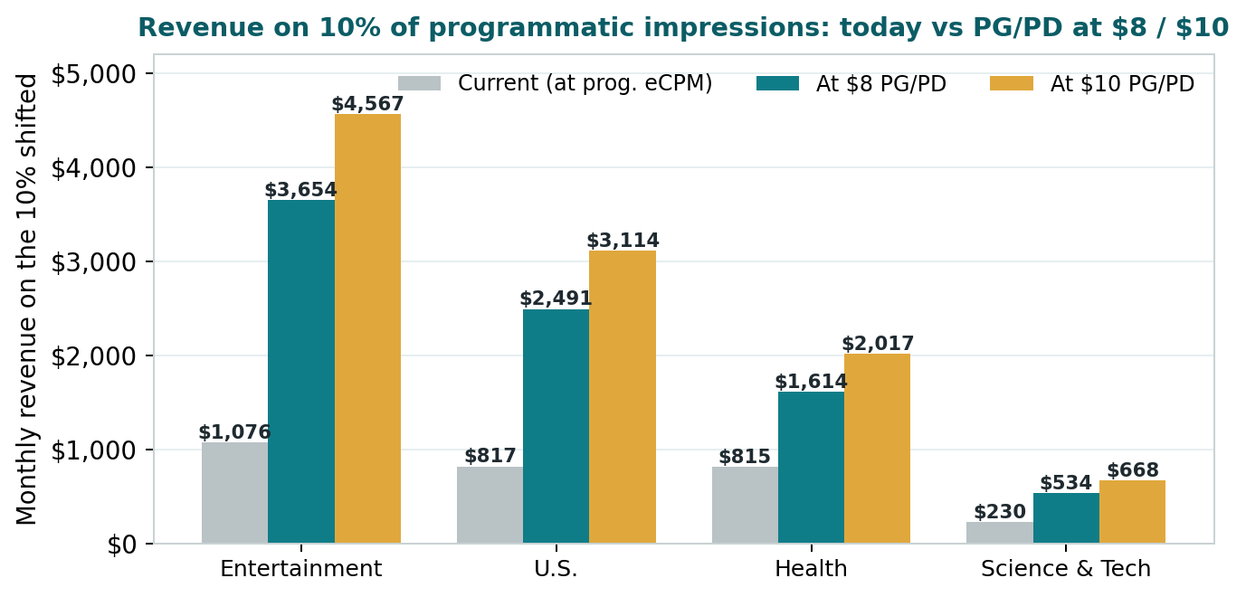
Figure 1 — Monthly revenue on the 10% shifted impressions: today vs PG/PD at $8 / $10.
3. Scenarios — 5% / 10% / 15% Shift
Incremental monthly revenue across the four sections at each shift level:
Shift level | Incremental / mo @ $8 | Incremental / mo @ $10 | Annualized @ $8 | Annualized @ $10
5% | $2,677 | $3,714 | $32,127 | $44,566
10% | $5,355 | $7,428 | $64,254 | $89,132
15% | $8,032 | $11,141 | $96,381 | $133,698

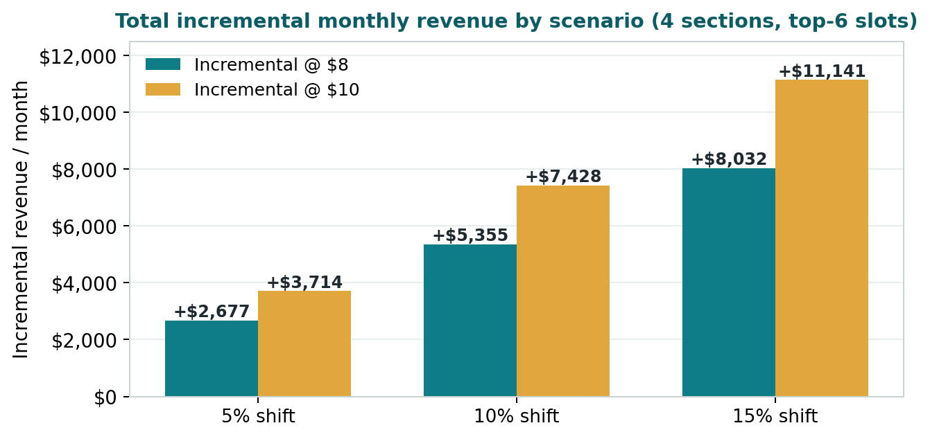
Figure 2 — Total incremental monthly revenue by scenario.
4. 30 / 60 / 90-Day Ramp
Monica asked for a phased build, not instant impact. PG/PD scales gradually as deals are signed and activated. The ramp maps to the shift scenarios above (blended across the four sections):
Period | Stage | % activated | Prog. imp / mo | PG/PD rev @ $8 | PG/PD rev @ $10 | Uplift @ $8 | Uplift @ $10
30 days | Small pilot | 5% | 518,283 | $4,146 | $5,183 | $2,677 | $3,714
60 days | Broader rollout | 10% | 1,036,566 | $8,293 | $10,366 | $5,355 | $7,428
90 days | Scaled rollout | 15% | 1,554,849 | $12,439 | $15,548 | $8,032 | $11,141

5. What This Means (for Monica)
- Current state — PG/PD is under ~0.1% of impressions today — effectively an untapped channel.
- Opportunity — premium slots clear at ~$2–$4 programmatically while direct earns $17–$29; PG/PD at $8–$10 captures the middle without touching direct.
- Impact — converting 10% of programmatic in these sections adds $5,355–$7,428/month (~$64,254–$89,132/year); 15% roughly scales that by 1.5×.
- Ramp — gradual over 30/60/90 days — pilot, broaden, scale — not an overnight shift.
One-line answer: “If we convert 10% of today's programmatic impressions in these high-value sections into PG/PD at $8–$10, we lift them from $2,938 to $8,293–$10,366 per month — roughly $5,355–$7,428 of incremental revenue every month, ramping over one quarter.”

Scope note: figures cover four sections (Entertainment, U.S., Health, Science & Tech) on the top-6 ad slots only; other sections (e.g., World, Politics) and remaining slots are additive and not included here. U.S. inventory, GAM Jan–May 2026, June excluded. Prepared by Databeat for TIME.

