DATABEAT | Prepared for TIME
Scaling Programmatic Guaranteed & Preferred Deals
The Case for a Dedicated PG/PD Sales Resource
An analysis of TIME's U.S. non-direct inventory and the incremental revenue available by converting under-priced programmatic impressions into deal-based demand.
Scope: U.S. inventory only
Data source: Google Ad Manager, Jan 2025 – Jun 2026
Note: June 2026 revenue/eCPM excluded (see Methodology)

Executive Summary
TIME's U.S. programmatic inventory is systematically under-monetized. Non-direct channels (programmatic + house) account for roughly two-thirds of all ad impressions yet contribute only about 15% of ad revenue, because that inventory clears at open-auction rates near $2–$3 versus $20+ on directly-sold deals. This is not a traffic problem — the impressions already exist. It is a monetization and go-to-market gap.
The mechanism to close the gap already exists inside the account and is proven: Preferred Deals clear at roughly $6 eCPM — more than double the general programmatic rate — but represent under 0.01% of impressions today. The opportunity is to package premium, high-impact ad units and take them to advertisers as Programmatic Guaranteed (PG) and Preferred Deals (PD) at negotiated rates of $8–$10.
The ask: Fund one dedicated PG/PD resource to proactively reach out to advertisers, build the deal pipeline, and run execution. On the top-6 ad units alone, a conservative 10% shift to PG/PD at $8 eCPM returns roughly $159K per year; a 20% shift at $10 returns roughly $430K — many times the fully-loaded cost of a single resource.

Metric (U.S.) | Direct | Programmatic | House
Share of impressions | 36% | 56% | 9%
Share of revenue | ~84% | ~15% | ~0.3%
eCPM | $20.19 | $2.33 | $0.30

Figures reflect FY2025 (a complete, clean year); impression mix is consistent across the full period. See Methodology for the June 2026 exclusion.
Data Scope & Methodology
- Scope — all figures are for TIME's U.S. inventory only, exported from Google Ad Manager for the period January 2025 – June 2026.
- Channel definitions — Direct = Standard + Sponsorship line items. Programmatic = Ad Exchange + Price Priority (Media.net, Amazon/A9, etc.) + Preferred Deal + EBDA/Open Bidding. House = house line items.
- June 2026 exclusion — June 2026 has been excluded from all revenue and eCPM figures. A fixed-cost (CPD) deal was mistakenly entered as a CPM value, which materially inflated reported June revenue and eCPM. Impression counts are unaffected by this error. To stay conservative, revenue and eCPM exhibits are anchored on FY2025 — a complete, clean year — and on programmatic figures, which are independent of the June direct-side error.
- Confidentiality — no individual advertiser names are disclosed in this document; demand is summarized at the channel and platform level.
1. Overall Performance: Direct vs Programmatic vs House
The headline of the entire analysis is a single mismatch: the way TIME earns money and the way TIME serves impressions are almost mirror images of each other.
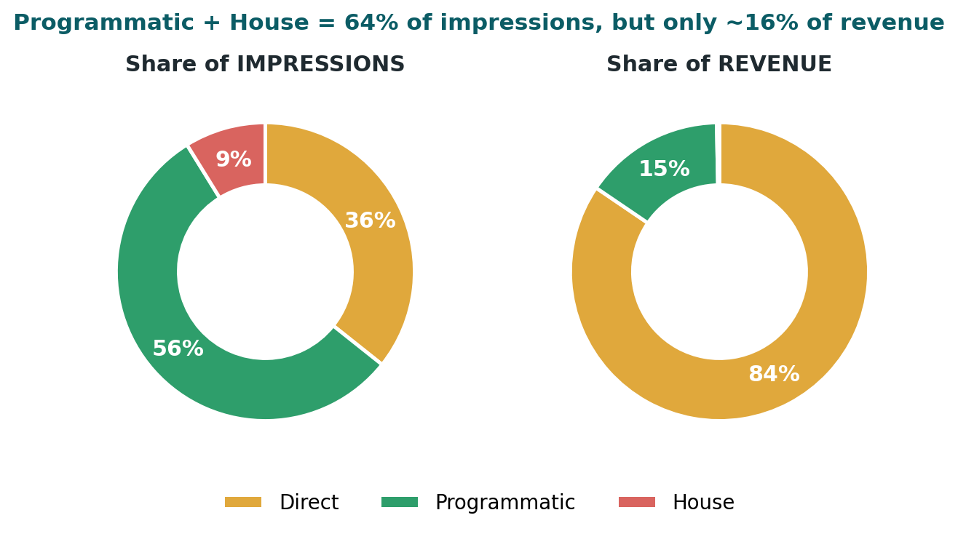
Figure 1 — U.S. impression share vs. revenue share (FY2025). Direct = gold, Programmatic = green, House = red.
Direct sales — where the team has genuinely improved and consistently commands $20+ eCPMs — converts about a third of impressions into ~84% of revenue. Programmatic does the opposite: it carries the majority of impressions but returns a fraction of the revenue, because it is largely sold through the open auction at remnant pricing. House inventory (~9% of impressions) is effectively unmonetized.
Channel | Revenue (FY25) | Rev share | Impressions (FY25) | Imp share | eCPM
Direct | $5,352,299 | 84.5% | 265.1M | 35.7% | $20.19
Programmatic | $959,994 | 15.2% | 412.5M | 55.5% | $2.33
House | $19,902 | 0.3% | 65.5M | 8.8% | $0.30
Total | $6,332,195 | 100% | 743.1M | 100% | $8.52

Why this matters: programmatic + house together are ~64% of U.S. impressions but ~15% of revenue. Even a small improvement in how that inventory is sold produces a large revenue effect, because the starting eCPM is so low.

2. Where the Programmatic Revenue Comes From
Within programmatic, revenue is concentrated in a handful of demand platforms — all transacting through the open auction or network backfill, none through negotiated deals. This is the demand we can re-capture at higher rates through PG/PD relationships.
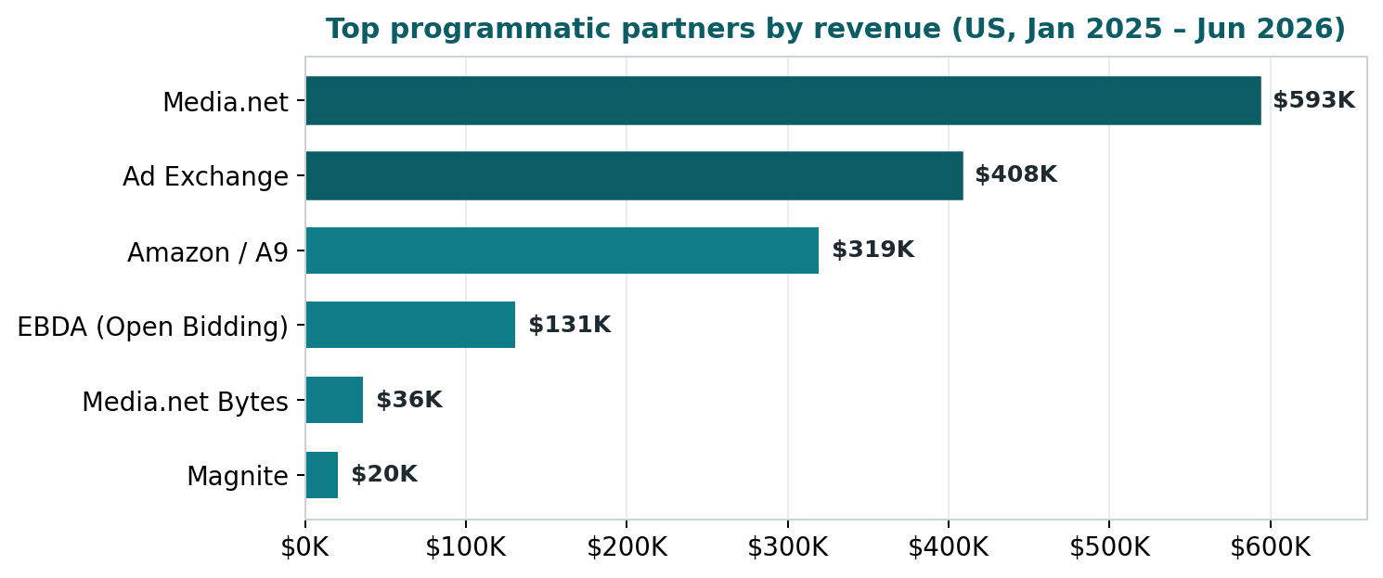
Figure 2 — Top programmatic partners by revenue (U.S., full period). Darker bars = largest partners.
The same advertisers and platforms buying TIME's inventory today through the open auction at ~$2–$3 are exactly the demand a dedicated resource would convert into direct PG/PD deals at negotiated, premium rates — capturing margin TIME currently leaves on the table.
3. The Ad-Unit Opportunity (Top 6 High-Impact Units)
Focusing on the six highest-volume, high-impact ad units, the pricing gap is stark and consistent: on the very same placement, directly-sold impressions earn roughly 6–13× what programmatic earns.
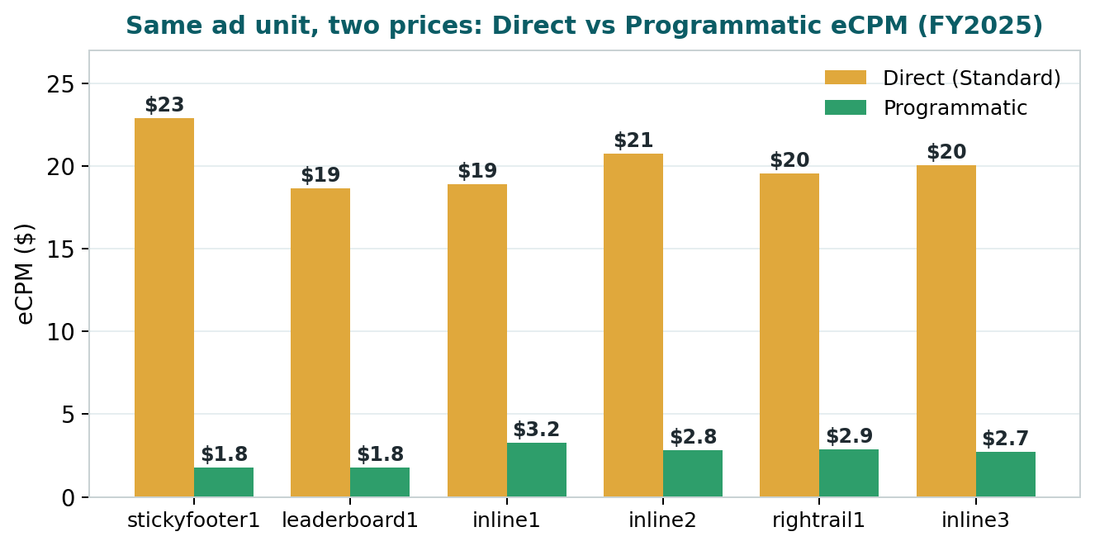
Figure 3 — Direct vs. Programmatic eCPM on the same ad unit (FY2025, U.S.).
Ad unit | Direct eCPM | Prog. eCPM | Prog. impressions | Gap
stickyfooter1 | $22.92 | $1.79 | 118.9M | 12.8×
leaderboard1 | $18.66 | $1.78 | 45.7M | 10.5×
inline1 | $18.91 | $3.25 | 37.1M | 5.8×
inline2 | $20.76 | $2.82 | 31.8M | 7.4×
rightrail1 | $19.56 | $2.88 | 18.9M | 6.8×
inline3 | $20.05 | $2.74 | 25.4M | 7.3×
Top-6 total | $20.42 | $2.26 | 277.8M | 9.0×

These six units carry roughly 278 million programmatic impressions a year that clear at ~$2.26. That is the pool a PG/PD motion targets — not by displacing direct sales, but by pricing the non-direct inventory far closer to its true value.
4. The Proof PG/PD Works Is Already in the Data
This is not a theoretical uplift. TIME's own account already shows that deal-based demand pays more:
Deal type | eCPM 2025 | eCPM 2026 | Impressions (period) | Read
General programmatic | $2.33 | $2.78 | 619.4M | Baseline (open auction)
Preferred Deal (PD) | $4.50 | $6.01 | 98,736 | ~2.2× baseline, tiny volume

The signal: Preferred Deals already clear at more than 2× the open-auction rate — yet they represent under 0.01% of impressions. The pricing power is proven; the volume is simply untapped. A $8–$10 target is a realistic step up from a $6 rate that is already being achieved today at negligible scale.

5. The Opportunity: Scaling Top-6 Inventory to $8–$10 eCPM
Applying conservative, achievable target eCPMs of $8 and $10 to a portion of the top-6 programmatic pool (278M impressions/year at a current $2.26) yields the following incremental annual revenue:
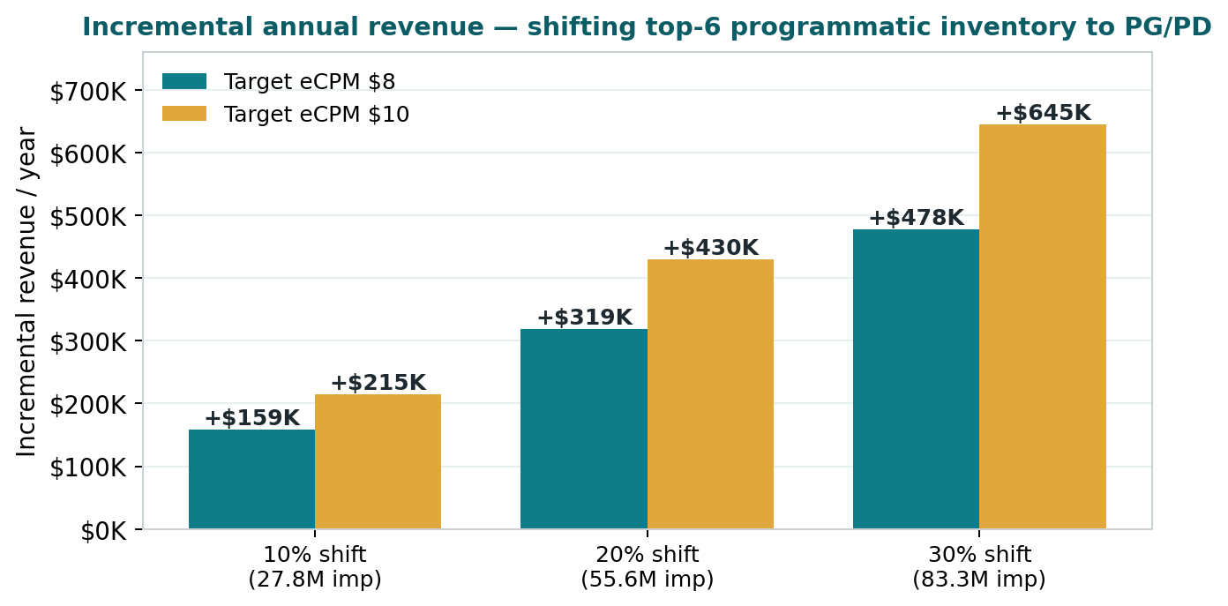
Figure 4 — Incremental annual revenue by shift level and target eCPM (top-6 ad units only).
Scenario | Impressions shifted | Target eCPM | Incremental / year
Conservative | 10% (27.8M) | $8 | +$159K
Conservative | 10% (27.8M) | $10 | +$215K
Base | 20% (55.6M) | $8 | +$319K
Base | 20% (55.6M) | $10 | +$430K
Upside | 30% (83.3M) | $8 | +$478K
Upside | 30% (83.3M) | $10 | +$645K

- Scope note — These figures cover the top-6 ad units only. The full U.S. programmatic pool is ~619M impressions, so the account-wide ceiling is materially higher.
- Plus — house inventory on these units (~14.4M impressions/yr at $1) adds a further ~$58K–$72K/yr if sold via PD at $5–$6 — near-zero-risk upside from currently unmonetized inventory.
6. The Ask: A Dedicated PG/PD Sales Resource
Capturing this opportunity requires someone whose full-time job is to turn under-priced programmatic inventory into negotiated deals. Today no one owns this motion end-to-end, which is precisely why the gap persists despite a strong direct team.
What the resource does
- Outreach & sales — proactively reach out to advertisers, agencies and DSP/SSP demand partners to build a PG/PD pipeline and bring in sales.
- Packaging — package premium, high-impact ad units into PG and PD offers with clear pricing, targeting and specs.
- Execution — set up and manage proposals and line items in GAM; run creative QA and launch readiness.
- Optimization — monitor delivery, pacing and discrepancies; deliver post-campaign reporting to drive repeat deals.
KPIs
KPI | Target
PG/PD deals closed / activated | monthly, growing quarter over quarter
Proposal turnaround time | < 48 hours
Campaign delivery rate | > 90%
Programmatic eCPM on packaged units | $8–$10 (from ~$2.3 today)
PG/PD share of programmatic revenue | 5–10% within 3 months (from <1%)

Return on the resource: even the most conservative scenario (10% shift at $8 ≈ +$159K/yr, top-6 units only) covers a fully-loaded resource several times over. The base case (~$319K–$430K/yr) makes the investment decision straightforward — and it scales as the pipeline matures across the full inventory.

7. Recommendation & Next Steps
The opportunity is real, quantified, low-risk and additive — it does not cannibalize the direct business; it prices the inventory the direct team does not sell. We recommend proceeding.
- 1. approve one dedicated PG/PD sales resource to own advertiser outreach, deal-making and execution.
- 2. start with the top-6 high-impact ad units and house inventory as the initial package.
- 3. set a 90-day first-quarter goal: 3–5 live PG/PD deals, delivery >90%, and PG/PD reaching 5–10% of programmatic revenue.
- 4. align on go-live timing and confirm target advertiser/agency list for initial outreach.
Prepared by Databeat for TIME · U.S. inventory · GAM Jan 2025 – Jun 2026 (June 2026 excluded). All revenue/eCPM figures anchored on the clean FY2025 period and June-independent programmatic data.

