DATABEAT | Prepared for TIME
PG/PD Conversion Targets — Section × Slot Analysis
A granular, ad-unit-level map of where TIME's premium inventory is being sold at open-auction programmatic prices instead of direct — and how much incremental revenue converting that slice to Preferred Deals / Programmatic Guaranteed would generate. US inventory · top-6 slots · Jan–May 2026.
Bottom line: 75% of programmatic impressions in these top slots (150M) sit in “target” pools — heavily programmatic (≥60%), barely sold direct (≤35%) — clearing at just $2.44 eCPM while direct on the same units fetches $19–$44. Converting 10% of that to PG/PD at $8–$10 adds $16,723–$22,734/month (~$200,681–$272,811/yr) — without touching the 18% of inventory that is direct-heavy and reserved for the sales team.

Scope & Method
- What — US inventory, six top slots × five sections (Entertainment, U.S., Health, Tech, Science), Jan–May 2026 (5 months).
- Data — GAM pivot with impressions AND CPM per section × slot for Standard (direct), Programmatic and House; reconciled to grand totals.
- Target rule — Programmatic share ≥ 60% AND direct share ≤ 35%. These are re-sellable via PG/PD with minimal direct cannibalization.
- Reserved rule — Direct share ≥ 40% — the sales team already owns these; excluded from conversion.
- Model — shift 5% / 10% / 15% of a slot's programmatic impressions to PG/PD at a fixed $8 and $10 eCPM; uplift is measured against that slot's actual programmatic CPM. Monthly = period ÷ 5.
1. Section-wise Summary
All five sections at a glance — total impressions and blended CPMs by channel, the programmatic vs direct split, and the target PG/PD opportunity within each section (10% shift).
Section | Direct imp | Prog. imp | House imp | Prog % | Dir % | Direct CPM | Prog CPM | Target opp/mo @$8 | @$10
Entertainment | 38,356,071 | 96,703,650 | 4,511,071 | 69% | 27% | $22.34 | $2.23 | $9,704 | $13,097
Health | 34,674,311 | 49,728,287 | 3,245,781 | 57% | 40% | $28.10 | $3.44 | $2,592 | $3,596
Science | 3,024,160 | 7,298,045 | 345,368 | 68% | 28% | $32.73 | $2.77 | $583 | $810
Tech | 7,395,966 | 7,795,502 | 448,926 | 50% | 47% | $24.46 | $3.54 | $293 | $402
U.S. | 16,706,979 | 38,525,271 | 1,759,285 | 68% | 29% | $24.56 | $2.38 | $3,552 | $4,828
All sections | 100,157,487 | 200,050,755 | 10,310,431 | 64% | 32% | $25.17 | $2.63 | $16,723 | $22,734

2. Slot-wise Summary
The six slots aggregated across all sections — showing where impression volume concentrates and how heavily each slot skews programmatic vs direct.
Slot | Direct imp | Prog. imp | House imp | Prog % | Dir % | Direct CPM | Prog CPM | Target opp/mo @$8 | @$10
stickyfooter1 | 32,532,070 | 91,556,001 | 3,874,619 | 72% | 25% | $23.72 | $2.14 | $10,739 | $14,401
leaderboard1 | 27,963,246 | 28,657,336 | 2,121,116 | 49% | 48% | $27.05 | $2.25 | $0 | $0
inline1 | 14,465,035 | 25,229,629 | 1,129,281 | 62% | 35% | $24.57 | $3.71 | $1,717 | $2,406
inline2 | 9,939,514 | 22,046,408 | 1,185,514 | 66% | 30% | $27.16 | $3.17 | $1,619 | $2,231
inline3 | 6,973,208 | 18,763,956 | 1,104,641 | 70% | 26% | $26.54 | $3.03 | $1,809 | $2,533
rightrail1 | 8,284,414 | 13,797,425 | 895,260 | 60% | 36% | $22.07 | $3.34 | $839 | $1,163
All slots | 100,157,487 | 200,050,755 | 10,310,431 | 64% | 32% | $25.17 | $2.63 | $16,723 | $22,734

3. Conversion Targets — Ranked
The 18 slots that meet the target rule, ranked by programmatic volume. Uplift is monthly at the base 10% shift.
Section · Slot | Prog. imp | Prog % | Dir % | Prog CPM | Direct CPM | Uplift/mo @ $8 | Uplift/mo @ $10
Entertainment · stickyfooter1 | 47,410,845 | 75% | 22% | $1.92 | $21.22 | $5,765 | $7,662
Health · stickyfooter1 | 20,185,172 | 63% | 34% | $2.53 | $26.29 | $2,208 | $3,016
U.S. · stickyfooter1 | 19,228,301 | 76% | 22% | $2.13 | $22.92 | $2,257 | $3,027
Entertainment · inline1 | 11,630,907 | 65% | 33% | $2.93 | $21.88 | $1,179 | $1,645
Entertainment · inline2 | 10,920,299 | 72% | 25% | $2.64 | $26.00 | $1,171 | $1,607
Entertainment · inline3 | 10,019,326 | 75% | 22% | $2.55 | $23.61 | $1,092 | $1,493
Health · inline3 | 4,930,438 | 63% | 32% | $4.11 | $29.55 | $384 | $581
Entertainment · rightrail1 | 4,846,780 | 69% | 28% | $2.88 | $19.14 | $496 | $690
U.S. · inline1 | 4,331,009 | 66% | 31% | $3.22 | $24.71 | $414 | $587
U.S. · inline2 | 3,319,301 | 70% | 25% | $2.85 | $27.76 | $342 | $475
Tech · stickyfooter1 | 2,725,359 | 62% | 34% | $2.62 | $28.67 | $293 | $402
U.S. · rightrail1 | 2,677,384 | 64% | 32% | $2.65 | $19.87 | $286 | $394
U.S. · inline3 | 2,359,398 | 71% | 24% | $2.66 | $28.08 | $252 | $346
Science · stickyfooter1 | 2,006,324 | 71% | 26% | $2.65 | $27.67 | $215 | $295
Science · inline1 | 1,280,246 | 72% | 26% | $3.19 | $26.84 | $123 | $174
Science · inline2 | 1,046,394 | 75% | 22% | $2.89 | $27.89 | $107 | $149
Science · inline3 | 781,024 | 74% | 22% | $2.77 | $27.19 | $82 | $113
Science · rightrail1 | 571,444 | 63% | 32% | $3.06 | $23.72 | $56 | $79
18 target slots | 150,269,951 | 70% | — | $2.44 | — | $16,723 | $22,734

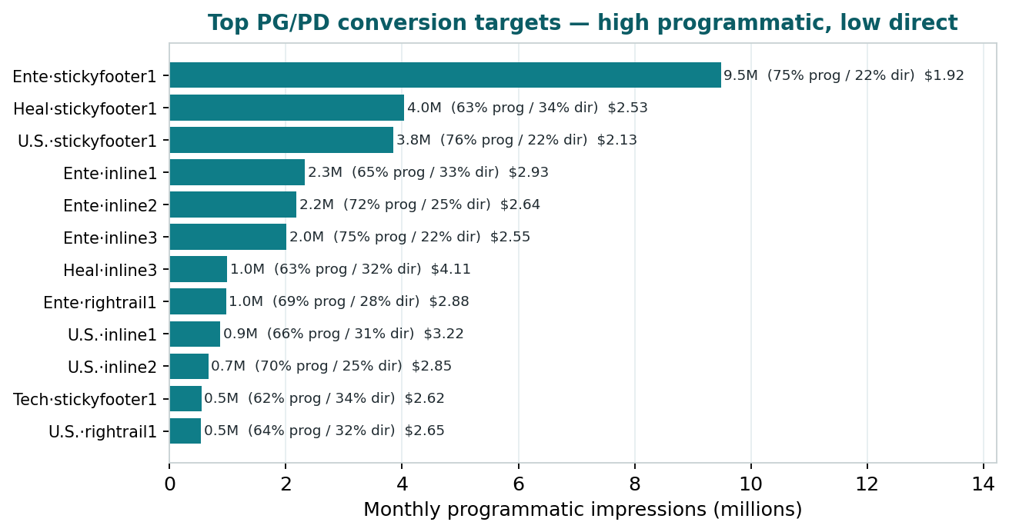
Figure 1 — Top targets by monthly programmatic impressions (prog% / dir% and current prog CPM labeled).
4. Reserved for Direct Sales
These slots are direct-dominant (direct share ≥ 40%) — the sales team already monetizes them well. We explicitly leave them out of the PG/PD push to avoid competing with direct.
Section · Slot | Direct imp | Dir % | Prog % | Direct CPM | Prog CPM
Tech · leaderboard1 | 2,502,857 | 60% | 37% | $20.64 | $2.97
Health · leaderboard1 | 8,665,005 | 53% | 43% | $32.25 | $2.81
Tech · inline1 | 1,245,304 | 51% | 47% | $23.65 | $5.53
Tech · rightrail1 | 866,947 | 50% | 47% | $27.96 | $3.85
U.S. · leaderboard1 | 5,864,010 | 45% | 51% | $25.97 | $2.13
Tech · inline2 | 777,475 | 45% | 52% | $25.27 | $4.24
Entertainment · leaderboard1 | 9,918,394 | 44% | 53% | $22.99 | $1.88
Health · rightrail1 | 3,808,220 | 42% | 54% | $22.90 | $4.11
Tech · inline3 | 501,022 | 41% | 55% | $25.62 | $3.95

Pattern: leaderboard1 across sections and most of Tech are direct territory — consistent with leaderboard being the premium billboard the sales team leads with.
5. Section-by-Section Detail — Every Slot
The full granular view: for each section, every slot's impressions, the CPMs it is selling at (direct vs programmatic), its programmatic/direct share, its classification, and the monthly PG/PD opportunity at 10%.
Entertainment
Slot | Direct imp | Prog. imp | Prog % | Dir % | Dir CPM | Prog CPM | Class | Opp/mo @$8 | Opp/mo @$10
stickyfooter1 | 13,767,927 | 47,410,845 | 75% | 22% | $21.22 | $1.92 | Target | $5,765 | $7,662
leaderboard1 | 9,918,394 | 11,875,493 | 53% | 44% | $22.99 | $1.88 | Reserved | — | —
inline1 | 5,880,365 | 11,630,907 | 65% | 33% | $21.88 | $2.93 | Target | $1,179 | $1,645
inline2 | 3,876,484 | 10,920,299 | 72% | 25% | $26.00 | $2.64 | Target | $1,171 | $1,607
inline3 | 2,914,244 | 10,019,326 | 75% | 22% | $23.61 | $2.55 | Target | $1,092 | $1,493
rightrail1 | 1,998,657 | 4,846,780 | 69% | 28% | $19.14 | $2.88 | Target | $496 | $690
Entertainment total | 38,356,071 | 96,703,650 | — | — | — | — |  | $9,704 | $13,097

Health
Slot | Direct imp | Prog. imp | Prog % | Dir % | Dir CPM | Prog CPM | Class | Opp/mo @$8 | Opp/mo @$10
stickyfooter1 | 11,067,220 | 20,185,172 | 63% | 34% | $26.29 | $2.53 | Target | $2,208 | $3,016
leaderboard1 | 8,665,005 | 7,007,562 | 43% | 53% | $32.25 | $2.81 | Reserved | — | —
inline1 | 4,831,301 | 6,850,100 | 57% | 40% | $27.80 | $5.15 | Secondary | — | —
inline2 | 3,772,312 | 5,874,817 | 59% | 38% | $28.50 | $4.24 | Secondary | — | —
inline3 | 2,530,253 | 4,930,438 | 63% | 32% | $29.55 | $4.11 | Target | $384 | $581
rightrail1 | 3,808,220 | 4,880,198 | 54% | 42% | $22.90 | $4.11 | Reserved | — | —
Health total | 34,674,311 | 49,728,287 | — | — | — | — |  | $2,592 | $3,596

Science
Slot | Direct imp | Prog. imp | Prog % | Dir % | Dir CPM | Prog CPM | Class | Opp/mo @$8 | Opp/mo @$10
stickyfooter1 | 723,615 | 2,006,324 | 71% | 26% | $27.67 | $2.65 | Target | $215 | $295
leaderboard1 | 1,012,980 | 1,612,613 | 60% | 38% | $44.32 | $2.39 | Secondary | — | —
inline1 | 453,383 | 1,280,246 | 72% | 26% | $26.84 | $3.19 | Target | $123 | $174
inline2 | 312,130 | 1,046,394 | 75% | 22% | $27.89 | $2.89 | Target | $107 | $149
inline3 | 229,424 | 781,024 | 74% | 22% | $27.19 | $2.77 | Target | $82 | $113
rightrail1 | 292,628 | 571,444 | 63% | 32% | $23.72 | $3.06 | Target | $56 | $79
Science total | 3,024,160 | 7,298,045 | — | — | — | — |  | $583 | $810

Tech
Slot | Direct imp | Prog. imp | Prog % | Dir % | Dir CPM | Prog CPM | Class | Opp/mo @$8 | Opp/mo @$10
stickyfooter1 | 1,502,361 | 2,725,359 | 62% | 34% | $28.67 | $2.62 | Target | $293 | $402
leaderboard1 | 2,502,857 | 1,551,790 | 37% | 60% | $20.64 | $2.97 | Reserved | — | —
inline1 | 1,245,304 | 1,137,367 | 47% | 51% | $23.65 | $5.53 | Reserved | — | —
inline2 | 777,475 | 885,597 | 52% | 45% | $25.27 | $4.24 | Reserved | — | —
inline3 | 501,022 | 673,770 | 55% | 41% | $25.62 | $3.95 | Reserved | — | —
rightrail1 | 866,947 | 821,619 | 47% | 50% | $27.96 | $3.85 | Reserved | — | —
Tech total | 7,395,966 | 7,795,502 | — | — | — | — |  | $293 | $402

U.S.
Slot | Direct imp | Prog. imp | Prog % | Dir % | Dir CPM | Prog CPM | Class | Opp/mo @$8 | Opp/mo @$10
stickyfooter1 | 5,470,947 | 19,228,301 | 76% | 22% | $22.92 | $2.13 | Target | $2,257 | $3,027
leaderboard1 | 5,864,010 | 6,609,878 | 51% | 45% | $25.97 | $2.13 | Reserved | — | —
inline1 | 2,054,682 | 4,331,009 | 66% | 31% | $24.71 | $3.22 | Target | $414 | $587
inline2 | 1,201,113 | 3,319,301 | 70% | 25% | $27.76 | $2.85 | Target | $342 | $475
inline3 | 798,265 | 2,359,398 | 71% | 24% | $28.08 | $2.66 | Target | $252 | $346
rightrail1 | 1,317,962 | 2,677,384 | 64% | 32% | $19.87 | $2.65 | Target | $286 | $394
U.S. total | 16,706,979 | 38,525,271 | — | — | — | — |  | $3,552 | $4,828

6. Conversion Model — Targets Only
Applying the shift to the 18 target slots (30.1M programmatic impressions/month, $73,198/mo today):
Shift level | Incremental / mo @ $8 | Incremental / mo @ $10 | Annualized @ $8 | Annualized @ $10
5% | $8,362 | $11,367 | $100,341 | $136,405
10% | $16,723 | $22,734 | $200,681 | $272,811
15% | $25,085 | $34,101 | $301,022 | $409,216

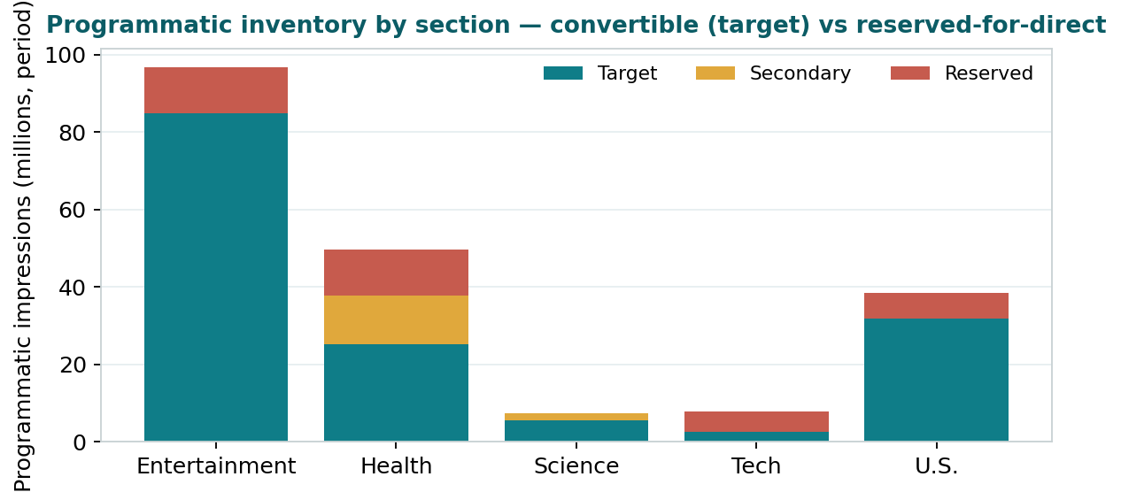
Figure 2 — Programmatic inventory by section: convertible target pool (teal) vs reserved-for-direct (red).
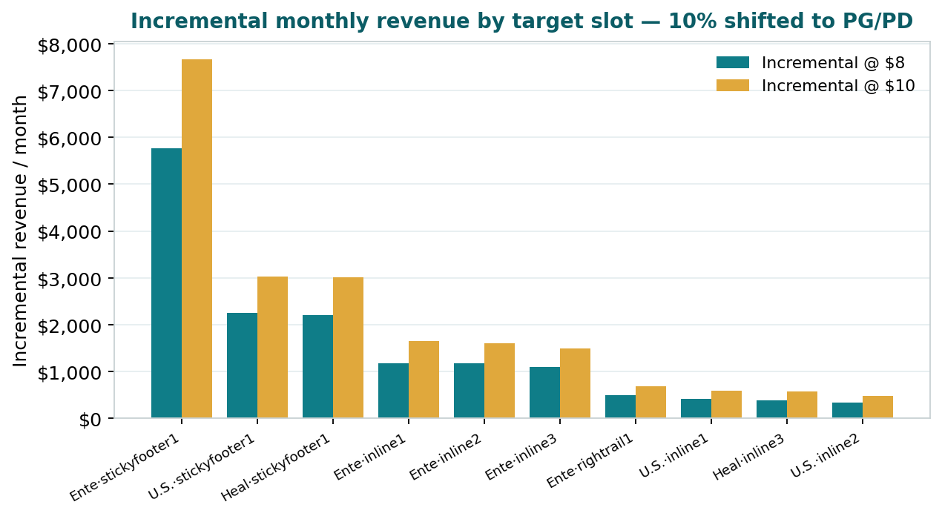
Figure 3 — Incremental monthly revenue by target slot at $8 / $10 (10% shift).
7. What This Means
- Scale — three-quarters of programmatic in these slots is convertible — high prog, low direct — so the opportunity is broad, not niche.
- Focus — stickyfooter1 (Entertainment, U.S., Health) alone drives ~61% of the 10% uplift — start there.
- Headroom — target pools clear at ~$2.44 vs direct at $19–$44; PG/PD at $8–$10 sits comfortably between — capturing value without undercutting direct.
- No conflict — leaderboard1 and most of Tech stay with direct sales; no channel conflict.
One-line answer: “Three-quarters of our programmatic in the top slots — 150M impressions clearing at ~$2.44 — is barely sold direct. Converting 10% to PG/PD at $8–$10 adds $16,723–$22,734 a month (~$200,681–$272,811/yr), led by stickyfooter1, while leaderboard1 stays with the direct team.”

Scope: 5 sections × 6 top slots, US, Jan–May 2026 (5 months). Impressions and CPMs from GAM pivot; every figure reconciled to grand totals (200.05M programmatic impressions; $2.63 blended prog CPM). Target = prog ≥ 60% & direct ≤ 35%; reserved = direct ≥ 40%. World & Politics not in this dataset (additive). Prepared by Databeat for TIME.

