DATABEAT | Prepared for TIME
PG/PD Incremental Revenue Model — Slot-wise
Section × slot view: how much additional revenue TIME can generate by converting a share of open-auction programmatic impressions into Preferred Deals / Programmatic Guaranteed, broken down to the individual ad slot (US inventory, top-6 slots)
Bottom line: across the five sections and six top slots, TIME serves ~11.1M programmatic impressions/month earning ~$32,359/month today (~$2.91 eCPM). Converting 10% into PG/PD at $8–$10 yields $8,891–$11,114/month vs $3,236 today — incremental $5,655–$7,878/month (~$67,862–$94,536/year). One slot — stickyfooter1 — is ~46% of the entire convertible pool, so it is the single highest-leverage place to start.

Scope & Method
- What — US inventory, six top slots (stickyfooter1, leaderboard1, inline1–3, rightrail1) across five sections (Entertainment, U.S., Health, Tech, Science).
- Data — GAM impressions pivot (section × slot), reconciled to the grand total (200.05M programmatic impressions).
- Assumptions — shift = share of programmatic impressions re-sold as PG/PD, priced at a fixed $8 and $10 eCPM; scenarios 5% / 10% / 15%.
- Formula — incremental = (shifted impressions ÷ 1000) × (PG/PD eCPM − current programmatic eCPM).
Two transparency notes (both editable in the companion spreadsheet): (1) this pivot carries impressions only, so current programmatic eCPM is applied from the confirmed section-level rate card — the same rate across a section's slots; slot-level eCPMs would refine the split but not the totals. (2) The programmatic volume implies an ~18-month window (Jan-2025–Jun-2026); “monthly” figures divide by 18. Confirm the export period and the per-month figures rescale exactly.
1. Current State — Programmatic Inventory by Slot
Aggregated across the five sections, here is how the programmatic impression pool and its current open-auction revenue split across the six slots:
Slot | Prog. imp (period) | Share | Monthly prog. imp | Current eCPM | Current rev / mo
stickyfooter1 | 91,556,001 | 45.8% | 5,086,444 | $2.84 | $14,464
leaderboard1 | 28,657,336 | 14.3% | 1,592,074 | $2.95 | $4,701
inline1 | 25,229,629 | 12.6% | 1,401,646 | $2.97 | $4,157
inline2 | 22,046,408 | 11.0% | 1,224,800 | $2.94 | $3,605
inline3 | 18,763,956 | 9.4% | 1,042,442 | $2.92 | $3,043
rightrail1 | 13,797,425 | 6.9% | 766,524 | $3.12 | $2,389
All 6 slots | 200,050,755 | 100% | 11,113,931 | $2.91 | $32,359

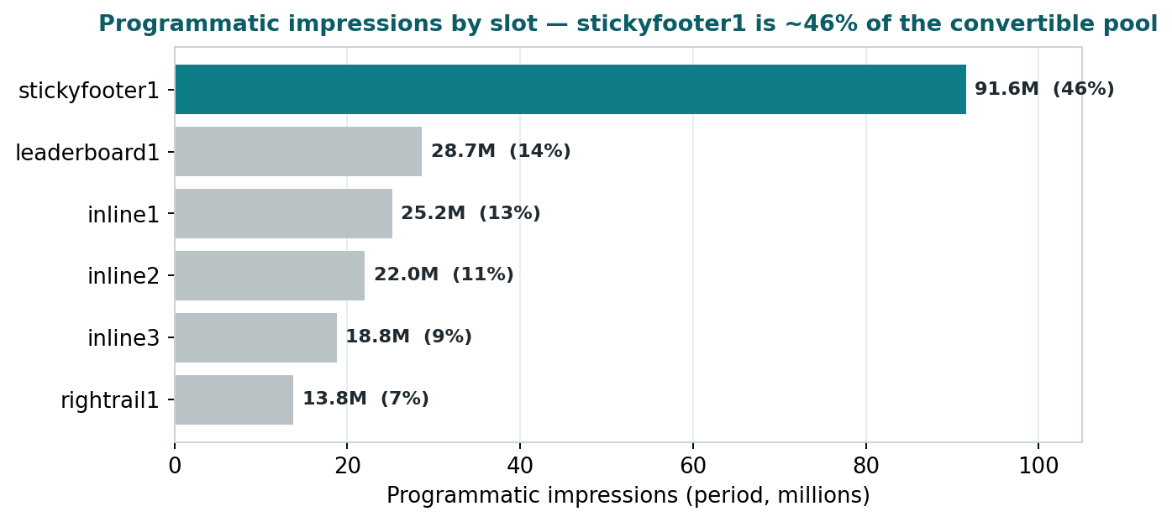
Figure 1 — Programmatic impressions by slot. stickyfooter1 alone is ~46% of the convertible pool.
2. The 10% Conversion — by Slot
Taking 10% of each slot's monthly programmatic impressions and re-selling as PG/PD at $8 / $10:
Slot | 10% imp / mo | Current rev | Rev @ $8 | Rev @ $10 | Uplift @ $8 | Uplift @ $10
stickyfooter1 | 508,644 | $1,446 | $4,069 | $5,086 | $2,623 | $3,640
leaderboard1 | 159,207 | $470 | $1,274 | $1,592 | $804 | $1,122
inline1 | 140,165 | $416 | $1,121 | $1,402 | $706 | $986
inline2 | 122,480 | $360 | $980 | $1,225 | $619 | $864
inline3 | 104,244 | $304 | $834 | $1,042 | $530 | $738
rightrail1 | 76,652 | $239 | $613 | $767 | $374 | $528
All 6 slots | 1,111,393 | $3,236 | $8,891 | $11,114 | $5,655 | $7,878

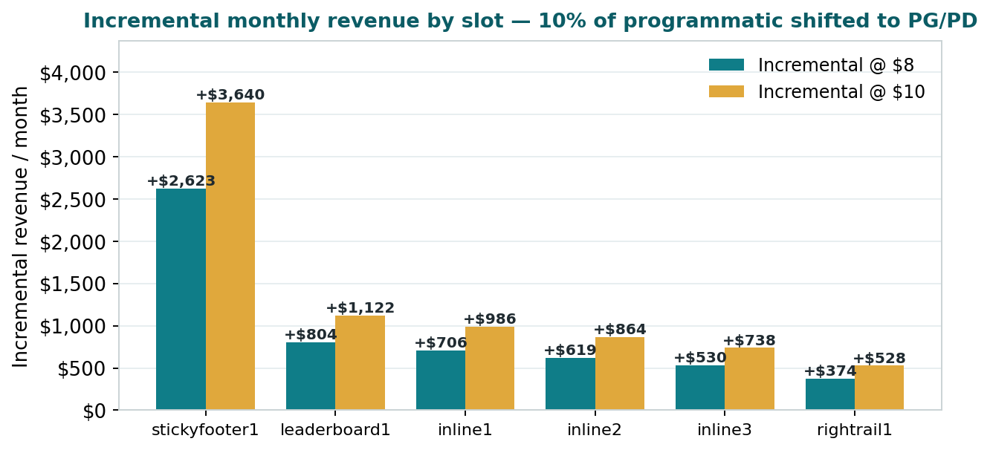
Figure 2 — Incremental monthly revenue by slot at $8 / $10 (10% shift).
Slot takeaway: stickyfooter1 alone contributes ~$2,623–$3,640/month of the total uplift — roughly 46%. Packaging stickyfooter1 as the first PG/PD product captures nearly half the opportunity from a single, high-viewability unit.

3. Full Detail — Section × Slot
The complete granular view Monica requested. Uplift is monthly, at the base 10% shift.
Section | Slot | Prog. imp (period) | Monthly imp | Cur. eCPM | Uplift/mo @ $8 | Uplift/mo @ $10
Entertainment | stickyfooter1 | 47,410,845 | 2,633,936 | $2.36 | $1,486 | $2,012
Entertainment | leaderboard1 | 11,875,493 | 659,750 | $2.36 | $372 | $504
Entertainment | inline1 | 11,630,907 | 646,162 | $2.36 | $364 | $494
Entertainment | inline2 | 10,920,299 | 606,683 | $2.36 | $342 | $464
Entertainment | inline3 | 10,019,326 | 556,629 | $2.36 | $314 | $425
Entertainment | rightrail1 | 4,846,780 | 269,266 | $2.36 | $152 | $206
Entertainment subtotal |  | 96,703,650 | 5,372,425 | $2.36 | $3,030 | $4,105
Health | stickyfooter1 | 20,185,172 | 1,121,398 | $4.04 | $444 | $668
Health | leaderboard1 | 7,007,562 | 389,309 | $4.04 | $154 | $232
Health | inline1 | 6,850,100 | 380,561 | $4.04 | $151 | $227
Health | inline2 | 5,874,817 | 326,379 | $4.04 | $129 | $195
Health | inline3 | 4,930,438 | 273,913 | $4.04 | $108 | $163
Health | rightrail1 | 4,880,198 | 271,122 | $4.04 | $107 | $162
Health subtotal |  | 49,728,287 | 2,762,683 | $4.04 | $1,094 | $1,647
U.S. | stickyfooter1 | 19,228,301 | 1,068,239 | $2.63 | $574 | $787
U.S. | leaderboard1 | 6,609,878 | 367,215 | $2.63 | $197 | $271
U.S. | inline1 | 4,331,009 | 240,612 | $2.63 | $129 | $177
U.S. | inline2 | 3,319,301 | 184,406 | $2.63 | $99 | $136
U.S. | inline3 | 2,359,398 | 131,078 | $2.63 | $70 | $97
U.S. | rightrail1 | 2,677,384 | 148,744 | $2.63 | $80 | $110
U.S. subtotal |  | 38,525,271 | 2,140,293 | $2.63 | $1,149 | $1,577
Tech | stickyfooter1 | 2,725,359 | 151,409 | $3.50 | $68 | $98
Tech | leaderboard1 | 1,551,790 | 86,211 | $3.50 | $39 | $56
Tech | inline1 | 1,137,367 | 63,187 | $3.50 | $28 | $41
Tech | inline2 | 885,597 | 49,200 | $3.50 | $22 | $32
Tech | inline3 | 673,770 | 37,432 | $3.50 | $17 | $24
Tech | rightrail1 | 821,619 | 45,646 | $3.50 | $21 | $30
Tech subtotal |  | 7,795,502 | 433,083 | $3.50 | $195 | $282
Science | stickyfooter1 | 2,006,324 | 111,462 | $3.39 | $51 | $74
Science | leaderboard1 | 1,612,613 | 89,590 | $3.39 | $41 | $59
Science | inline1 | 1,280,246 | 71,125 | $3.39 | $33 | $47
Science | inline2 | 1,046,394 | 58,133 | $3.39 | $27 | $38
Science | inline3 | 781,024 | 43,390 | $3.39 | $20 | $29
Science | rightrail1 | 571,444 | 31,747 | $3.39 | $15 | $21
Science subtotal |  | 7,298,045 | 405,447 | $3.39 | $187 | $268
GRAND TOTAL |  | 200,050,755 | 11,113,931 | $2.91 | $5,655 | $7,878

4. Scenarios — 5% / 10% / 15% Shift
Shift level | Incremental / mo @ $8 | Incremental / mo @ $10 | Annualized @ $8 | Annualized @ $10
5% | $2,828 | $3,939 | $33,931 | $47,268
10% | $5,655 | $7,878 | $67,862 | $94,536
15% | $8,483 | $11,817 | $101,794 | $141,804

5. What This Means (for Monica)
- Focus — go slot-first, not section-first: stickyfooter1 is ~46% of the programmatic pool — one product captures nearly half the upside.
- Impact — converting 10% of programmatic across these slots adds $5,655–$7,878/month (~$67,862–$94,536/year); 15% scales it ~1.5×.
- Headroom — premium slots clear at ~$2–$4 programmatically vs direct at $17–$33; PG/PD at $8–$10 captures the middle without cannibalizing direct.
- Sequence — stickyfooter1 → leaderboard1 → inline units, phased over 30/60/90 days as deals are signed.
One-line answer: “Slot-by-slot, converting 10% of programmatic in these top-6 units to PG/PD at $8–$10 lifts them from $3,236 to $8,891–$11,114 per month — ~$5,655–$7,878 incremental every month — and nearly half of that comes from a single unit, stickyfooter1.”

Scope note: five sections (Entertainment, U.S., Health, Tech, Science) × six top slots; US inventory. Impressions from GAM pivot; current programmatic eCPM applied from the confirmed section rate card (impressions-only source). Monthly = period ÷ 18 (assumed window Jan-2025–Jun-2026; confirm). World & Politics not included (additive). Prepared by Databeat for TIME.

