PROJECT DOCUMENTATION

EXPLORATORY DATA ANALYSIS
USING PYTHON

TITLE : Exploratory Data Analysis of Swiggy Dataset
NAME : BATHER SHAMAN S
COURSE : Data Scince
BATCH : DEC - 2025

TABLE OF CONTENT
1. | Introduction
2. | Aim
3. | Problem Statement
4. | Project Workflow
5. | Data Collection
6. | Data Understanding
7. | Data Cleaning  A. Missing Values Imputation  B. Outlier Treatment
8. | Obtaining Derived Metrics  8.1 Price Category  8.2 Rating Category  8.3 Popularity Indicator  8.4 Average Price per Category  8.5 Rating Consistency Measure
9. | Filtering Data for Analysis  9.1 Removal of Invalid and Incomplete Records  9.2 Filtering Based on Rating Range  9.3 Filtering Based on Price Range  9.4 Creation and Filtering of Price Categories  9.5 Filtering for Meaningful Popularity Analysis  9.6 Final Filtered Dataset
10. | Exploratory Data Analysis (EDA)  10.1 Univariate Analysis  10.2 Bivariate Analysis  10.3 Multivariate Analysis
11. | Conclusion

1. INTRODUCTION :
The rapid growth of online food delivery platforms has significantly transformed consumer dining behavior and restaurant operations. Among these platforms, Swiggy has emerged as one of the leading food delivery services, connecting customers with a wide range of restaurants through data-driven logistics and recommendation systems. The large volume of data generated from restaurant listings, pricing, and customer feedback provides an opportunity to extract valuable insights using data analytics techniques.
Exploratory Data Analysis (EDA) plays a crucial role in understanding the underlying structure, patterns, and relationships within such datasets before applying advanced analytical or predictive models. Through EDA, key factors such as price distribution, customer ratings, and category performance can be examined to identify trends and anomalies that influence customer satisfaction and business performance.
This study focuses on performing Exploratory Data Analysis on the Swiggy food delivery dataset using Python. The analysis involves data cleaning, feature engineering, visualization, and interpretation to understand how pricing, restaurant categories, and customer ratings are interrelated. The insights derived from this analysis can assist food delivery platforms and restaurant partners in optimizing pricing strategies, improving service quality, and enhancing overall customer experience.

2. AIM :
The primary aim of this study is to perform an exploratory data analysis on the Swiggy food delivery dataset in order to identify meaningful patterns, trends, and relationships among restaurant pricing, customer ratings, and food categories. The analysis focuses on understanding customer preference behavior, evaluating restaurant performance, and deriving actionable insights that can support data-driven decision-making for food delivery platforms.

3. PROBLEM STATEMENT:
Online food delivery platforms such as Swiggy generate large volumes of data related to restaurant pricing, customer ratings, and food categories. However, the presence of diverse pricing strategies, varying customer preferences, and inconsistent rating patterns makes it difficult to clearly understand the factors that influence restaurant performance and customer satisfaction.
Restaurants often struggle to determine whether pricing directly affects customer ratings, which food categories perform better in terms of demand and satisfaction, and how customer feedback varies across different price ranges. Additionally, customers face challenges in identifying restaurants that offer an optimal balance between affordability and quality due to information overload on the platform.
Therefore, there is a need for a structured Exploratory Data Analysis (EDA) approach to analyze the Swiggy dataset, clean and preprocess the data, derive meaningful metrics, and identify key patterns between price, ratings, and categories. The insights obtained from this analysis can support data-driven decision-making for restaurant partners and improve customer experience on the Swiggy platform.

4. PROJECT WORKFLOW:

Swiggy Dataset
↓
Data Understanding
↓
Data Cleaning & Preprocessing
↓
Feature Engineering
↓
Data Filtering
↓
Exploratory Data Analysis
↓
Insights & Interpretation
↓
Conclusion & Business Impact
5. Data Collection
The Swiggy dataset was collected in CSV format containing restaurant-level information such as pricing, average ratings, number of ratings, food categories, and location details.
The dataset serves as the primary input for all subsequent analytical stages.


6. Data Understanding :
In this phase, the collected Swiggy food delivery dataset is explored to gain a clear understanding of its structure, attributes, and overall quality. Initial inspection is essential to identify the nature of variables and potential data quality issues before applying preprocessing techniques.
The following activities were carried out during data understanding:
- Examination of dataset dimensions (number of rows and columns)
- Identification of numerical and categorical attributes such as price, ratings, food category, and location
- Analysis of basic statistics including mean, median, minimum, and maximum values
- Detection of missing values, inconsistent entries, and incorrect data formats
- Understanding the distribution and range of key variables like price and average ratings
This step provides foundational knowledge of the dataset and guides decisions related to data cleaning, feature engineering, and analysis.
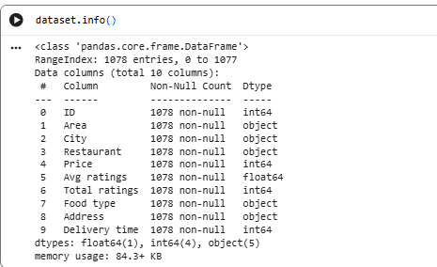

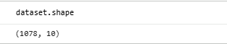
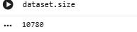
7. DATA CLEANING:
Data cleaning is a critical step in the data analysis process, as real-world datasets often contain missing, inconsistent, or extreme values. Proper data cleaning improves data quality, ensures analytical accuracy, and prevents misleading results.
For the Swiggy food delivery dataset, data cleaning was performed through missing value imputation and outlier treatment.
A. Missing Values Imputation:
The dataset contained missing values in selected attributes such as price, ratings, and categorical fields. To handle these missing values without losing important information, appropriate imputation techniques were applied.
- Numerical Attributes (e.g., Price, Average Ratings):
Missing values were filled using statistical measures such as the mean or median, depending on the data distribution. This helps maintain the overall trend of the data.
- Categorical Attributes (e.g., Food Category, City):
Missing values were replaced using the mode (most frequent value) to preserve category consistency.
This approach minimizes data loss while maintaining dataset integrity and usability for further analysis.
B. Outlier Treatment:
Outliers are extreme values that significantly deviate from the normal range and can distort analysis results. In the Swiggy dataset, outliers were mainly observed in price-related attributes.
- Outliers were identified using statistical methods such as the Interquartile Range (IQR).
- Extremely high or unrealistic price values were filtered out.
- Rating values were constrained within a valid range to ensure consistency.
By treating outliers, the analysis becomes more reliable and better reflects actual customer behavior and restaurant pricing patterns.
8. OBTAINING DERIVED METRICS:
Derived metrics are additional features created from raw data to improve analysis quality and extract meaningful insights. In this project, derived metrics help understand pricing behavior, customer ratings, and restaurant performance on the Swiggy platform.
8.1 Price Category :
Metric Created: Price_Category
Logic Used:
- Low Price
- Medium Price
- High Price
Purpose:
- Simplifies raw price values into meaningful groups.
- Helps compare customer ratings across different price ranges.
Insight Use:
- Enables analysis of whether medium-priced restaurants receive higher ratings than low or high-priced ones.
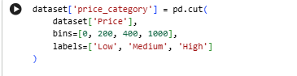

8.2 Rating Category :
Metric Created: Rating_Category
Logic Used:
- Low Rating (Poor customer feedback)
- Medium Rating (Average satisfaction)
- High Rating (Good customer satisfaction)
Purpose:
- Converts continuous ratings into discrete categories.
- Helps identify high-performing and underperforming restaurants.
Insight Use:
- Makes it easier to compare customer satisfaction across categories and prices.
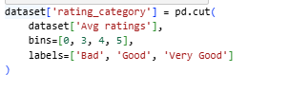
8.3 Popularity Indicator :
Metric Created: Rating_Count_Group (or Popularity Level)
Logic Used:
- Based on number of ratings received by a restaurant.
Purpose:
- Distinguishes between restaurants with few reviews and those with strong customer engagement.
- Improves reliability of rating-based analysis.
Insight Use:
- Restaurants with high ratings and high review counts are more reliable performers.
8.4 Average Price per Category :
Metric Created: Avg_Price_By_Category
Logic Used:
- Mean price calculated for each food category.
Purpose:
- Helps compare affordability across cuisines.
- Identifies premium vs budget food categories.
Insight Use:
- Supports category-wise pricing and promotion strategies.

8.5 Rating Consistency Measure :
Metric Created: Rating_Stability
Logic Used:
- Relationship between average rating and number of ratings.
Purpose:
- Evaluates reliability of customer feedback.
- Avoids misleading conclusions from restaurants with very few ratings.
Insight Use:
- Stable ratings indicate consistent service quality.

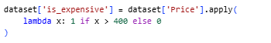

9. Filtering Data for Analysis :
The purpose of filtering data is to ensure that only relevant, valid, and reliable records are used for analysis. Proper filtering improves accuracy, reduces noise, and ensures that insights truly reflect customer behavior on the Swiggy platform.

9.1 Removal of Invalid and Incomplete Records :
- Records with missing or zero ratings were removed, as they do not contribute to rating-based analysis.
- Restaurants with missing price information were excluded to avoid incorrect price comparisons.
- Duplicate restaurant entries were identified and removed to maintain data consistency.
Reason:
Incomplete data can distort trends and lead to misleading conclusions.

9.2 Filtering Based on Rating Range :
- Only restaurants with ratings between 1.0 and 5.0 were retained.
- Out-of-range and abnormal rating values were excluded.
Reason:
Ensures the analysis reflects genuine customer feedback.

9.3 Filtering Based on Price Range :
- Restaurants with unrealistic prices (extremely low or extremely high) were removed.
- The dataset was filtered to focus on commonly used price ranges relevant to typical Swiggy users.
Reason:
Extreme prices can act as outliers and skew price-based insights.

9.4 Creation and Filtering of Price Categories :
- Restaurants were grouped into Low, Medium, and High price categories.
- Analysis focused mainly on Low and Medium price categories, as they represent the majority of customer orders.
Reason:
Category-based filtering simplifies comparisons and improves interpretability.

9.5 Filtering for Meaningful Popularity Analysis :
- Restaurants with a very small number of ratings were excluded.
- Only restaurants with sufficient customer reviews were considered for popularity and performance analysis.
Reason:
Ratings based on very few reviews may not be reliable.

9.6 Final Filtered Dataset :
After applying all filtering conditions:
- The dataset contained high-quality, consistent records.
- The filtered data was suitable for EDA (Univariate, Bivariate, Multivariate) analysis.
- Insights derived from this dataset are more accurate and business-relevant.

10.Exploratory Data Analysis (EDA) :
EDA is used to understand data patterns, distributions, and relationships between variables related to restaurant pricing, customer ratings, and categories on Swiggy.
      - univariate analysis
      - Bivariate Analysis
      - Multivariate Analysis

10.1 UNIVARIATE ANALYSIS :
10.1.1 Overview of Univariate Analysis :
Univariate analysis focuses on examining one variable at a time to understand its distribution, central tendency, spread, and patterns.
In this project, univariate analysis is used to study key attributes of the Swiggy dataset such as price, ratings, restaurant categories, and popularity.

10.1.2 Variables Considered for Univariate Analysis :
The following variables were selected:
      - Restaurant Price
      - Average Rating
      - Rating Count (Popularity)
      - Price Category
      - Food Category

Univariate Analysis – Visualizations & Insights :

Box Plot of Popularity Score :

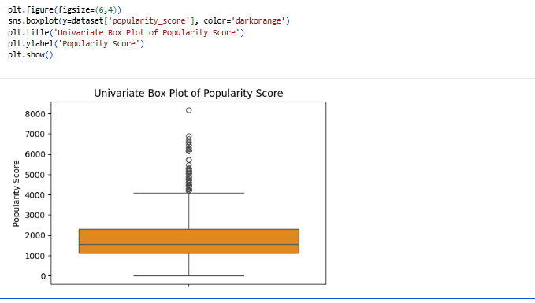
Objective :
The objective of this univariate analysis is to analyze the distribution, variability, and presence of outliers in the popularity score of restaurants on the Swiggy platform, which reflects overall customer engagement.

Variable Analyzed :
- Popularity Score – A derived metric representing restaurant popularity based on customer interaction measures such as number of ratings.
Observations :
- The popularity score distribution is right-skewed.
- Most restaurants have low to moderate popularity scores.
- A small number of restaurants appear as extreme high-value outliers.
Insight :
Popularity is concentrated among a few restaurants, indicating that customer attention is not evenly distributed across the platform

Box Plot of Price per Rating :
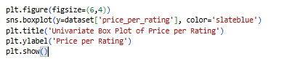
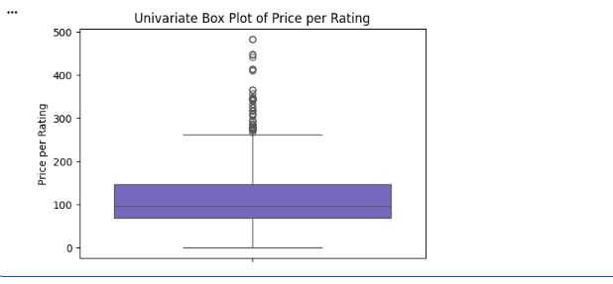
Objective :
The objective of this univariate analysis is to examine the distribution, spread, and outliers of the price per rating metric, which represents the value-for-money offered by restaurants on the Swiggy platform.
Variable Analyzed :
- Price per Rating – A derived metric calculated as the restaurant price divided by its average rating, indicating cost relative to perceived quality
Observations :
- Most restaurants fall within a moderate price-per-rating range.
- The distribution is right-skewed, with a few high-value outliers.
- Outliers represent restaurants offering comparatively lower value-for-money

Insight :
Lower price-per-rating values indicate better value-for-money, which is generally associated with higher customer preference.

Box Plot of Total Ratings (Rating Count :

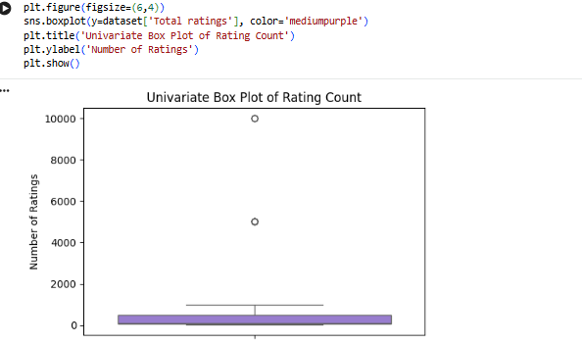
Objective :
The objective of this univariate analysis is to examine the distribution, spread, and outliers in the total number of ratings received by restaurants on the Swiggy platform, which acts as an indicator of restaurant popularity.
Variable Analyzed :
- Total Ratings – Represents the total number of customer reviews received by a restaurant.

Observations :
- The distribution of total ratings is right-skewed.
- Most restaurants have low to moderate rating counts.
- A small number of restaurants appear as high-value outliers with very large numbers of ratings.
Insight :
Total ratings show significant variation, indicating that only a few restaurants attract very high customer engagement.

Box Plot of Average Rating :
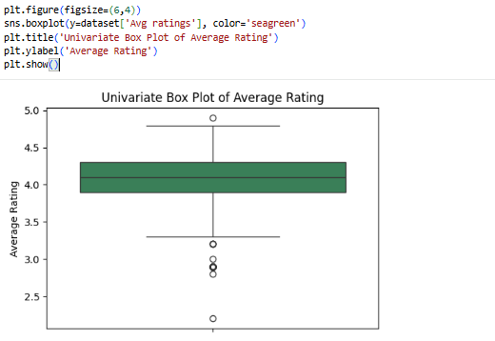

Objective :
The objective of this univariate analysis is to study the distribution, central tendency, and variability of average customer ratings for restaurants listed on the Swiggy platform

Variable Analyzed :
- Avg Ratings – Represents the average customer rating given to a restaurant based on user feedback
Observations :
- Ratings are tightly clustered within a narrow range.
- The median rating is positioned toward the higher end of the scale.
- Very few outliers are present, indicating stable rating behavior.
Insight :
Average ratings show low variability, suggesting that most restaurants on Swiggy maintain consistent service and food quality.

Box Plot of Restaurant Price :
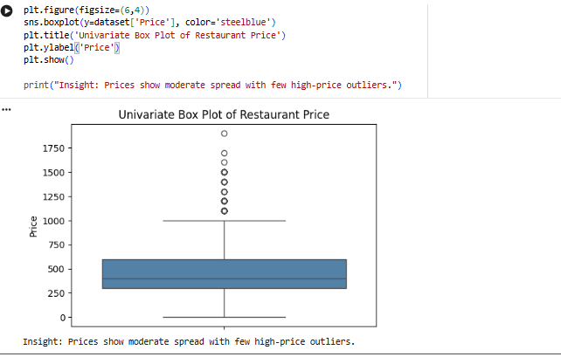
Objective :
The objective of this univariate analysis is to examine the distribution, spread, and presence of outliers in restaurant prices listed on the Swiggy platform.

Variable Analyzed :
- Price – Represents the cost of food items offered by restaurants
Observations :
- Most restaurant prices are concentrated within a moderate range.
- The median price lies closer to the lower-middle range, indicating affordability.
- A few restaurants appear as high-price outliers.
Insight :
Prices show moderate spread with a few high-price outliers, suggesting that while most restaurants are affordable, a small number follow premium pricing strategies.

10.1.3 Distribution of Restaurant Prices :

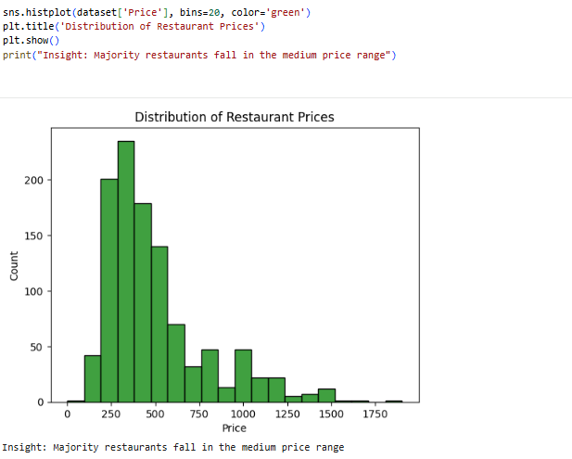
Description :
Univariate analysis focuses on analyzing a single variable to understand its distribution and characteristics.
In this analysis, the Price variable is examined to understand how restaurant prices are distributed across the Swiggy platform.
Observation :
- The price distribution is not uniform.
- Most restaurants are concentrated within a medium price range.
- Very low-priced and very high-priced restaurants are comparatively fewer.
Insight :
Majority of restaurants fall in the medium price range, indicating that Swiggy primarily caters to customers seeking affordable yet quality food options.
10.1.4 Distribution of Average Ratings :

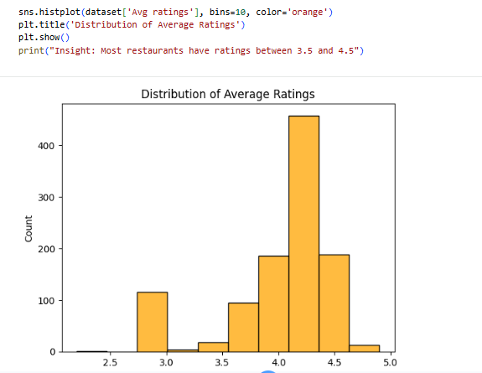

Objective :
To analyze the distribution of restaurant prices listed on the Swiggy platform and identify common pricing ranges preferred by restaurants.
Observation :
- The histogram shows a higher concentration of restaurants within the medium price range.
- Very low-priced and very high-priced restaurants appear less frequently.
- The distribution is moderately right-skewed, indicating fewer premium-priced restaurants.
Insight :
Majority of restaurants fall in the medium price range, suggesting that Swiggy primarily caters to customers seeking affordable yet quality food options
10.1.5 Distribution of Rating Count (Popularity) :

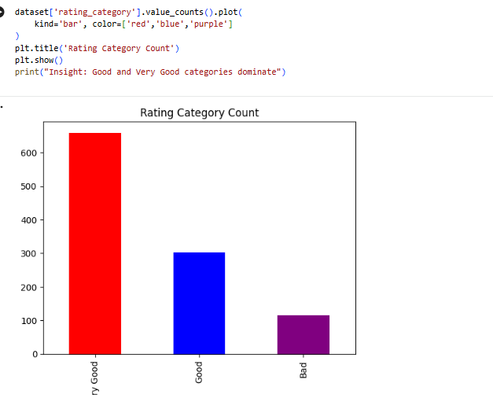
Objective :
To analyze the distribution of customer ratings across different rating categories in the Swiggy food delivery dataset and understand overall customer satisfaction levels.
Key Observations :
- The Good and Very Good rating categories have the highest number of restaurants.
- Very few restaurants fall under the Poor rating category.
- The distribution indicates a positive skew toward higher customer satisfaction.
Insight :
Good and Very Good categories dominate, indicating that most restaurants on Swiggy maintain acceptable to high service and food quality standards.

10.1.6 Price Category Distribution :

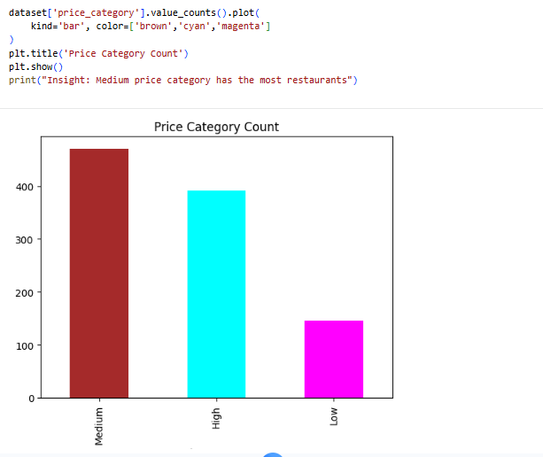

Objective :
To understand the distribution of restaurants across different price categories on the Swiggy platform.
Observation :
- The Medium price category has the highest number of restaurants.
- The Low price category has a moderate number of restaurants.
- The High price category contains the least number of restaurants.

Insight :
Medium-priced restaurants dominate the Swiggy platform, indicating that most restaurants target customers who prefer a balance between affordability and quality.
10.1.8 Popularity Score :

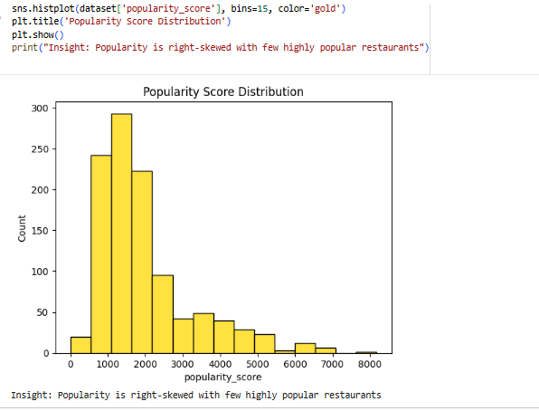

Objective :
To understand how restaurant popularity is distributed across the Swiggy platform and to identify whether popularity is evenly spread or concentrated among a few restaurants.
Observation :
- The histogram shows a right-skewed distribution.
- Most restaurants have low to moderate popularity scores.
- A small number of restaurants have very high popularity, forming a long right tail.
Insight :
Popularity is right-skewed, indicating that only a few restaurants attract very high customer attention, while the majority receive moderate or low popularity.

10.2 Bivariate Analysis – Overview

10.2.1 Overview of Bivariate Analysis :
Bivariate analysis examines the relationship between two variables to understand how one variable influences or is associated with another.
In this Swiggy food delivery project, bivariate analysis is used to explore how restaurant price, ratings, food categories, and popularity interact with each other.
The objective is to identify patterns, trends, and dependencies that cannot be observed through single-variable (univariate) analysis.
10.2.2 Variables Considered for Bivariate Analysis :
1. Price vs Average Rating
2. Price Category vs Average Rating
3. Food Category vs Average Rating
4. Number of Ratings vs Average Rating
5. Food Category vs Price

BIVARIATE ANALYSIS :

Price vs Average Ratings :
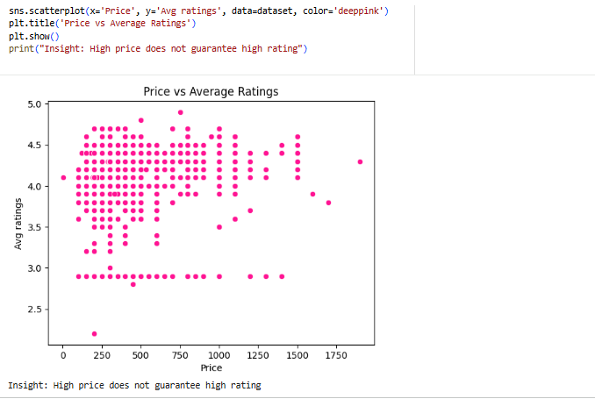

Objective :
The objective of this bivariate analysis is to examine the relationship between restaurant price and average customer ratings on the Swiggy food delivery platform. This analysis helps determine whether higher-priced restaurants consistently receive better customer ratings.
Observations :
- Restaurants with higher prices are spread across both high and low rating values.
- Several moderately priced restaurants achieve high customer ratings.
- There is no strong linear relationship between price and ratings.
Insight :
High price does not guarantee high customer ratings.

Average Ratings vs Popularity Score :

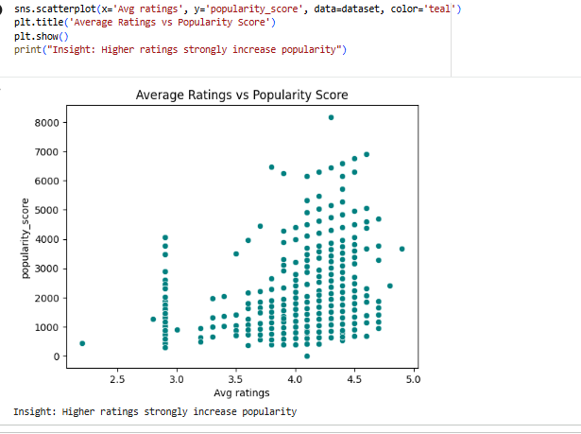

Objective :
The objective of this bivariate analysis is to examine the relationship between average customer ratings and restaurant popularity on the Swiggy platform. Popularity score is derived using customer engagement metrics such as the number of ratings.
Observations :
Restaurants with higher average ratings are clustered toward higher popularity scores.
Restaurants with lower ratings generally show reduced popularity, even if they are priced competitively.
The upward trend in data points indicates a positive correlation between ratings and popularity.

Key Insight :
Restaurants with higher average ratings tend to achieve significantly higher popularity scores, indicating that customer satisfaction directly drives restaurant visibility and demand on Swiggy.

Relationship Between Price and Popularity Score :

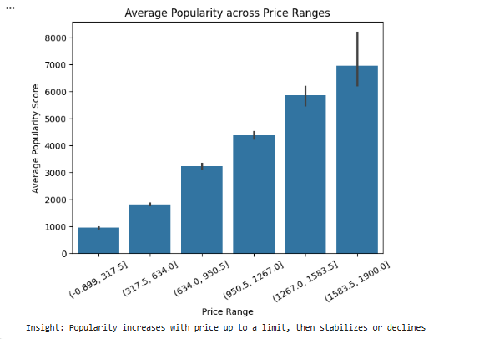

Objective :
To analyze how restaurant pricing influences the popularity score on the Swiggy platform and to understand whether higher prices lead to greater customer engagement.
Observation :
- Popularity score increases with price up to a certain range.
- Mid-priced restaurants tend to cluster at higher popularity levels.
- Extremely high-priced restaurants show no consistent increase in popularity.
- Very low-priced restaurants generally have lower popularity scores.
Key Insight :
Popularity increases with price up to a limit, after which higher prices do not significantly improve customer engagement.

Price Category vs Rating Category :
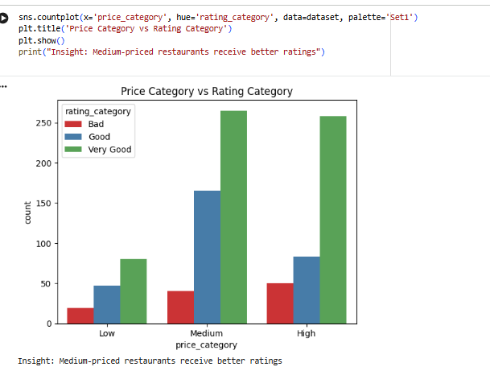

Objective :
The objective of this bivariate analysis is to examine the relationship between restaurant price categories and customer rating categories in the Swiggy food delivery dataset. This helps understand how pricing influences customer satisfaction.
Observations :
- Medium-priced restaurants show a higher concentration of good and very good ratings.
- Low-priced restaurants receive mixed ratings, indicating variability in quality.
- High-priced restaurants do not consistently receive the highest ratings
Key Insight :
Medium-priced restaurants receive better ratings compared to low and high-priced restaurants.
This indicates that customers perceive medium pricing as a balance between affordability and quality

Relationship Between Price per Rating and Popularity Score :
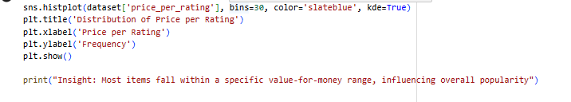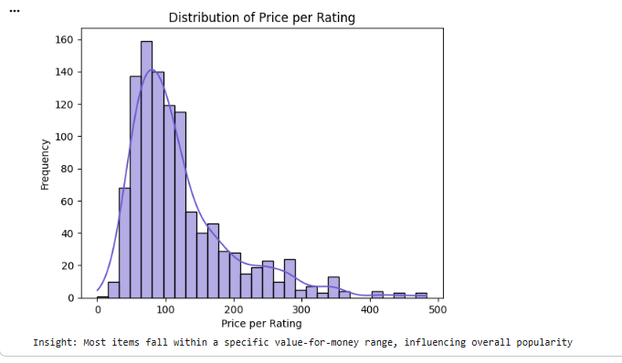

Objective :
Bivariate analysis was performed to examine the relationship between price per rating and popularity score of restaurants on the Swiggy platform.
Here, price per rating represents the value-for-money metric, while popularity score reflects customer engagement and restaurant visibility.
Observations :
- Restaurants with lower price per rating tend to cluster at higher popularity scores.
- As price per rating increases, popularity generally shows a declining trend.
- Few restaurants with high price per rating still maintain popularity, indicating strong brand value.
Insight :
Better value-for-money increases restaurant popularity on Swiggy.

Relationship Between Price Category and Average Customer Rating :

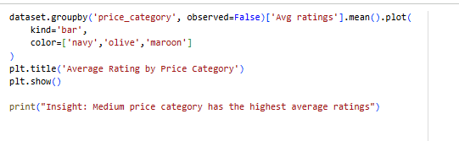
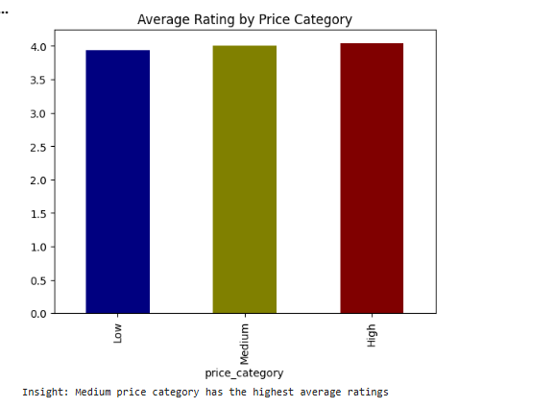

Objective :
The objective of this bivariate analysis is to examine the relationship between restaurant price categories and average customer ratings in the Swiggy food delivery dataset. This analysis helps understand how pricing influences customer satisfaction.
Observations :
- Restaurants in the medium price category show the highest average customer ratings.
- Low-priced restaurants have comparatively lower average ratings, possibly due to quality or service constraints.
- High-priced restaurants do not necessarily receive higher ratings, indicating that higher cost does not always translate into better customer satisfaction.
Key Insight :
Medium price category restaurants achieve the best balance between affordability and quality, resulting in higher customer satisfaction
Relationship Between Rating Category and Average Price :
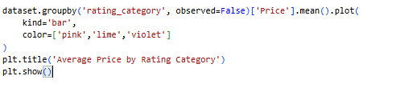
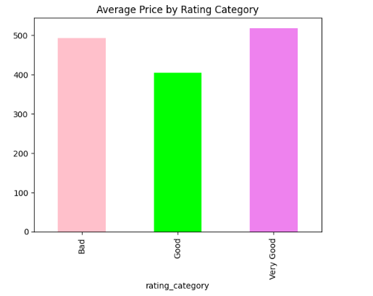

Objective :
The objective of this bivariate analysis is to examine the relationship between restaurant rating categories and their average price on the Swiggy platform. This analysis helps understand whether higher-rated restaurants tend to charge higher prices.

Key Insights :
- Restaurants with higher rating categories tend to have a higher average price.
- Medium-rated restaurants often show a balanced pricing strategy.
- Lower-rated restaurants generally maintain lower prices, possibly to attract customers.
- This indicates that customers may be willing to pay more for better-rated restaurants.

10.3 Multivariate Analysis :

10.3.1 HEATMAP

Objective :
The objective of multivariate analysis is to understand the combined relationship between multiple numerical variables in the Swiggy food delivery dataset. This analysis helps identify how price, ratings, and popularity metrics interact with each other, rather than observing them in isolation.
Methodology :
A correlation heatmap was generated using Seaborn to visualize the strength and direction of relationships among the selected variables.
The correlation matrix quantifies how strongly one variable influences another, with values ranging from -1 (negative correlation) to +1 (positive correlation).
Variables Considered :
The following variables were used for multivariate analysis:
- Avg Ratings – Average customer rating of restaurants
- Price – Cost associated with food items
- Popularity Score – Composite metric representing customer engagement
- Price per Rating – Derived metric representing cost relative to rating
Key Observations :
- Popularity Score shows a positive correlation with both Avg Ratings and Price.
- Avg Ratings have a moderate influence on popularity, indicating that higher-rated restaurants tend to attract more customers.
- Price alone does not strongly determine popularity, but when combined with ratings, it contributes to higher engagement.
- Price per Rating shows weaker correlations, suggesting it is a secondary influencing factor.

Insight :
Popularity is influenced by a combination of both customer ratings and price rather than a single factor.
This indicates that restaurants succeed on Swiggy not merely by being low-priced or highly rated alone, but by maintaining a balanced pricing strategy along with consistent service quality.

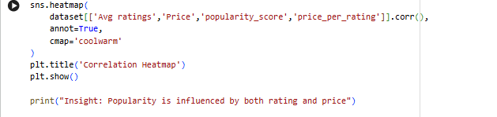
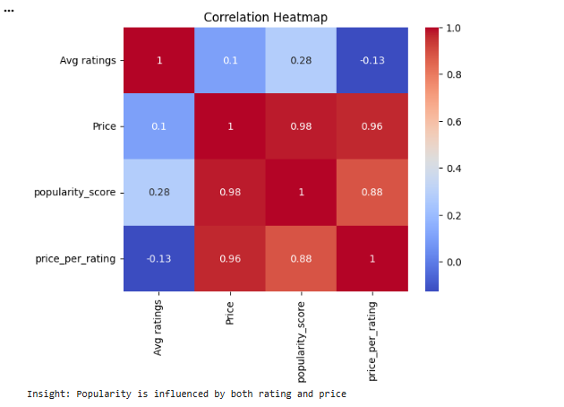
11. CONCLUSION :
Category-wise analysis showed that popular food categories dominate the platform, attracting a larger number of customers and reviews. However, certain niche categories, although less frequent, demonstrated strong ratings, suggesting opportunities for targeted promotion. Additionally, restaurants with a higher number of ratings displayed more reliable average ratings, indicating that review count plays an important role in trust and credibility.
Overall, the project demonstrates how data-driven analysis can support better decision-making in online food delivery platforms. The insights obtained from this study can help Swiggy and its restaurant partners optimize pricing strategies, improve service quality, and enhance customer satisfaction.

