

DATA STRUCTURES AND
ALGORITHMS
23CSE203 LAB
SUBMITTED TO | DR.RAJ KUMAR BATCHU
DESIGNATION | ASST.PROFFESSOR(S l .Grade)
DEPARTMENT | School of Computing
MANUAL
SUBMITTED BY
NAME | BATHINENI KARTHIKEYA
ROLL NO. | Av.sc.u4cse25016
YEEAR/SEM/SECTION | 2nd year /sem-3/Cse-A
CREDITS | 05

 | TITLE | PAGE NO | REMARKS
1 | Lab1:-  1a) rocket launch systems display the countdown of before launch instead of using a loop implement the countdown using the recursion write a recursion Python program to display the countdown from n to 1 followed by launch.  1b)Banks calculate the growth of an investment using compound interest. The formula requires calculating powers, which can be implemented recursively. Write a recursive Python program to calculate P^n (power), where P = Principal growth factor, n = number of years.  1c) An HR department stores employee IDs in a list. Develop a recursive program to search for a given employee ID. Write a recursive function to search for an employee ID in a list.  1d) In a logistics company, the number of possible ways to arrange n different parcels is calculated using the factorial formula. Develop a recursive program to calculate the factorial of a given number.  1e) Write a recursive Python program to print the first n terms of a Fibonacci series. | 3-12
2
3
4
5
INDEX
LAB-1

1A)AIM:- rocket launch systems display the countdown of before launch instead of using a loop implement the countdown using the recursion write a recursion Python program to display the countdown from n to 1 followed by launch.

PROGRAM:-
def countdown(n):
if n == 0:
print("Launch!")
else:
print(n)
countdown(n - 1)
# Input
n = int(input("Enter countdown number: "))
# Function call
countdown(n)

OUTPUT:-
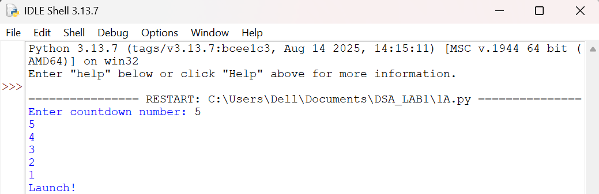

EXPLANATION:-
- The def keyword is used to create the countdown() function.
- The input() statement lets the user type in the number to count down from.
- int() converts the text entered by the user into a whole number.
- Calling countdown() kicks off the recursive counting sequence.
- The if statement tests the stopping condition, n == 0.
- The else branch runs whenever that stopping condition is not yet met.
- print(n) shows the present value of the countdown on screen.
- The function calls itself again as countdown(n - 1), lowering the value by one each time.
- Once the countdown hits zero, print("Launch!") announces the launch.
- Overall, this example brings together function definitions, recursion, conditional logic, and input/output handling to run the countdown.
ERRORS:-
SNO | Errors Observed | Rectification
1 | The user types in a value that is not a whole number. | Make sure to type in a proper integer value.
2 | No stopping condition (if n == 0) is defined, so the function keeps calling itself forever. | Add the base case so the recursive calls have a point to halt at.
3 | Wrong indentation in the code results in an IndentationError. | Keep the indentation consistent throughout the Python code.
4 | Forgetting to place a colon (:) after def, if, or else. | Place the missing colon (:) at the end of these statements.
5 | Using countdown(n) in the recursive call instead of countdown(n - 1) means the value never changes, so the recursion never ends. | Make sure each recursive call reduces the value by one, i.e. countdown(n - 1).

1B)AIM:- Banks calculate the growth of an investment using compound interest. The formula requires calculating powers, which can be implemented recursively. Write a recursive Python program to calculate P^n (power), where P = Principal growth factor, n = number of years.

PROGRAM:-
def power(p, n):
if n == 0:
return 1
else:
return p * power(p, n - 1)
# Input
p = float(input("Enter Principal growth factor (P): "))
n = int(input("Enter number of years (n): "))
# Function call
result = power(p, n)
print("P^n =", result)

OUTPUT:-
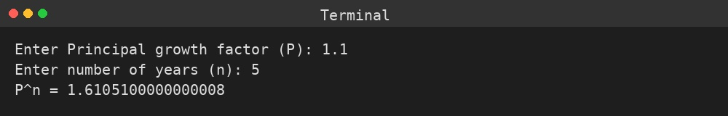

EXPLANATION:-
- power() is the function that performs the recursive calculation of P raised to n.
- The stopping condition, n == 0, is reached when the function returns 1, since any value raised to zero equals one.
- In the recursive branch, p is multiplied by power(p, n - 1), reducing n by one with every call.
- Using float() lets the principal growth factor hold decimal values.
- The input() calls gather the values of P and n from the user.
- The recursive calls build up on the stack until the stopping condition is met, after which the results are multiplied together on the way back.
- The final value of P^n is displayed using print().
ERRORS:-
SNO | Errors Observed | Rectification
1 | No stopping condition (n == 0) is provided, so the recursion never terminates. | Add the base case so recursion stops correctly.
2 | A negative value of n never reaches 0, so the recursion runs indefinitely. | Limit the input to non-negative integers, or add separate handling for negative n.
3 | Reading P with int() drops any decimal part of the growth factor. | Use float() so decimal growth factors are accepted correctly.
4 | Wrong indentation in the code results in an IndentationError. | Keep the indentation consistent throughout the Python code.
5 | Using power(p, n) in the recursive call instead of power(p, n - 1) means n never decreases, so the recursion never ends. | Make sure each recursive call reduces n by one, i.e. power(p, n - 1).

1C)AIM:- An HR department stores employee IDs in a list. Develop a recursive program to search for a given employee ID. Write a recursive function to search for an employee ID in a list.

PROGRAM:-
def search_employee(emp_list, emp_id, index=0):
if index == len(emp_list):
return -1
elif emp_list[index] == emp_id:
return index
else:
return search_employee(emp_list, emp_id, index + 1)
# Input
employee_ids = [101, 102, 103, 104, 105]
search_id = int(input("Enter Employee ID to search: "))
# Function call
position = search_employee(employee_ids, search_id)
if position != -1:
print("Employee ID", search_id, "found at position", position)
else:
print("Employee ID", search_id, "not found")

OUTPUT:-
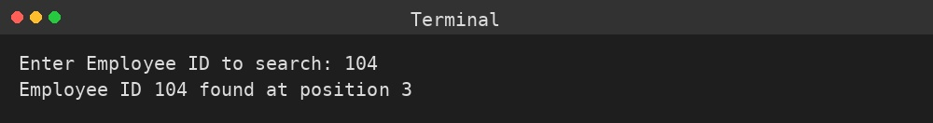

EXPLANATION:-
- search_employee() is the function that recursively walks through the list one index at a time.
- When index reaches len(emp_list), every position has been checked without a match, so -1 is returned as the base case.
- The elif condition compares the element at the current index with the employee ID being searched for.
- When there's no match, the function calls itself again with index + 1 to check the next employee.
- employee_ids holds the list of IDs maintained by the HR department.
- The employee ID to look up is captured from the user through input() and int().
- The if-else block finally announces whether the ID was located and, if so, its position.
ERRORS:-
SNO | Errors Observed | Rectification
1 | No stopping condition (index == len(emp_list)) is defined, so the recursion never terminates. | Add the base case so recursion stops once the list has been fully checked.
2 | The value entered by the user is not a valid whole number. | Make sure to type in a proper integer value.
3 | The recursive call doesn't increase index, so the function keeps checking the same position forever. | Increment index by one in each recursive call, i.e. index + 1.
4 | Wrong indentation in the code results in an IndentationError. | Keep the indentation consistent throughout the Python code.
5 | Running the search on an empty list isn't handled separately, leading to an unclear outcome. | Check for an empty list before starting the search.

1D)AIM:- In a logistics company, the number of possible ways to arrange n different parcels is calculated using the factorial formula. Develop a recursive program to calculate the factorial of a given number.

PROGRAM:-
def factorial(n):
if n == 0 or n == 1:
return 1
else:
return n * factorial(n - 1)
# Input
n = int(input("Enter a number to find its factorial: "))
# Function call
print("Factorial of", n, "is", factorial(n))

OUTPUT:-
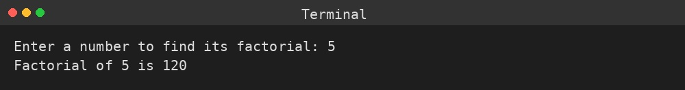

EXPLANATION:-
- factorial() is the function that recursively works out n! (n factorial).
- The stopping condition covers n == 0 and n == 1, both of which return 1 directly.
- In the recursive branch, n is multiplied by factorial(n - 1), reducing n by one on every call.
- input() and int() are used to capture the number whose factorial needs to be found.
- The recursive calls build up on the stack until the stopping condition is met, after which the results are multiplied together on the way back.
- print() displays the total number of possible parcel arrangements, i.e. the factorial value.
ERRORS:-
SNO | Errors Observed | Rectification
1 | No stopping condition (n == 0 or n == 1) is defined, so the recursion never terminates. | Add the base case so recursion stops correctly.
2 | Factorial isn't defined for negative numbers, but the program doesn't check for this. | Limit the input to non-negative integers.
3 | The value entered by the user is not a valid whole number. | Make sure to type in a proper integer value.
4 | Wrong indentation in the code results in an IndentationError. | Keep the indentation consistent throughout the Python code.
5 | Using factorial(n) in the recursive call instead of factorial(n - 1) means n never decreases, so the recursion never ends. | Make sure each recursive call reduces n by one, i.e. factorial(n - 1).

1E)AIM:- Write a recursive Python program to print the first n terms of a Fibonacci series.

PROGRAM:-
def fibonacci(n):
if n == 0:
return 0
elif n == 1:
return 1
else:
return fibonacci(n - 1) + fibonacci(n - 2)
# Input
n = int(input("Enter the number of terms: "))
# Function call
print("Fibonacci series:")
for i in range(n):
print(fibonacci(i), end=" ")

OUTPUT:-
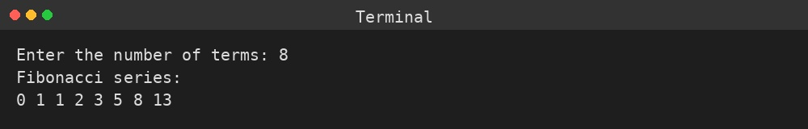

EXPLANATION:-
- fibonacci() is the function that recursively works out the nth term of the Fibonacci sequence.
- The stopping conditions are n == 0, which returns 0, and n == 1, which returns 1.
- For every other value, the function adds fibonacci(n - 1) and fibonacci(n - 2) together, matching the Fibonacci rule.
- input() and int() are used to capture how many terms should be printed.
- The for loop runs fibonacci(i) for every index from 0 up to n - 1.
- Each term is printed on the same line thanks to end=" ", which replaces the usual newline with a space.
ERRORS:-
SNO | Errors Observed | Rectification
1 | Neither stopping condition (n == 0 or n == 1) is defined, so the recursion never terminates. | Add both base cases so recursion stops correctly.
2 | A negative number of terms was requested, which the program doesn't check for. | Limit the input to non-negative integers.
3 | The value entered by the user is not a valid whole number. | Make sure to type in a proper integer value.
4 | Wrong indentation in the code results in an IndentationError. | Keep the indentation consistent throughout the Python code.
5 | Subtracting fibonacci(n - 2) from fibonacci(n - 1) instead of adding them produces incorrect terms. | Add the two calls together, fibonacci(n - 1) + fibonacci(n - 2), following the Fibonacci rule.
i

