**Menu Pilihan**

{ Judul }

program MenuPilihan;

{I.S. : User memilih salah satu menu}

{F.S. : Menampilkan hasil dari menu yang dipilih}

uses crt, sysutils;

{ Kamus }

var Pilihan: integer;

{ M x N }

var M, N, Hasil, i: integer;

{ Suku ke-N }

var

m00, m01, m02, m03, x, total: integer;

{ Algoritma }

begin

{ Input }

repeat

clrscr; textcolor(white);

gotoxy(28, 1); write('Menu Pilihan');

gotoxy(28, 2); write('------------');

gotoxy(8, 4); writeln('1. M x N menggunakan operator +');

gotoxy(8, 5); writeln('2. Barisan dari N suku: 2, 3, 5, 15, ... ');

gotoxy(8, 6); writeln('0. Keluar');

gotoxy(8, 7); write('PILIHAN ANDA? '); readln(Pilihan);

while (Pilihan < 0) or (Pilihan > 2) do

begin

gotoxy(8, 8); textcolor(yellow);

write('Pilihan hanya 0 / 1 / 2, Ulangi tekan enter!');

readln;

gotoxy(8, 8); clreol;

gotoxy(22, 7); clreol; textcolor(white);

readln(Pilihan);

end;

case (Pilihan) of

1: begin

clrscr();

writeln('Perkalian M x N');

writeln('------------');

{ Input }

Hasil := 0;

write('Masukkan nilai M: '); readln(M);

write('Masukkan nilai N: '); readln(N);

{ Proses }

gotoxy(1, 5); write(M, ' x ', N);

gotoxy(18, 5); write('= ');

{ Kondisi (Pemilihan) }

// Kondisi M = 0 or N = 0

if (M = 0) or (N = 0) then

// Aksi

Hasil := 0

else

// Kondisi M > 0 or M < 0; N > 0

// M = 3; N = 2

if ((M > 0) or (M < 0)) and (N > 0) then

begin

// Perulangan (for)

for i := 1 to N do

begin

write(M);

Hasil := Hasil + M;

if (i <> N) then

write(' + ');

end;

end

else

// Kondisi N < 0; M = 3; N = -2

if (M > 0) and (N < 0) then

begin

// Perulangan (for)

for i := 1 to M do

begin

write(N);

Hasil := Hasil + N;

if (i <> M) then

write(' + ');

end;

end

// Kondisi M & N < 0

else

begin

M := M * -1; // Positif

N := N * -1; // Positif

// Perulangan (for)

for i := 1 to N do

begin

write(M);

Hasil := Hasil + M;

if (i <> N) then

write(' + ');

end;

end;

gotoxy(18, 6);

writeln('= ', Hasil);

readln;

end; // EndDepend M x N

2: begin

clrscr();

writeln('Barisan dari N suku');

writeln('-------------------');

write('Masukkan nilai N: '); readln(x);

if (x > 0) and (x <= 10) then

begin

write('Deretnya adalah: ');

for i := 1 to x do

begin

m00 := 2;

m01 := i - 1;

m02 := sqr(i) - 3*i + 2;

m03 := m02 * (i - 3) * 7;

total := m00 + m01 + (m02 div 2) + (m03 div 6);

// Un := 2 + (n - 1) + ((n^2 - 3n + 2) / 2) + ((n^3) / 6)

write(total);

if (i <> x) then

write(', ');

end;

writeln();

writeln('Nilai suku ke-', x, ' adalah: ', total);

end

else

write('Nilai N hanya boleh dari 1 - 10!');

readln;

end;

0: begin

gotoxy(8, 9); writeln('Kamu Keluar!');

end;

end;

until (Pilihan = 0);

end.

**Screenshot**

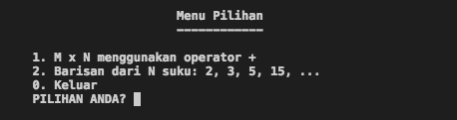

**Salah Menu**

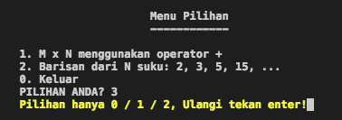

1. **Perkalian M x N**

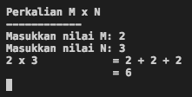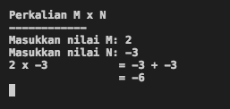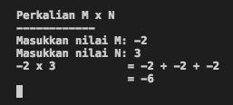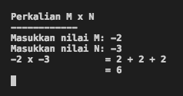

**2. N suku (Rumus deret tingkat 3)**

