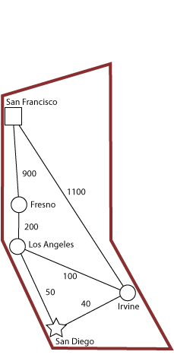

**Problem: Find shortest route from San Diego to San Francisco**

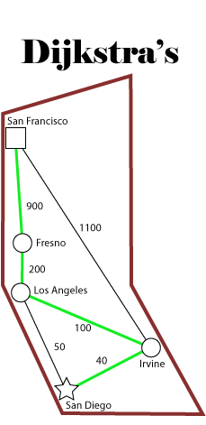

|  |  |  |
| --- | --- | --- |
| **City** | **Distance** | **Total** |
| Irvine | 40 | 40 |
| Los Angeles | 100 | 140 |
| Fresno | 200 | 340 |
| San Francisco | 900 | 1240 |

**T1 = 1240**

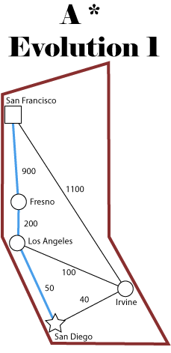

|  |  |  |  |
| --- | --- | --- | --- |
| **City** | **Distance** | **Total** | **< T1?** |
| Los Angeles | 50 | 50 | Y |
| Fresno | 200 | 250 | Y |
| San Francisco | 900 | 1150 | Y |

**T2 = 1150**

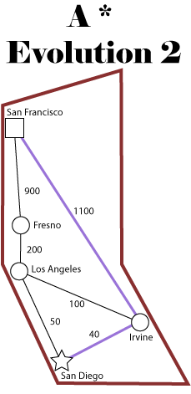

|  |  |  |  |
| --- | --- | --- | --- |
| **City** | **Distance** | **Total** | **<** |
| Los Angeles | 50 | 50 | Y |
| Fresno | 200 | 250 | Y |
| San Francisco | 900 | 1150 |  |

|  |  |  |  |
| --- | --- | --- | --- |
| **City** | **Distance** | **Total** | **< T2?** |
| Irvine | 40 | 40 | Y |
| San Francisco | 900 | 1140 | Y |

**T3 = 1140**