FCS Website Update

# Account Info:

URI: FCSRespite.com

Cost: $14.04

Hosting: Namecheap

Plan: Value

Cost: $9.88 / year

Expires: July 2, 2018

# Site Info:

Framework:

Twitter Bootstrap 3.0

Pages:

|  |  |  |
| --- | --- | --- |
| **Name** | **Filename** | **Purpose** |
| Main, Default, Home | Index.html | Main landing page |
| Employee Memo | Memo.html | Update employees on status |
| Services | Services.html | Display parent provider manual |
| About | About.html | Provide information about business |
| Contact | Contact.html | Provide contact information |

# Main Page

Sections / Panels:

Memo modal, Providers, Services, About, Contact

Images:

1). <https://pixabay.com/en/kern-river-outdoors-nature-water-1693392/>

Completed:

Basic setup

Implemented framework

Navigation bar with collapse

First Jumbotron

Closable modal

To Do:

Add all sections to main page

Find 3 more images for sections

Find or make background for main top banner

Add favicon

Choose color scheme - <http://paletton.com/>

Screenshots:

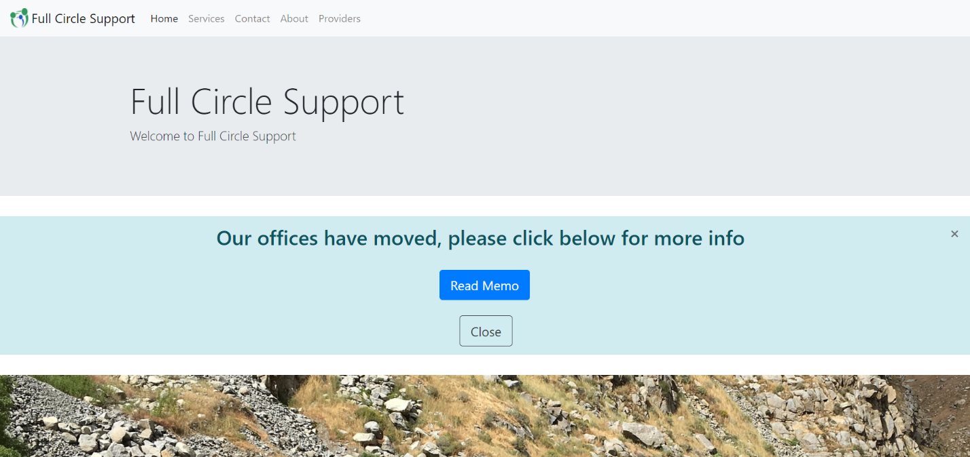

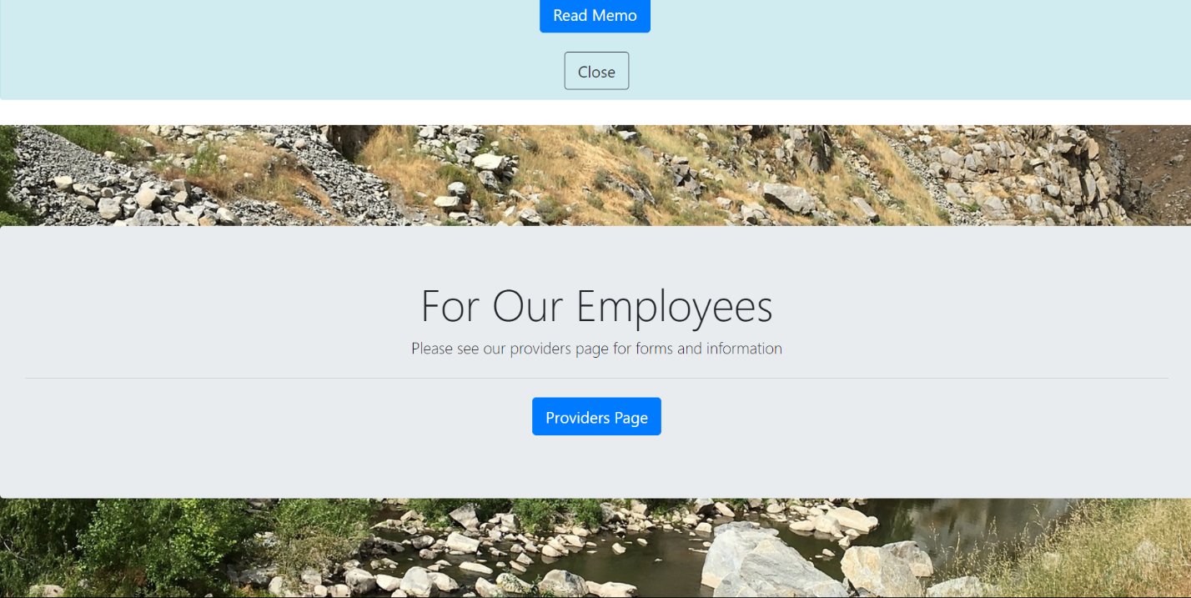

# Memo

To Do:

Create page

# Services

To Do:

Create page

# About

To Do:

Create page

# Contact

To Do:

Create page

# Update 2

## General

Completed:

Fixed navigation bar icon, did not close previously

Found images for third break

Re-arranged order of links and breaks based on importance

## Main

To Do:

Create banner art

Pick Color scheme

Add favicon

Choose color scheme - <http://paletton.com/>

Add all sections to front page

Test on all browsers

Validate code

Deploy website

## Memo

To Do: Create page

## Services

To Do: Create page

## About

To Do: Create page

## Contact

To Do: Create page