1. Let $P(n)$ be the statement that $1x1!+ 2x2! +…+ nxn! = \left(n+1\right)!-1$ for the positive integer n. **(20 pts)**
2. Prove in the base step?

**Answer:**

1. Prove in the inductive step?

**Answer:**

**2. a) (15 pts)**

Function $f:Student_Id→ Student_Score$ $f: \{(1001, 75), (1002, 45), (1013, 90), (1015, 70), (1016, 65), (1021, 80), (1023, 53), (1030, 86)\}$

Function $g: Student_Score→Grade_Table$

**Find $(g o f ) (a) = g (f (a))$, for each**

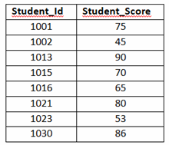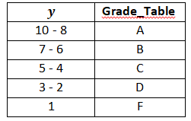



**Answer:**

**b)** Is the function $f$ onto function? **(5 pts)**

**Answer:**

□ YES □ NO

**3.** The X numbers may be defined recursively by $X_{0}=0, X_{1}=1$ and $X_{n }={2X}_{n-2}+ X_{n-1}$

1. Please find the $X_{n}$ series in the following table. **(5 pts)**

|  |  |  |  |  |  |  |  |
| --- | --- | --- | --- | --- | --- | --- | --- |
| **n** | **0** | **1** | **2** | **3** | **4** | **5** | **6** |
| **An** | 2 | 1 | 1 | 5 | 17 | 101 | 201 |
| **Xn** | 0 | 1 | **?** | **?** | **?** | **?** | **?** |

1. Write the formula of interrelations between $X_{n}$ and $A_{n}$. **(15 pts)**

**Answer:**

**4. a)** Are G and H graphs isomorphic? Please explain with reasons. **(10 pts)**

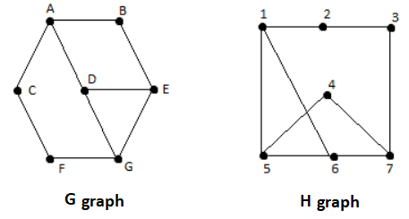

**Answer:**

**b)** Is H graph planer? Please explain with reasons. **(5 pts)**

**Answer:**

**c)** Find the chromatic number of H graph. **(5 pts)**

**Answer:**

**5.** Find an Euler circuits and/or Euler paths for the following graph. If your answer is “yes”, please write the circuit and/or path. **(10pts)**

|  |  |
| --- | --- |
| **Euler circuit** | **Euler path** |
| Yes/ No | Yes/ No |
|  |  |

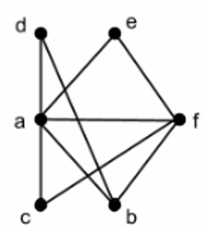

**6.** Solve the traveling salesman problem for this graph by determining a Hamilton circuit with minimum total distance. **(10pts)**

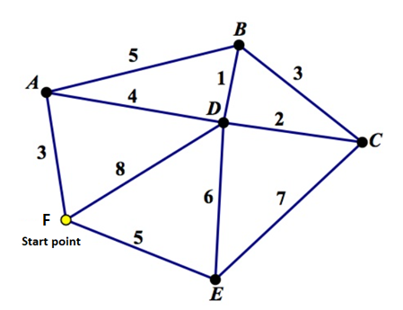

**Answer:**