**15.05.2023**

**CSE1120 Discrete Structures**

**2022-2023 SPRING SEMESTER**

**COMPUTER PROJECT**

**Deadline: 02.06.2023/23:00**

* **Upload your project to Mic. Teams.**
* **You have to be a group of 2 students for this project.**
* **Please write the solutions and codes of each quesitons that included the screenshots of the outputs of the programs to the report.**
* **Report cover page is indicated below.**
* **Please upload the source files of each question as .rar or .zip file.**

**Question 1:**

**a)** Use mathematical induction to show that

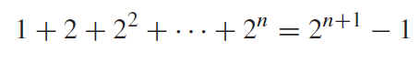

for all nonnegative integers *n*.

**b)** Write a computer program that validates this equation.

**Question 2:**

$A=\{1, 2, 3, 4 ,5\}$ and $B=\{t, u, v, w, x, y, z\}$

**a)** If a fuction $f:A→B$ is randomly generated, what is th probability that it is one to one?

**b)** Write a computer program to generate random functions $f:A→B$ and have the program print out how many functions it generates that is one to one?

**Question 3:**

Write a recursive method to generate Lucas numbers.

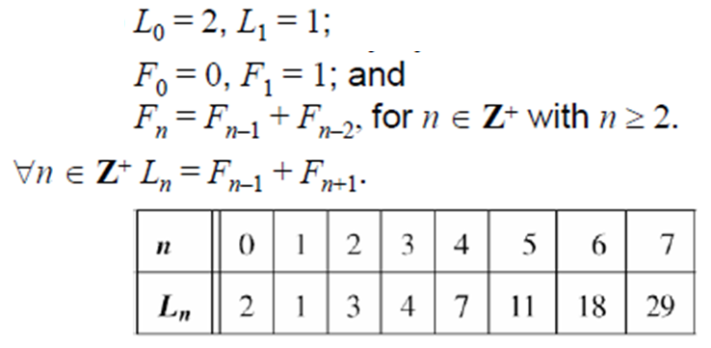

**Question 4:**

Write a computer program to find a route with the least total airfare that visits each of the cities in this graph, where the weight on an edge is the least price available for a flight between the two cities.

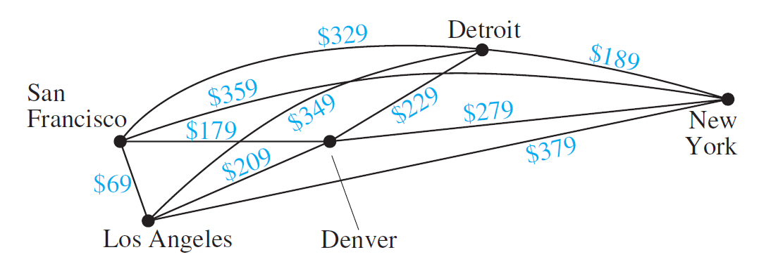



**FACULTY OF ENGINEERING**

**COMPUTER ENGINEERING DEPARTMANT**

**2022-2023 SPRING**

**CSE1120 DISCRETE STRUCTURES**

**COMPUTER PROJECT**

|  |  |  |
| --- | --- | --- |
| **Student Id** | **Name Surname** | **1st /2nd Ed.** |
|  |  |  |
|  |  |  |