TD03 - Git Local Workflow
Daphné CORTESSE

Part 1 - The local Git model
Git has three local steps. Files move from the working tree to the staging area. Then they move to the local history.
Working tree: the files I am editing now. A file can be modified without being in a commit.
Staging area: the exact changes I chose for the next commit. Modified is not the same as staged.
Commit: a saved project state. It has an author, a date, a message, an identifier and the changed content.

Part 2 - Verify Git identity
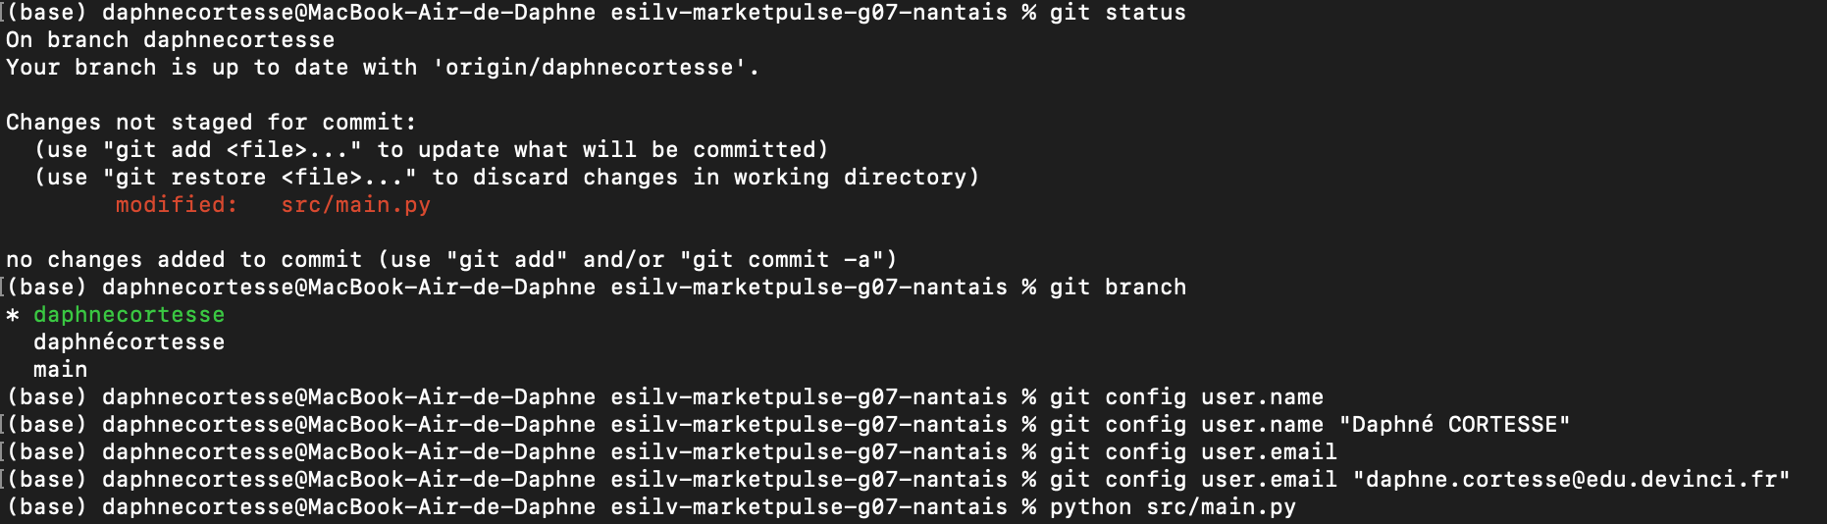
I set my Git identity with git config.
Name: Daphné CORTESSE
Email: daphne.cortesse@edu.devinci.fr
This is my own identity. My commits are linked to me.

Part 3 - Inspect the real TD02 changes
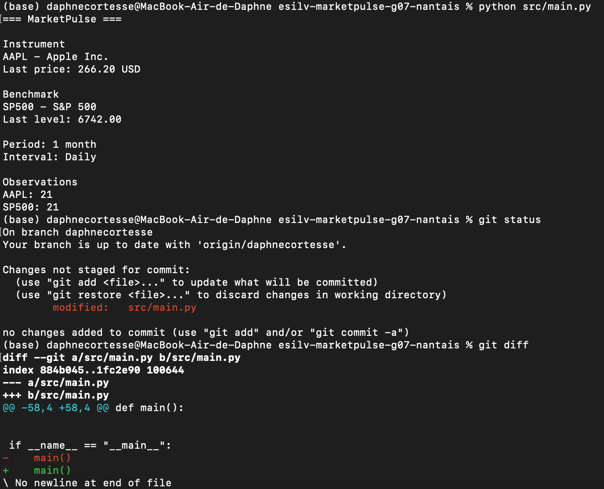
I ran python src/main.py first. MarketPulse works. Then I ran git status and git diff.
1. Which files are modified? Only src/main.py. It is listed as modified and not staged.
2. Which lines were added? One line: main() at the end of the file, inside the if __name__ == "__main__": block.
3. Which lines were removed? One line: the old main() line at the same place.
4. Does the diff match my work? Yes. It is the TD02 work in src/main.py. The two lines look the same. The only change is the end of the file: the new version has no newline at the end.
5. Is there debugging output to remove? No. I see no print or temporary code in the diff.

Part 4 - Understand git status and git diff
git status shows the state of the repository. Here it shows one tracked file that is modified. There is no untracked file. Nothing is staged.
git diff shows the unstaged changes line by line. A red line starting with - was removed. A green line starting with + was added.

Part 5 - Stage the intended change
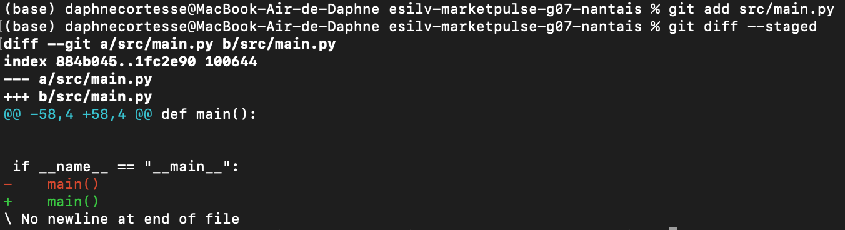
I staged only the file I wanted: git add src/main.py. I did not use git add ..
Then I ran git diff --staged. It shows the same change as before. This is the change selected for the next commit.
git diff shows the unstaged changes.
git diff --staged shows the changes selected for the next commit.
After git add, the change is staged. So git diff shows nothing for this file.

Part 6 - Create the first meaningful commit
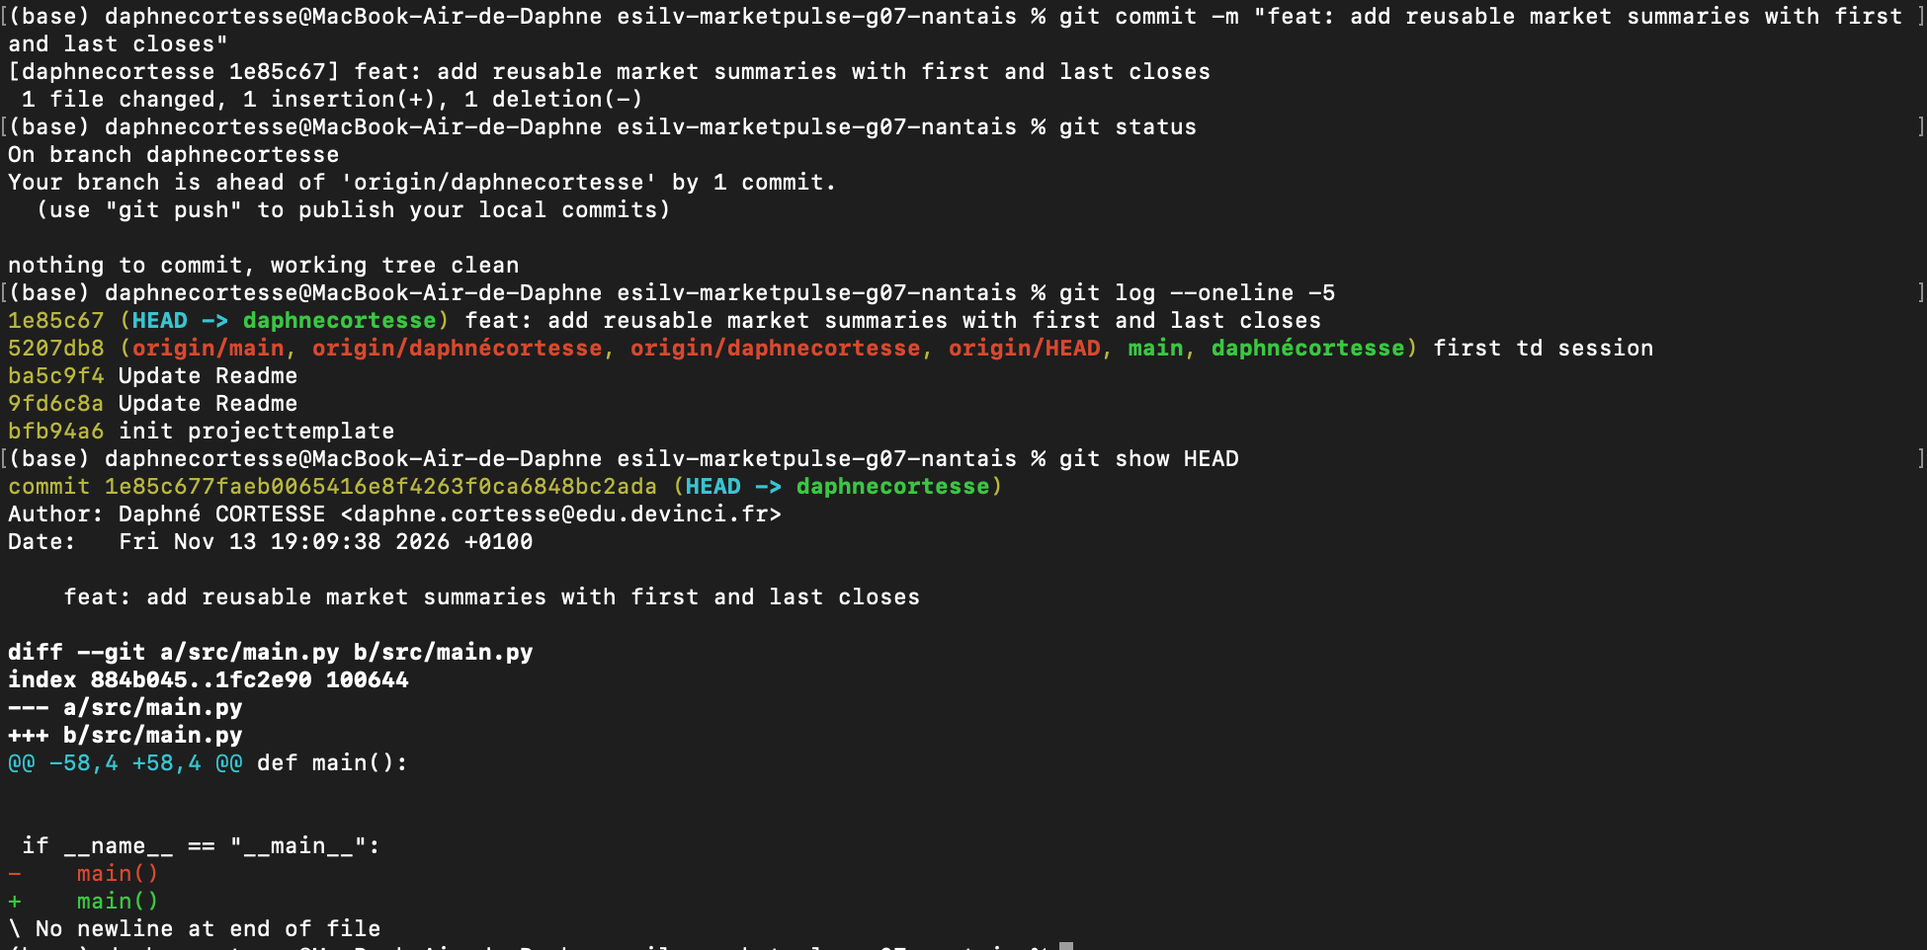
MarketPulse ran correctly before the commit (see Part 3). Then I created the commit.
Command: git commit -m "feat: add reusable market summaries with first and last closes"
Result: commit 1e85c67. Git reports 1 file changed, 1 insertion and 1 deletion.
The message starts with feat: and says what the work does. It is not a vague message like "update".

Part 7 - Read the local history
After the commit, git status says "nothing to commit, working tree clean". It also says my branch is ahead of origin by 1 commit.
git log --oneline -5 shows my new commit at the top. The commit before it is 5207db8 first td session.
Short identifier: 1e85c67
Commit message: feat: add reusable market summaries with first and last closes
I inspected the commit with git show HEAD.
1. Which files changed? Only src/main.py.
2. What does the diff represent? The change from Part 3: the last line main() of the file, with the end-of-file newline change.
3. Why is the message appropriate? It uses the feat: prefix and describes the TD02 work: market summaries with first and last closes.
4. Who is the author? Daphné CORTESSE <daphne.cortesse@edu.devinci.fr>, on Fri Nov 13 2026 at 19:09:38 +0100.

Part 8 - Commit quality and traceability
Which commit is mine? 1e85c67.
What did I change? One line in src/main.py.
Why did I change it? To save my TD02 work in the Git history.
Can I explain the diff? Yes. One line was removed and one line was added. The end of the file changed.
Can I reproduce the change? Yes. I edit the end of src/main.py, then I run git add src/main.py and git commit.
My commit is small and has one purpose. It touches one file.

Part 9 - Local vs remote Git
TD03 stays local. My commit is in my local history only. I did not push it. I did not open a Pull Request. Push and Pull Requests come in TD05.

Part 10 - CORE validation
I ran git status, git log --oneline and python src/main.py. I inspected my commit with git show HEAD. Here are the concepts in simple words.
Working tree: my files on disk, where I edit.
Staging area: the list of changes ready for the next commit.
Commit: a saved snapshot with author, date and message.
Commit identifier: the unique code of a commit, like 1e85c67.
git status: shows which files are modified, staged or untracked.
git diff: shows the unstaged changes.
git diff --staged: shows the staged changes.
git add: moves a change to the staging area.
git commit: saves the staged changes in the local history.
git log: lists the commits.
git show: shows one commit and its diff.

Final checklist
[x] My Git identity is correct
[x] I inspected the real TD02 working changes
[x] I used git status
[x] I used git diff
[x] I staged an intended change
[x] I inspected git diff --staged
[x] I created a meaningful local commit
[x] I can find the commit in git log
[x] I can inspect it with git show
[x] I can explain the diff
[x] MarketPulse still runs
[x] I did not need a remote push or Pull Request

