

**NAME: NGUYEN BAT KHAI**

**STUDENT CODE: GCH17459**

Contents

I. Introduction 3

II. Unemployment among graduates 3

1. What is Unemployment? 3

2. Types of Unemployment 3

3. Reasons for Unemployment 4

4. Consequences of Unemployment 4

5. Conceptual Framework 4

6. Overeducation: Mismatching Supply/Demand 5

7. Imbalance between Individual Perspectives and Reality 6

8. Skills and Ability to Hire 7

9. Comprehensive Model 8

10. Unemployment in US 9

11. Unemployment in around the world 10

12. Unemployment in Vietnam 14

13. Opinion 20

14. Why Are College Students Not Guaranteed a Job after Obtaining a Degree? 23

III. Conclusion 24

IV. Reference 26

# Introduction

In recent years, there has not been much research on the effectiveness of the school program / concept improvement since it was launched at Putra University Malaysia in May 2006. As well as pre-enrollment programs. Other uses in various public higher education institutions. One of the examples of pre-employment programs in other public higher education institutions is the Pre-Recruitment Program at the University of Malaya, with the goal of preparing their graduates for the job market.

Although more and more private and higher education institutions are following the steps of Putra University Malaysia in implementing the program related to the Perfect School concepts. But there is still the effect of these programs in the context of graduate employment which is still vague to this day.

College students often attend their academia and graduate within a certain time frame. Although graduates want to be accepted based on return on investment, they sometimes face unemployment after graduation. Unemployment is an individual disadvantage because it leads to financial liabilities based on university debt and cost education. will increase unnecessarily. This study shows how graduates deal with graduation and how they get rid of it. When I make some policy recommendations, the following describes general graduate unemployment and its related components.

# Unemployment among graduates

## What is Unemployment?

Unemployment refers to a situation in which a skilled and talented person wants to do a job. But it is impossible to find a suitable job for a number of reasons.

## Types of Unemployment

Now we know what unemployment is, but being unemployed doesn't just mean that the person has no job. Similarly, unemployment also includes people working in fields outside of their specialty.

Different types of unemployment include disguised unemployment, seasonal unemployment, open unemployment, technology unemployment, structural unemployment. In addition, a number of other unemployed are cyclical, educated, underemployed, frictionless, chronic and ordinary.

Above all, seasonal unemployment, unemployment and disguised unemployment are the most common ones found in Vietnam.

## Reasons for Unemployment

In a country like Vietnam, there is much reason for a large section of the population for being unemployed. Some of these factors are population growth, slow economic growth, seasonal occupation, slow growth of the economic sector, and fall in the cottage industry.

Moreover, these are the major reason for unemployment in Vietnam. Also, the situation has become so drastic that highly educated people are ready to do the job of a sweeper. Besides, the government is not doing his work seriously.

Apart from all these, a large portion of the population is engaged in the agricultural sector and the sector only provides employment in harvest or plantation time.

In addition, the biggest reason of unemployment in Vietnam’s its vast population which demands a large number of jobs every year which the government and authorities are unable to provide.

## Consequences of Unemployment

If everything is going to happen like it is now, unemployment will become a big problem. In addition, the following occurs in an economy that is an increase in poverty, an increase in crime rates, exploitation of labor, political instability, mental health and loss of skills. As a result, all of this will eventually lead to the collapse of the nation.

## Conceptual Framework

Higher education plays an important role in training future community members based on social needs. After college, graduates hope they will find a higher value job than high school graduates, and the extension of unemployment has a negative impact on the welfare of fish. (Winkelmann, 2009). The fear of unemployment affects how students plan their careers because college students sometimes consider studying beyond their final year and they tend to choose natural sciences, rather than faculties. social studies or other humanities (Bedard & Herman, 2008; Gerardi, Herkenhoff, Ohanian, & Willen, 2013). Therefore, graduates find themselves in a complex decision-making process affected by various external environmental factors. These include market conditions, excessive education issues, personal perspectives and skills and employability. College-preparatory college students are influenced by these components when planning for a career, networking and gathering useful information about the job market (Cai, 2013). However, two students who choose the same major will not necessarily have the same job opportunities and expected profits after graduation may also differ (Carnevale & Cheah, 2013). In this respect, university students are required to be more careful in preparing to reduce the risk of future unemployment. Although more educated people have more opportunities related to job search, training and information, college graduates are still struggling to survive in the job market (Cairo & Cajner). , 2016).

## Overeducation: Mismatching Supply/Demand

One reason why graduate is unemployed is excessive education in the labor market. From an economic perspective, excessive education is illustrated by graduates who exceed the socially optimal level of education. Therefore, if there are 100 available positions that require bachelor's degree skills and there are 100 graduates who meet the job requirements, the optimal social status in the job market is achieved. Every student in a job position requires a certain level of academic achievement by type. Previous economic studies focused on structural unemployment, resulting from the natural mismatch between available jobs and workers based on job mobility and wage bargaining costs (Herz & Van Rens, 2011). Meanwhile, the surplus of graduates with advanced degrees can be considered in a more realistic law of supply and demand in the labor market. Excessive search for their future jobs is based on their education. According to the labor supply and demand law, they should get a job regardless of their education level. It was at this time that a conflict occurred. While the group wants to earn more profits to balance the cost of education, the usual workplace requires lower education requirements that do not provide sufficient salaries or benefits to offset the opportunity cost of education. Ironically, students strive to receive higher profits in the job market resulting in them leaving the team to get a stable job position. The gap between labor supply and labor demand creates unemployment (Figure 1). Part of unemployed graduates (part (a)) may come from over-education cohort, negatively affecting their income, even though they find a job later because of the law of supply and demand. (Dolton & Silles, 2008)

While all students experience the impact of oversupply on the market, those with excessive impairment face a different situation than their counterparts with the right level of education. The second group has a more flexible attitude and tends to apply to lower benefits and profits because their expectations and sinking costs from their education costs are lower than those of the reduced-rate group. These differences allow this group to find work easier. Moreover, for those with reduced education, it means that group members may be older and have more college debt, thus having more serious financial problems than their counterparts.

## Imbalance between Individual Perspectives and Reality

When graduates consider their next step after graduation, their expectations and plans play an important role in deciding their actions. They interact with other sources of influence such as peer groups and faculty members to determine their future careers. These social interactions throughout the surrounding area have spilled into their internal decision-making processes (Topa, 2001). The government or other stakeholders also help them plan or take appropriate actions at work market and government involvement through an education and training system that guides graduates in career planning (Shamsuddin, Isa, Aziz, Mahheads, & Alagari, 2013). McKeown and Lindorff (2011) point out that organizations are responsible for providing useful career services, but their findings suggest that graduates find job opportunities as a result of their efforts. There, rather than through organizational support.

University students accumulate knowledge and information about career paths in their academic careers, and through this process, they form their own perspectives and expected results. Although the main curriculum and organization provide useful skills, employment opportunities and expected profits vary according to individual circumstances, especially if the chosen major is relevant to the occupation. and specific industries. The market requires different sizes of the workforce to meet social needs and internal requirements. For example, emerging majors such as the healthcare industry show that unemployment is relatively low compared to the humanities and traditional liberal arts (Carnevale, Cheah, & Strohl, 2013). So graduates with different majors who want to get a job at the same time, their job search may have different results depending on the needs of the market. Through training and learning, college students close the gap between expected return and the reality after graduation. However, employers' perceptions of graduates sometimes exist outside of their preparation. Although higher education is a production line for graduates willing to work, employers actually think of different graduation outcomes. Lowden, Hall, Elliot and Lewin (2011) explain to employers Perceptions about the employing skills of recent graduates through a number of concepts. Job-related programs, such as internships, that organizations offer cannot afford actual hiring (Allison, Harvey, & Nixon, 2002). Depending on the majors and academic background, such programs may not be sufficient to raise the level of student employers and employers are often skeptical about whether the organization provides operational support. The main fit in the program or not. Differences in perception between graduates and employers cause unemployment.

## Skills and Ability to Hire

The gap between students who have developed on-campus skills and abilities and actual job requirements may be another reason for unemployment. Ensuring a job depends not only on their academic performance, but also on their individual background. Race, gender, and socioeconomic also play a role in whether an applicant is hired (Morley, 2001). In addition, the skills and experience gained through the university curriculum are sometimes insufficient for entry positions (Pauw, Bhorat, Goga, Mucube, Oosthuizen, & Van der Westhuizen, 2006). Sometimes education is limited to the general level, does not provide specific skills that need to be hired (Pawy, Oosthuizen, & Van Der Westhuizen, 2008). The traditional curriculum provided by the school does not match the actual needs of society and these differences contribute to unemployment (Sparber & Fan, 2012). Compared to two-year institutions or vocational colleges, four-year institutions offer a broader curriculum to develop advanced citizens, and the design and structure of their courses tend to More focused on this task. In this respect, the work experience or practical ability of graduates can be is ignored by the organization, although it is important to consider employers' needs in designing and distributing degree courses (Mason, Williams, & Cranmer, 2009). The vocational education and training system combine work experience and general education to ensure the adaptation of the country's social needs and institutional context (Zimmermann, Biavaschi, Eichhorst, Giulietti, Kendzia, Murirlev, & Schmidl, 2013). In other words, the market requires both a well-trained workforce and an accurate awareness of the market's needs to facilitate a suitable job position. And then the market shares information for jobs on the actors. Postgraduate competence and employment are linked to two concepts: company needs and personal accomplishments (Teijeiro, Rungo, & Freire, 2013). Professionalism measures the employability of a graduate student and the effort to meet a company's job requirements is essential for hiring after graduation.

## Comprehensive Model

Although many factors explain the unemployed graduates, the four concepts discussed above relate to the multidimensional aspects of the problem (Figure 2). These factors are representative components that describe the unemployment rate of graduates at an individual level because they reflect different entities. Interaction between including organization, external environment and attitudes personal on psychological and physical aspects. While graduates begin their university education with diverse educational goals and life plans, their career paths after graduation eventually interact with aspects of the environment. outside as the job market. These changing external factors sometimes affect graduates' future plans or affect them to go into different fields. The complex interaction between these components causes unemployment in society, and so future graduates should consider reducing the gap between their ideal career goals and the likelihood of real employment. to avoid future unemployment.

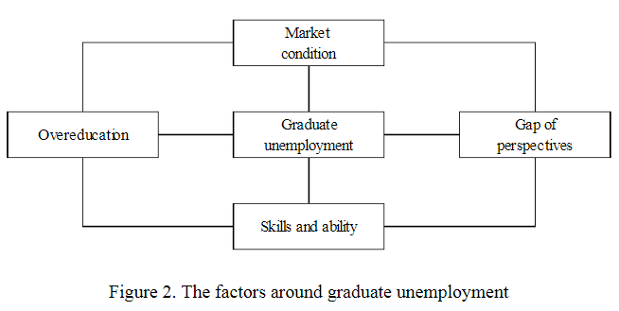

Postgraduate unemployment is not only a personal matter, but also related to other social issues such as crime, poverty and life satisfaction. So, a comprehensive review of society is needed to solve the problem of unemployment. Although graduates have accumulated appropriate skills and abilities through their higher education, the market may not be suitable for them based on available capital. To improve the unemployment rate, there should be cooperation between individuals and society

## Unemployment in US

The US Bureau of Labor Statistics (BLS) revealed last week that 14.7% of Americans (or about 23 million) are currently unemployed due to COVID-19. It has the highest unemployment rate since the Bureau began monitoring monthly unemployment in 1948, with some saying the actual figure is much higher.

The report office also details job losses by industry, with some of the biggest losses in the industries that university students create: Education and health services (-2,544,000), businesses and businesses. specialized service enterprises (-2,128,000) and government (-980,000).

IDEALS, our national representative who studies more than 120 colleges and universities, asked students about their experiences in various forms at the university, but we also asked about career aspirations. their karma.

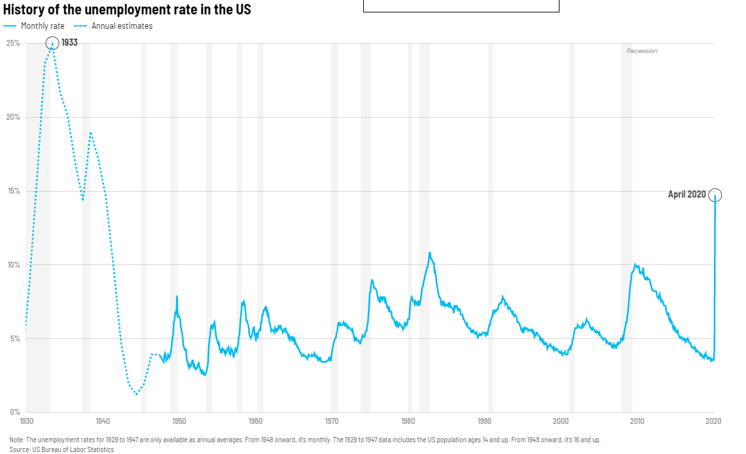

In Spring 2019, we asked college seniors – last year’s graduating class – what industries they planned to enter upon graduation, and some of the highest proportions of students selected education and health care (24 percent combined), business (20 percent), and government (4 percent). Taken together, this means that about 50 percent of students who graduated just one year ago aspired to enter industries with some of the greatest job loss numbers in April 2020. Smaller proportions of students expected to pursue careers in media (3.9 percent), social services (1.9 percent), advocacy (1.7 percent), religious and intentionally secular communities (0.91 percent) or the service sector (0.28 percent), while 6.4 percent reported being unsure about their career aspirations.

There is, however, a silver lining to these findings. Notably, less than 1 percent of last year’s graduating class aspired to enter leisure and hospitality professions (included in what IDEALS termed the “service sector”), which far and away saw the greatest job losses in April 2020 (-7,653,000) according to the BLS report. This is likely because many jobs in the service sector do not require a post-secondary degree.

Another reason to hope is that the lions hare of last year’s grads (31 percent) planned to enter more than one employment sector, according to our study. Perhaps this indicates that graduates aren't locked into one sector, demonstrating a versatility that could be a huge advantage in the current job market.

But for a perplexing number of recent college graduates, our findings suggest that they are facing, or will soon face, what some are calling the “worst job market in modern history.” To make matters worse, thousands of internships are being canceled, which are usually a dependable stepping stone into industries like business and government.

All of this is bad news for higher education, which is considered an attractive option to most 14-23 year-olds because they want better jobs and financial security. Public universities have also faced mounting pressure from their state governments to improve their job placement rates (i.e. performance funding), with the threat of losing critical state funding if their outcomes don’t measure up.

Finally, recent graduates should maintain a healthy diet of hope. Although Americans have an insatiable appetite for bad news, a recent report shows that 46% of about 7,000 companies are still hiring. This unique waiting season may be the only chance new graduates have to honestly assess what they will bring to a new job - social habits, work ethics and any plans. They have (or don't have) to develop personally and professionally. Although the ideal job may not be available right now, taking this time to improve and prepare will pay off in the long run.

## Unemployment in around the world

Experts agree: high unemployment threatens growth and social cohesion. What they disagree is what unemployment is. While the unemployment rate represents the percentage of the workforce out of work, in fact, there are many ways to calculate it. Measuring unemployment in a country and comparing international rates is a very complex issue.

The math is clear: unemployment is calculated by dividing the number of unemployed individuals by all individuals in the labor force. The problem begins when finding out exactly how many of these people. This is not just a matter of collecting vast amounts of data on time or on conflicting methods: the same individuals in question often cannot know whether they should consider themselves employed or unemployed.

For example, one person who takes a full-time job deserves a decent and stable compensation for a part-time position that pays a small portion by default classified as an employee, while another person is proactive. looking for a job but taking a few weeks off work can not only stop being considered unemployed, but it doesn't even count as part of the workforce. An individual who wants to work but cannot because of a disability or medical condition in the same position.

As a result, many economists believe that, because of the existence of unemployed people or hidden statistics of unemployed people that have been misleading and painted a too rosy picture of the labor force. Needless to say, unemployment and underemployment are difficult to measure.

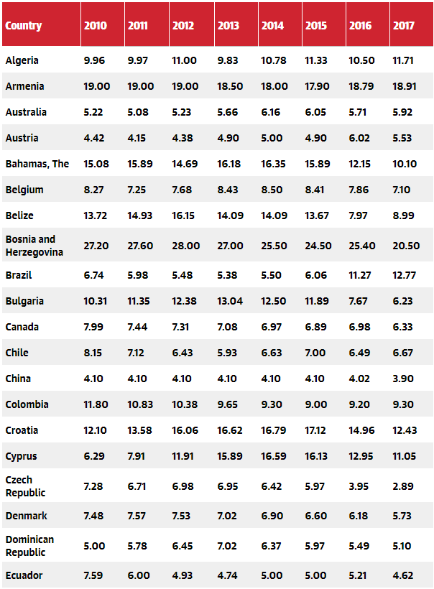

The peak was 5.9% in 2009, when the most severe financial crisis ended, the world unemployment rate began to gradually decrease. After 2014, it was basically stable around 5.5%, with the total number of unemployed estimated to exceed 192 million.

The report also emphasizes that in recent years, the process of reducing vulnerable jobs (jobs with low wages and without guarantees or guarantees) has stalled. There are an estimated 1.4 billion workers in the states with vulnerable jobs in 2017 and 35 million more are expected to join in 2019.

The curse unemployment rate, needless to say, also hides an understanding of the various basic realities at the regional level.

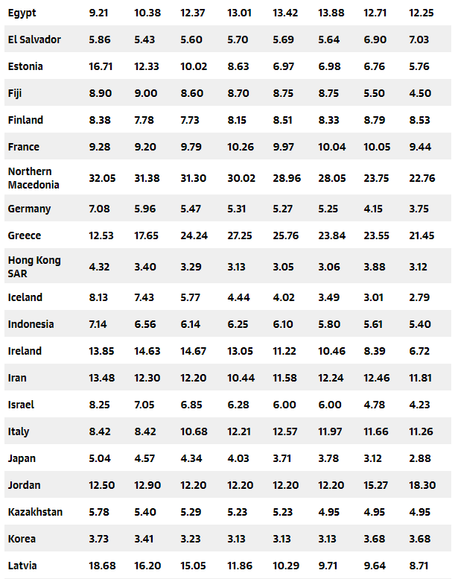

According to ILO, northern Africa features the highest jobless percentage in the world, 11.5 in 2018, with youth and women being over-represented among the unemployed. In Sub-Saharan Africa, where one in three workers is living in conditions of extreme poverty and three out of four are in vulnerable employment, the rate is expected to stick to levels seen since 2017 at 7.2%. Both in Canada and to a greater degree in the United States, owing to a strong economy, the number of people out of work is at historic lows with a compound rate close to 4%. In Latin America and the Caribbean, the proportion of working-age people not earning compensation is projected to decrease marginally, from 8.2% in 2017 to 7.7% by 2019.

In the Middle East where unemployment for this year is projected at 7.8%, one-third of the almost 5 million people without jobs are women even though they represent just 16% of the labor force. In Central and Western Asia, the regional jobless rate is expected to remain at 8.5% in 2018 and 2019, with vulnerable employment affecting about 30% of workers.

Meanwhile, Asia and the Pacific are continuing to create jobs at a fast pace, keeping the unemployment low by international standards at around 4%. However, almost half of all workers—more than 900 million—are in vulnerable forms of employment.

In Eastern Europe, falling jobless rates in nations such as Poland, Ukraine and Slovakia only partly offset expectations of growing unemployment in the Czech Republic: the proportion of labor force out of work in the region is projected to decline modestly from 5.2% this year to 5.1% the next.

In Northern, Southern and Western Europe, helped by better than expected economic activity, unemployment is on course to decrease from 8.4% in 2017 to 7.7% in 2017 and 7.4% in 2019. The largest overall improvements, of the order of two percentage points, are likely to be seen in Spain and Greece (14.6% and 21.1% estimated respectively this year). In Italy, France and Portugal unemployment rates have been declining in the years following the debt crises and will continue to do so in 2019, albeit at a slower pace than before. In Ireland and in the UK, they should remain stable at around 6% and 4% each.

## Unemployment in Vietnam

Vietnam is developing a market economy with socialist orientation. In fact, in recent years, the growth of all economic sectors has become stronger and stronger than ever. However, the strong, diverse and complex development of the market economy has posed many challenges such as labor choices, market denials leading to job losses and unemployment of workers, especially among young people. According to World Bank statistics, the youth unemployment rate of Vietnam was 6.26% in 2010. After that, the rate dropped significantly to 5.09% in 2012, but then. increased to 6.39% and 7.28% in 2016 and January 2017. These data are shown in Figure 1 below. However, these figures do not take into account current employment issues in Vietnam, causing many young people to accept jobs that require lower levels of education and skills. Although the income is also lower than they can be, they need it to sustain their life with limited spending.

In particular, some information from the Ministry of Labor, Invalids and Social Welfare shows that the unemployment rate compared to the first months of 2016 is increasing in both quantity and rate, especially among young people. age with high educational level. It is a fact that young people with a university or higher degree have the highest unemployment rate. Recent statistics in the third quarter of 2016 show that about 1.2 million people of working age are unemployed, it has increased by more than 29 thousand people compared to the previous quarter. Among the unemployed, an estimated 456.2 thousand people are technically proficient and most of them (202.3 thousand people) belong to the higher education group (122.4 thousand people). and vocational college degree (73.8 thousand people). The number of unemployed people lasted longer (more than 1 year) accounted for more than 22.6% of the total unemployed.

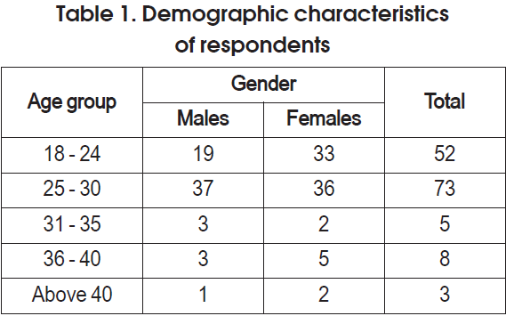

Above showed respondents by gender and age range. Of these 55.3% (78) were female and 44.7% (63) were male. The imbalance of data collection due to the survey is done randomly on the Internet through Facebook. However, based on the data, it can be seen that it was not difficult to access some of the female youths who aged from 18 to 24. They can be guessed to be unemployed and is processing to seek the job. That why they just stay at home, carry out household chores and have more time to use the Internet than male. Too, this also can explain that the unemployment is more widespread among the 18 to 24 year age range. It was looked for that this is the age when most youths have completed the full-time schooling in school and start to seek the jobs for the long journey

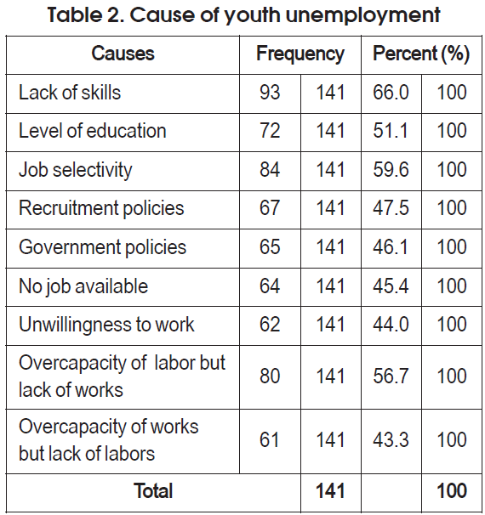

Above, it can be seen that most of the respondents think that lack of skills and job selection are the main causes of the high unemployment rate among young people, about 66% and 59.6% respectively. On the other hand, 56.7% of the respondents said that the redundancy of labor but lack of employment is a major unemployment problem among young people while 51.1% of respondents think that education is a problem. The topic of youth unemployment in society. The lowest rate of 43.3% said that the work surplus but labor shortage is the cause of youth unemployment. Finally, this may explain that the most important key to a job is work experience. Instead, in order to get the desired job, students need not only a certain level of education but also real involvement in tasks.

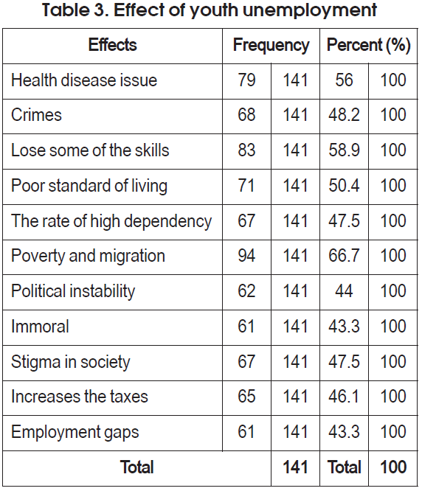

Above, describe the influencing factors of youth unemployment. It can be seen that most of the respondents think that poverty and migration and loss of some skills are the main effects of high youth unemployment, about 66.7% and 58.9%, respectively. On the other hand, 56% of the respondents think that health problem is the main problem of youth unemployment while 50.4% and 48.2% of respondents think that poor living standards and crime affect unemployed youth. The lowest rate of 43.3% thought that the unscrupulous gap and employment was the impact of youth unemployment. Obviously, when unemployment occurs, workers lose an income. Therefore, this problem causes serious poverty for the community. And, in order to survive in society, they will tend to migrate to another area to find any job or any way to earn living expenses. Eventually, day by day, their professional skills will disappear.

* In fact, after completing the study, the author realized that lack of work skills, education, high requirements for job selection and lack of work capacity but lack of work are the main factors that cause unemployment among young people. Among these factors, inexperience, as well as work skills, are the most important cause of youth unemployment. It is a fact that, although the Vietnamese economy is developing recently, more than thousands of new graduates each year, only a small percentage of students are recruited because of recent graduates. No work skills. While studying, most students believe that to meet the requirements of the job, they need to have a lot of computer and foreign language certificates. Therefore, they only need to pay attention to study at centers to get their degree. However, in reality, businesses always focus on work skills, the best way to manage difficult cases, communication skills and teamwork leadership. In fact, companies often offer one to two months probationary period and during this period, not many candidates are really able to handle the job. Even the best graduates with high scores, these students are still not appreciated and not accepted. As a result, there is a current paradox that although the number of graduates with high unemployment rates, companies still lack labor, because the students do not have the skills to meet the needs of employers. use.
* On the other hand, regarding the effects of youth unemployment, five factors can be identified as a loss of work skills, health problems, poor living standards, increased violent crime and poverty and social migration. Among these factors, lost job skills and poverty and social migration are two major problems affecting youth unemployment. Economically, unemployment is linked to poverty and migration. High unemployment rate not only causes great damage to the economy but also causes many difficulties for the lives of workers. Clearly, although unemployed people are unable to produce products, they still have to spend a certain amount of money, especially in young people who have higher consumption levels than others. Assuming that the unemployed were employed, they could create a minimum consumption value. That means the government will not lose trillions of dollars to unemployment every year. Moreover, unemployment not only affects the economy but also causes social migration. Unemployed people tend to travel to other areas to find jobs, which causes a lot of housing volatility as well as increasing social evils. Clearly, when it comes to the causes of social evils, it is found that unemployment is significantly related to social evils such as drugs, theft, prostitution, collective rape in gangsters, etc. Simply because it can bring income to the participants. While other avenues to create jobs for them have been closed, the path to social evils is generally easy and difficult to control and prevent. Work skills are slowly being lost for this reason
* Based on the conclusions of the study, some suggestions are given as follows:
* First, education in Vietnam is currently not related to training and needs. Enrollment targets are set by each school to meet teaching needs but not to meet industry-specific job needs. As a result, the annual number of graduates is much higher than the actual demand as well as the number of redundant students will be unemployed. The cost of training a student to complete the entire course is not small, so when students are unemployed a few years after graduation as a case of their knowledge decreases. That means that most efforts and investments are wasted. In addition, in previous years, many new universities applied for establishment. Schools also apply to open branches in different localities to increase enrollment quotas. However, this expansion is large to increase profits without the purpose of improving teaching effectiveness; It leads to an increase in the number of unemployed students. As a result, a new educational model has an interaction between theory and practice that needs to be developed. Specifically, the school should link with businesses to create job opportunities for students to help them see real skills in work as well as improve professional knowledge. It is essential that students quickly grasp the nature of the work they have chosen.
* Legal institutions should then implement policies to address the employment of young people according to target groups. For groups of young people who graduate from university, college and vocational secondary school, they should be used in economic sectors with high requirements on labor quality, preferential policies and employment of talents. For young people who have completed their studies, they do not have the conditions to study higher, so they need policies to support vocational training, career development and agricultural production. In addition, industrial zones should be developed to attract more unskilled workers for the works. Priority is given to sending laborers to work in the direction of expanding the market, encouraging household economic development and creating jobs for young people. For unemployed youth, it is necessary to encourage the development of the private sector, small and medium enterprises, individual business households and small businesses to attract more workers and create jobs for them. . Apply supportive policies and create favorable conditions for unemployed youth to access preferential loans to self-control and increase income for young people to improve their living standards.
* Finally, the government should have policies to improve the unemployment insurance system to support the unemployed. It is a fact that unemployment insurance can assist to ensure the lives of workers as well as help them to find jobs and return to work as soon as possible. In addition, unemployment insurance helps reduce the burden on the state and business budgets. In Vietnam, due to the fact that unemployment has only been recognized in recent years, the establishment of unemployment fund is in the early stage of research and faces many difficulties as well as complexity. One of the difficulties is the funding source, identifying the beneficiary and the time to get it. In the short term, due to the fund's limitations, unemployment insurance is only available for people who lose their jobs and only cover a certain period of time while workers still cannot find jobs. In the future, unemployment insurance is needed for both young and old people who have yet to find jobs

## Opinion

A lot of people will complain about youth, as well as every generation. They say millennials are too lazy and enjoy. That their parents work harder and they should be grateful.

However, that is not really fair. Their parents are not 100k student debt, unemployment is not rampant, and automation has not replaced them with unprecedented prices.

Graduates entering the workforce have done nothing wrong. They certainly are not lazy. They are simply given a path, a choice in life: going to school, getting a degree, and then you can get a job.

They have spent all their time, effort and money working on this goal. The Belgian's promise of success in this way may not be clearly written, but society has given them little choice. The education system encourages them to do so and their parents will probably follow.

After graduation, they realized that this economic promise did not come true easily. Again, they did nothing wrong. The problem is within the framework and the way our economic model encourages people.

The economy is largely controlled by companies. They have money and jobs. They decide whether to hire you or not. If these companies don't need your skills, you're out of luck. The previous sentence seems so important that it may not guarantee a second look.

But really, that's the way we choose to see reality.

We are cycling through this education system with not so many options and then the companies seeking profit to make a living. These are the same companies that want to maximize efficiency and win twice to lay off employees or restructure when things go well. But it is not the fault of the companies. They simply operate in a world where profit maximization is the driving force.

As the job market becomes more and more competitive, current and recent college graduates are finding it difficult to find jobs.

As technology has evolved, many areas have been fully or partially automated. Economically, financial analysts as well as other types of data interpreters on Wall Street are almost completely overthrown by the effects of artificial intelligence.

The typical timeline of the labor force transition from school to youth is not the same as 20 years ago. For our parents, a college degree can guarantee a stable job right after graduation. Not to mention they can get the aforementioned degree and often complete the debt waiver at school if they get a part-time salary.

We can see how the success of the previous generations created the domino effect with the younger generations. Our parents and counselors insist that the only expected plan after high school is going to college, getting a degree and getting a high-paying job.

Due to the increase in the number of university graduates, it seems that the percentage of youth and young people being recruited is higher, but this is not the case. With so many university degrees out there just waiting to be pulled out of the application pool, the job market has become increasingly competitive. Employers are looking for more experienced candidates than just well-educated people.

An impressive academic career and tangible experience is considered necessary to get your footing with an employer, even for entry-level jobs and current college students seeking experience. the real world.

In the last semester alone, I have been trying to find a job to help with college costs while building my resume. Although I did a lot of work during high school, they were all considered to be under the dining table facilities and would not be considered the true experience of a future employer.

This whole process is very ridiculous to me. I feel very disappointed. I was ready to work hard, but the opportunity was not simply what they had.

Internships are a possible solution, but there is a catch.

Unpaid internships are an opportunity to provide a hands-on, hands-on experience that is directly applicable to your field. Internships allow you to build connections and networks with professionals.

Regardless of the advantages and unpaid work experience offered to young people, these positions are often exploitable and impractical in parallel with the soaring cost of a university degree.

Under the guise of providing skill development in a field of your choice, employers get tons of freelance workers. These internships, while being advertised as a useful tool in climbing the corporate ladder, are really class divisions. There is no way I can accept an unpaid internship, while supporting myself through college. The same thing holds true for many other students.

Although our unemployment rate reporting statistics are maintaining record lows, the job market is really becoming increasingly selective about who gets hired and who doesn't. As automation continues to evolve and education becomes a necessary sign in resumes, it is important that we reevaluate this impact on adolescents and inexperienced teens. how.

## Why Are College Students Not Guaranteed a Job after Obtaining a Degree?

In the article, recent university graduates are looking for good jobs? talked about how the Great Depression led many college graduates to struggle to find jobs in their major. The article also talked about college graduates graduating from university without jobs due to the Great Depression. The article writes, The Great Depression has caused many recent college graduates to struggle to find a job using their education (Abel, Dietz, Su 2014). The major recession is the period when the economy declined between the late 2000s and early 2010s. With that economic downturn, it still affects today's economy, reducing the likelihood of having a job. to unemployed or underemployed people. If our country is in an economic downturn, then how can college graduates get the jobs they want if they don't have jobs. With the economic downturn, this could affect the graduate employment rate. The article also states that, between 1990 and Q1 2013, the unemployment rate averaged 4.3% for recent college graduates compared to 2.9% for all graduates. university (Abel, Dietz, Su 2014). Due to the economic downturn, it has caused many university graduates to be unemployed. With the decline in the economy, it can greatly affect the number of jobs available to everyone. The article Why college graduates are returning to community college also talks about how the major recession affects many graduates. The author says this by saying that After the aftermath of the Great Depression, thousands of students have learned the bitter lesson that the college degree they pay for does not guarantee a stable job. In response many people have chosen graduate school to put forward their status, pay and secure a job bump (Koeppel). If our economy is in a recession, it can cause people to lose their jobs or become unemployed, but as time goes by as the economy rises, the likelihood of employment will increase.

College students spend tens of thousands of dollars and a lot of time pursuing degrees, all in the hope that one day they will get the dream job. Students taking classes are said to better prepare for their dream job. Students who take classes are supposed to help them better prepare for their future careers, but those classes often don't teach them the life skills they will need after college. Articles Recent college graduates are looking for good jobs? talk about college graduates not quickly joining the workforce due to their abilities or feeling like they're not ready for the job. The article writes, recent graduates tend to take some time after they graduate to find jobs that fit their education (Abel, Dietz, Su 2014). While taking the time to find work that is appropriate for their education, they often find a part-time job or work in a place that does not require a college degree, leaving them underemployed. The article stated that, while these jobs do not require a bachelor's degree, they tend to be career-oriented, relatively skilled and fairly well compensated. At the other end of the spectrum, low-paid jobs paid an average salary of less than $ 25,000 per year in 2012, and included jobs such as barista, food server and cashier (Abel, Dietz, Su 2014). The article also talks about recent college graduates working part-time and how it's growing fast. In contrast, the proportion of recent college graduates working part-time has increased from about 15% in 2000 to 23% in 2011, with a direct increase especially after the last two recessions ( Abel, Dietz, Su 2014). So, is college really worth the money? College is great if you want to be successful and get a high-paying job, but with the job prospects falling, you might not even get the chance to get your dream job.

Moreover, the sudden decline of the job may be due to technological progress. As the years passed, technology became more and more developed. This makes it hard for people to get a job because technology can now do more than before. Writers Study and Declare The Following According to this study, businesses aggressively hired college-educated workers in an effort to adapt to technological changes that occurred in the 1980s and 1990. However, as the information technology revolution reached maturity, the demand for cognitive skills also decreased. As a result, during the first decade of the 2000s, many college graduates were forced to move down to the career hierarchy to take on jobs typically performed by lower-skilled workers. (Abel, Dietz, Su 2014).

# Conclusion

In short, it seems normal to hear an unemployed adult. But on the other hand, it's quite a shocking news when we hear the news of graduation being unemployed. It becomes even more shocking when we hear that unemployed graduates are from Public University, especially the graduates who are the highest unemployed, accounting for 51%. The second highest unemployment is that of graduating from private universities accounting for 34%. Meanwhile, the rest graduated from polytechnic and community, respectively 13% and 2%. Often people like employers will want to recruit or hire a university graduate because they are known as an educated person with special qualifications especially the public. It is because they are considered to be excellent academically because although they can study and pass in the course of study at the University. There are many reasons for graduating from Unemployment University, as their on-campus learning process focuses more on theory than on reality. Not having enough available means can also lead to a lack of practices that will leave them unemployed. In addition, the number of students in a class affects their academic performance by not being able to ask or discuss things they don't understand. Finally, the lack of race and ethnicity in the population discourages speaking English and improves communication skills and soft skills. That is some reason why they are unemployed. Now, here are some implications or effects if a particular unemployed person graduate. At first, they could not meet their needs and financial obligations like paying rent for motorbike rental, etc. They also tend to commit crimes because of their inability to legally earn money to cover living expenses. Third, there will be high poverty rates due to high unemployment rates due to the inability to support itself.

College students formulate a career plan in their school life and try to follow it after graduation. Becoming a competent worker in society is the first step to show their ability, and the transition from student to worker through schooling is a positive cycle for a sustainable society. . Well-educated workers contribute to resolving social issues and create a solid foundation of social standards. Moreover, the proper hiring of a company allows society to meet all unmet needs such as university debt and poverty. This article provides a number of factors that explain the unemployment of graduates on an individual level and the four main factors that play a role in providing evidence of why graduates are unemployed. Karma. Although excessive education is due to excess educational services from institutions, the gap in personal opinion is related to individual priorities and priorities. Taking into account market factors, a combination of both components is necessary to fully understand unemployment.

# Reference

1. References
2. Allison, J., Harvey, C., & Nixon, I. (2002). Enhancing employability: a long term strategic
3. challenge. LTSN Generic Centre.
4. Arkes, J. (2010). Using unemployment rates as instruments to estimate returns to schooling.
5. Southern Economic Journal, 76(3), 711-722. https://doi.org/10.4284/sej.2010.76.3.711
6. Bastedo, M. N., & Gumport, P. J. (2003). Access to what? Mission differentiation and
7. academic stratification in US public higher education. Higher Education, 46(3), 341-359.
8. https://doi.org/10.1023/A:1025374011204
9. Bedard, K., & Herman, D. A. (2008). Who goes to graduate/professional school? The
10. References
11. Allison, J., Harvey, C., & Nixon, I. (2002). Enhancing employability: a long term strategic
12. challenge. LTSN Generic Centre.
13. Arkes, J. (2010). Using unemployment rates as instruments to estimate returns to schooling.
14. Southern Economic Journal, 76(3), 711-722. https://doi.org/10.4284/sej.2010.76.3.711
15. Bastedo, M. N., & Gumport, P. J. (2003). Access to what? Mission differentiation and
16. academic stratification in US public higher education. Higher Education, 46(3), 341-359.
17. https://doi.org/10.1023/A:1025374011204
18. Bedard, K., & Herman, D. A. (2008). Who goes to graduate/professional school? The
19. Allison, J., Harvey, C., & Nixon, I. (2002). Enhancing employability: a long term strategic
20. challenge. LTSN Generic Centre.
21. Arkes, J. (2010). Using unemployment rates as instruments to estimate returns to schooling.
22. Southern Economic Journal, 76(3), 711-722. https://doi.org/10.4284/sej.2010.76.3.711
23. Bastedo, M. N., & Gumport, P. J. (2003). Access to what? Mission differentiation and
24. academic stratification in US public higher education. Higher Education, 46(3), 341-359.
25. https://doi.org/10.1023/A:1025374011204
26. Bedard, K., & Herman, D. A. (2008). Who goes to graduate/professional school? The
27. Allison, J., Harvey, C., & Nixon, I. (2002). Enhancing employability: a long term strategic
28. challenge. LTSN Generic Centre.
29. Arkes, J. (2010). Using unemployment rates as instruments to estimate returns to schooling.
30. Southern Economic Journal, 76(3), 711-722. https://doi.org/10.4284/sej.2010.76.3.711
31. Bastedo, M. N., & Gumport, P. J. (2003). Access to what? Mission differentiation and
32. academic stratification in US public higher education. Higher Education, 46(3), 341-359.
33. https://doi.org/10.1023/A:1025374011204
34. Bedard, K., & Herman, D. A. (2008). Who goes to graduate/professional school? The
35. Allison, J., Harvey, C., & Nixon, I. (2002). Enhancing employability: a long term strategic
36. challenge. LTSN Generic Centre.
37. Arkes, J. (2010). Using unemployment rates as instruments to estimate returns to schooling.
38. Southern Economic Journal, 76(3), 711-722. https://doi.org/10.4284/sej.2010.76.3.711
39. Bastedo, M. N., & Gumport, P. J. (2003). Access to what? Mission differentiation and
40. academic stratification in US public higher education. Higher Education, 46(3), 341-359.
41. https://doi.org/10.1023/A:1025374011204
42. Bedard, K., & Herman, D. A. (2008). Who goes to graduate/professional school? The
43. Allison, J., Harvey, C., & Nixon, I. (2002). Enhancing employability: a long term strategic
44. challenge. LTSN Generic Centre.
45. Arkes, J. (2010). Using unemployment rates as instruments to estimate returns to schooling.
46. Southern Economic Journal, 76(3), 711-722. https://doi.org/10.4284/sej.2010.76.3.711
47. Bastedo, M. N., & Gumport, P. J. (2003). Access to what? Mission differentiation and
48. academic stratification in US public higher education. Higher Education, 46(3), 341-359.
49. https://doi.org/10.1023/A:1025374011204
50. Bedard, K., & Herman, D. A. (2008). Who goes to graduate/professional school? The
51. Allison, J., Harvey, C., & Nixon, I. (2002). Enhancing employability: a long term strategic
52. challenge. LTSN Generic Centre.
53. Arkes, J. (2010). Using unemployment rates as instruments to estimate returns to schooling.
54. Southern Economic Journal, 76(3), 711-722. https://doi.org/10.4284/sej.2010.76.3.711
55. Bastedo, M. N., & Gumport, P. J. (2003). Access to what? Mission differentiation and
56. academic stratification in US public higher education. Higher Education, 46(3), 341-359.
57. https://doi.org/10.1023/A:1025374011204
58. Bedard, K., & Herman, D. A. (2008). Who goes to graduate/professional school? The
59. Allison, J., Harvey, C., & Nixon, I. (2002). Enhancing employability: a long term strategic
60. challenge. LTSN Generic Centre.
61. Arkes, J. (2010). Using unemployment rates as instruments to estimate returns to schooling.
62. Southern Economic Journal, 76(3), 711-722. https://doi.org/10.4284/sej.2010.76.3.711
63. Bastedo, M. N., & Gumport, P. J. (2003). Access to what? Mission differentiation and
64. academic stratification in US public higher education. Higher Education, 46(3), 341-359.
65. https://doi.org/10.1023/A:1025374011204
66. Bedard, K., & Herman, D. A. (2008). Who goes to graduate/professional school? The
67. Allison, J., Harvey, C., & Nixon, I. (2002). Enhancing employability: a long term strategic
68. challenge. LTSN Generic Centre.
69. Arkes, J. (2010). Using unemployment rates as instruments to estimate returns to schooling.
70. Southern Economic Journal, 76(3), 711-722. https://doi.org/10.4284/sej.2010.76.3.711
71. Bastedo, M. N., & Gumport, P. J. (2003). Access to what? Mission differentiation and
72. academic stratification in US public higher education. Higher Education, 46(3), 341-359.
73. https://doi.org/10.1023/A:1025374011204
74. Bedard, K., & Herman, D. A. (2008). Who goes to graduate/professional school? The
75. Allison, J., Harvey, C., & Nixon, I. (2002). Enhancing employability: a long term strategic
76. challenge. LTSN Generic Centre.
77. Arkes, J. (2010). Using unemployment rates as instruments to estimate returns to schooling.
78. Southern Economic Journal, 76(3), 711-722. https://doi.org/10.4284/sej.2010.76.3.711
79. Bastedo, M. N., & Gumport, P. J. (2003). Access to what? Mission differentiation and
80. academic stratification in US public higher education. Higher Education, 46(3), 341-359.
81. https://doi.org/10.1023/A:1025374011204
82. Bedard, K., & Herman, D. A. (2008). Who goes to graduate/professional school? The

