# Overview

With the need to use the website to manage personnel in the business as well as use to sell products. My goal is to build a sales and staff management website. To be able to combine both trade and management together. The website will be sales related to computer components and management based on the departments of the business. Below is a summary of the functions based on the decentralized authority: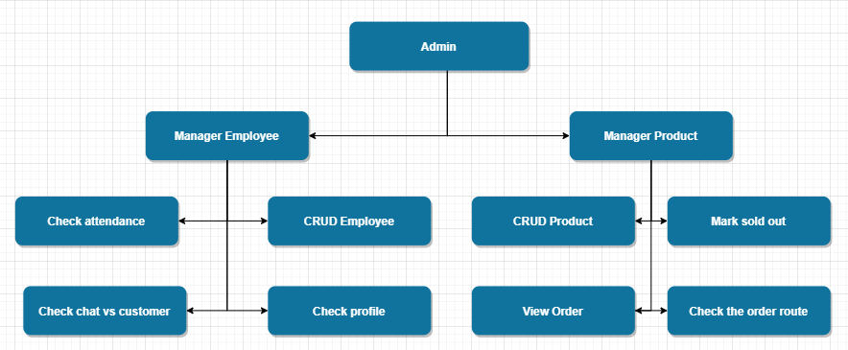

At the administrator's account (admin). This account will have full rights inside the system. Can view everything inside the system. (manager product + manager employee).

The account of a manager product (manager product), goods manager. By adding deleting items, categories, marking items sold out to see the number of clicks on products, orders, SEO-related parameters of the website such as traffic per day. From there, you can make a business plan.

Business employee account (manager employee), employee management. Check employee activities such as chat history with customers, attendance records of employees.

Sale employee account (emp sales <= manager employee). Employees can take attendance by visiting the website and checking the attendance check box. The time can be determined by the current time at which the employee has access to (real-time). This Sale employee account can chat online with customers for advice.

There is also a shipper account. Shipping staff account (shipping emp <= manager product). The shipping staff has access to timekeeping and shipping orders. In the route the order will have the status of the package as in which warehouse and on the way to transport. Customers and managers can track this through the order code.

In this project, I chose the language of JavaScript and used a very powerful UI library, React, as a front-end. I had a good time learning and practicing them so I thought I could use them. And for the back-end, I need to learn a lot more to be able to learn how to build a server and write APIs for my project.

# Aim

My purpose is to be able to integrate management and commerce into the same system. Not many businesses use this method to grow their business, but this is a way to reduce website management costs and put two separate systems into one system.

# Objectives

## Learning about using ReactJS

I have used several languages ​​before to build a front-end of a basic website like PHP and some PHP frameworks. But that is not what I have mastered. That's why I need to learn a lot more to be able to handle it better on ReactJS like:

* Handle API
* Create functionality based on those APIs

Deliverables:

* Basic front-end for the website system

## Learning about build server and writing API

I have an understanding of how to query in a database through a few basic products in the PHP language, but this is my biggest weakness. I have never learned or read more about server and writing API. I need to practice more about python and NodeJS.

Work:

* Learn about Python
* Learn how the REST and RESTful API works

Deliverables:

* The most basic demo database

## Analysis

…