Kubernetes
tools:

- kubectl -
  - kubernetes command line tool
  - runs commands against the cluster – interacts with the cluster
  - deploy applications, inspect and manage cluster resources, and view logs

- kind -
  - runs kubernetes on system

- minikube -
  - runs kubernetes locally
  - single node cluster set up
  - deploys kubernetes image to docker

- kubeadm -
  - sort of an admin tool
  - create manage clusters
  - create and manage minimum viable secure cluster in a user friendly way

creating a deployment:

- from command line -
kubectl create <deployment/service/pod/namespace> <name> --image=<image:tag>

Pods:
- workload in a kubernetes env – automic unit in kubernetes
- in the previous tep of creating a deployment, a pod was automatically created to host the deployment
- A Pod is a Kubernetes abstraction that represents a group of one or more application containers (such as Docker), and some shared resources for those containers -
  - shared storage – volumes
  - a unique cluster ip – networking
  - information on how to run each container
- A Pod models an application-specific "logical host" and can contain different application containers which are relatively tightly coupled
- The containers in a Pod share an IP Address and port space, are always co-located and co-scheduled, and run in a shared context on the same Node
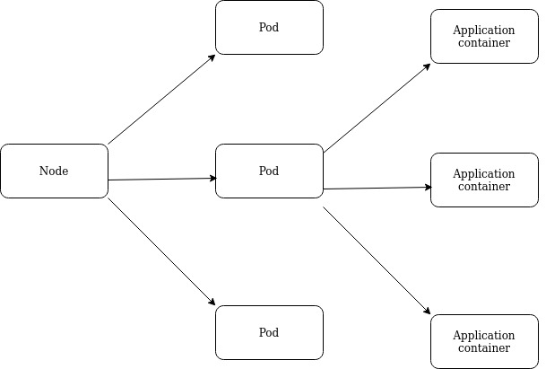

- When we create a Deployment on Kubernetes, that Deployment creates Pods with containers inside them (as opposed to creating containers directly). Each Pod is tied to the Node where it is scheduled, and remains there until termination (according to restart policy) or deletion. In case of a Node failure, identical Pods are scheduled on other available Nodes in the cluster.

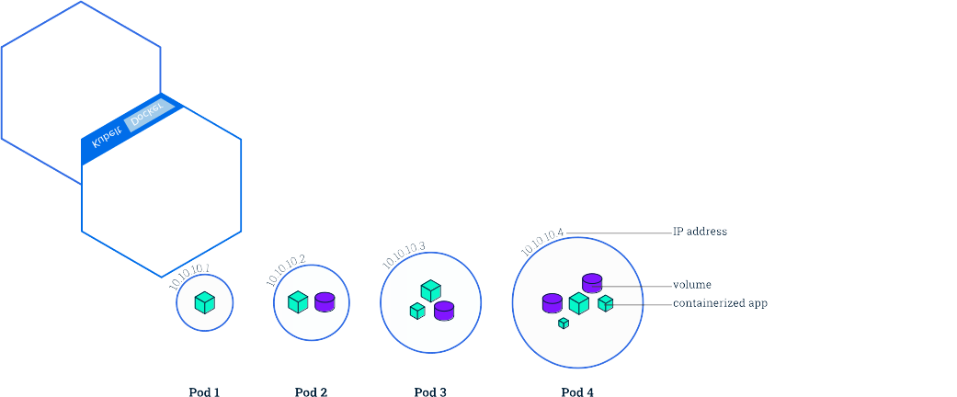

Nodes:
- A Node is a worker machine in Kubernetes and may be either a virtual or a physical machine, depending on the cluster
- A Pod always runs on a Node

Orchestration is managed through a series of watch-loops, also known as operators or controllers. Each controller interrogates the kube-apiserver for a particular object state, modifying the object until the declared state matches the current state. The default, newest, and feature-filled controller for containers is a Deployment. A Deployment ensures that resources are available, such as IP address and storage, and then deploys a ReplicaSet. The ReplicaSet is a controller which deploys and restarts containers, Docker by default, until the requested number of containers is running. Previously, the function was handled by the ReplicationController, but has been obviated by Deployments. There are also Jobs and CronJobs to handle single or recurring tasks.

There are several other API objects which can be used to deploy pods. A DaemonSet will ensure that a single pod is deployed on every node. These are often used for logging and metrics pods. A StatefulSet can be used to deploy pods in a particular order, such that following pods are only deployed if previous pods report a ready status.

Master Node Components:
kube-apiserver
The kube-apiserver is central to the operation of the Kubernetes cluster.
All calls, both internal and external traffic, are handled via this agent. All actions are accepted and validated by this agent, and it is the only agent which connects to the etcd database. As a result, it acts as a master process for the entire cluster, and acts as a frontend of the cluster's shared state. Each API call goes through three steps: authentication, authorization, and several admission controllers.
kube-scheduler
The kube-scheduler uses an algorithm to determine which node will host a Pod of containers. The scheduler will try to view available resources (such as volumes) to bind, and then try and retry to deploy the Pod based on availability and success.
There are several ways you can affect the algorithm, or a custom scheduler could be used instead. You can also bind a Pod to a particular node, though the Pod may remain in a pending state due to other settings.
One of the first settings referenced is if the Pod can be deployed within the current quota restrictions. If so, then the taints and tolerations, and labels of the Pods are used along with those of the nodes to determine the proper placement.

etcd Database
The state of the cluster, networking, and other persistent information is kept in an etcd database, or, more accurately, a b+tree key-value store. Rather than finding and changing an entry, values are always appended to the end. Previous copies of the data are then marked for future removal by a compaction process. It works with curl and other HTTP libraries, and provides reliable watch queries.
Simultaneous requests to update a value all travel via the kube-apiserver, which then passes along the request to etcd in a series. The first request would update the database. The second request would no longer have the same version number, in which case the kube-apiserver would reply with an error 409 to the requester. There is no logic past that response on the server side, meaning the client needs to expect this and act upon the denial to update.
There is a master database along with possible followers. They communicate with each other on an ongoing basis to determine which will be master, and determine another in the event of failure. While very fast and potentially durable, there have been some hiccups with some features like whole cluster upgrades. Starting with v1.15.1, kubeadm allows easy deployment of a multi-master cluster with stacked etcd or an external database cluster.

Other Agents
The kube-controller-manager is a core control loop daemon which interacts with the kube-apiserver to determine the state of the cluster. If the state does not match, the manager will contact the necessary controller to match the desired state. There are several controllers in use, such as endpoints, namespace, and replication. The full list has expanded as Kubernetes has matured.
Remaining in beta as of v1.16, the cloud-controller-manager interacts with agents outside of the cloud. It handles tasks once handled by kube-controller-manager. This allows faster changes without altering the core Kubernetes control process. Each kubelet must use the --cloud-provider-external settings passed to the binary.

Minion/ Worker Node components:

kubelet
The kubelet interacts with the underlying Docker Engine also installed on all the nodes, and makes sure that the containers that need to run are actually running.
It is the heavy lifter for changes and configuration on worker nodes. It accepts the API calls for Pod specifications (a PodSpec is a JSON or YAML file that describes a Pod). It will work to configure the local node until the specification has been met.
Should a Pod require access to storage, Secrets or ConfigMaps, the kubelet will ensure access or creation. It also sends back status to the kube-apiserver for eventual persistence.

kube-proxy
The kube-proxy is in charge of managing the network connectivity to the containers. It does so through the use of iptables entries. It also has the userspace mode, in which it monitors Services and Endpoints using a random high-number port to proxy traffic. Use of ipvs can be enabled, with the expectation it will become the default, replacing iptables.

Container Runtime
The container runtime is the software that is responsible for running containers. Kubernetes supports several container runtimes: Docker, containerd, cri-o, rktlet and any implementation of the Kubernetes CRI (Container Runtime Interface).

Containerizing an Application

To containerize an application, you begin by creating your application. Not all applications do well with containerization. The more stateless and transient the application, the better. Also, remove any environmental configuration, as those can be provided using other tools, like ConfigMaps and secrets. Develop the application until you have a single build artifact which can be deployed to multiple environments without needing to be changed, using decoupled configuration instead. Many legacy applications become a series of objects and artifacts, residing among multiple containers.

Multi-Container Pod Terminology
- Ambassador
This type of secondary container would be used to communicate with outside resources, often outside the cluster. Using a proxy, like Envoy or other, you can embed a proxy instead of using one provided by the cluster. It is helpful if you are unsure of the cluster configuration.
- Adapter
This type of secondary container is useful to modify the data generated by the primary container. For example, the Microsoft version of ASCII is distinct from everyone else. You may need to modify a datastream for proper use.
- Sidecar
Similar to a sidecar on a motorcycle, it does not provide the main power, but it does help carry stuff. A sidecar is a secondary container which helps or provides a service not found in the primary application. Logging containers are a common sidecar.

readinessProbe
Oftentimes, our application may have to initialize or be configured prior to being ready to accept traffic. As we scale up our application, we may have containers in various states of creation. Rather than communicate with a client prior to being fully ready, we can use a readinessProbe. The container will not accept traffic until the probe returns a healthy state.
With the exec statement, the container is not considered ready until a command returns a zero exit code. As long as the return is non-zero, the container is considered not ready and the probe will keep trying.
Another type of probe uses an HTTP GET request (httpGet). Using a defined header to a particular port and path, the container is not considered healthy until the web server returns a code 200-399. Any other code indicates failure, and the probe will try again.
The TCP Socket probe (tcpSocket) will attempt to open a socket on a predetermined port, and keep trying based on periodSeconds. Once the port can be opened, the container is considered healthy.
- livenessProbe
Just as we want to wait for a container to be ready for traffic, we also want to make sure it stays in a healthy state. Some applications may not have built-in checking, so we can use livenessProbes to continually check the health of a container. If the container is found to fail a probe, it is terminated. If under a controller, a replacement would be spawned.

Design Concepts:

Traditional Applications - Considerations
- One of the larger hurdles towards implementing Kubernetes in a production environment is the suitability of application design.
- Traditional applications were built and deployed with the expectation of long- term processes and strong interdependence.

Decoupled Resources
- The use of decoupled resources is integral to Kubernetes.
- Instead of an application using a dedicated port and socket, for the life of the instance, the goal is for each component to be decoupled from other resources.
- The expectation and software development toward separation allows for each component to be removed, replaced, or rebuilt.
- Instead of hard-coding a resource in an application, an intermediary, such as a Service, enables connection and reconnection to other resources, providing flexibility.

Transience
- Equally important is the expectation of transience. Each object should be developed with the expectation that other components will die and be rebuilt.
- With any and all resources planned for transient relationships to others, we can update versions or scale usage in an easy manner.

