SmartCare v0.4 - Domain Implementation Workbook
Week 7 student resource

1. UML-to-Code Trace
UML element | Python element | Implemented? | Notes
Attributes: PatientID, Name, Email, Phone number, Date of birth. | Self.patient=patientID  Self.full_name = Name  Self.email = Email  Self.phone_number = Phone_number  Self.date_of_birth = Date_Of_Birth | Yes
Patient.validate_patient() | def validate_patient(self) -> bool | Yes
Patient.update_patient() | def update_records(self) -> | Yes
Patient.search_patient() | N/A | Omitted
Patient.view_appointment_history() | N/A | Omitted
Attributes: Practitioner_id, PatientID, Name, Specialty | Self.practitoner_id = practitioner_id  Self.patient=patient_ID  Self.name = name  Self.specialty = specialty | Yes
Practitioner.view_schedule() | N/A | Omitted
Practitioner.validate_gp_info() | def validate_gp_info(self) -> bool | Yes
AppointmentID, PatientID, PractitionerID, Date_time, Status | self.appointment = appointment_id  self.patient = patient_id self.practitioner_id = practitioner_id self.date_time = Date_time self.status = status | Yes
Appointment.book_appointment | def book_appointment(self) -> None | Yes
Appointment.cancel_appointment | def cancel_appointment(self) -> None | Yes
Appointment.validate_appointment_time() | def validate_appointment_time(self) -> bool | Yes
Appointment.check_double_booking() | N/A | Omitted

2. Domain Invariants
Class | Invariant / rule | How protected
Patient | Name should not be empty field | Added in patient class within the validate_patient method by using an if statement to check whether or not the name field is empty.
Patient | Phone number must follow valid pattern | Added in patient class within the validate_patient method by using an if statement to check whether or not the phone number field follows the 8 number structure (01234567)
Patient | Email must be in valid format | Added in patient class within the validate_patient method by using an if statement to check whether or not the email field has an at symbol within it.
Patient | Date of birth cannot be in future | Added in patient class within the validate_patient method by using an if statement to check whether or not the date is correct by using the datetime module to check for correct structure and whether or not the date is in the future.
Practitioner | Name should not be an empty field | Added in practitioner class within the Validate_gp_info class using an if statement to check if the name field is empty.
Appointment | Check appointment time | Added in Appointment class within validate_patient_time() method by checking the strucute of the date and time, then checking whether or not the date is scheduled in the future.
Appointment | Ensure status is either Booked or Cancelled. | Added in Appointment class within the check status method to check the status, which came from a separate class called status.
Appointment | Cannot cancel already cancelled appointment. | Added in Appointment class within cancel_appointment() method by checking what the current status is and if it is set to cancel then raise error else set the value of status to cancel.

3. Composition / Inheritance Decisions
Relationship | Decision | Rationale
Appointment to patient | Aggregation | The Appointment class references patient_id.
Appointment to practitioner | Aggregation | The Appointment class references practitioner_id.
Patient to Practitioner | Compulsion | Both these classes do not reference one another as they are independent entities.

4. AI Pair-Programming Record
AI contribution | Conforms? | Decision | Reason | Verification
Validating time logic  Appointment.validate_time | Yes | Accepted | Uses in-built python modules such as datetime. | Tested with valid formats.
Implementation of book_appointment() and cancel_appointment with verification checks | Yes | Accepted | Allows all validations to be checked one after another before validating status. | Tested the cancel_appointment() function twice to see if it raises error of not allowing cancellation if appointment was already cancelled.
Check_double_booking method implemented with list. | Partially | Accepted | Allows quick validation of no double booking without using databases. | Tested the check_double_booking() function by booking two appointments at the same time.

5. Updated UML
Insert updated UML only if implementation revealed a justified design change. Explain every change.
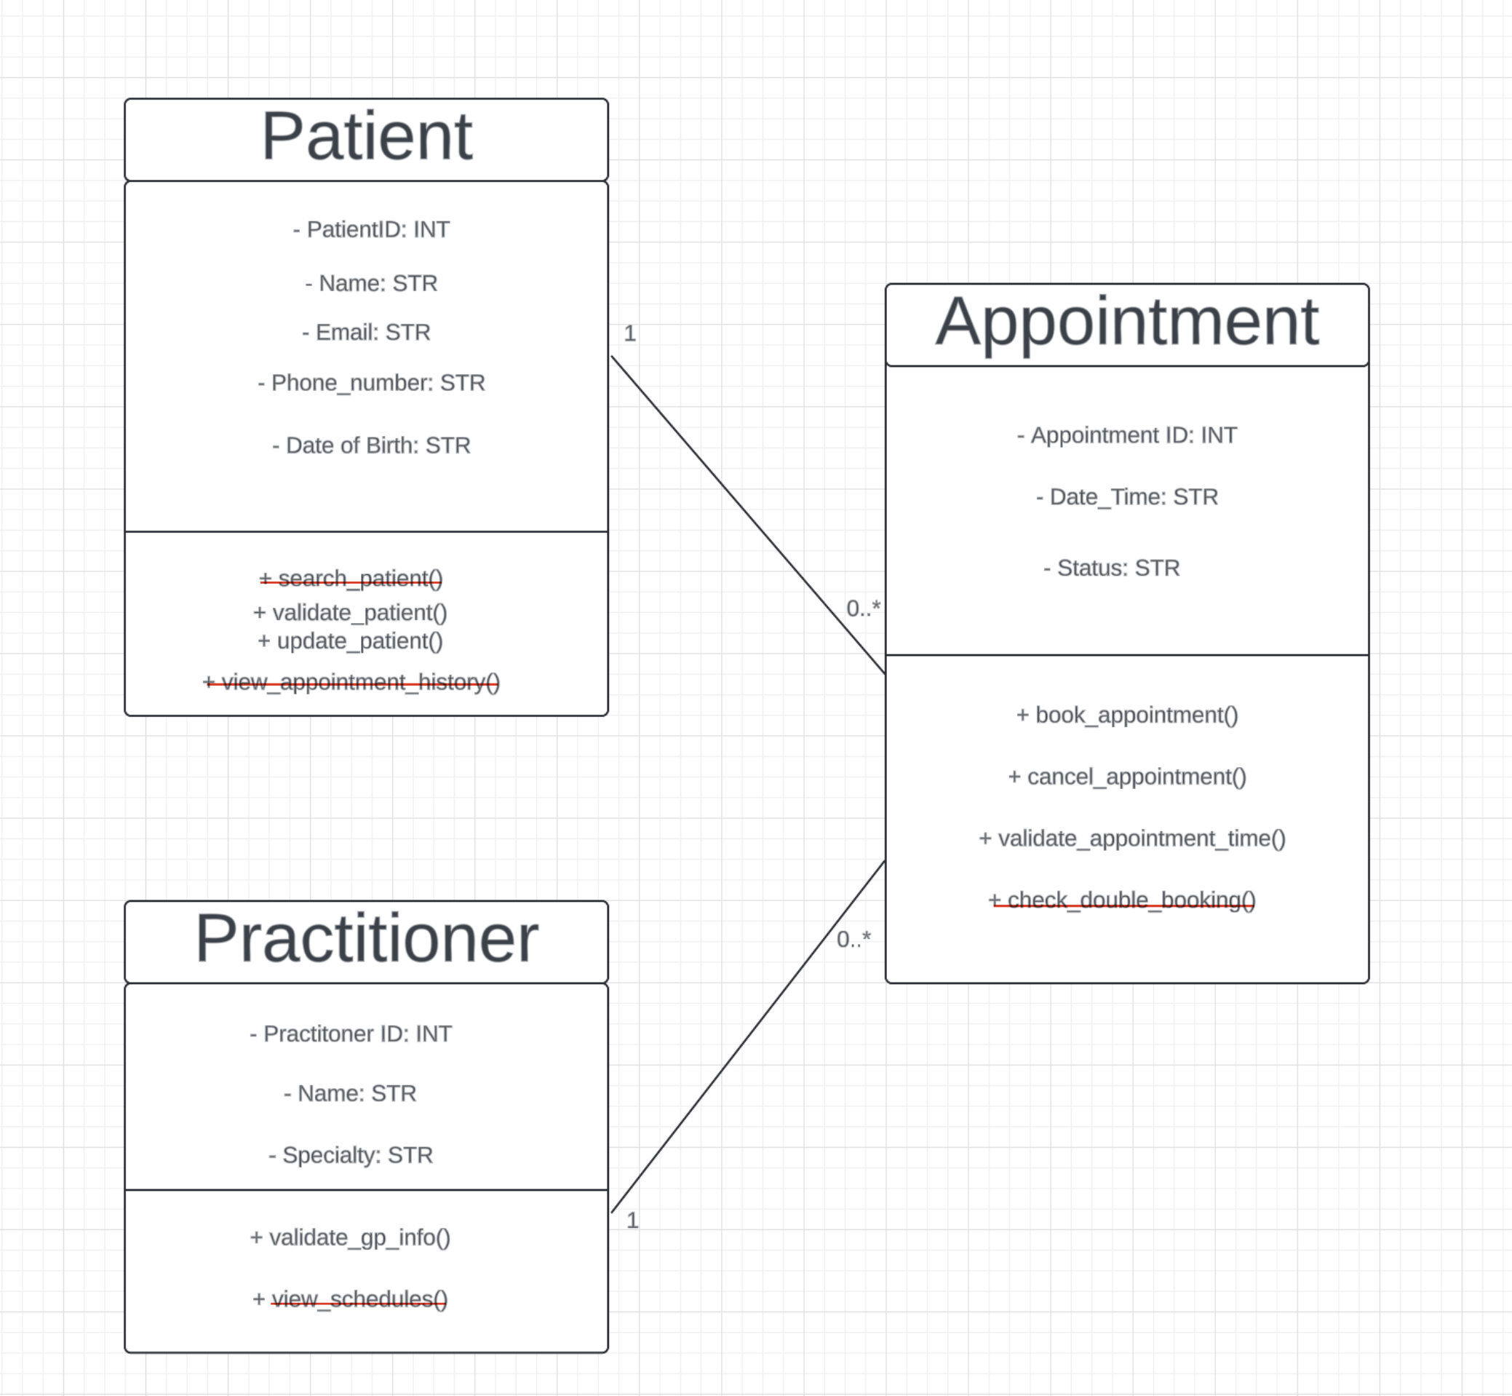

Note: This is the exact UML design I put into AI, so in the first section where it asks for UML-to-code trace I have used the methods from these, but once I popped it into AI the methods changed which I have discussed about in section 2.
All the methods with a strikethrough are methods which require a database connection to either search for patients, view patient schedules, check double bookings (although this was done using a list and viewing appointment history. That is why I decided to exclude them because they required a database connection which was out of scope.

