Assignment 2- Case Study

Stage 3 Lab Activities

SmartCare Domain Modelling
AI OFF -> AI ON -> COMPARE -> VERIFY | 1 hour

A - Requirements Review
Highlight nouns, verbs and business rules in SmartCare v0.2.
Nouns
Verbs
Business rules
I have highlighted the nouns, verbs and business using the following colors (listed above) in the business rules SmartCare v0.2 from Week 5.

B - Candidate Classes
Record candidate concepts, supporting requirements, state and behaviour.
Candidate class | State | Behaviour | Supporting requirements
Patient | - Patient_id  - Full_name  - Email  - Phone_number  - Date_of_birth | - Search_patient()  - Validate_patient()  - Update_records()  - View_appointment_history() | FR-01, FR-03, FR-04, FR-05, FR-08, FR-12
General Practitioner | - Practitioner_id  - Name  - Specialty  - Patient_id | - Validate_GP_info()  - View_Schedule() | FR-09, FR-11, US-04
Appointment | - Appointment_id  - Patient_id  - Practitioner_id  - Date_time  - Status | - Book_appointment()  - Cancel_appointment()  - Validate_appointment_time()  - Check_double_booking()  - Send_reminder()  (optional method) | FR-02, FR-05, FR-06, FR-07, US-02, US-06
Report Generation (assumed) | - Report_id  - Patient_id  - Generated_date  - content | - generate_report() | FR-10, Acceptance Criteria

C - CRC Cards
Create CRC cards for Patient, Practitioner and Appointment.
Card 1: Appointment
Class name: Appointment
Responsibilities: Managing the booking of appointments by creating, cancelling and validating appointment times.
Collaborators: Patient and Practitioner
Card 2: Patient
Class name: Patient
Responsibilities: Getting user input to validate them, search for them and view the history of past appointments if available updating the records of the most recent visits.
Collaborators: Appointments
Card 3: Practitioner
Class name: Practitioner
Responsibilities: Validate the GP’s personal information and allowing them to view their appointment schedule.
Collaborators: Appointments and patient

D - UML Model
Draw classes, attributes, operations, associations and multiplicities.
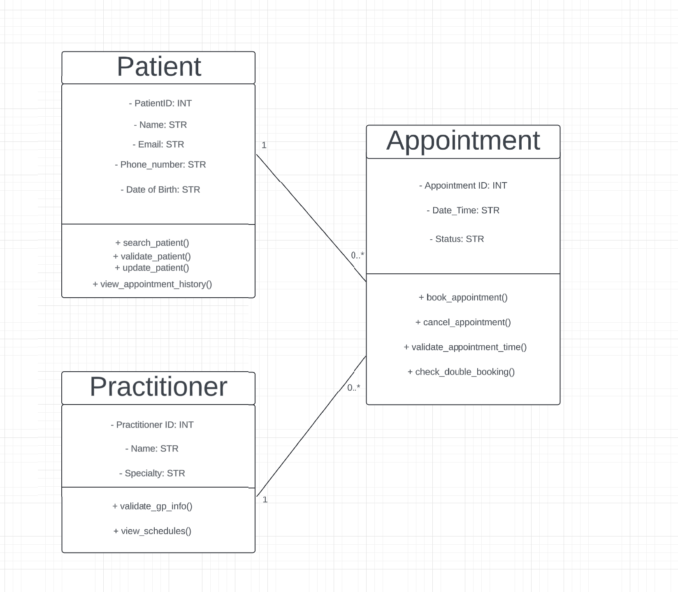

E - AI Design Review
Ask AI to suggest classes and relationships using only confirmed requirements; require supporting requirement IDs.
Act as a software architect. Read the following requirements: [attached document]. Identify candidate classes and relationships using only the provided requirements. Do not add extra systems like payment gateways or notification servers unless explicitly requested.

F - Compare and Decide
Record at least one accepted, modified and rejected AI suggestion.
Keep Patient, Practitioner, and Appointment as domain classes because all three are explicitly required in the CRC-card activity and supported elsewhere in the handout.
Modified suggestion:
Rename General Practitioner to Practitioner for consistency with the CRC and Python-skeleton instructions. This avoids treating two labels from the handout as two separate domain classes. \
Rejected suggestion:
Reject Report Generation as a confirmed class at this stage because the source explicitly identifies it as “assumed.” It therefore lacks confirmed requirement support

G - Python Skeletons
Create simple Patient, Practitioner and Appointment class skeletons.

H - Consistency Check
Check model-code consistency; do not implement full behaviour yet.

Reflection
What modelling decision was hardest? Where did AI over-design? What evidence supported your final choices?
I had deeply though about having a separate class for report generation and having a reminder system. AI suggested that I don’t include reminders as it was outside of the scope and it told me to not have a separate class for report generation but instead to use it either with other classes or outside other classes in another section with code.

