SmartCare v0.3 - Domain Model Workbook
Week 6 student resource

Requirement-to-Concept Trace
Requirement | Concept | State/behaviour | Decision
FR-01 | Patient | Search_patient() | Keep with patient
FR-02 | Appointment | Validate_double_booking() | Keep with appointment
FR-03 | Patient | Validate_patient() | Keep with patient
FR-05 | Appointment | Validate_appointment() | Keep with appointment
FR-06 | Patient | Send_reminder() | Out of scope
FR-07 | Appointment | Cancel_appointment() | Keep with appointment
FR-08 | Appointment | View_appointment_history() | Keep with appointment
FR-09 | Practitioner | Validate_GP() | Keep with General practitioner
FR-10 | Report Generation | Generate_report() | Modify
FR-11 | Practitoner | View_Schedule() | Keep with General practitioner
FR-12 | Patient | Update_patient() | Keep with patient

CRC Cards

Patient
Responsibilities | Collaborators
Searching, updating and viewing the history of patients. | Appointment
Validating pateints personal information.

Practitioner
Responsibilities | Collaborators
Viewing the history of past appointments | Patient
Validating General practitioners personal information.

Appointment
Responsibilities | Collaborators
Creating, cancelling and validating appointment times. | Patient
 | Practitioner

Optional class
Responsibilities | Collaborators

UML Class Diagram
Insert/draw UML here. Include defensible relationships and multiplicities.
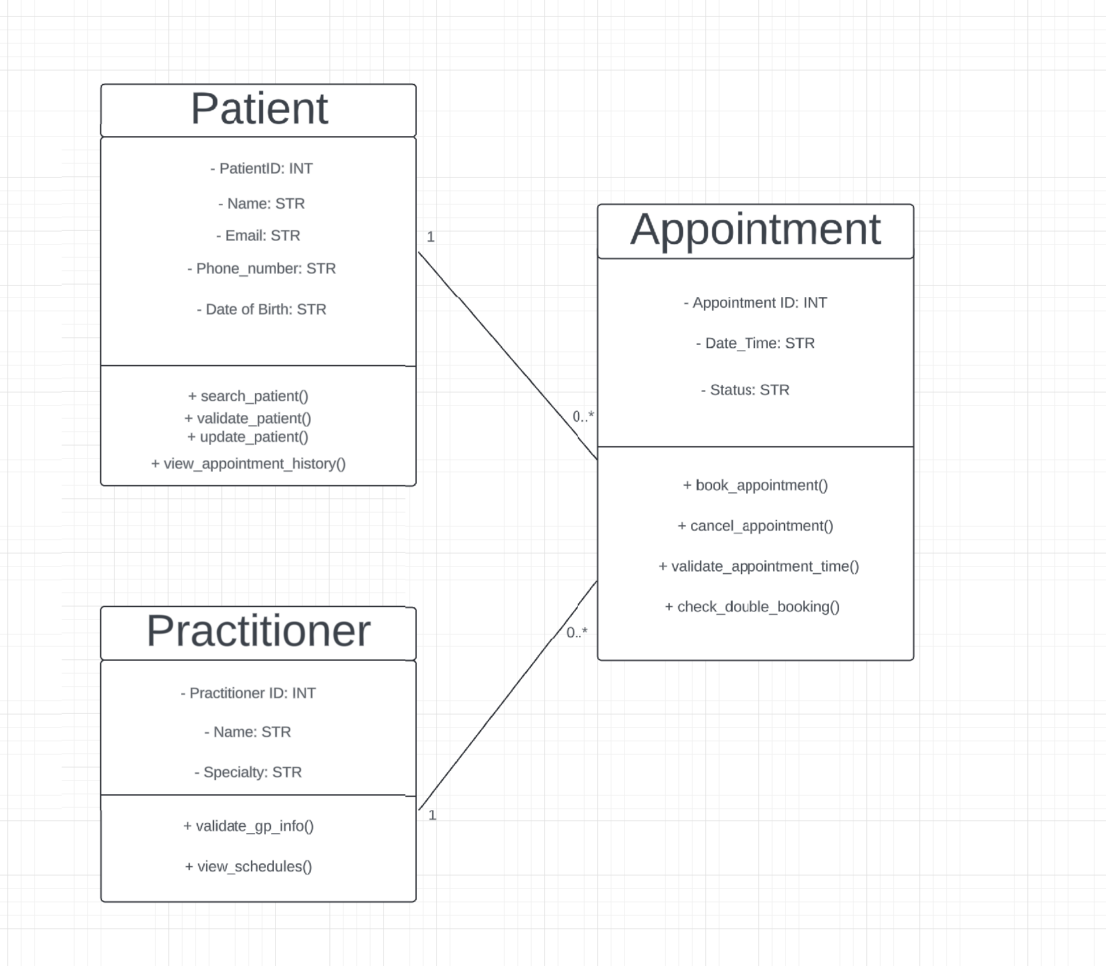

Design Rationale
Explain class selection, responsibility allocation and key relationships.
- A patient can have many appointments (1 to many relationship)
- A general practitioner can have many appointments (1 to many relationships)
- An appointment can only have on patient (1 to 1 relationship)
- A patient can only book one appointment at any given time (1 to 1 relationship)

AI Design Review Record
AI suggestion | Evidence | Decision | Reason | Model change
Add a check double booking method to the appointment class. | FR-01 | Accepted | This validation is important as it prevents two or more appointments being booked at the same time. | Add a validate_double_booking() method to the appointment class.
Not adding any form of a billing system. | Out of scope | Accepted | Billing was out of scope so not adding it is the right way to go. | Nothing needs to be changed.
Remove class for report and keep it separately. | FR-10 | Accepted (Modified) | Report generation class was an assumed class meaning that it may have to be included within another class or not in any class at all. | Remove the Report class and either added it to one of the other classes or create a separate function to handle reports.
Add a reminder system. | FR-07 | Rejected | Is out of the scope and overcomplicates the system. | Nothing needs to be changed keep code as is and do not include reminder system.
Rename general practitioner to practitioner. | FR-09. FR-11 | Accepted. | Avoids creating two separate domain classes. | Throughout code change general practitioner to just practitioner to keep it short and consistent.

