**Pebble App User Documentation**

**Pebble App is a Pebble smartwatch application with functions of temperature display, light switch, and stop watch. This document explains the functions and the usage of the Pebble App.**

**Functions**

**User are provided with the following functions:**

**1. Get the most recent temperature read from sensor**

**2. Get the average, low, and high sensor reading for the past hour.**

**3. Switch temperature unit between Fahrenheit and Celsius.**

**4. Put the sensor into a stand-by mode in which it is not reporting temperature readings and resume from the stand-by mode.**

**5. Put the Arduino board into party mode in which the RGB light switch between seven colors.**

**6. Get stop watch counting in range 0 to 99 seconds and have the counted time displayed on Arduino**

**7. Get the historical average, low, and high sensor reading for the period that the app has been working so far.**

**8. Error message displayed for middle ware or sensor disconnection.**

**Usage**

**Here is the instruction on how to use the app:**

**First, the user should click the SELECT button to enter the watch menu, and use the UP and DOWN button to find the Pebble App and click SELECT to enter the app.**

**Then, the user can click/double click UP, SELECT and DOWN button to use the various functions. Detail functions and corresponding button clicks are provided below.**

**Finally, click BACK button to exit the app.**

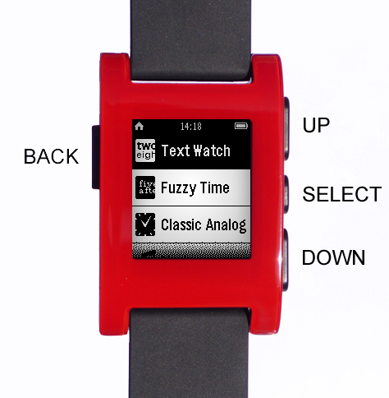

**Pebble Watch Buttons**

**Pebble App function table**

|  |  |
| --- | --- |
| **Function** | **Button click** |
| **Display most recent sensor read, and average, low, high sensor read for the past hour** | **Single click SELECT** |
| **Switch temperature unit between Fahrenheit and Celsius on display** | **Single click UP** |
| **Switch to / from stand-by mode** | **Single click DOWN** |
| **Switch Arduino board to/from party mode** | **Double click UP** |
| **Stop watch start counting** | **Double click SELECT** |
| **Stop watch stop counting** | **Double click SELECT** |
| **Stop watch restart a new count** | **Double click SELECT** |
| **Exit stop watch** | **Single click DOWN** |
| **Display historical average, low, high sensor read since the app start working.** | **Double click DOWN** |