# **Chapter 1**

# **Introduction**

## Project Overview

“Development of E-Commerce Website for Maker’s IT ” is safe and very much secure, which is reliable, available, and easily accessible to users. There will be two types of users with authorization power for login the system.

System admin will handle the all information in the system. Admin have the permission to access all the product information. Customer can view all the product and their related information. The ultimate objective of the system is to provide facility to the owner and the customer for management of a company. Security of this system is very high and the possibility of doing wrong in the calculation is low. The proposed system will involve computerized Apply system, database storage, retrieval (using defined functions), evaluation, agreement, modifications and decision making supports which will make all processes involving the system much faster and easier for the users.

## Objective

The objective of developing such a computerized system is to reduce the paper work and safe of time in employee management. There by increasing the efficiency and decreasing the work load.

The system provides user the information about employee, leave and related information. The system must provide the flexibility of generating the required documents on screen as well as on printer when required.

### 1.2.1 Broad Objectives

The broad objective of this project is to use my educational knowledge and experience acquired from IUBAT in the real life working environment by developing an “Development of E-Commerce website for Maker’s IT.” of Maker’s IT that has been assigned to me. This report is generated to describe the processes and works done in different levels of E-Commerce system. In this report I have described every part of the development segments with proper illustrations that can be used by the organization.

### 1.2.2 Specific Objectives

* To make an automated system that can handle update of every product information including product details, product availability, product quantity and product selling price.
* To make a system that will be very user friendly.
* To manage organizational information.
* To reduce time wastage that occurred in manual system.

## Scope of this Project

This software have the capacity to deal with the product information, their availability and information backup. All approved individual can utilize the software with their username, password. Using this software package authority can keep track of their product. Software should have the feature of storing every product information without any inconvenience.

## Benefits of the System

* Admin will add product
* Admin will add product category wise.
* Admin will give descriptions of the product.
* Admin can see every orders from customers.
* Admin can manage inventory.
* Customer can view the product.
* Customer can view the details of the product.
* Customer can add to cart as much quantity as he/she may needs.
* Customer can remove any product from the cart.
* Customer will get invoice.
* System can easily store information.
* System can easily provide information to the customer.
* It will have less time consuming than the manual system.
* Customer can easily access to the site.
* Customer can easily view all the products and order as much quantity as he/she may needs.
* The system will insure the Security.

## Methodology

The Development process on **“Development of E-Commerce website for Maker’s IT.”** through **“Rapid Application Development(RAD) Model “** will complete following the structure described later on Software Analysis and Design.

**1.5.1 Data Source**

There are two sorts of data sources, from where I utilized the data to develop the software project and they are:

* **Primary data** are gathered from the organizations. The organization’s practical experience, observation and face to face interview with our own web developers helped me gathering the primary data.
* **Secondary Data** are gathered by studying diverse articles, blogs and websites.

## Software Process Model

For developing a system or project I have to follow a process model. To find out the problem and select the appropriate solution I have followed the basic process model, Which is RAD Process Model.

Rapid Application development is a form of Agile software development methodology unlike waterfall methods RAD emphasize working software and user feed back over strict planning and requirement recording.RAD is ales talk and more action.

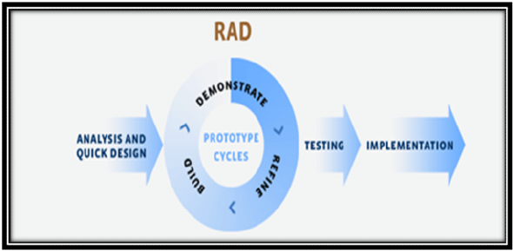

**Fig 1.1:** RAD Model (Tutorials Point, 2018)

### 1.6.1 Why RAD Model?

While the waterfall model is very slow phasing in recent years. The RAD process models provides a number of benefits, particularly for larger system that require the stages and deadlines. Some points are given below:

* Customers and Owners Satisfaction.
* In RAD Process Model more interaction maintained within developing and testing team in this process model.
* Customer can change or add requirements any stage.
* It concentrate on every process with expert team members. (Tutorials Point, 2018)

## Feasibility Study

The aims of any feasibility study are to find out whether a system is worth implementing and if can be implemented within the existing budget and schedule. The input of the feasibility study is a set of preliminary requirements. There are many different types of feasibility study, some of the most important list are given below.

* Technical feasibility
* Economic feasibility
* Operational feasibility (Wikipedia, n.d.)

### 1.7.1 Technical Feasibility

Technical feasibility concern about the hardware capability, reliability as well as availability also the skills of the team. This study looks at the hardware and software available to perform for the proposed system.

Requirements for System operation:

* Processor: Dual core or higher.
* Ram: 2GB or higher.
* Hard Disk Space: 750GB or higher.
* System: Windows/7/8/10
* Technology: Server/Local server/MYSQLI
* Software: Any Modern updated browser(Opera/Firefox/Chrome).

### 1.7.2 Economic Feasibility

Economic feasibility determines whether the system is economically feasible or not. It also determines what extent a new system is cost effective. We consider whether the company will be able to pay for redesigning and the system will be cost effective or not. The proposed system is within our budget for development.

### 1.7.3 Operational feasibility

Operational feasibility determines whether the proposed system can solve the problems as well as concerns about user acceptance, management support and requirements entities. It will help to track down all the information.