**Chapter 2**

**The Organization**

* 1. **Organizational Overview**

Maker’s IT Limited is an Electronics, web and Android solutions provider at its core with the highly qualified developers having experience of more than 3 years in various and complex designs. Other than our core service like web design and development. Maker’s IT has satisfied the clients with the services like Electronics Product, Mobile app Design and development, Software and Mobile Testing, SEO and Social Media Designing & Development. We are customer centric and divert our efforts to act as a one stop solution provider in the area of IT. In every area of our operations we work hard in understanding the Client’s requirement and providing the solution. (Makers IT, 2017)

* 1. **Our Services**
* Making Electronics Product.
* Web Application.
* Android Application.
* Software Development.
  + 1. **Making Electronics Product**

Electronics product has always been a most selling and growing because of its usability and demand. Having a different kind of electronics product could be the game changing market tool. So, to meet the clients demand we develop different kinds of customized electronics products.

* + 1. **Web-Design**

At Maker’s IT, we focus on creating search engine friendly, aesthetically appealing and interactive website designs. It is a known fact that to build a strong web presence and to secure the countless marketing opportunities available on the internet, a good website is imperative, thus triggering a race for Website Design while designing and developing your website, our professionals keep in mind key factors like easy-navigation, overall consistency and content quality, stipulated timeframes and budget. Higher for the company is to be ranked on the Search Engine result pages.

* + 1. **Android Application**

In recent years, application market is exploding the demand for mobile apps is growing because of its portability and efficiency. Having an app for any business or promotion it can be a game changing marketing tool to drive traffic and revenue. So, to meet clients demand we develop Android Application.

**2.2.4 Software Development**

At Maker’s IT we offer fully integrated software development and technical support solutions. Maker’s IT is well-experienced custom software Development Company and software outsourcing company. We have great expertise in the development of custom software applications due to our professional team efforts in performing the work according to the need of our offshore clients. We strive to focus on the customer and deliver solutions designed around their requirements rather than focusing on a specific technology and expecting the customer to adapt to the technology and platform of our choice. We use to fulfill specific needs of our clients as per their convenience for their business.

* 1. **Location**

House: Apt-12/C, Tropical Aladdin Tower, Plot- 32/C

Road- 02

Sector- 03

Uttara Model Town

Dhaka, Bangladesh 1230

Website: www.makersorb.com

* 1. **Vision**
* To build a trusted IT Companies in Bangladesh
* To be the largest Electronics & Software Companies in Bangladesh
* To be the largest online retailer
* To be the best choice for people when they like to Apps Development
* To be the largest SEO (search engine optimization) Marketing Company in Bangladesh
* To be the largest IT company in World.

* 1. **Mission**

Produce excellent service in the field of IT Service, Software Development, Website Design & Development, Apps Development, SEO (Search Engine Optimization), SMM (Social Media Marketing), Online Advertisement, e-database systems and banking home and abroad, E-commerce and Consultancy with maximum effort driven toward customer satisfaction.

**Our Mission at a glance:**

* To achieve maximum customer satisfaction over the entire life cycle of our customer solution via our excellence of products and solutions.
* To consistently enhance our competitiveness and deliver profitable growth.
* To practice highest standards of corporate governance and be a financially sound company.
* To be a partner in nation building and contribute towards Bangladesh economic growth.
* To encourage ideas, talent and value systems and become the customers of choice.
* To earn the trust and confidence of all customers, exceeding their expectations.
* To uphold the guiding principles of trust, integrity and transparency in all aspects of interactions and dealings. Vision to build upon a reputation of being one of the most innovative IT Solution and Service provider. We believe in doing our work in the most efficient way with robust and structured methodology, with gradual evolution from hard-work to smart- work culture, at client’s end also.
  1. **Organizational Structure**

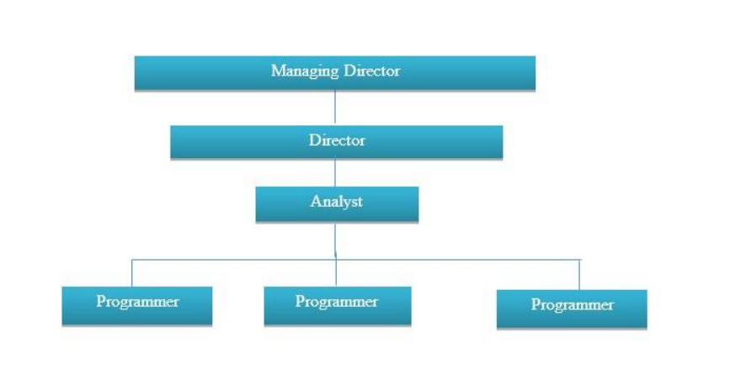

Figure 2.1: Organizational Structure of Maker’s IT.