**Chapter 3**

**Requirement Engineering**

**3.1 Requirement Engineering**

Requirement engineering refers to the process of defining, documenting and maintaining requirements and to the subfields of systems engineering and software engineering concerned with this process. Designing and building an elegant computer program that solves the wrong problem serves no one’s need. That’s why it is important to understand what the customer wants before we begin to design and build a computer-based system. Requirement engineering encompasses the tasks that lead to an understanding of what the business impact of the software will be, what the customer wants, and how end-users will interact with the software. (Search soft Quality, 2018)

**3.2 Requirement Analysis**

Typically, requirements are presented into two level of detail; user and system requirements, where user need a high-level statements of the requirements, while system developers need a more detailed system specification. So, user and system requirements just refer to different level of detail. In the following task phases the requirement analysis was done. (Search soft Quality, 2018)

**User requirement 1:**

Admin dashboard contains all options for changing the application content from admin dashboard.

**System requirement 1.1:**

Admin panel will be accessed by admin.

**System requirement 1.2:**

Admin must login.

**User requirement 2** :

Admin will add products.

**System requirement 2.1:**

Admin must login through his/her valid username and password.

**System requirement 2.2:**

After login admin get Product option. After clicking the product there will be a drop-down menu option named **Add new** there admin can add product.

**System requirement 2.3:**

Admin will add product category wise.

**System requirement 2.4:**

Admin can give a description of the product.

**User requirement 3:**

Admin can confirm the order from the customer.

**System requirements 3.1:**

Admin must login the system.

**System requirements 3.2:**

Afterlogin the system, Admin get a option named **Order**.Through this option admin can confirm any order.

**System requirement 3.3:**

Admin can view all the order.

**System requirement 3.4:**

Admin can see all the pending order.

**System requirement 3.5:**

Admin can see all the delivered order

**System requirement 3.6:**

Admin can see all the returned order.

**System requirement 3.7:**

Admin can see all the cancel order.

**User requirement 4:**

Admin can handle product information in details.

**System requirement 4.1:**

Admin must login the system.

**System requirement 4.2:**

After login the system admin will get a option named product. Through this option admin can update the quantity of the product.

**System requirement 4.3:**

After login the system admin will get a option named product. Through this option admin can delete the product.

**User requirement 5:**

Admin can check the status for the order.

**System requirement 5.1:** Admin must login the system.

**System requirement 5.2:** Admin will see a dash board on the dashboard admin will get to see all the status for the order **.**

**User requirement 6:**

Admin can manage inventory.

**System requirement 6.1:** After getting feedback from the stuff admin can update the status

## User requirement 7:

## Admin can add stuff

**System requirement 7.1:**

Admin must login to the system.

**System requirement 7.2:**

Admin will see a dashboard. In the dash board there will be a option named stuff. Through this option admin can manage the stuff.

**System requirement 7.3:**

Admin can add new stuff.

**System requirement 7.4:**

Admin can see the stuff list.

## User requirement 8:

## Anybody can order any products

**System requirement 8.1:**

User need to register a form after submitting the form user can login to the system.

**System requirement 8.2:**

User can see any product. User can see any products category wise.

**System requirement 8.3:**

User can view the details of the product.

**System requirement 8.4:**

User can add to cart products as much quantity as he/she may needs.

**System requirement 7.5:**

User can remove any product from the cart.

**System requirement 7.6:**

User will get an invoice.

**3.3** **Functional Requirements:**

Functional requirement specifies a function that a system or system component must be able to

perform. In this software, they are:

* Customer Online order System.
* Customer Order Confirmation.
* Product Details view.
* Add to cart.
* Invoice Generate.
* Admin will see the order.
* Admin can update the product quantity
* Admin can confirm the order.
* After confirming the order Admin can give the status for the order.

**3.4** **Non-Functional Requirements:**

**Security requirements:**

* System will have a very secure login.
* Password will be invisible.
* Authentication Users.
* Protecting Routes.

**Reliability requirements:**

* The system should be consistent and should give the desired results.

**Efficiency requirements:**

* The software should be efficient enough to take less memory of the computer system.

there should not be any performance degradation.

**Usability requirements:**

* The system should be easily usable by the stuff of the basic learning of computer systems can operate it.

**3.5** **Use Case Diagram**

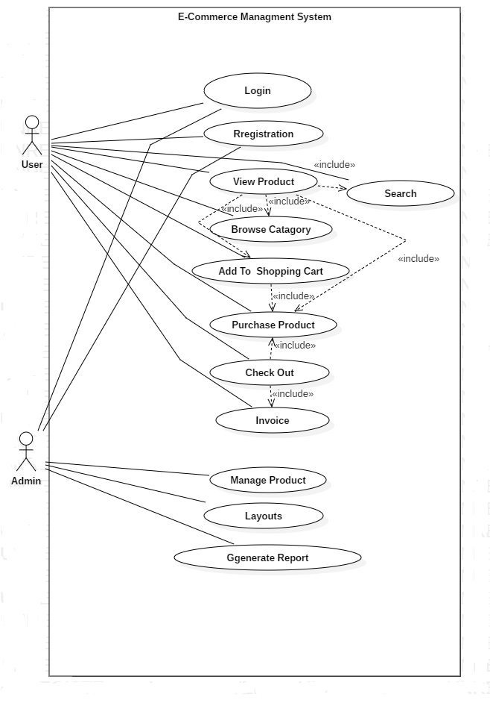

Figure 3.1: Use Case Diagram.