Software Architecture Document

for

Mobile Point of Sale
Prepared by
Atit Leelasuksan 5510546221
Pawin Suthipornopas 5510546123
Poramate Homprakob 5510546077
Rungroj Maipradit 5510546654
Sarathit Sangtaweep 5510546182
Group Boom Boom And Friends (BBAF)

Table of Contents
1. Overview 1
1.1 Purpose 1
1.2 Architecture Representation 1
2. Architectural Factors 1
3. Architectural Decisions and Rationale 1
3.1 Design of Inventory and Stock Records 2
4. Logical View 4
4.1 Domain Vocabulary 6
5. Data View 7
6. Process View 11
7. Use Case View 11
8. Deployment View 12
9. References 12

Revision History
Name | Date | Reason For Change
James Brucker | 28/11/2013 | Create template based on Larman, Chapter 39. Content and guidelines from several sources. See references.
James Brucker | 30/11/2013 | Update formatting and references. Incorporate Thai’s suggestions.
James Brucker | 2/12/2013 | Add Author to each View section. Please write name of main author for each view.
Pawin Suthipornopas | 6/12/2013 | Add details on Overview, Architectural Factors and Architectural Decisions and Rationale. Also add details to Deployment view. Update References.
Pawin Suthipornopas | 7/12/2013 | Add details about Process View from Atit. Edit header for all pages and update the front page too.
Sarathit Sangtaweep | 7/12/2013 | Add details about Logical View from myself and Rungroj.  Add details about Data View from Poramate.  Update the front page.

Overview

Purpose
This document aims to deliver every single detail of how come we develop this application, why do we have to design it like this, and why don't we design it like that. Its main purpose is to serve for the greater good of software development including both designing and coding. However, this document will mostly cover on the architectural view of the project.

This project features how to make use of the Android Software Development Kit, along with Eclipse as our tool to make this POS on Android. We chose SQLite as a database as it is an open-source and also easy to understand and use. Also this project doesn't require external internet connection for the application to work, as it should be a choice for portable point of sale machine, as we intended. We use a lot of design principles and patterns such as Facade, Adapter, Singleton, Controller and many more. Because we see the opportunity to make a usable application that is also capable of greater developing process to improve it more than we already did.

Architecture Representation
The architecture and significant decisions about architecture, design, and technologies used in the POS are described below. The architecture is described by:
Architectural Factors: requirements, constraints, and design goals that influence the architecture.
Architectural Decisions: important design decisions and the reasons for them. It also describes reasons why we did not make certain choices.
Logical View: the structure and function of the software. This includes an overall view using a package diagram showing layers and components, a Domain Model showing the logical model of the problem, and software level UML diagrams for additional detail. It also shows the major components and dependencies on external components. Significant design patterns are described.
Data View: shows external data formats such as file formats and database formats. It also describes the data flows in the application.
Process View: shows how the application actually runs as processes and threads, and how those processes and threads interact.
Use Case View: Use Cases are included in the SRS. See the SRS for complete Use Cases, including Use Case diagram.
Deployment View: shows how the application is deployed as artifacts on physical hardware. It also describes the mechanisms (means) of deploying the application.

Architectural Factors
Requirements:
For the first requirement for us, this project needs to use Java as a programming language, and Android as a tool for this project to run on. As this is a part of the “Software Specification and Design” subject, we need to learn how to work as a team using the same language and device. Also, Java has its own version of SDK for Android, and it is officially published by Google themselves. Which make this tool easy for us to use, and also legal too. Android is also easier to maintain than other mobile operating system these days and we don't have to deal with the Apple's AppStore. Android SDK is very easy to understand and has a lot of familiar classes and functions too.
Constraints:
Most obstacle we've faced so far is that these developing process is very new to our whole team. We have never make a software this big, with many people like this, and with tools like these before. So at first we start up very slow, trying to learn how things work first before speeding up as the time goes on. Other than that it is also vital that we listen to our project advisor and make use of it, depend on it a lot as it is very critical that we follow what customer wants.

Extra thing to add is that you can go and look for our SRS document for further info of why, and how we chose this kind of design and requirements for our project. It is available on our Git.

Architectural Decisions and Rationale
What we think we should do:
  - Using only one class to store product's information to prevent confusion. And for easily coding between developers.
  - Make use of only open source externals, such as SQLite as a database to prevent future problems such as piracy.
  - Use the built-in database that doesn't need internet connection for the program to work.
What we should not:
  - Having many classes with high dependencies.
  - Think of too many supplementary features before the main one is finished.

Design of Inventory and Stock Records
Author: Atit Leelasuksan
At first, we design inventory model to be Product and ProductQuantity to be associated. But we found it make design more complex and dizzy so we decide to change to be single class to record data as “ProductDescription” which is a Product and keep quantity in database.

Our ProductDescription consists of id, name, description, price, cost and date modified. We got some feedback from our advisor that quantity can be negative because if the customer pick something that our stock show that is zero quantity but the customer pick a real product from our shop we must make sale of that product anyway.

So basically; instead of having a lot of classes to support product's elements, we declare it as a one whole class that has many things inside instead, and just write some getter and setter methods to put it all out to use. It is more convenience this way, according to our experimentation.

Logical View
Author: Sarathit Sangtaweep, Rungroj Maipradit
Package View (*Note InventoryansSaleActivity is InventoryActivity)
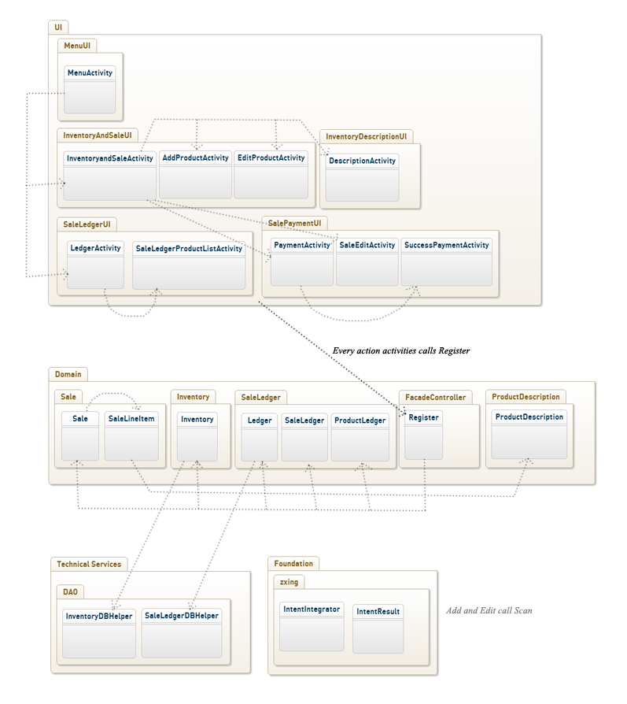

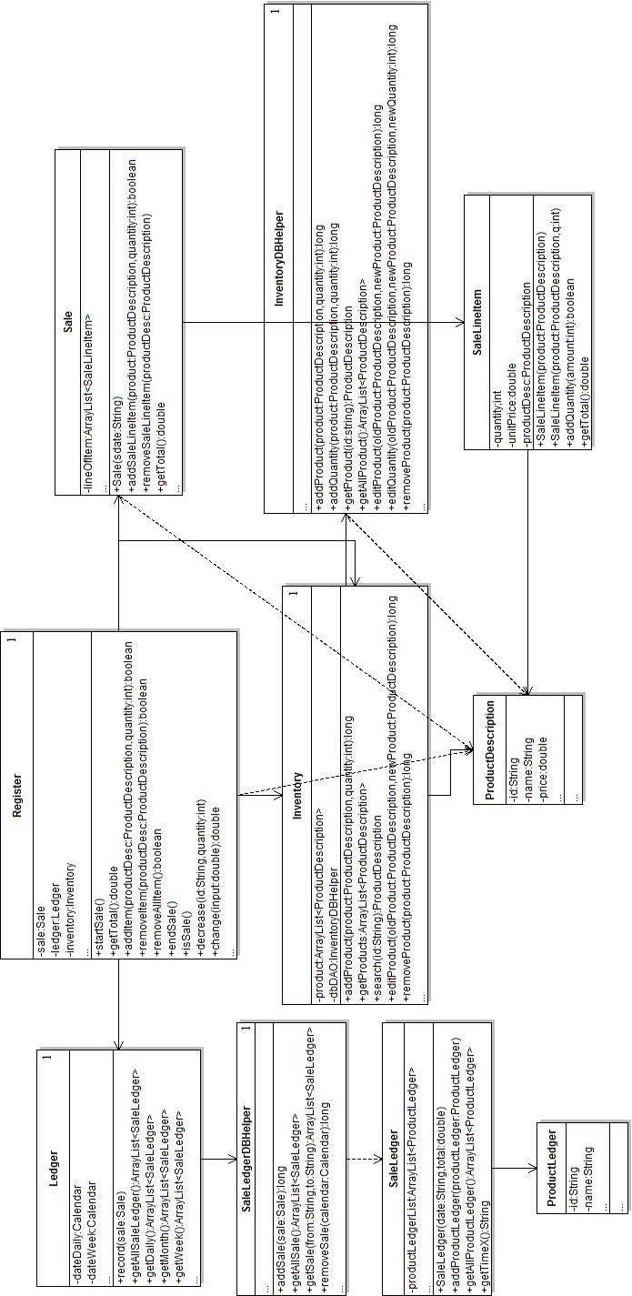
Design Class Diagram

Design Patterns
Adapter Pattern: SaleLedgerListViewAdapter, InventoryListViewAdapter, SaleListViewAdapter
Facade Pattern: Register
Singleton Patten: DBHelper, Register, Inventory
Delegate Pattern: Register, Inventory , Ledger
Controller Pattern: Register

Register is a Facade and Controller which receives the command from UI and delegate the responsibility to the other class. E.g. Inventory, Sale
Singleton Pattern is used for the entire database access object such as Inventory and Ledger to prevent multi-thread reading data from the database which may cause application to crash.
Inventory and Ledger delegate responsibility to store data to database to database access object.
SaleListViewAdapter and other adapter are used to implement its data to use and show in list view.

Domain Vocabulary
SaleLedger – a record of sales, which can be for a given time period of time .
Inventory – represent all items in the store.
Sale - represent one sale.
SaleLineItem - represent one type of item that customer buy.
Ledger - a filter that is used to determine which sale is going to show.
Inventory Database Helper – a connector that is used to connect with inventory database.
SaleLedgerDatabaseHelper – a connector that is used to connect with SaleLedger database.
Register - a controller for sale that is used to delegate responsibility to the other classes.
ProductDescription - a description of the product.
ProductLedger - a description of sale line item.

Data View
Author: Poramate Homprakob
Add Product
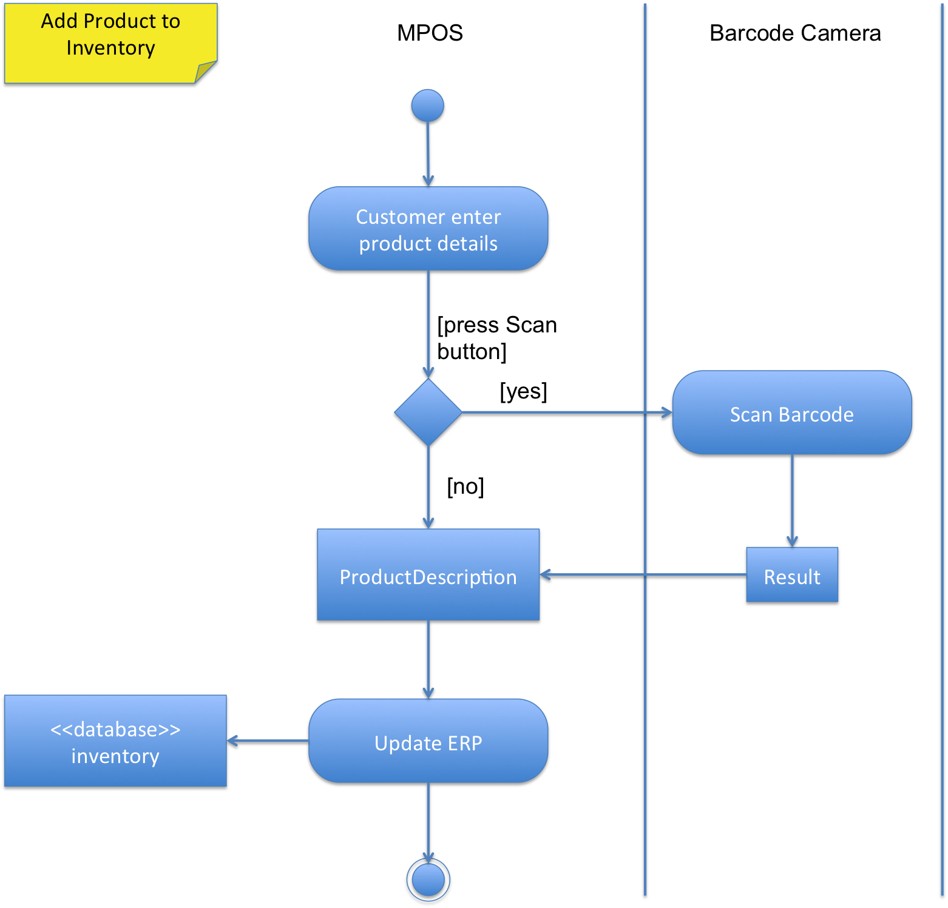
Transformation of product description read from application text field into ProductDescription object is done with the inventory system.
Transformation of product id read from external scan barcode system which is optional, is done by inventory system. Usually is a plain text format.
Transformation of ProductDescription written to ERP database (inventory) is done by InventoryDBHelper.

Edit Product

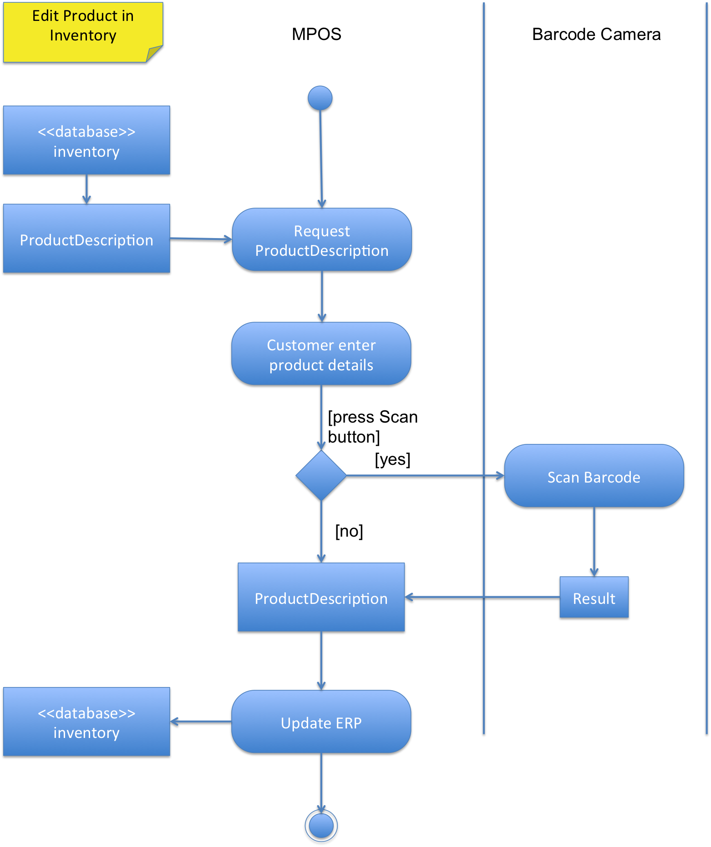

Transformation of product description read from Inventory database into ProductDescription object is done with the inventory system.
Transformation of product id read from external scan barcode system which is optional, is done by inventory system. Usually is a plain text format.
Transformation of ProductDescription written to ERP database (inventory) is done by InventoryDBHelper.

Make Sale

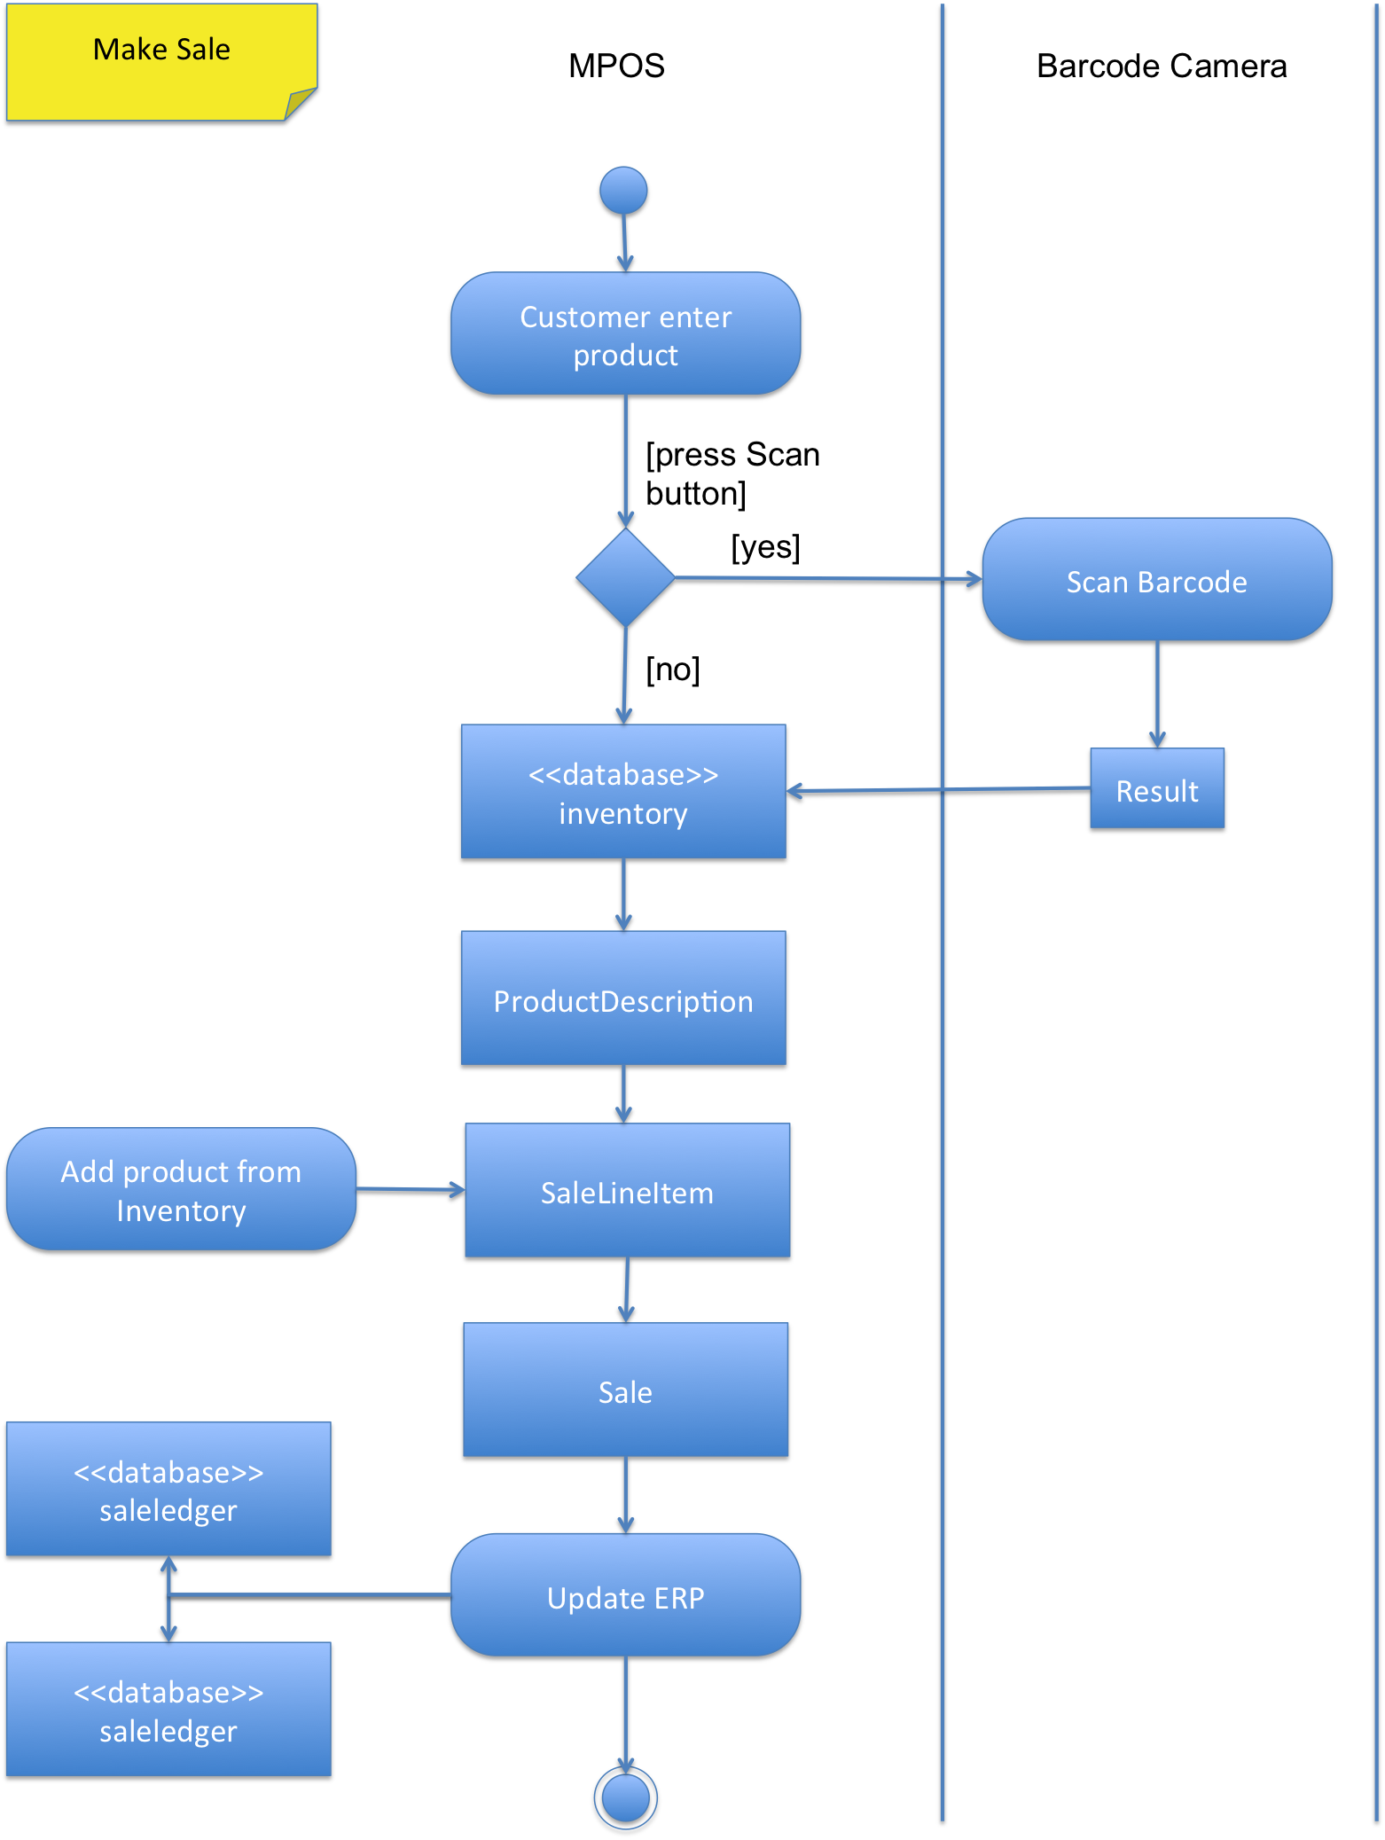
Transformation of product id read from external scan barcode system which is optional, is done by inventory system. Usually is a plain text format.
Transformation of ProductDescription object which is read from inventory database by using id text from barcode or text field into SaleLineItem object is done with the inventory system
Transformation of ProductDescription object get from inventory into SaleLineItem is done with inventory system.
Transformation of SaleLineItem object into Sale object is done with the sale system
Transformation of Sale written to ERP database (saleledger and productledger) is done by SaleLedgerDBHelper.

View Ledger

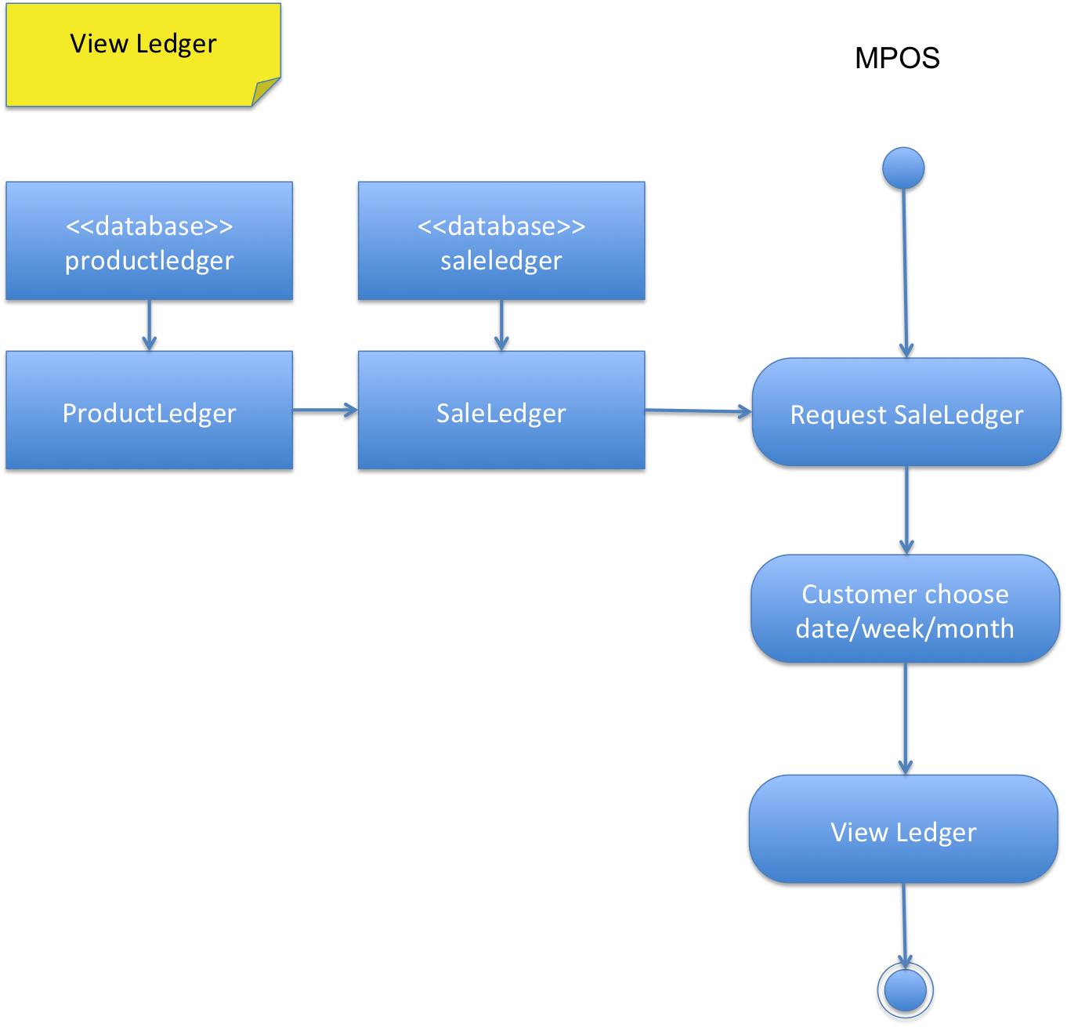

Transformation of ProductLedger which is read from productledger by using date text as a key which is read from saleledger into SaleLedger is done with the ledger system.
Transformation of SaleLedger to be shown is done by ledger system.

Process View
Author: Atit Leelasuksan
Our application run in single thread and no either service or content provider, we use only activity. Our application start at MenuActivity then choose Inventory or Ledger to start the process, Inventory have an option for add, remove and edit to perform with inventory (stock). It also have tab Sale to perform a sale with enter item and edit price function. Ledger would show a stat of previous sale in day, week or month. (I was reduce form of input manually and scan to be add/enter item)
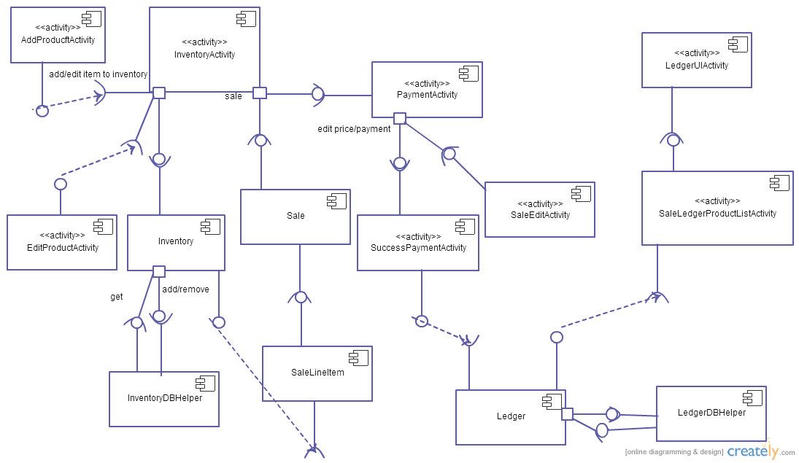

Use Case View
The Use Cases are included in the SRS. See the SRS for Use Cases.
You can access our SRS file directly from the Git page in the docs folder.
https://github.com/batmaster/MPOS

Deployment View
Author: Pawin Suthipornopas 5510546123
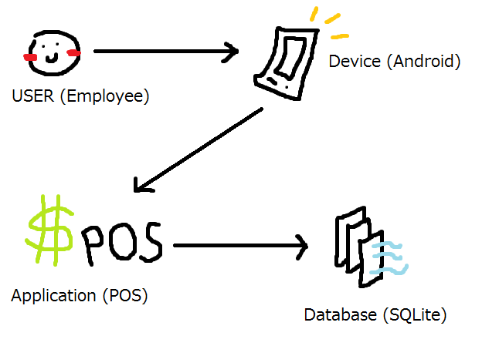
Mainly our application's physical deployment of artifacts are described like this picture below:
It is based on only Android, and runs entirely using Android device and does not require external program or application to run. User simply access our application through the device they own, and communicate with the database which is also built-in in the application, using SQLite.
Our application can be install (for now) by copying the APK file and paste it into the device, through the Android operating system which can start it right away from the application collection screen.

References
https://github.com/batmaster/MPOS
http://en.wikipedia.org/wiki/Deployment_diagram

