BABU BANARASI DAS
UNIVERSITY
2026-2027
SCHOOL OF COMPUTER APPLICATIONS
NoSQL Project On
Cricket Player Management System Using MongoDB
Submitted to: Submitted by:
Mr. Harendra Singh Ansh Srivastava
Department: BCA (DS & AI) Roll no: 1250258099
Date: 25th September university roll no

ACKNOWLEDGEMENT
I sincerely express my gratitude to my teacher Mr. Harendra Singh for giving me the opportunity to work on this NoSQL project titled “Cricket Player Management System Using MongoDB”.
This project helped me understand the basic concepts of NoSQL databases and learn how MongoDB is used to create, retrieve, update, sort and delete data. I also learned how different query operators such as greater than, less than, equal to, AND, and OR are used in MongoDB.
I am thankful to my teacher for the guidance and support provided throughout the completion of this project.

INTRODUCTION
MongoDB is a popular NoSQL database management system that stores data in the form of documents. Unlike traditional relational databases, MongoDB does not require data to be stored in fixed rows and columns.
In this project, a Cricket Player Management System has been created using MongoDB. The database contains information about 50 players, including their player ID, name, age, runs, and team.
Different MongoDB operations have been performed on the player data, such as inserting, displaying, updating, deleting, sorting, counting, and searching records. Comparison operators such as $eq, $gt, $lt, $gte, and $lte have also been demonstrated.

OBJECTIVES
• To understand the concept of NoSQL databases.
• To learn the basic features of MongoDB.
• To create a database and collection.
• To insert 50 player records.
• To perform CRUD operations.
• To use comparison operators.
• To perform sorting and filtering.
• To understand AND and OR operations.

1. CREATE DATABASE
MongoDB Query:
use CricketDB
Explanation: Creates or switches to the CricketDB database.
Output Screenshot:
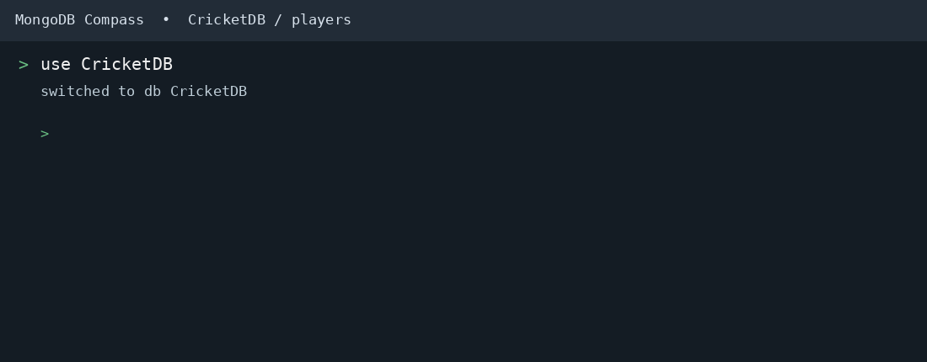

2. CREATE COLLECTION
MongoDB Query:
db.createCollection("players")
Explanation: Creates a collection named players.
Output Screenshot:
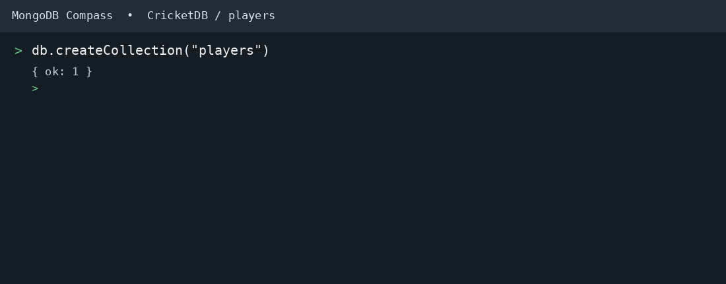

3. INSERT 50 PLAYERS
MongoDB Query:
db.players.insertMany([
{playerId:1, name:"Aarav", age:24, runs:620, team:"India"},
{playerId:2, name:"Vihaan", age:28, runs:540, team:"Australia"},
{playerId:3, name:"Aditya", age:30, runs:470, team:"England"},
{playerId:4, name:"Arjun", age:25, runs:445, team:"India"},
{playerId:5, name:"Kabir", age:26, runs:780, team:"Australia"},
{playerId:6, name:"Rohan", age:27, runs:830, team:"India"},
{playerId:7, name:"Yash", age:29, runs:310, team:"South Africa"},
{playerId:8, name:"Ishaan", age:31, runs:800, team:"England"},
{playerId:9, name:"Reyansh", age:22, runs:760, team:"India"},
{playerId:10, name:"Dev", age:28, runs:480, team:"New Zealand"},
{playerId:11, name:"Kunal", age:29, runs:630, team:"India"},
{playerId:12, name:"Manav", age:27, runs:495, team:"Australia"},
{playerId:13, name:"Dhruv", age:26, runs:920, team:"England"},
{playerId:14, name:"Ritvik", age:25, runs:360, team:"India"},
{playerId:15, name:"Atharv", age:30, runs:800, team:"South Africa"},
{playerId:16, name:"Vivaan", age:24, runs:660, team:"Australia"},
{playerId:17, name:"Shaurya", age:32, runs:575, team:"India"},
{playerId:18, name:"Ayaan", age:27, runs:930, team:"England"},
{playerId:19, name:"Krish", age:29, runs:795, team:"India"},
{playerId:20, name:"Samarth", age:26, runs:910, team:"Australia"},
{playerId:21, name:"Rudra", age:28, runs:560, team:"South Africa"},
{playerId:22, name:"Parth", age:23, runs:530, team:"India"},
{playerId:23, name:"Laksh", age:26, runs:940, team:"New Zealand"},
{playerId:24, name:"Veer", age:21, runs:635, team:"Australia"},
{playerId:25, name:"Aryan", age:27, runs:880, team:"India"},
{playerId:26, name:"Harsh", age:30, runs:705, team:"England"},
{playerId:27, name:"Abhinav", age:31, runs:400, team:"South Africa"},
{playerId:28, name:"Siddharth", age:29, runs:695, team:"Australia"},
{playerId:29, name:"Nakul", age:26, runs:900, team:"India"},
{playerId:30, name:"Shivansh", age:25, runs:660, team:"England"},
{playerId:31, name:"Tanish", age:28, runs:440, team:"Australia"},
{playerId:32, name:"Ansh", age:27, runs:840, team:"India"},
{playerId:33, name:"Varun", age:24, runs:860, team:"New Zealand"},
{playerId:34, name:"Pranav", age:30, runs:470, team:"South Africa"},
{playerId:35, name:"Madhav", age:32, runs:470, team:"India"},
{playerId:36, name:"Ayush", age:29, runs:290, team:"Australia"},
{playerId:37, name:"Naman", age:23, runs:370, team:"England"},
{playerId:38, name:"Om", age:27, runs:800, team:"India"},
{playerId:39, name:"Raghav", age:28, runs:635, team:"Australia"},
{playerId:40, name:"Rajat", age:25, runs:555, team:"New Zealand"},
{playerId:41, name:"Sarthak", age:22, runs:600, team:"India"},
{playerId:42, name:"Adit", age:24, runs:695, team:"South Africa"},
{playerId:43, name:"Vansh", age:29, runs:395, team:"England"},
{playerId:44, name:"Samar", age:31, runs:520, team:"Australia"},
{playerId:45, name:"Yuvraj", age:26, runs:250, team:"India"},
{playerId:46, name:"Kartik", age:30, runs:440, team:"New Zealand"},
{playerId:47, name:"Zaid", age:28, runs:395, team:"South Africa"},
{playerId:48, name:"Aniket", age:26, runs:840, team:"Australia"},
{playerId:49, name:"Bhavya", age:29, runs:625, team:"India"},
{playerId:50, name:"Chirag", age:24, runs:435, team:"England"}
])
Explanation: Inserts multiple player documents into the collection.
Output Screenshot:
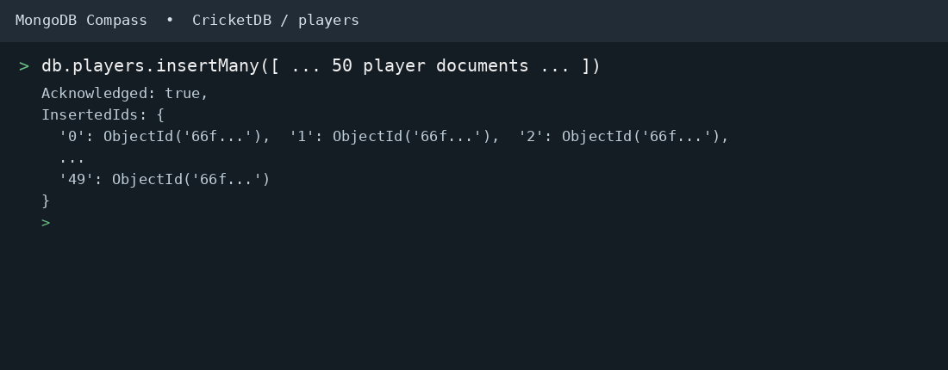

4. DISPLAY ALL PLAYERS
MongoDB Query:
db.players.find()
Explanation: Retrieves all documents from the players collection.
Output Screenshot:
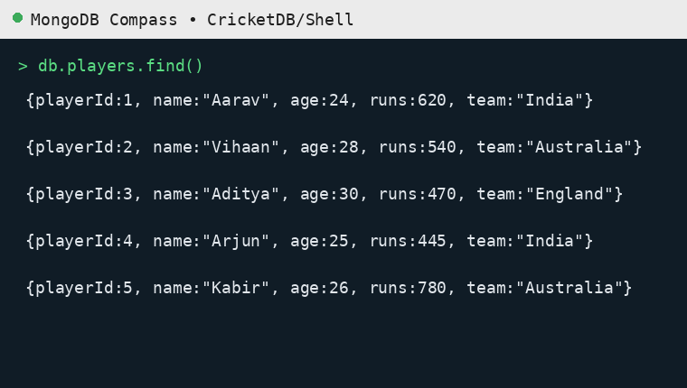 | 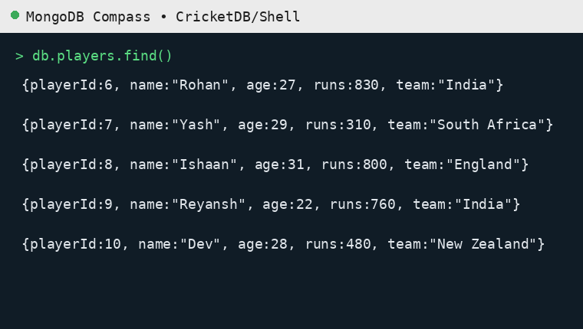 | 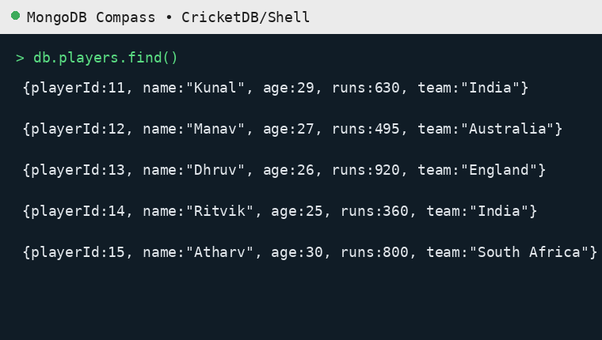 | 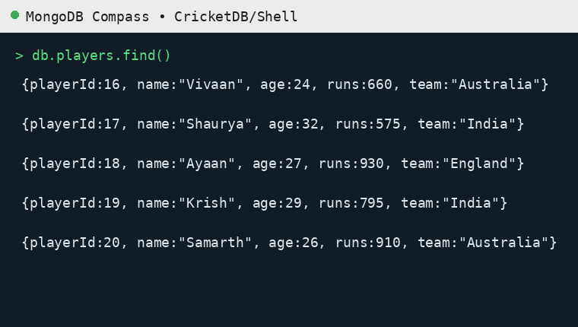
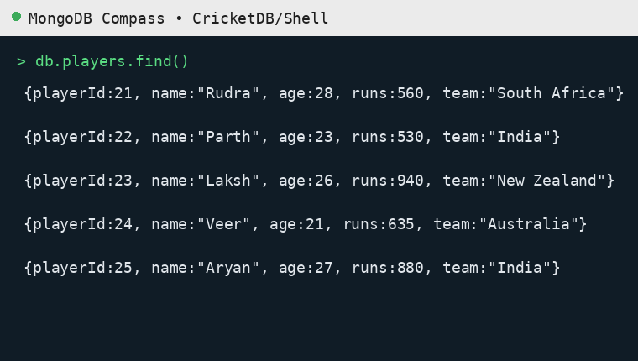 | 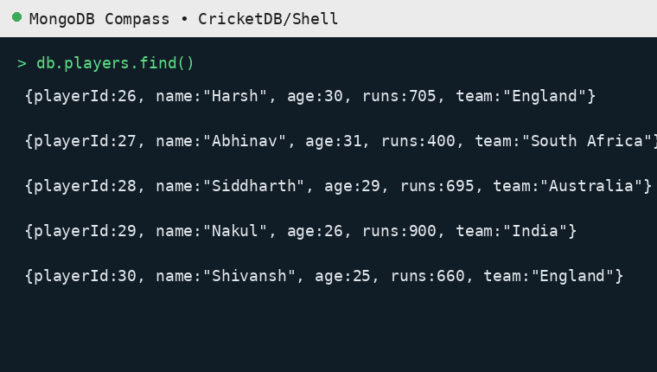 | 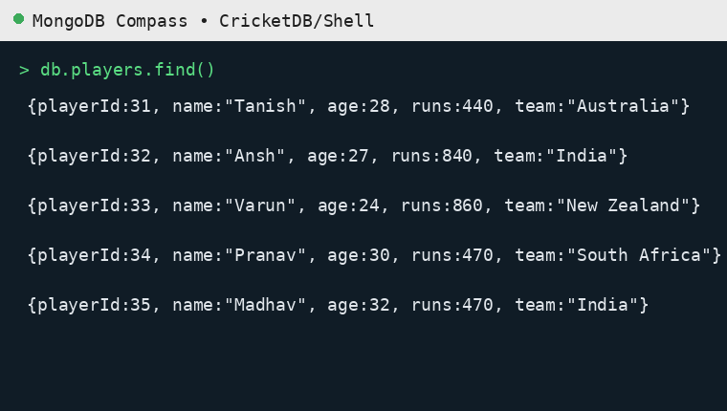 | 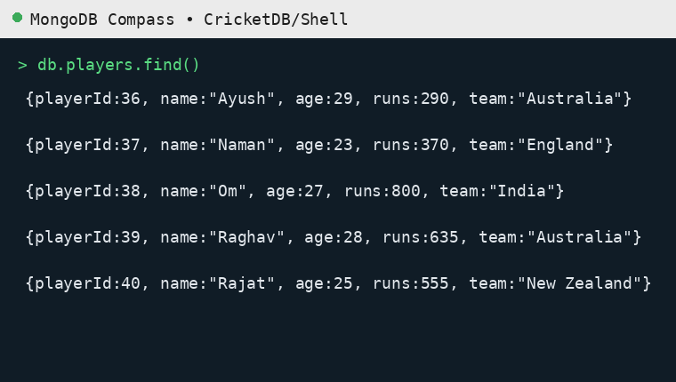
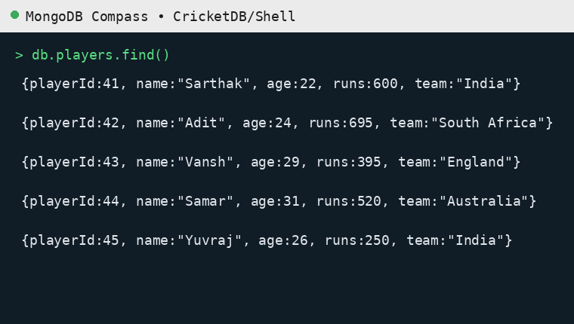 | 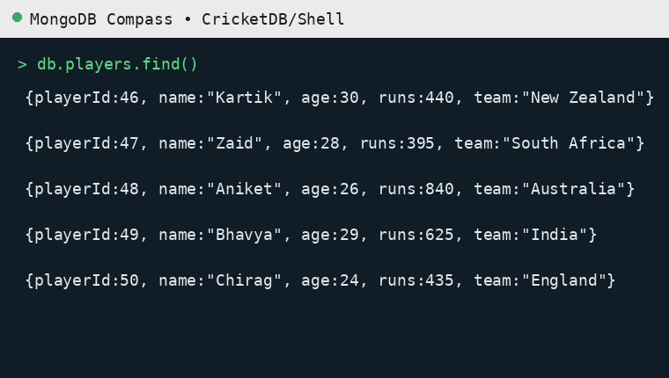

5. EQUAL TO — $eq
MongoDB Query:
db.players.find({runs: {$eq: 620}})
Explanation: Finds players whose runs are exactly 620.
Output Screenshot:
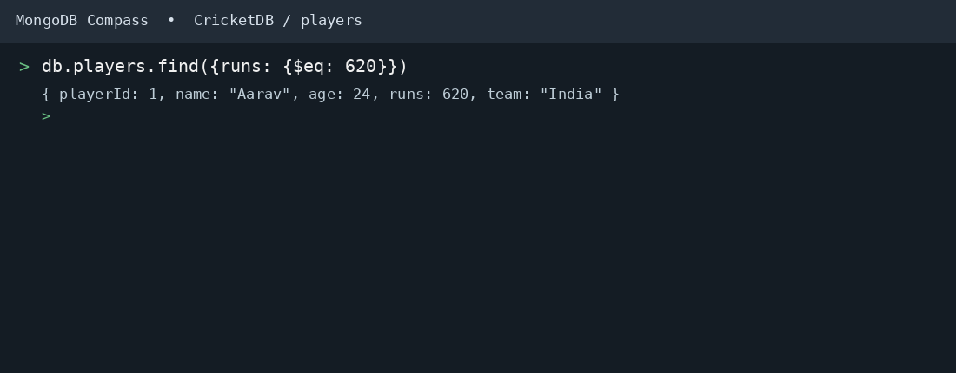

6. GREATER THAN — $gt
MongoDB Query:
db.players.find({runs: {$gt: 850}})
Explanation: Finds players whose runs are greater than 850.
Output Screenshot:
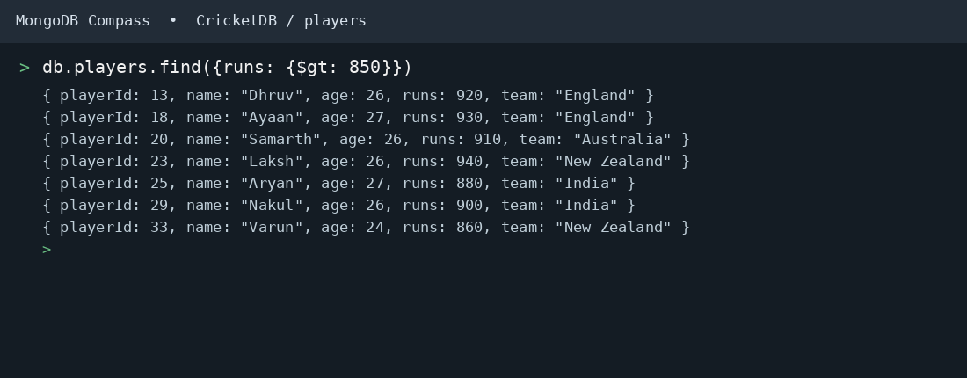

7. LESS THAN — $lt
MongoDB Query:
db.players.find({runs: {$lt: 350}})
Explanation: Finds players whose runs are less than 350.
Output Screenshot:
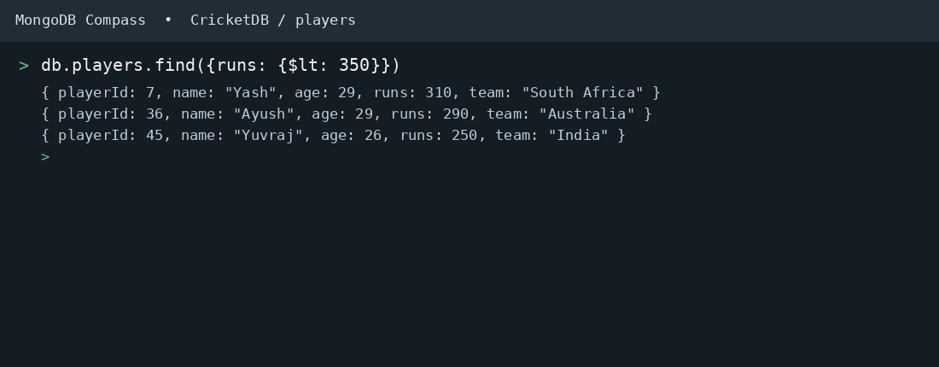

8. GREATER THAN OR EQUAL TO — $gte
MongoDB Query:
db.players.find({runs: {$gte: 900}})
Explanation: Finds players whose runs are 900 or above.
Output Screenshot:
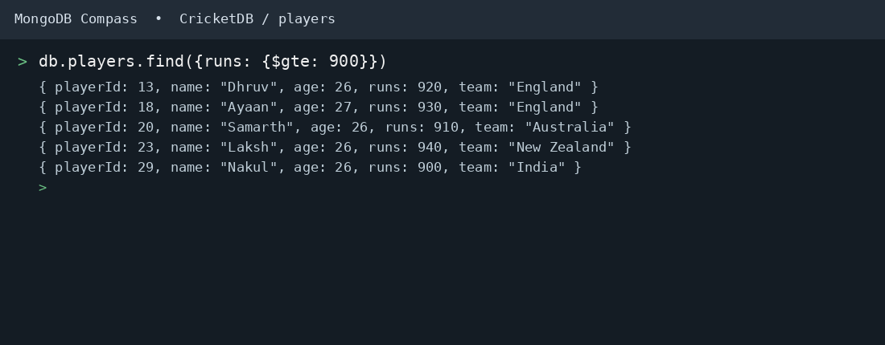

9. LESS THAN OR EQUAL TO — $lte
MongoDB Query:
db.players.find({runs: {$lte: 400}})
Explanation: Finds players whose runs are 400 or below.
Output Screenshot:
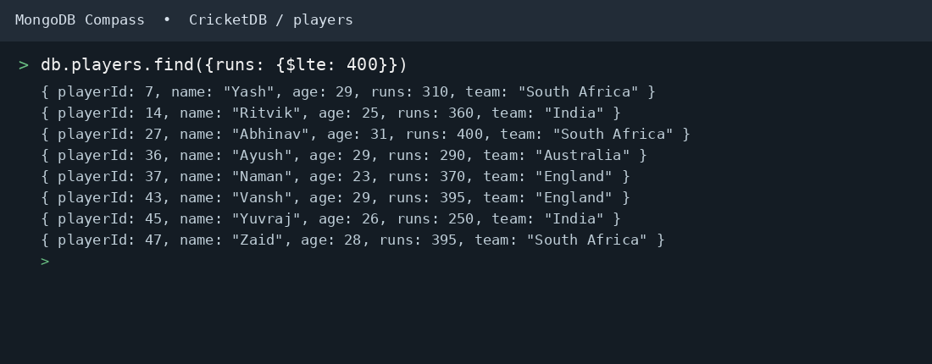

10. UPDATE OPERATION
MongoDB Query:
db.players.updateOne(
{playerId:5},
{$set:{runs:950}}
)
Explanation: Updates the runs to 950 of the player with playerId 5.
Output Screenshot:
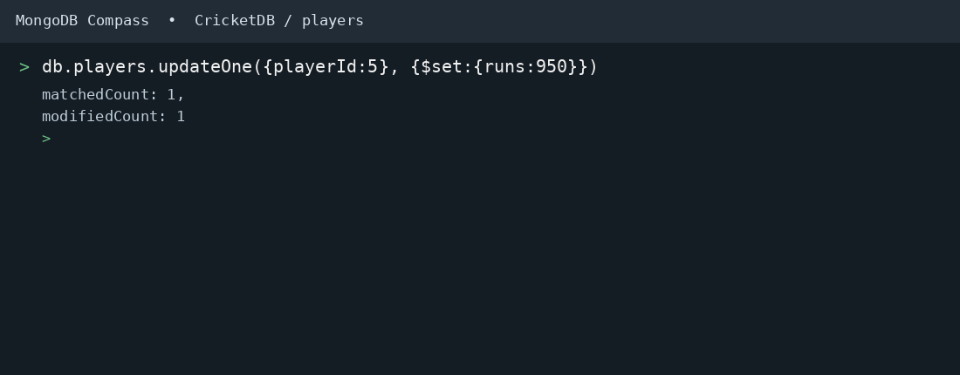

11. DELETE ONE OPERATION
MongoDB Query:
db.players.deleteOne({playerId:10})
Explanation: Deletes one document matching playerId 10.
Output Screenshot:
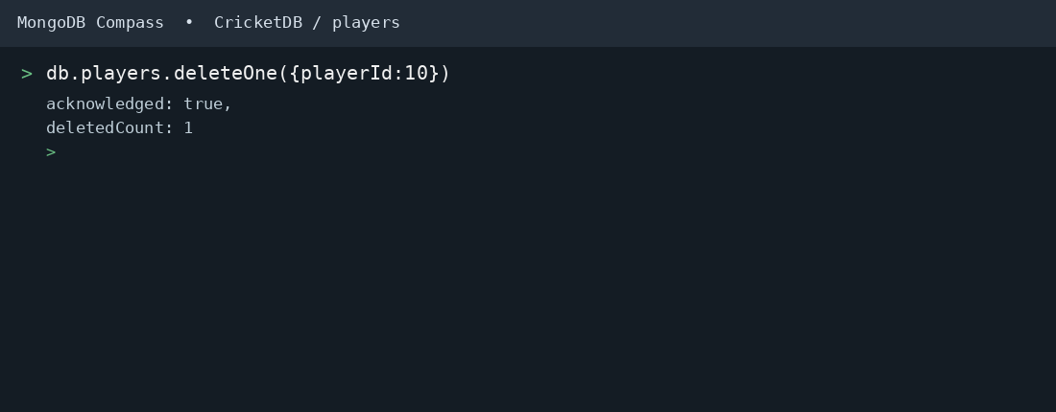

12. DELETE MANY OPERATION
MongoDB Query:
db.players.deleteMany({
runs: {$lt:350}
})
Explanation: Deletes all players having runs below 350.
Output Screenshot:
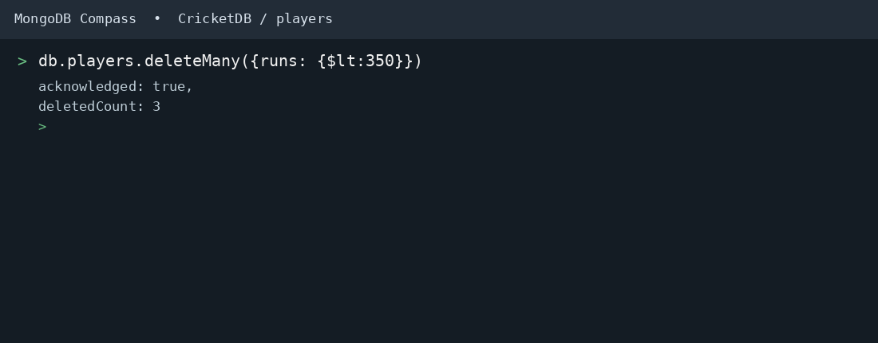

13. AND OPERATION — $and
MongoDB Query:
db.players.find({
$and:[
{runs:{$gt:800}},
{age:26}
]
})
Explanation: Finds players satisfying both conditions.
Output Screenshot:
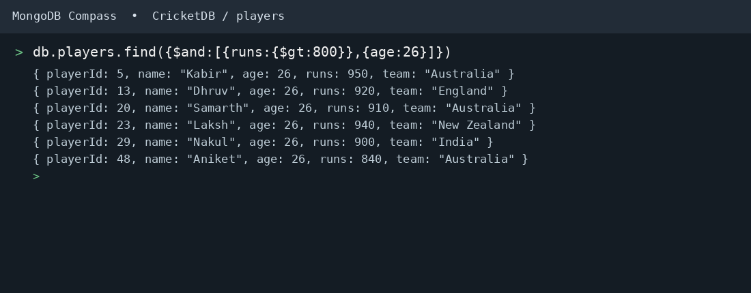

14. OR OPERATION — $or
MongoDB Query:
db.players.find({
$or:[
{team:"India"},
{team:"Australia"}
]
})
Explanation: Finds players who belong to India or Australia.
Output Screenshot:
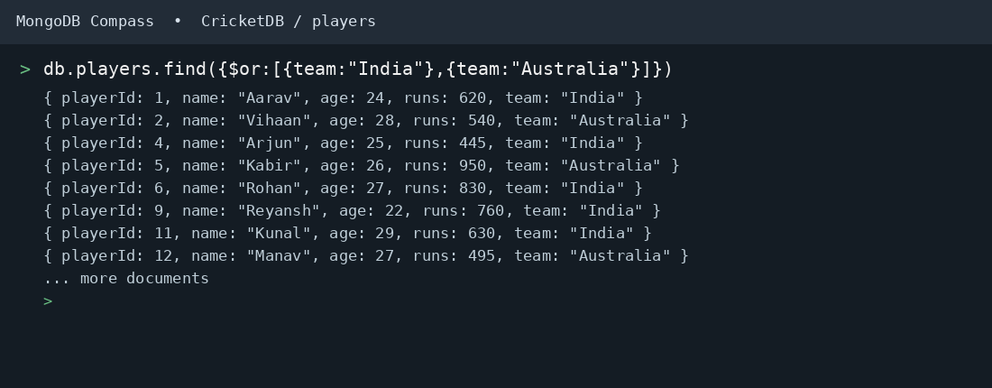

15. SORT OPERATION
A. MongoDB Query:
db.players.find().sort({runs: 1})
Explanation: Sorts players by runs from lowest to highest. Use 1 for ascending order.
Output Screenshot:
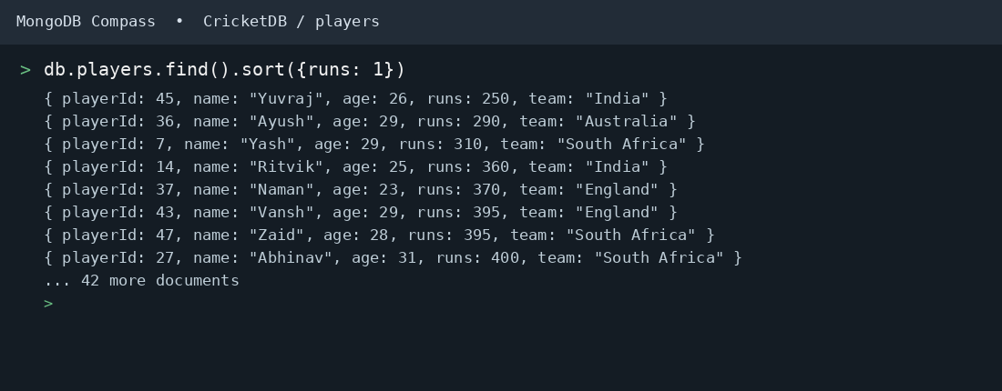
B. MongoDB Query:
db.players.find().sort({runs: -1})
Explanation: Sorts players by runs from highest to lowest. Use -1 for descending order.
Output Screenshot:
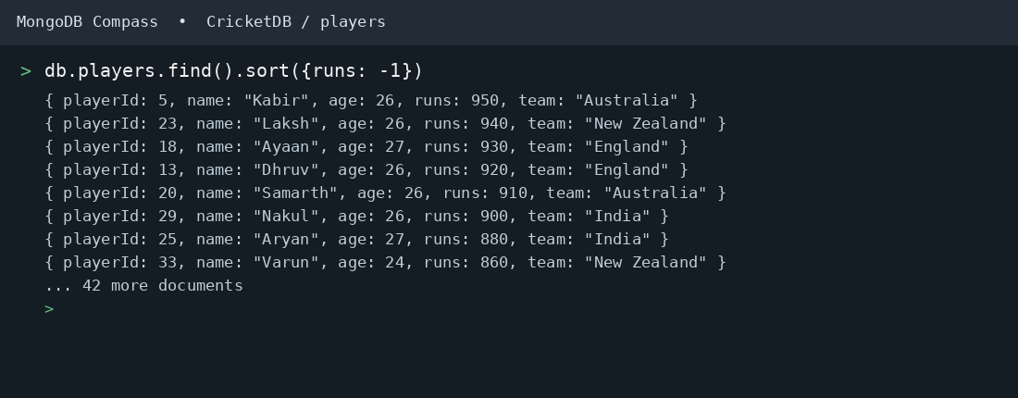

16. LIMIT OPERATION
MongoDB Query:
db.players.find().limit(5)
Explanation: Displays only the first five player documents.
Output Screenshot:
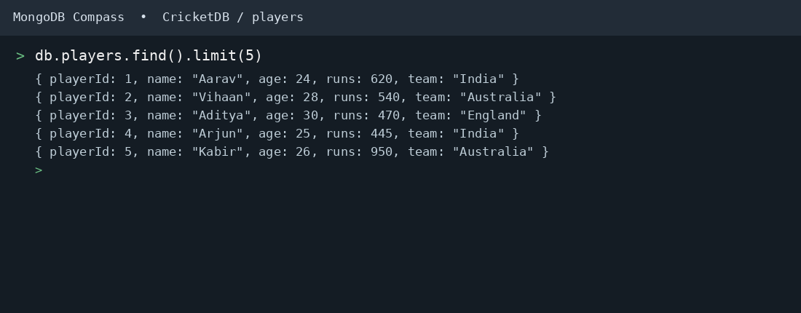

17. SEARCH BY TEAM
MongoDB Query:
db.players.find({team:"India"})
Explanation: Finds all players who belong to the India team.
Output Screenshot:
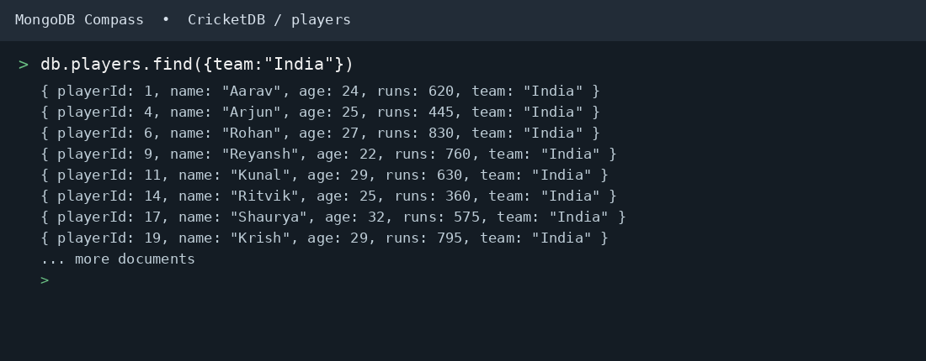

18. COUNT DOCUMENTS
MongoDB Query:
db.players.countDocuments()
Explanation: Counts documents currently present in the collection (performed after the delete operations).
Output Screenshot:
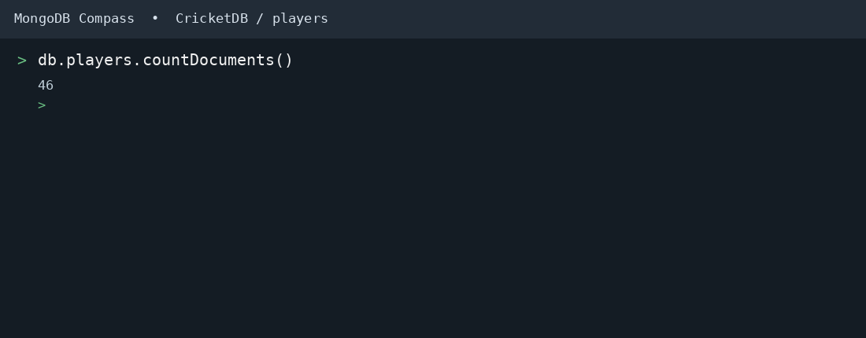

MONGODB OPERATORS USED
Operator | Meaning | Example
$eq | Equal to | runs: {$eq:620}
$gt | Greater than | runs: {$gt:850}
$lt | Less than | runs: {$lt:350}
$gte | Greater than or equal to | runs: {$gte:900}
$lte | Less than or equal to | runs: {$lte:400}
$and | All conditions true | $and:[...]
$or | At least one condition true | $or:[...]

CONCLUSION
This project provided practical knowledge of NoSQL databases using MongoDB. A Cricket Player Management System containing player information was created and different MongoDB operations were performed on the data.
Through this project, I learned how to insert, retrieve, update, and delete documents. I also learned how to arrange data in ascending and descending order, how comparison operators such as $eq, $gt, $lt, $gte, and $lte work, along with logical operators such as $and and $or.
Overall, this project helped me understand how MongoDB can be used to manage and query cricket player data efficiently.

