**BLM1033 - Devre Teorisi ve Elektronik Devreler**

**Ödev #01**

**Batuhan Odçıkın**

**22011093**

**Diode Clippers**

The diode in a series clipper “clips” any voltage that does not forward bias it. Here are some simulations of clipper series.

Here is a positive parallel clipper circuit. This clipper circuit is used for clipping positive voltage of a AC voltage source. At positive voltage, diode lets the current pass and behaves like a short circuit, but at negative voltage diode don’t lets to current pass so the resistor draws voltage. As a result, positive voltage gets clipped.

**metin, ekran görüntüsü, diyagram, grafik yazılımı içeren bir resim

Açıklama otomatik olarak oluşturuldu**

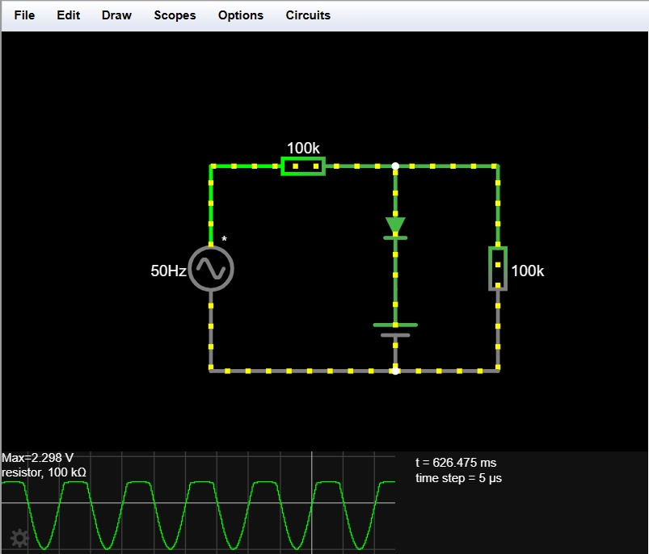

In this circuit, a DC voltage source connected as a serial to the diode with opposite direction. This DC voltage source leads to add a base voltage to clipped positive voltage. When at positive voltage, diode behaves like a short circuit, and DC voltage source produces positive voltage to resistor.

metin, ekran görüntüsü, diyagram, öykü gelişim çizgisi; kumpas; grafiğini çıkarma içeren bir resim

Açıklama otomatik olarak oluşturuldu

In this circuit, DC voltage source adds base voltage to negative voltage. It works same as previous circuit, but DC voltage source connected opposite way, so it produces negative voltage to resistor when the diode behaves as a short circuit.

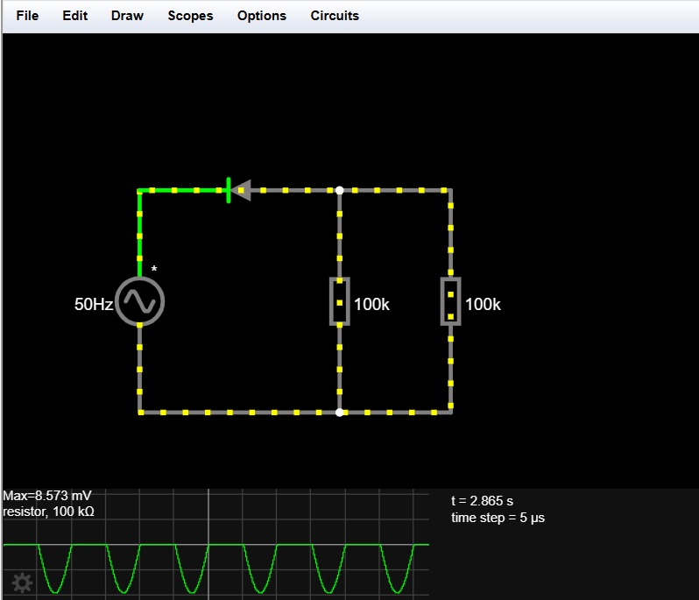

Here is a positive biased clipper circuit. This clipper circuit is used for clipping positive voltage of a AC voltage source. At positive voltage, diode don’t lets to current pass so resistor can’t draw positive voltage but at negative voltage, diode behaves like short circuit and current can passes through resistor. As a result, positive voltage is became clipped.

metin, ekran görüntüsü, diyagram, öykü gelişim çizgisi; kumpas; grafiğini çıkarma içeren bir resim

Açıklama otomatik olarak oluşturuldu

In this circuit, a DC voltage source added as serial connected to diode, opposite direction. That leads to strengthen the negative voltage because when the diode lets to current pass which is the negative voltage, DC voltage source became straight and adds power to negative voltage.

metin, ekran görüntüsü, öykü gelişim çizgisi; kumpas; grafiğini çıkarma, multimedya yazılımı içeren bir resim

Açıklama otomatik olarak oluşturuldu This circuit works as same as the previous one. The only difference is the DC voltage source connected opposite way (straight way for diode) so when the negative current passes through the resistor, DC voltage source weakens the AC voltage sources voltage.