REGRESSION

DATASET: The “Automobile Price Raw” dataset contains raw automobile-related data used for Machine Learning and predictive analysis. It includes various vehicle features such as brand, engine specifications, fuel type, dimensions, horsepower, and pricing information. This dataset is commonly used for training and evaluating ML models for automobile price prediction and data analysis in Microsoft Azure Machine Learning Studio.
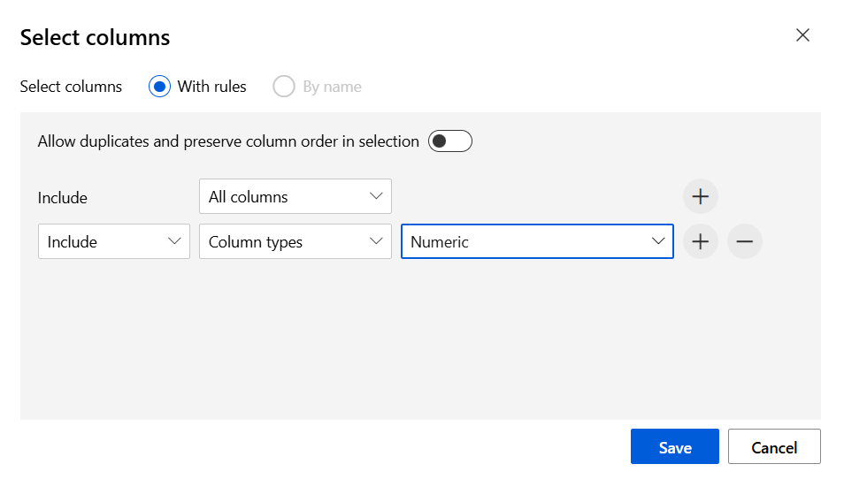
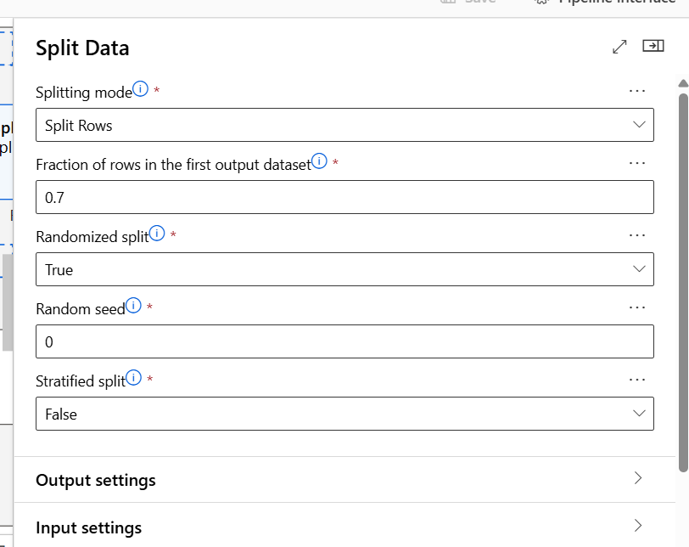

ALGORITHMS 01: POISSON REGRESSION
PIPELINE
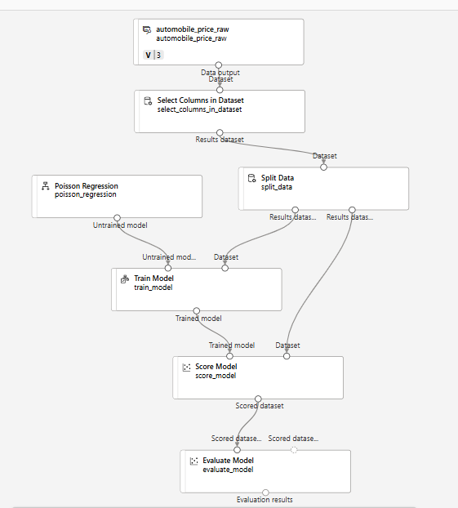

CREATING A COMPUTE

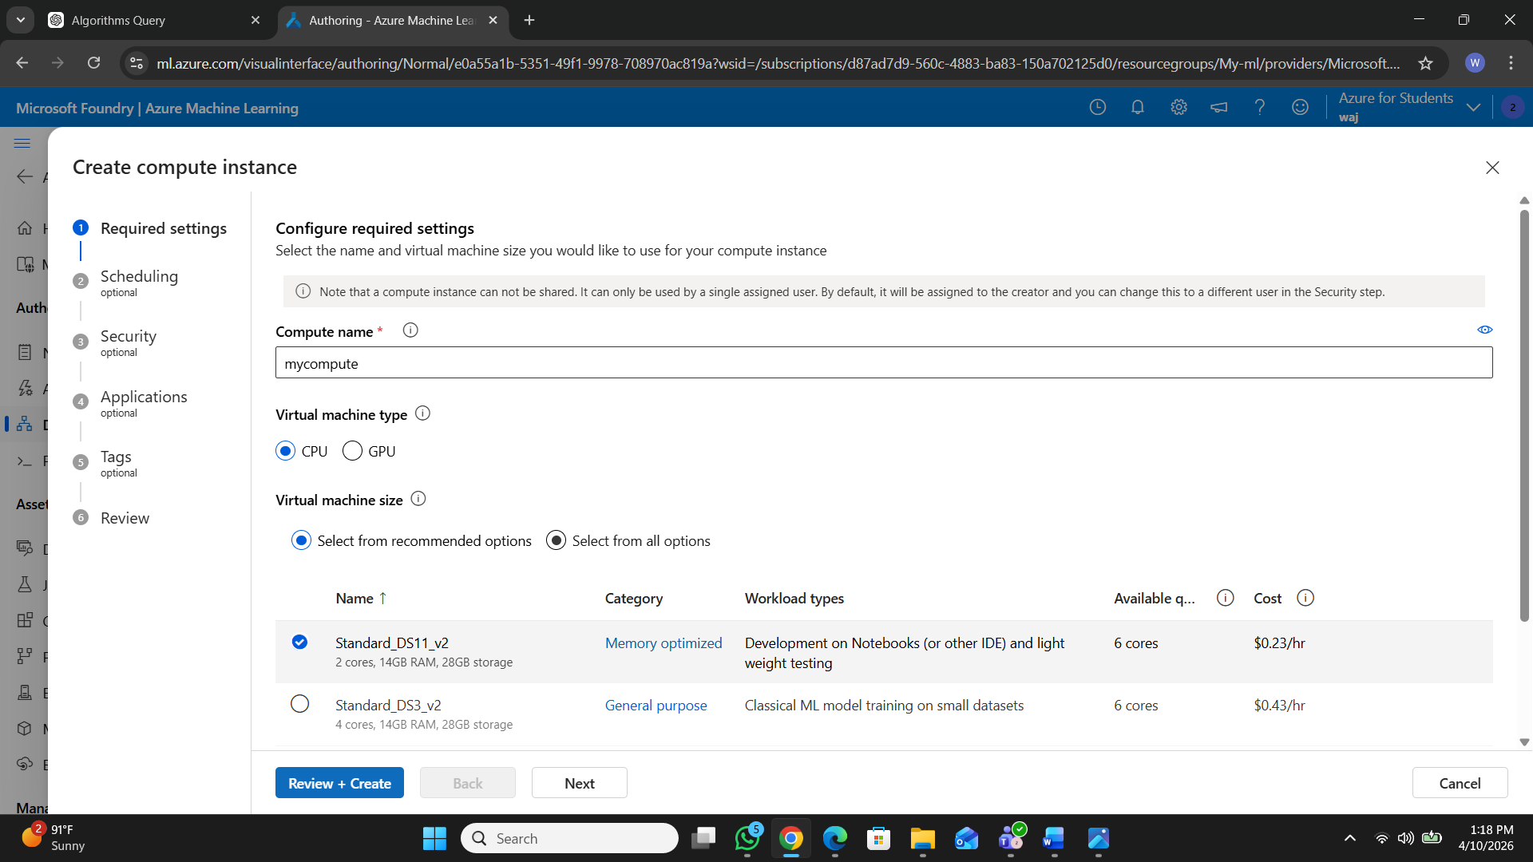

RUNNING A PIPELINE

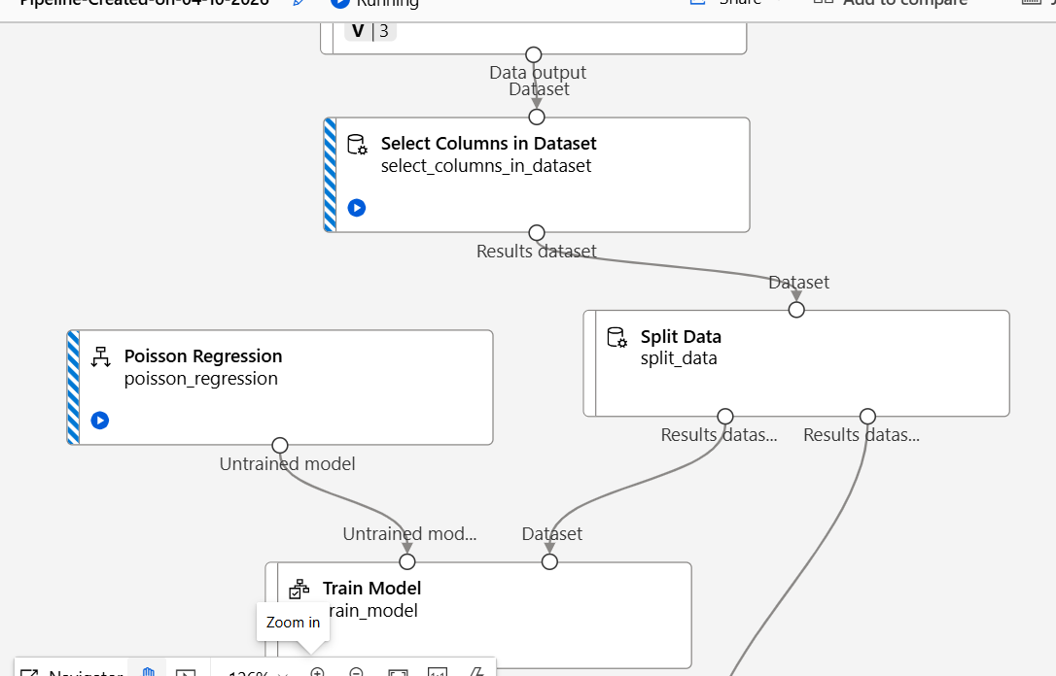
MATRICS OVERVIEW

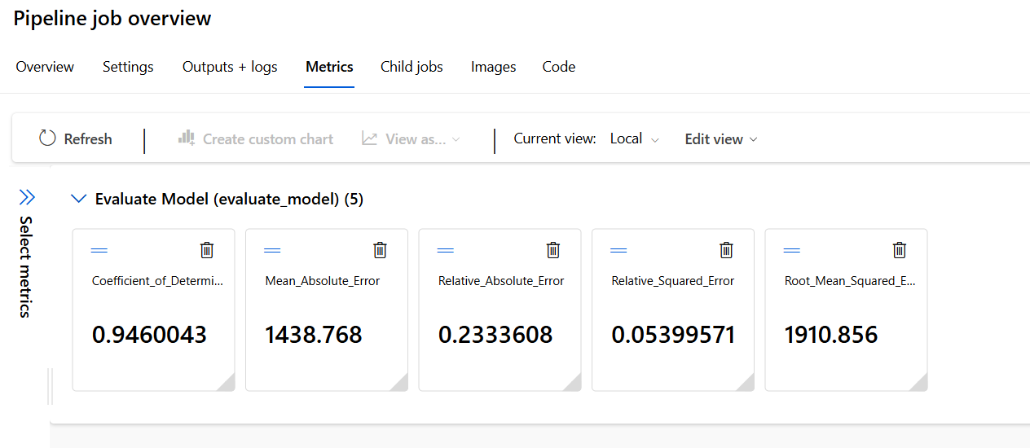

ALGORITHMS 02: DECISION FOREST REGRSSION

PIPELINE
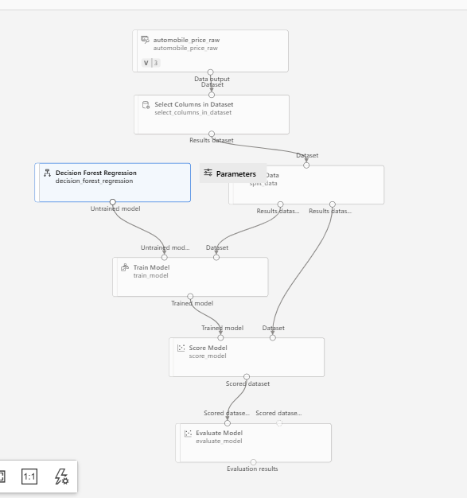

RUNNING A PIPELINE
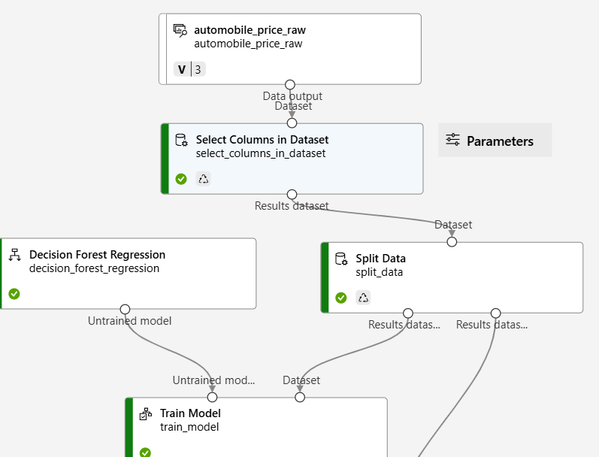

MATRICS OVERVIEW
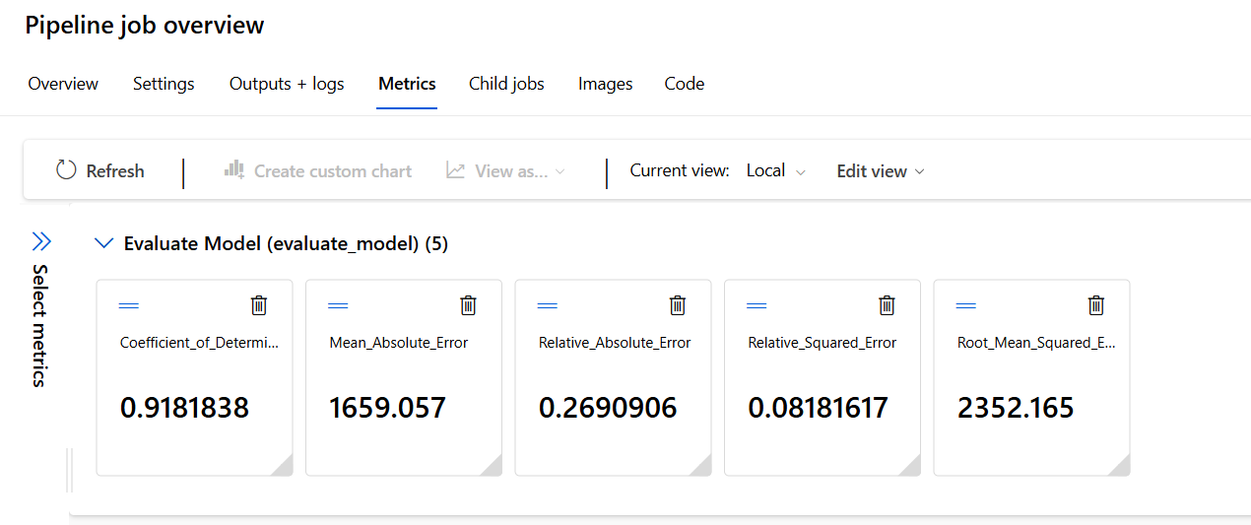
Comparison of Models:

We used two models: Poisson Regression and Decision Forest Regression to predict price values. After running both models, we compared their performance using evaluation metrics such as R² score, MAE, and RMSE.

The Decision Forest Regression model performed better than Poisson Regression. It has a higher R² score, which means it explains the data more accurately. Also, its MAE and RMSE values are lower, which shows that the prediction errors are smaller.

On the other hand, Poisson Regression gives less accurate results because it is a simpler model and cannot handle complex patterns in the data.

Conclusion:
Overall, Decision Forest Regression is the better model for price prediction because it provides more accurate and reliable results compared to Poisson Regression.

