CLASSIFICATION
Students-performance
This project uses a dataset to solve a real-world problem using machine learning techniques. The dataset contains multiple features that help in predicting the target variable. The goal is to analyze patterns in data and apply classification algorithms.

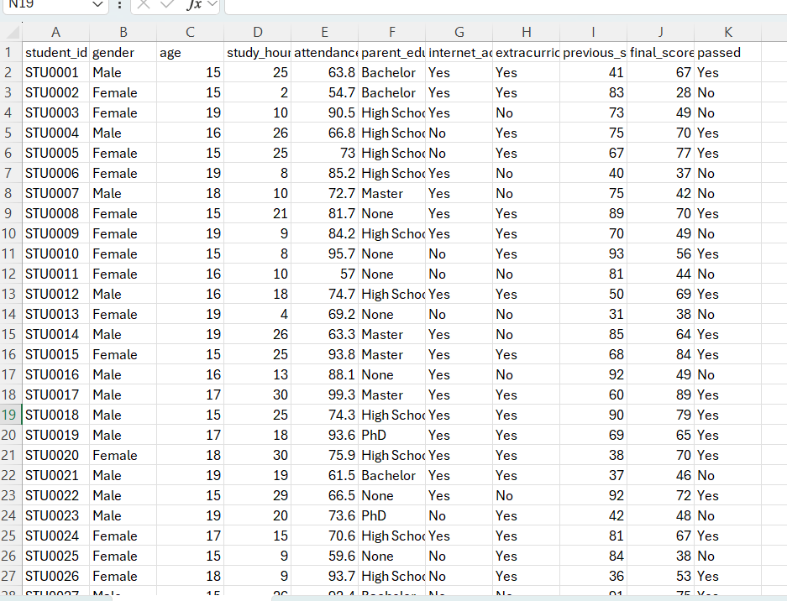

- Features (Inputs): student_id, gender, age, study-hours, attendance, parent-education, internet_access, extracurricular, previous_score, final_score, passed.
- Target Variable: passed

ALGORITHM 1: LOGISTIC REGRESSION
Logistic Regression is a supervised learning algorithm used for binary classification problems. It predicts the probability of a class using a sigmoid function.
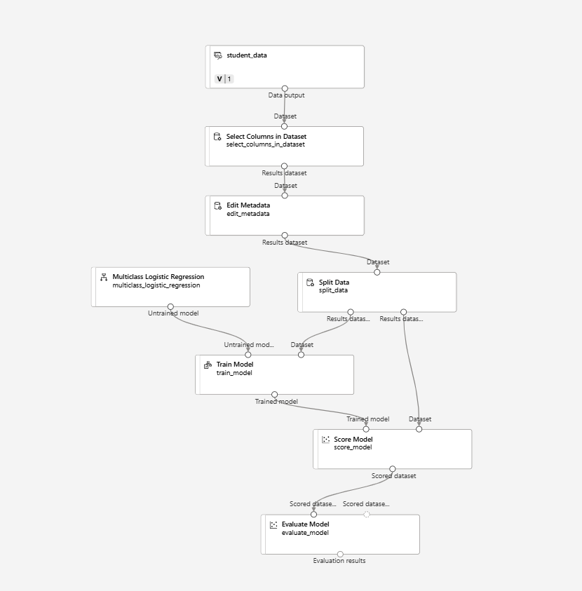
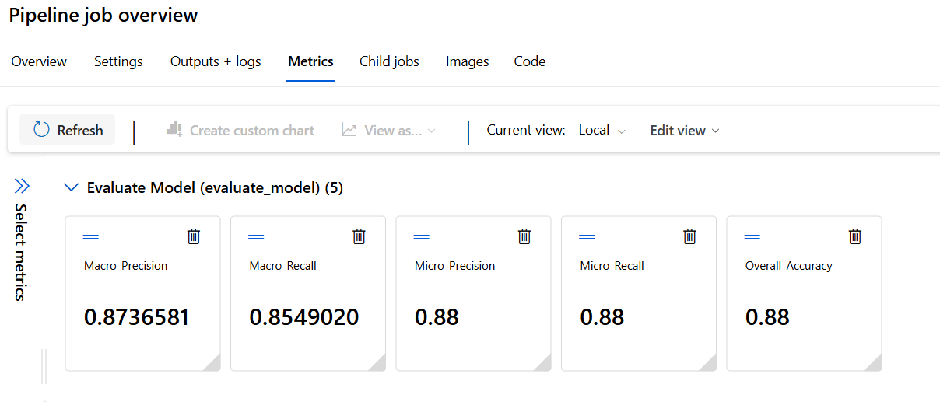
ALGORITHM 2: DECISION TREE
Decision Tree is a model that splits data into branches based on conditions. It is easy to interpret and works well with both numerical and categorical data.

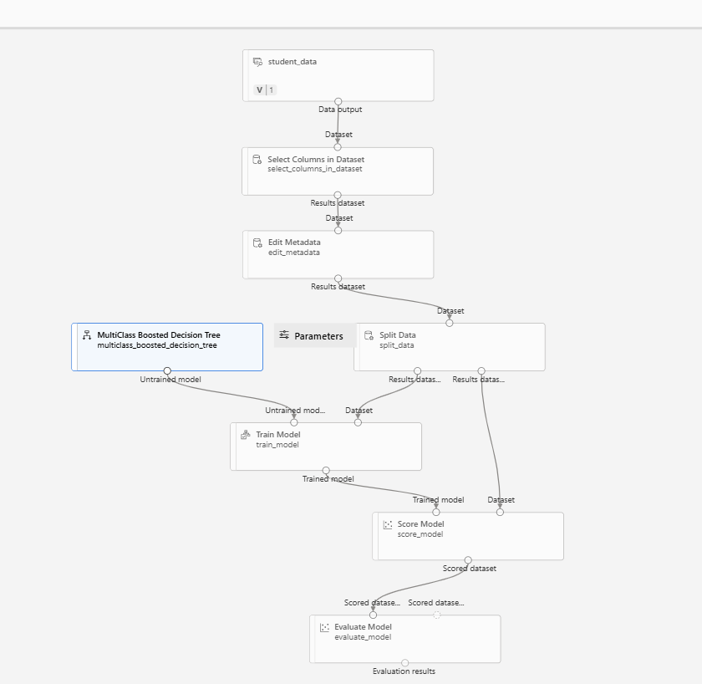
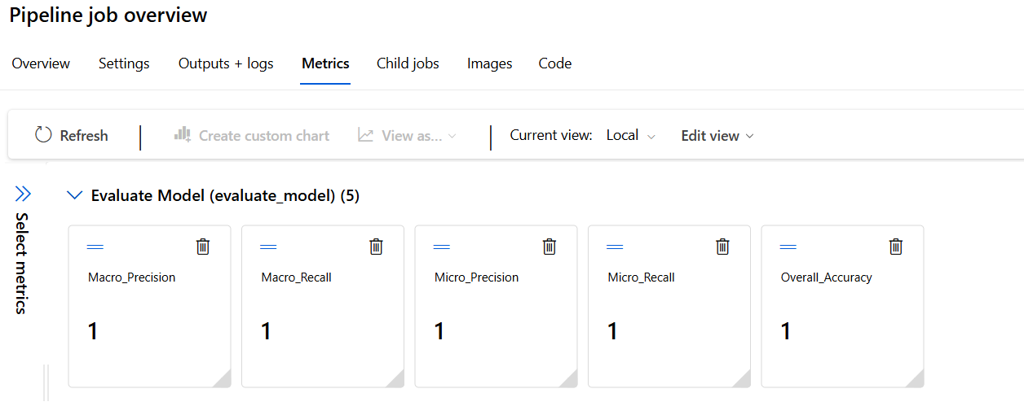

RESULTS

Algorithm | Macro-Precision | Macro-Recall | Micro-Precision | Micro-Recall | Overall-Accuracy
Logistic Regression | 87% | 85% | 88% | 88% | 88%
Decision Tree | 1 | 1 | 1 | 1 | 1

Results conclude that logistic regression performance good as compare to decision tree because it gives the over-fitting for the same dataset used for the other algorithm

