CLUSTERING
Mall-Customer
This project uses a dataset to solve a real-world problem using machine learning techniques. The dataset contains multiple features that help in predicting the target variable. The goal is to analyze patterns in data and apply clustering algorithm.

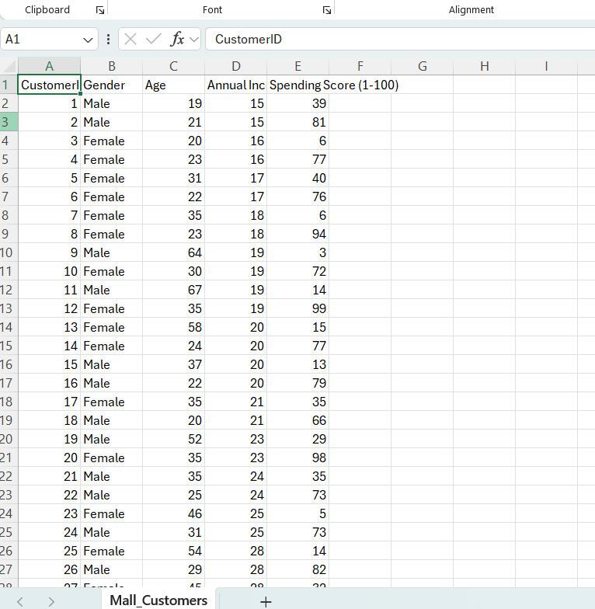

- Features (Inputs): customer id, Gender, Annual Income, Spending score.
- Target Variable: all columns exclusively gender

Algorithm : K-Means
K-Means groups data into k clusters based on distance.
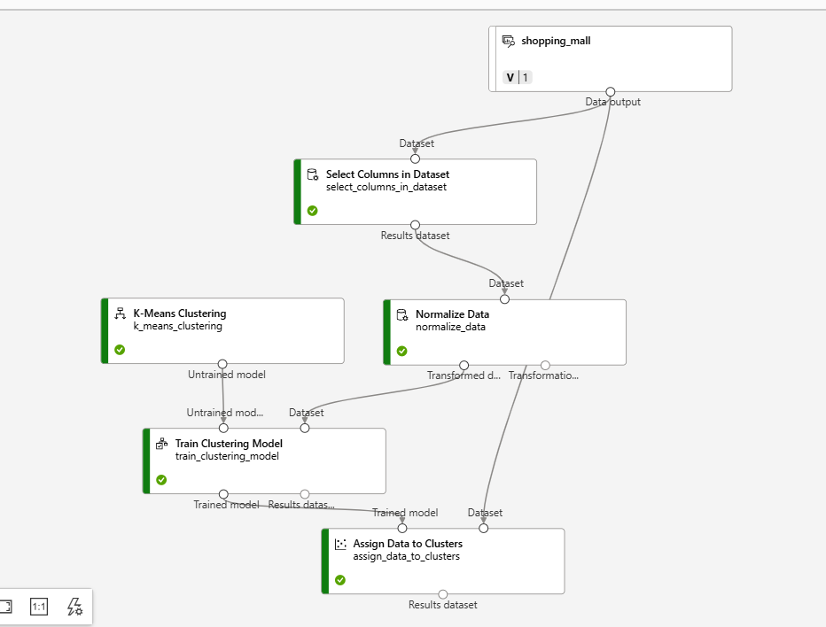

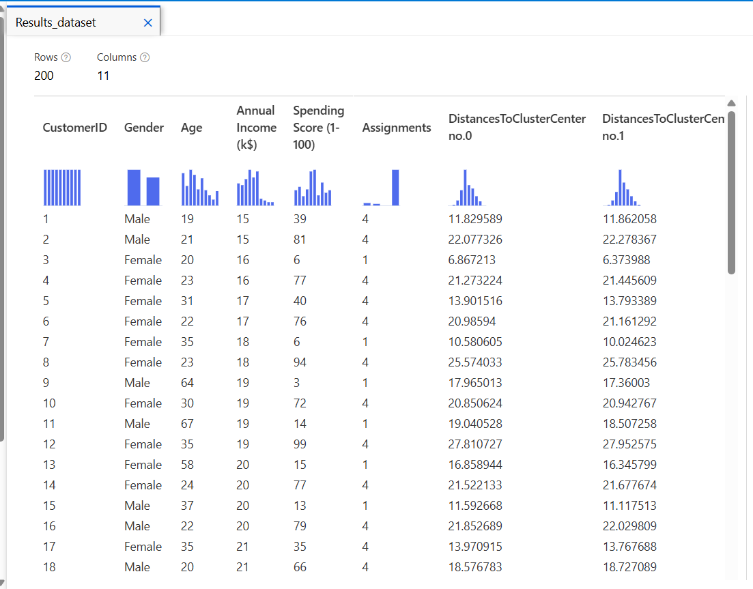

Results conclude that most nearest cluster is no.4 and secondly near is no.1

