# **Project Leaders**

Xintao Pang

**BLENet: a Bio-inspired Lightweight and Efficient Network for Left Ventricle Segmentation in Echocardiography**

In echocardiography, accurate segmentation of the left ventricle at end-diastole (ED) and end-systole (ES) is crucial for quantitative assessment of left ventricular ejection fraction. However, as a dynamic imaging modality requiring real-time analysis and frequently performed in various clinical settings with portable devices, this challenges mainstream approaches that primarily enhance model performance by increasing the number of parameters and computational costs, while lacking targeted optimization for its characteristics. To address these challenges, we propose BLENet, a lightweight segmentation model inspired by biological vision mechanisms. By integrating key mechanisms from biological vision systems with medical image features, our model achieves efficient and accurate segmentation. Specifically, the center-surround antagonism of retinal ganglion cells and the lateral geniculate nucleus exhibits high sensitivity to contrast variations, corresponding to the distinct contrast between the ventricular chamber (hypoechoic) and myocardial wall (hyperechoic) in ultrasound images. Based on this, we designed an antagonistic module to enhance feature extraction in target regions. Subsequently, the directional selectivity mechanism in the V1 cortex aligns with the variable directional features of the ventricular boundary, inspiring our direction-selective module to improve segmentation accuracy. Finally, we introduce an adaptive wavelet fusion module in the decoding network to address the limited receptive field of convolutions and enhance feature integration in cardiac ultrasound. Experiments demonstrate that our model contains only 0.16M parameters and requires no pre-training. On the CAMUS dataset, it achieves Dice coefficient values of 0.951 and 0.927 for ED and ES phases respectively, while on the EchoNet-Dynamic dataset, it achieves 0.933 and 0.909, with an inference speed of 112 FPS on NVIDIA RTX 2080 Ti. Evaluation on an external clinical dataset indicates our model's promising generalization and potential for clinical application.

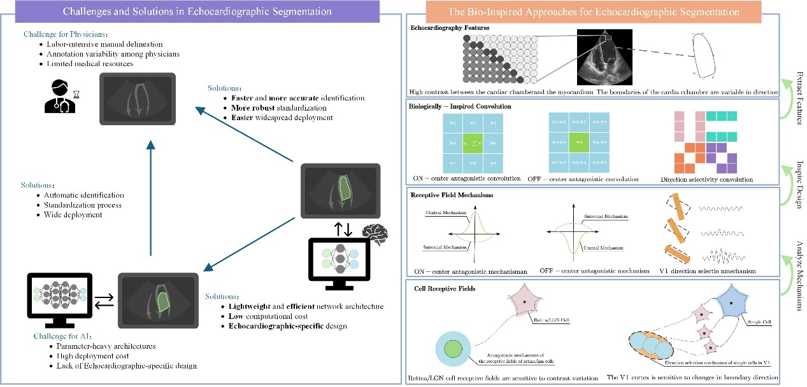

**Fig.1** Bio-Inspired Solutions for Challenges in Echocardiographic Segmentation. As shown in the left image, physicians face heavy workloads and inconsistencies when manually annotating the left ventricle in cardiac ultrasound images. While AI can alleviate these issues, it often involves complex parameters, high deployment costs, and neglects imaging characteristics. To address these challenges, we draw inspiration from the biological visual system for a more efficient solution. We analyzed the imaging features of cardiac ultrasound (such as the distinct brightness contrast between the heart cavity and myocardium, and the multi-directional variability of the ventricular boundary, as shown in the first row) and found a natural correspondence with the biological visual system’s processing mechanisms. Notably, convolution operations themselves are inspired by biological vision. Based on this, we designed two biologically inspired convolution modules—antagonistic convolutions inspired by the on-center (center inhibits surround) and off-center (surround inhibits center) mechanisms, and direction-selective convolution (as shown in the second row)—organized hierarchically to form a lightweight model with only 0.16M parameters. This model reduces the deployment challenges of large models with high number of parameters and computational costs. It also achieves faster, more accurate automatic segmentation, significantly easing the workload of physicians. The integration of biological mechanisms with computational efficiency demonstrates how natural designs can effectively tackle complex medical image analysis challenges.

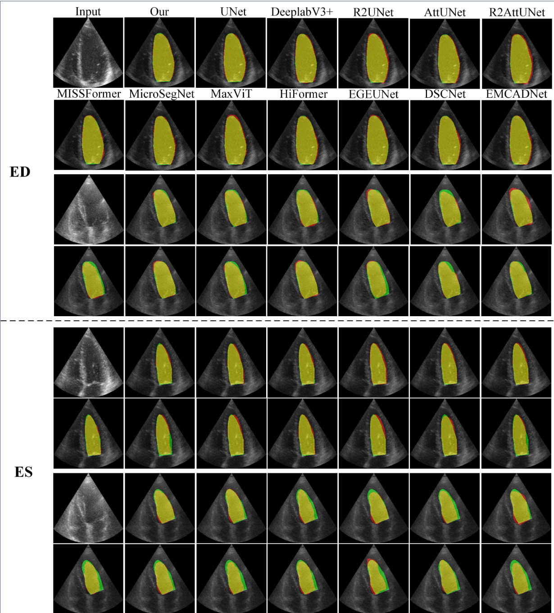  
Fig.2 Visualization Comparison of Model Segmentation with SOTA Models on the CAMUS Dataset