一级标题：APTw imaging and segmentation

二级标题：APT fast imaging

内容：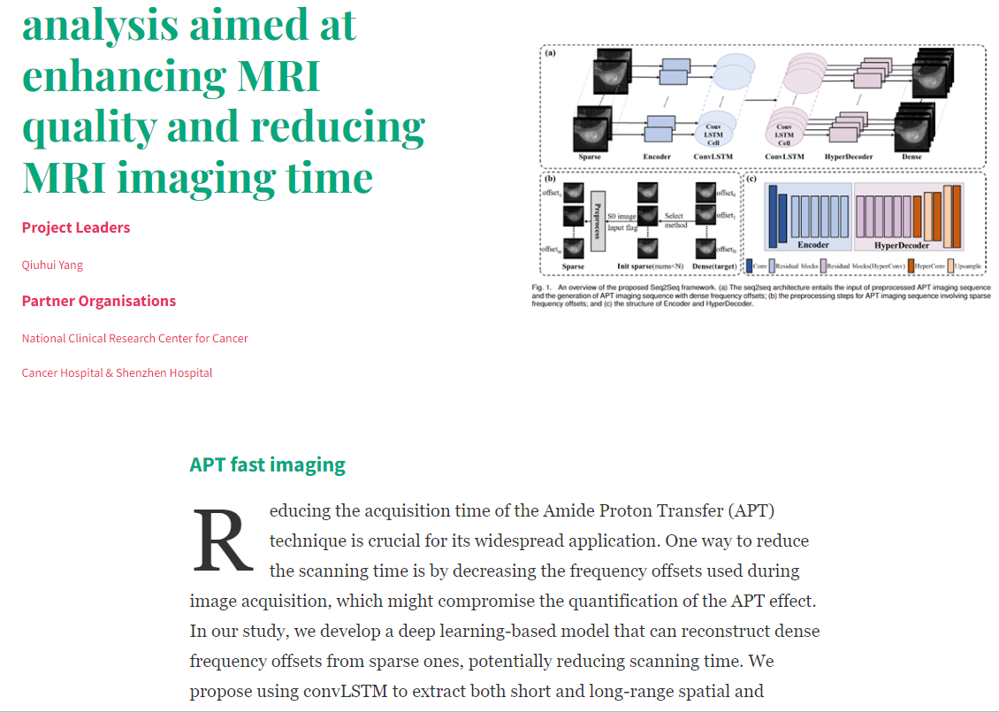

二级标题：APT Segmentation

一级标题：Analysis of the entire group

二级标题：APT fast imaging

内容：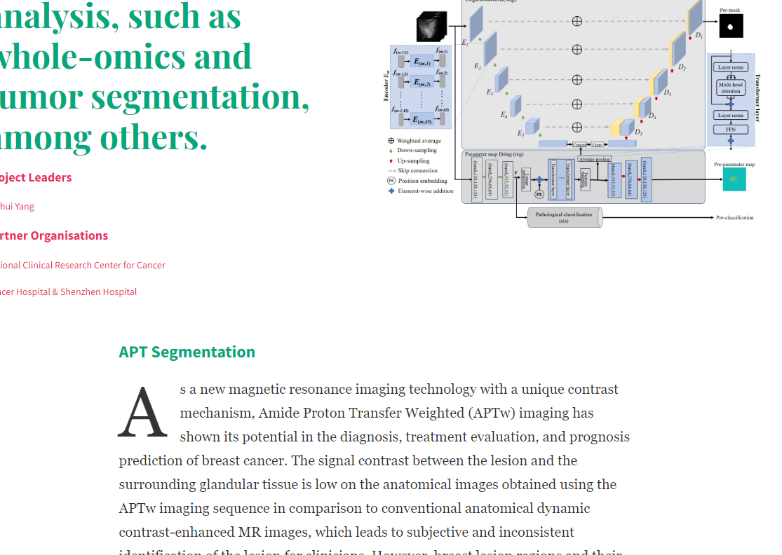

一级标题：Analysis of the entire group

内容：**UniMRISegNet: Universal 3D Network for**

**Various Organs and Cancers Segmentation on**

**Multi-Sequence MRI**

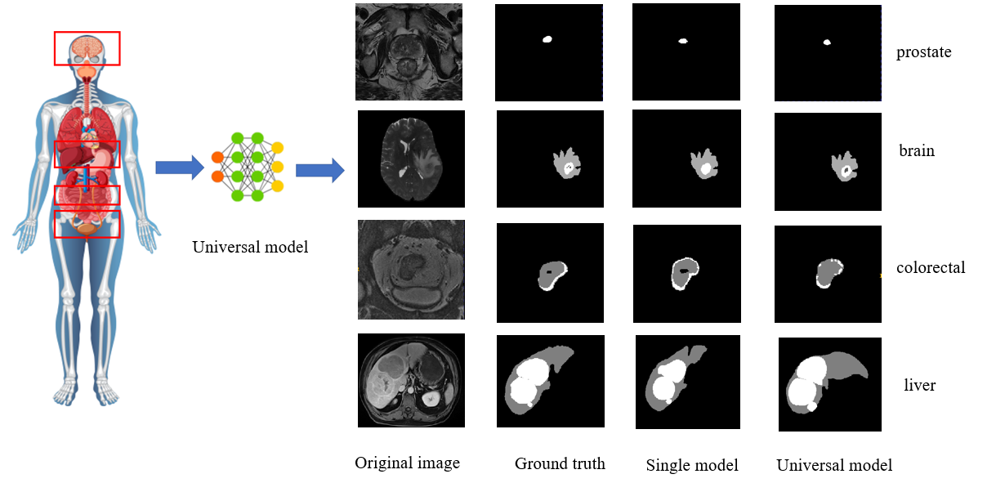

Magnetic Resonance Imaging (MRI) stands as a cornerstone in modern medical diagnostics, renowned for its unparalleled ability to provide exquisite soft tissue contrast. This advanced imaging modality has become an indispensable tool in patient screening processes. The versatility of MRI is underscored by its array of imaging sequences, including T1-weighted (T1w), T1-weighted contrast-enhanced (T1c), T2-weighted (T2W), T2-fluid attenuated inversion recovery (T2f), and Apparent Diffusion Coefficient (ADC), among others. Each sequence offers a unique perspective on the lesions within the body, providing crucial information that aids clinicians in formulating accurate diagnoses and treatment plans.

Despite its numerous advantages, the diversity of MRI sequences poses a substantial challenge for radiologists. They are often burdened with the arduous and time-intensive task of manually labeling multiple organs or cancerous regions in three-dimensional (3D) space, based on various MRI sequences. This process is not only labor-intensive but also prone to human error, which can impact patient care. Furthermore, existing automated segmentation methods are largely tailored to specific MRI sequences, organs, or types of cancer. This specialization results in a lack of generality, making these methods less adaptable to a broader range of medical imaging tasks. As the number of tasks for which these methods are trained increases, inference speeds tend to slow down, and the parameter counts, leading to increased computational complexity.

In light of these challenges, there is an urgent demand for the development of an automatic universal 3D segmentation network. Such a network would need to be capable of handling multiple MRI sequences, as well as segmenting various organs and types of cancer. This innovative approach would not only streamline the diagnostic process but also enhance the overall efficiency and accuracy of medical imaging analysis, ultimately contributing to improved patient outcomes.

一级标题：MR image denoising

内容：