**Title**

CLIP-Driven Universal Model for Tumor Detection Based on Magnetic Resonance Images

**Research Background**

Tumor is one of the main causes of death in humans, and early detection and discovery of tumors through imaging means is crucial for patient treatment and prognosis. Magnetic Resonance Imaging (MRI) with an advantage of non-invasive, no radiation, and high spatial resolutions, which has been recognized as an important tool for screen and detection of tumor. The common tumor types, including brain tumor, prostate tumor, and breast tumor, which as shown in Fig 1.

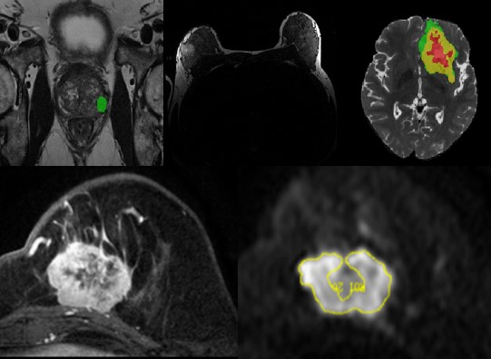

Fig 1. Common tumor types, including brain tumor, prostate tumor, and breast tumor.

**Research Problem**

However, most of the current AI algorithms for tumor detection focus on a single organ and a single task, which greatly limits the universality of the AI algorithm and the transfer learning ability of downstream tasks.

**Research Objective**

Therefore, Our main research objective is to develop an expansive unified model，specifically grounded in the analysis of magnetic resonance (MR) tumor images. This ambitious undertaking aims to furnish a multifaceted solution, concurrently addressing various pivotal tasks integral to tumor characterization. These tasks encompass, but are not limited to, precise segmentation, nuanced classification discerning between benign and malignant manifestations, and the sophisticated classification of tumors based on molecular attributes. The overarching objective is to devise a model of notable sophistication and versatility, capable of comprehensively enhancing the diagnostic capabilities within the realm of tumor analysis and contributing substantively to the field of medical imaging research.

**Research Route**

The specific research route is shown in fig 2, specifically, the universal model supports multi MR input forms, such as T1, T1w, T2, Flair, DWI, DCE, and ADC. In addition, it also supports multiple organ sites, such as brain, chest, and abdomen. In output part, the universal model supports different tasks, such as segmentation of tumor, classification of benign and malignant of tumor, classification of tumor molecular, and prediction of biochemical recurrence.

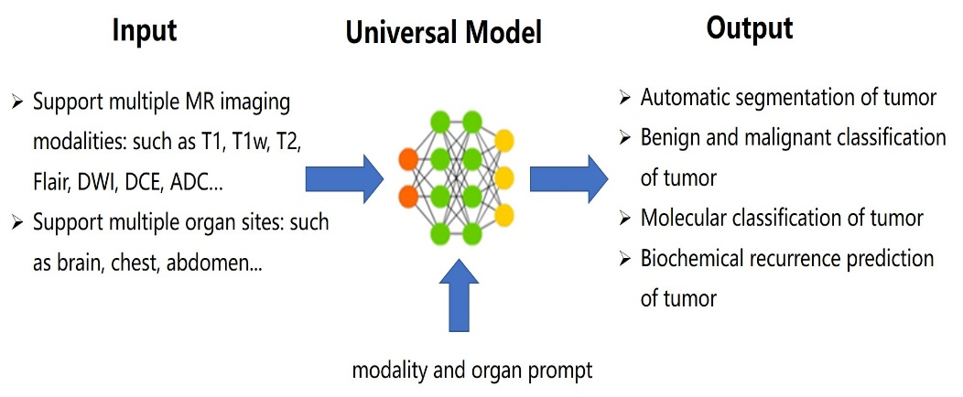

Fig 2. Overall research route

**Initial Research Result**

As shown in fig 3, which is our different model’s performance in segmentation of brain tumor and prostate cancer.

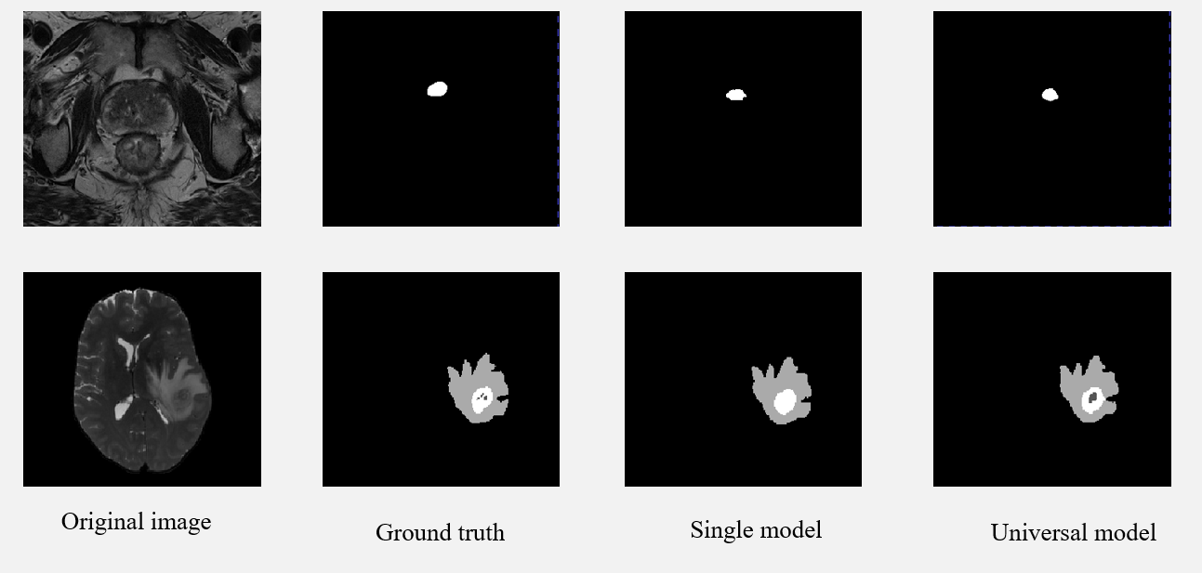

Fig 3. Comparison of different models in segmentation of tumor