个人研究

1.题目

An Explainable MRI Framework for Breast Tumor Using Amide Proton Transfer Weighted Imaging

2.代表性图片

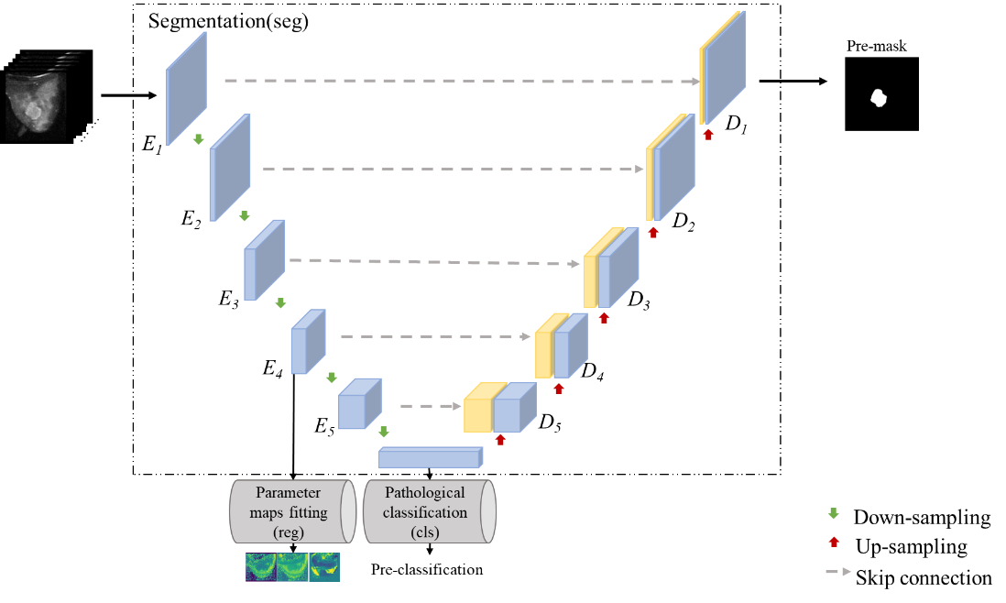

3.具体内容

（1）研究目的

乳腺癌是危害女性健康的恶性疾病，早发现与早治疗是提高乳腺癌患者存活率的重要手段。核磁乳腺检查具有较高的安全性，适合乳腺常规普查。

Breast cancer is a malignant disease that endangers women's health. Early detection and early treatment are important means to improve the survival rate of breast cancer patients. Magnetic resonance imaging (MRI) breast examination has high safety and is suitable for routine breast screening.

（2）研究背景及当前研究存在的问题

核磁共振成像是国际上公认的有效乳腺癌检查方法之一，具有软组织分辨和空间分辨率高的特点，且可进行多种层面、多种参数、多种序列的技术成像，能够提供大量信息。但它存在灰度不均匀、边界模糊的问题，导致其在临床应用中难以分割肿瘤区域。

MRI is one of the internationally recognized effective methods for breast cancer detection. It has the characteristics of soft tissue resolution and high spatial resolution. However, it has the problems of uneven gray level and fuzzy boundary, which makes it difficult to segment the tumor region in clinical application.

（3）研究方法

APT图像序列在乳腺肿瘤及其周围腺体组织具有明显的APTw效应，因此我们提出了一种基于多任务学习的可解释乳腺肿瘤分割网络。该方法结合APT参数图和病理数据辅助肿瘤分割任务。研究利用卷积神经网络分别提取APT图像序列的特征，分析不同脉冲频率对分割的贡献程度，提高模型的可解释性。

APT image sequences have obvious APTw effects in breast tumors and their surrounding glandular tissues, so we propose an interpretable breast tumor segmentation network based on multi-task learning. This method combines APT parameter map and pathological data to assist tumor segmentation task. This paper uses convolutional neural network to extract the features of APT image sequences, analyzes the contribution of different pulse frequencies to segmentation, and improves the interpretability of the model.

（4）研究结果

通过APT图像序列进行肿瘤分割和分类的结果表明，不同脉冲频率的饱和图像对分割结果的重要性有所不同，可以根据重要程度筛选成像时使用的频率，有利于减少成像时间。结合APT参数图和病理数据的分割结果优于仅使用APT图像序列，说明APT效应有助于提高肿瘤分割的准确性。

The results of tumor segmentation and classification by APT image sequences show that the importance of saturated images with different pulse frequencies to segmentation results is different, and the frequency used in imaging can be selected according to the importance, which is beneficial to reduce the imaging time. The segmentation results obtained by combining the APT parametric map and pathological data are better than those obtained by using only APT image sequences, indicating that the APT effect helps to improve the accuracy of tumor segmentation.

（5）研究总结

研究提出的结合APT图像序列的深度学习多任务模型可提升乳腺肿瘤分割的准确率，为乳腺肿瘤诊断提供了新思路。

The proposed deep learning multi-task model combined with APT image sequence can improve the accuracy of breast tumor segmentation, which provides a new idea for breast tumor diagnosis.